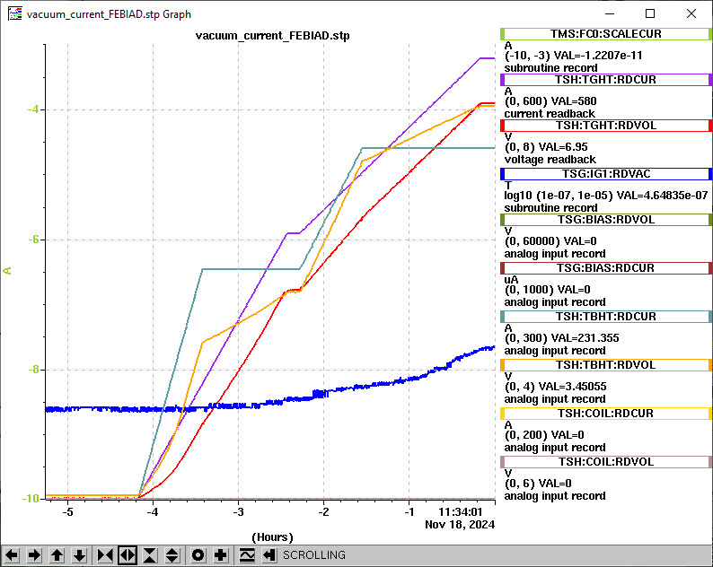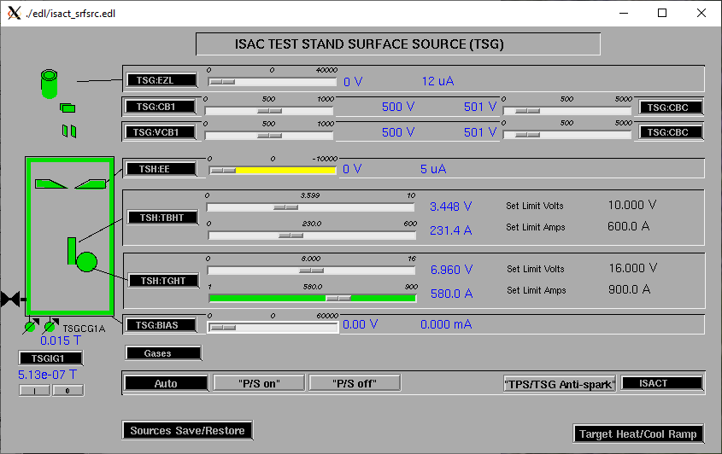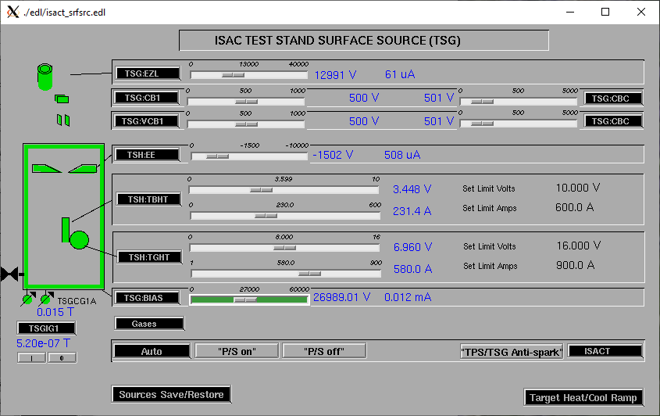 <https://isacwserv.triumf.ca/onlylocal/isactdata/save_restore/masscorr/2024-11-18-13-47%20LP-SIS%20UC%2347%20Empty%20-%20Scan%201>

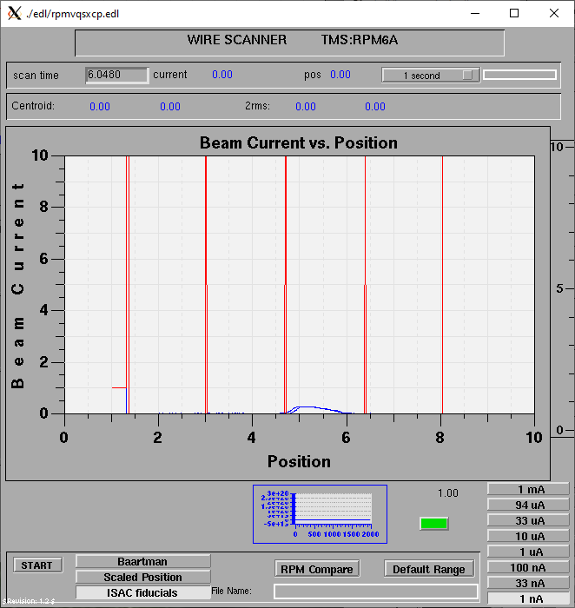

Mass 23

Mass 23

