2024-09-11

Date: June 21, 2024
Author: Dave Neilson
Elog: https://elog.triumf.ca/TIS/Test-Stand/1021
Target/No.#: TiC#24D
Source: HP-SIS
Target Oven W.O#: 45447-27
Heat Shield W.O#: 45235-25

Objectives:
- For experiments:
  - https://mis.triumf.ca/science/experiment/view/S1188
  - https://mis.triumf.ca/science/experiment/view/S1603
- Desired beams during operation:
  - 1° - 37K, 38mK
  - 2° - 80Rb
Findings:
- No unexpected ions or contaminants
- Clean output at the desired RIB output range
Procedure and results:
Initially, the target was heated up to TGHT/TBHT 580A/230A.

At 580A/230A, a mass scan was taken with the standard optical tune (at end of report).

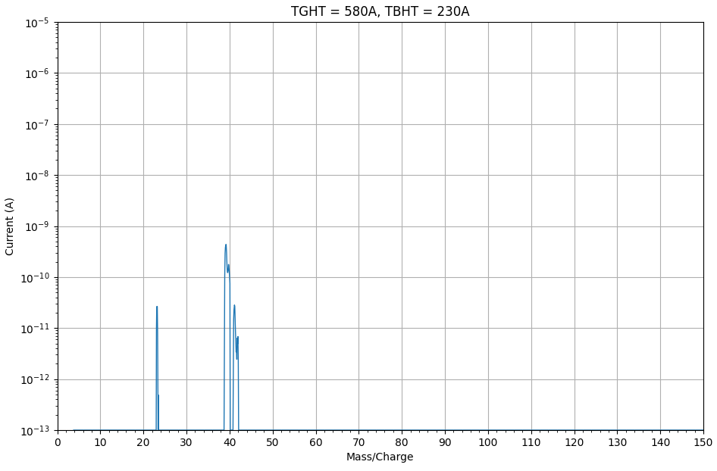
Figure R1. Beam current vs mass number at 580A/230A, full range. A mass scan taken when the target was first ramped up to operational temperatures, with TGHT/TBHT 580A/230A. Peaks with current greater than 10 pA are located at 23, 39, and 41.

Peaks in figure R1 are likely associated with sodium (23) and potassium (39, 41). Sodium and potassium are commonly seen in such scans and are to be expected. In the region of scheduled isotopes (37, 38, 80), there are no impactful contaminants.
During this evaluation, there was a technical issue with recording background level signals on FC6 at the ISAC test stand. This causes signals at values less than 1 pA to essentially disappear.

Beam tuning parameters:
- As per 2024-01-25 ISAC test stand tune.
