2024-06-21

Date: June 21, 2024

Author: Dave Neilson

Elog: https://elog.triumf.ca/TIS/Test-Stand/1011

Target/No.#: TiC#24C

Source: HP-SIS

Target Oven W.O#: 45447-29

Heat Shield W.O#: 45235-19

**Objectives:**

* For experiments:
  + <https://mis.triumf.ca/science/experiment/view/S1188>
  + <https://mis.triumf.ca/science/experiment/view/S1603>
* Desired beams during operation:
  + 1° - 37K, 38mK
  + 2° - 80Rb

**Findings:**

* No unexpected ions or contaminants
* Clean output at the desired RIB output range

**Procedure and results:**

Initially, the target was heated up to TGHT/TBHT 440A/230A. The high voltage bias was gradually increased to 38 kV. At voltages above 33kV, sparking was occasional but infrequent. At 38kV, it was deemed to be sufficient for high voltage conditioning, given the operational voltage.

At 580A/230A, a mass scan was taken with the standard optical tune (end of report).

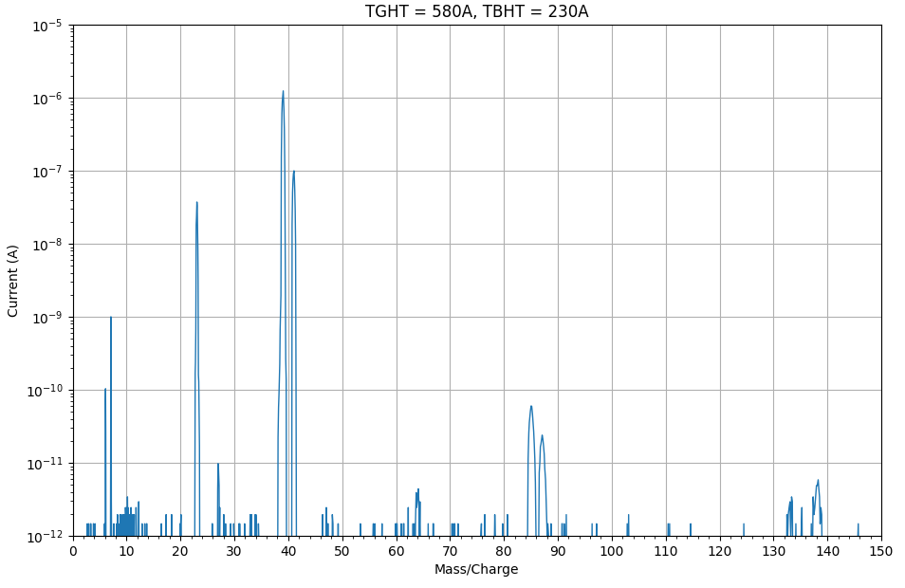

**Figure R1. Beam current vs mass number at 580A/230A, full range.** A mass scan taken when the target was first ramped up to operational temperatures, with TGHT/TBHT 580A/230A. Notable peaks with current greater than 10 pA are located at 6, 7, 23, 39, 41, 85, and 87.

Peaks in figure R1 are likely associated with lithium (6, 7), sodium (23), potassium (39, 41), and rubidium (85, 87). Lithium, sodium, and potassium are commonly seen in such scans and are to be expected. The rubidium peaks are less frequently seen and may be a result of contamination. In the region of scheduled isotopes (37 & 38), there are no impactful contaminants.

Figure R2 and R3 show the data as figure R1 above on a longer scale for increased peak clarity.

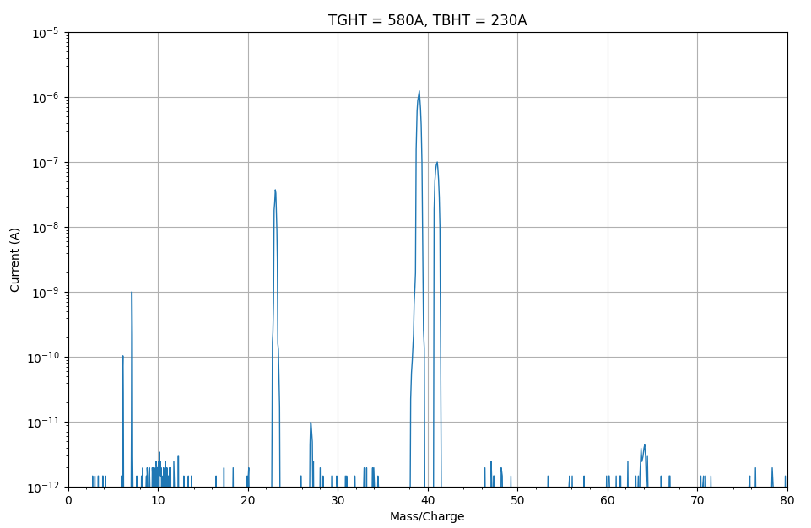

**Figure R2. Beam current vs mass number at 580A/230A, range [0, 80].** A mass scan taken when the target was first ramped up to operational temperatures, with TGHT/TBHT 580A/230A. Notable peaks with current greater than 10 pA are located at 6, 7, 23, 39, and 41.

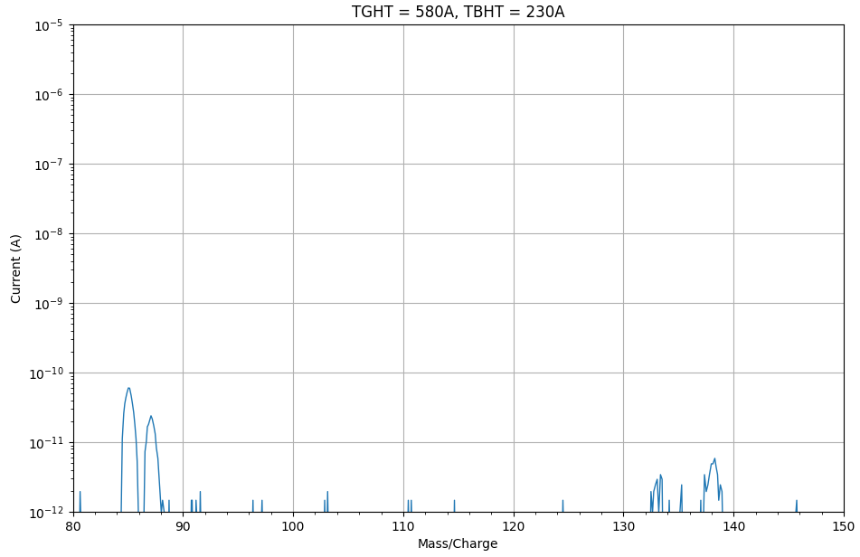

**Figure R3. Beam current vs mass number at 580A/230A, range [0, 80].** A mass scan taken when the target was first ramped up to operational temperatures, with TGHT/TBHT 580A/230A. Notable peaks with current greater than 10 pA are located at 85, 87.

**Beam tuning parameters:**

* **As per 2024-01-25 ISAC test stand tune.**

