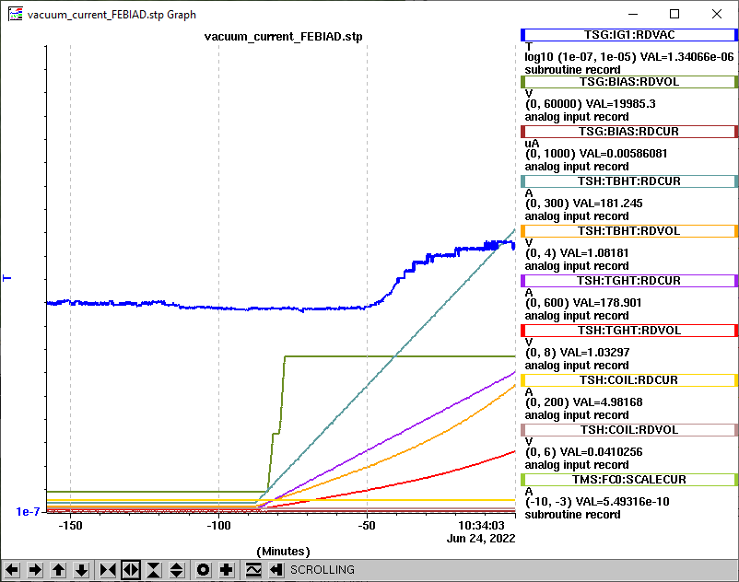https://isacwserv.triumf.ca/onlylocal/isactdata/save_restore/masscorr/2022-06-24-19-37%20SiC%2344

Mass 38

Mass 38

Mass 38

https://isacwserv.triumf.ca/onlylocal/isactdata/save_restore/masscorr/2022-06-24-19-55%20SiC%2344

Mass 27

Mass 27

Mass 27

Mass 38

Mass 38

Mass 38

