Conditioning Report
Target material and number |  | Ta#62
Target WO-SN |  | 44691-4
Operator name |  | Aaron Schmidt
Heating start date and time |  | 2021-06-27 03:55
BIAS
Voltage [kV] |  | 30
Current [µA] |  | 17
Extraction Electrode (EE)
Voltage [kV] |  | -1.5
Current [µA] |  | 510
TGHT
Current [A] |  | 580.2
Voltage [V] |  | 6.750
TBHT
Current [A] |  | 231.4
Voltage [V] |  | 2.613
FEBIAD ANODE
Voltage [V] |  | -
Current [mA] |  | -
FEBIAD COIL
Current [A] |  | -
Voltage [V] |  | -
Flow and Temperature HS + MSP |  | N/A
Flow [lpm] |  | N/A
Temperature increase [C] |  | N/A
FC6 currents [A]
SIS | 7Li | 2.96E-10
FEBIAD | 20Ne | -
SIS | 23Na | 5.60E-10
SIS | 39K | 3.27E-09
SIS | 85Rb | 1.45E-10
SIS | 133Cs | 1.40E-08
Heating end date and time |  | 2021-06-27 16:30

Comments
RGA unavailable.
Emittance meter unavailable.

Plots

8h Vacuum Pump Down
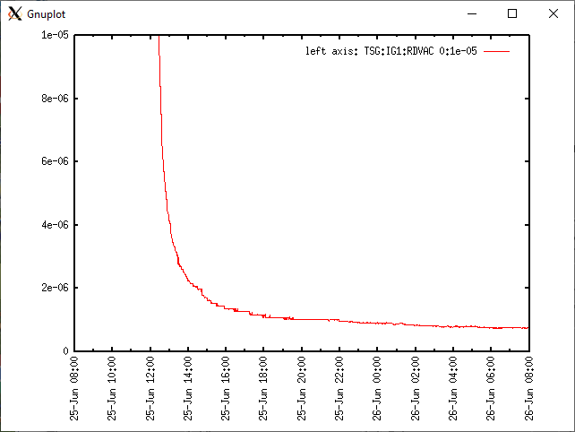

Target Heat Sequence Setup
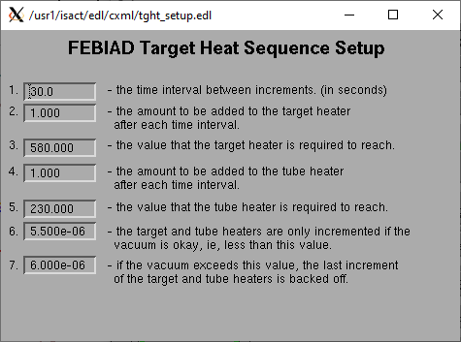

Source Tuning

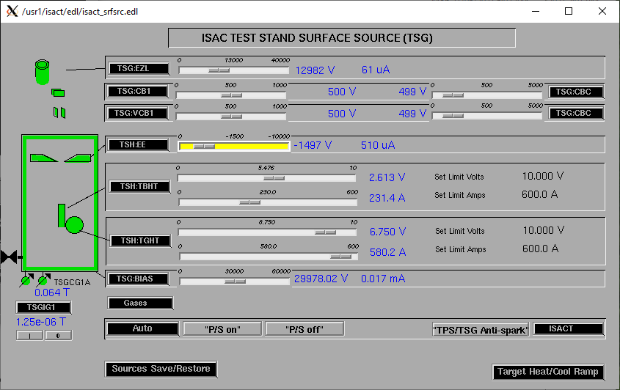

Wire Scanners RPM0A and RPM0B
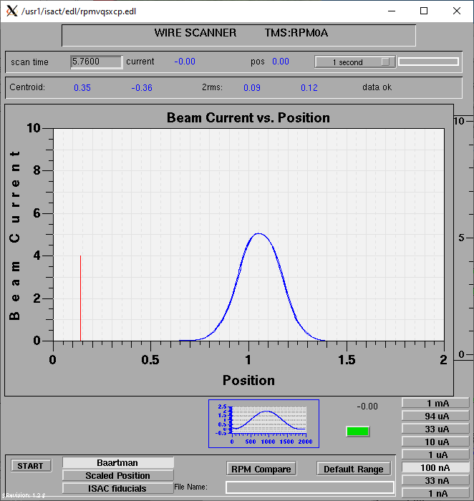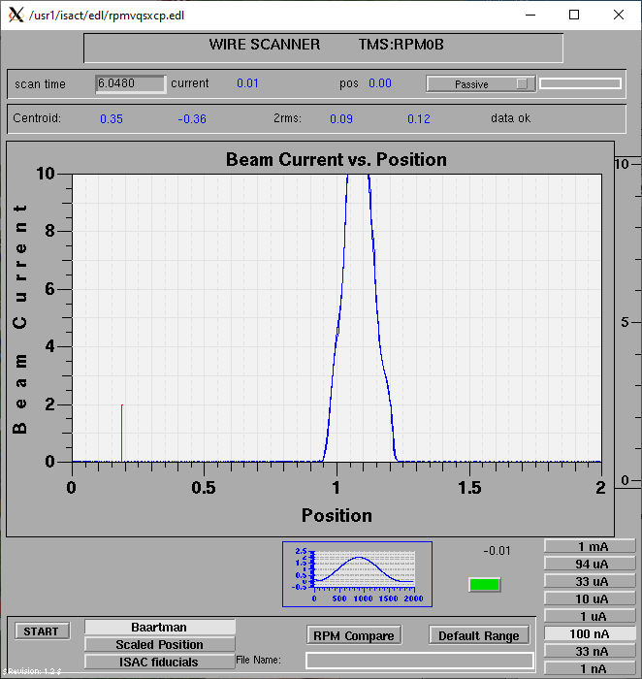

Optics Tuning

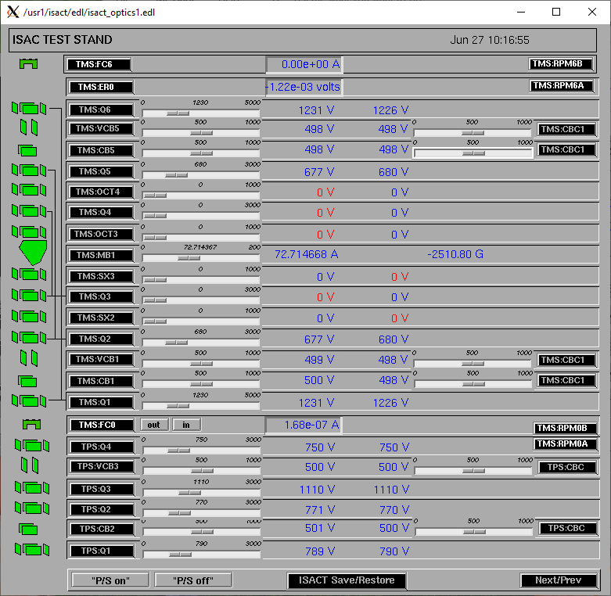

Wire Scanners RPM6A and RPM6B

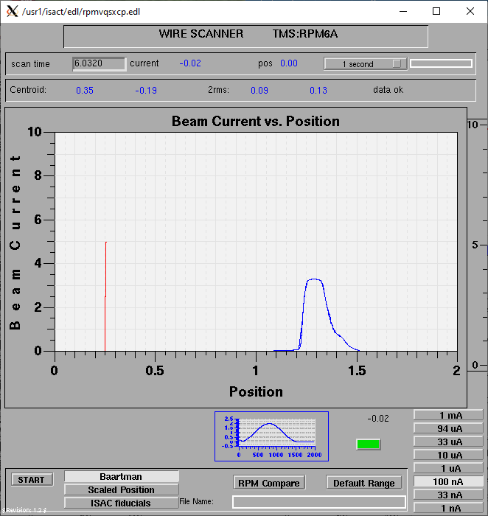
Mass 136
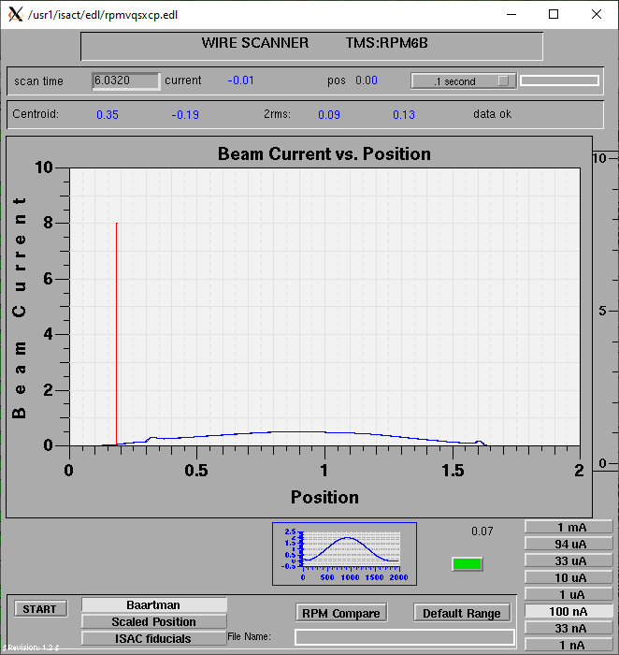
Mass 136

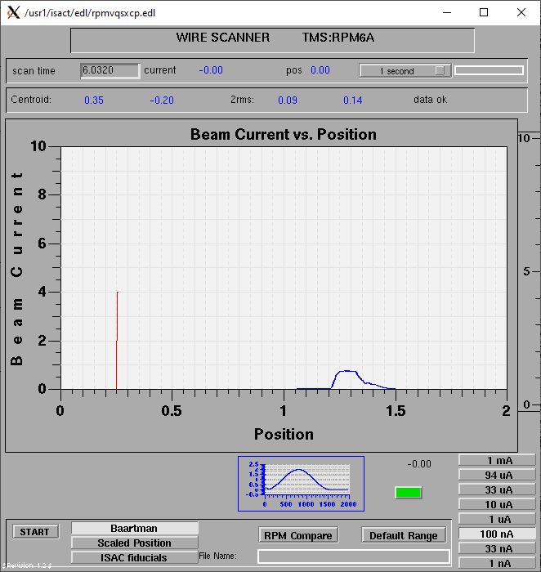
Mass 40
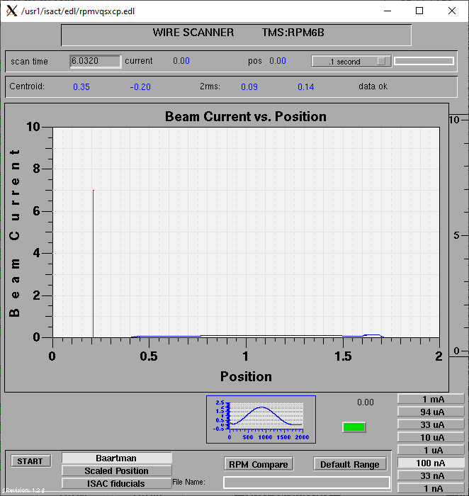
Mass 40

Mass Scan
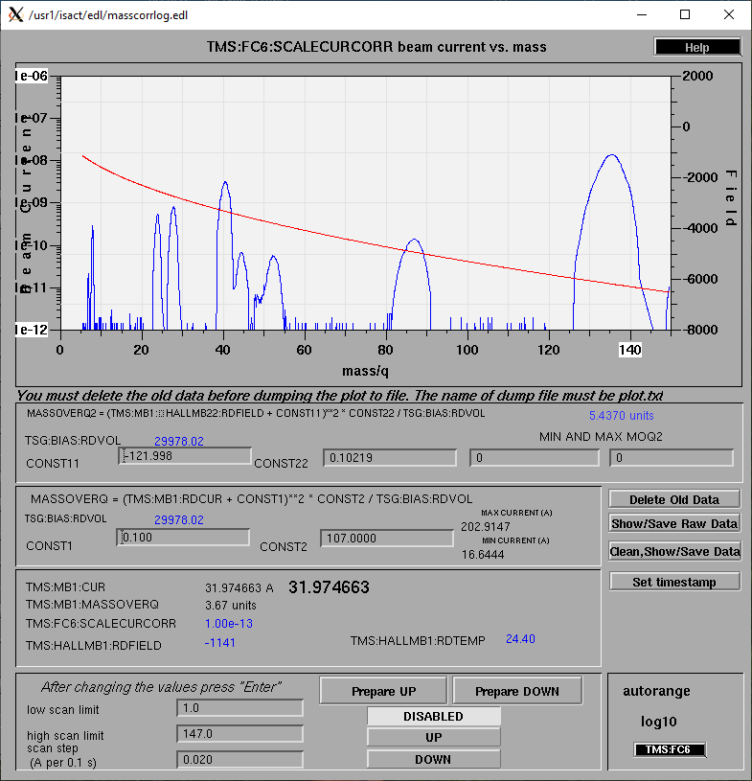http://isacwserv.triumf.ca/onlylocal/isactdata/save_restore/masscorr/2021-06-27-10-38%20Ta%2362

Cooling Parameters
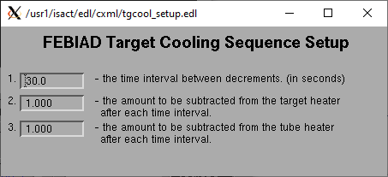

Overview Plots

Vacuum and FC0

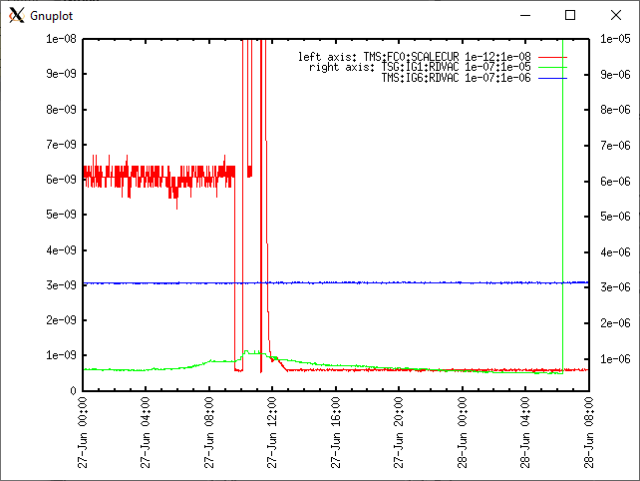

Heating, EE and BIAS

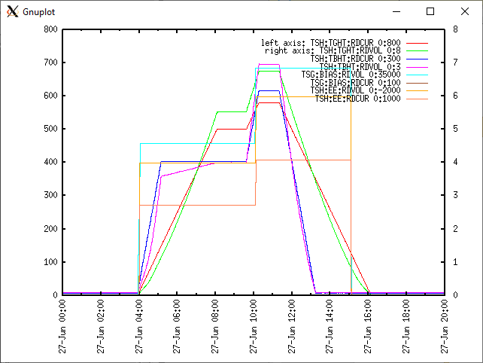

TGHT and TBHT Voltage

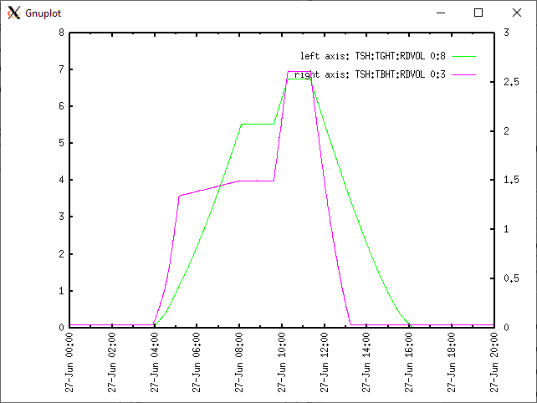

Flow and cooling water temperatures
Done remotely* Heat wave w/ +35-40C temperatures also messing with the water temperature.

RGA

N/A

Emittance Scan

N/A E-rig malfunction. Connection/cable?

