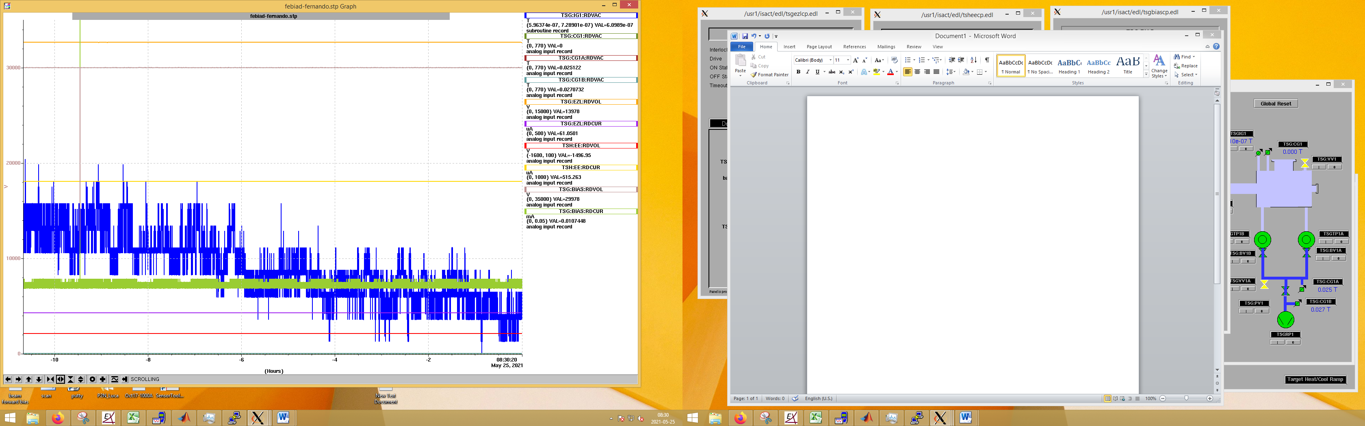30KV over night only 1 spark.

35KV no spark (5min)

40KV/-2/14 no spark (5min)

45KV/-2/14 1 spark while ramping up. No spark for 5min after

50KV/-2/14 jump up and down 0.075mA while ramping but no spark. 3 sparks in a row. 1 spark

50KV/-2.5/20 things seem stable. 5 min no spark.

Going to 55 massive spark.

55KV/-2.5/20 things quiet after big spark making EE volt jump. 1 spark (current limited wasn’t at 55KV yet) set of sparks