Initial tune:

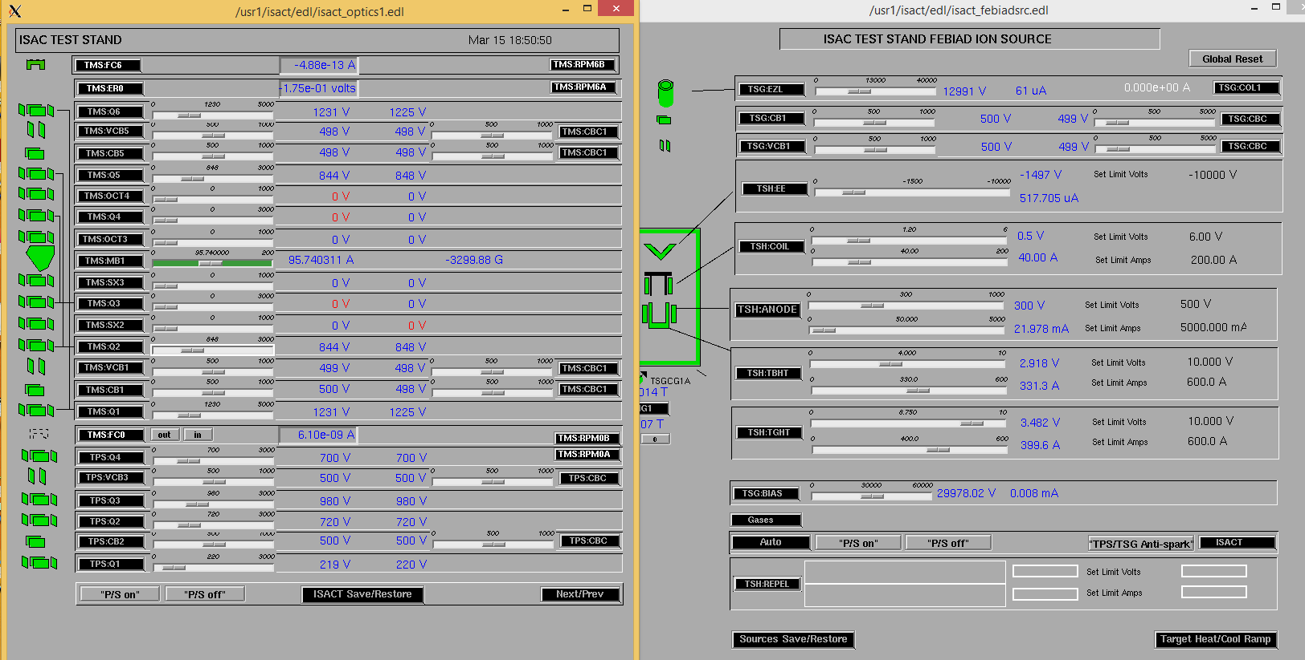

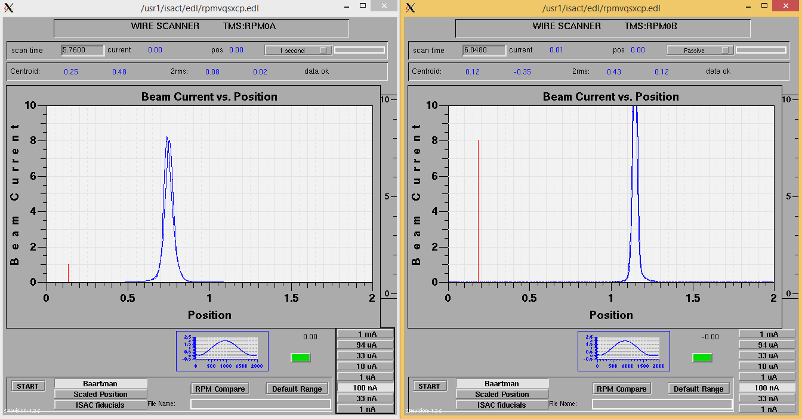

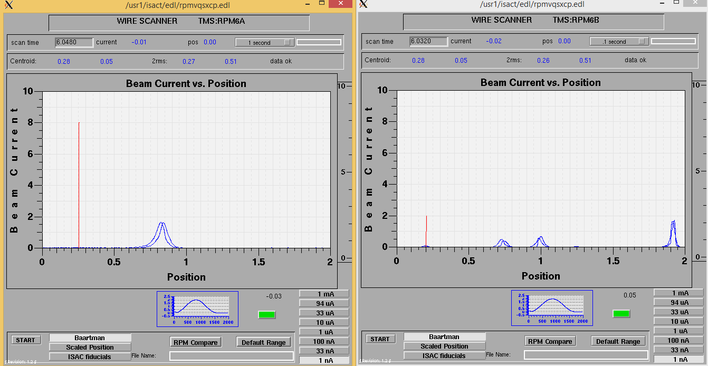

Thursday Tune:

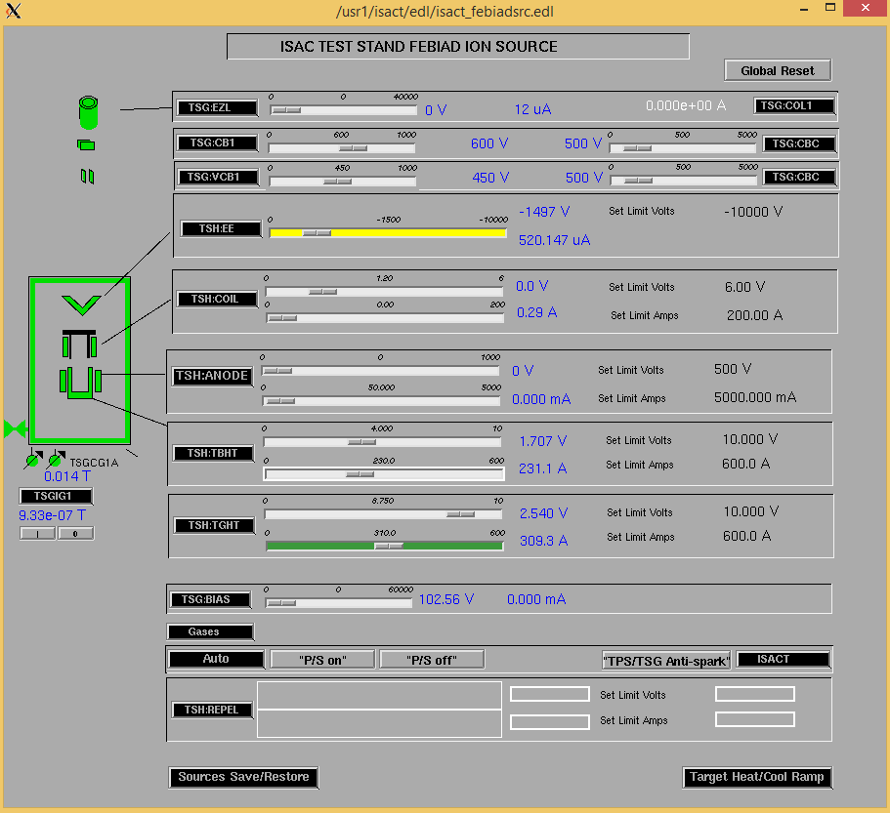

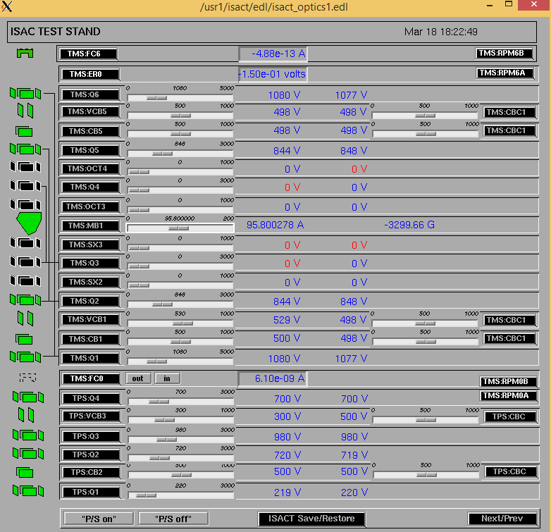

Friday March 19:

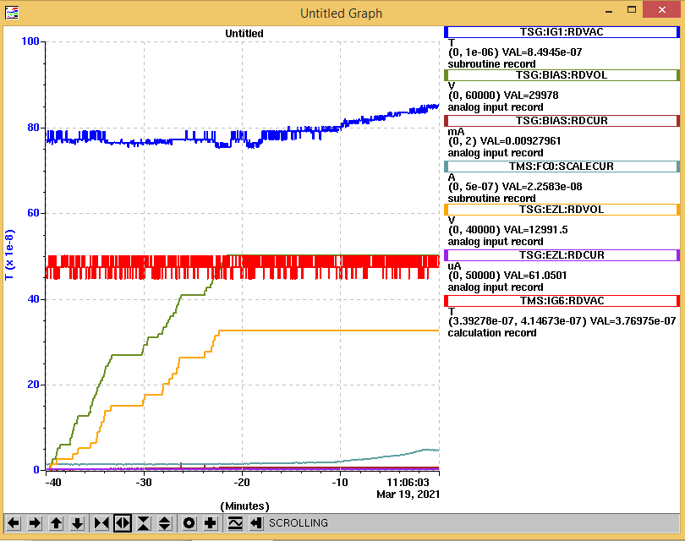

Found beam. Emittance meter position at 32mm, slightly above center.

Final tune:

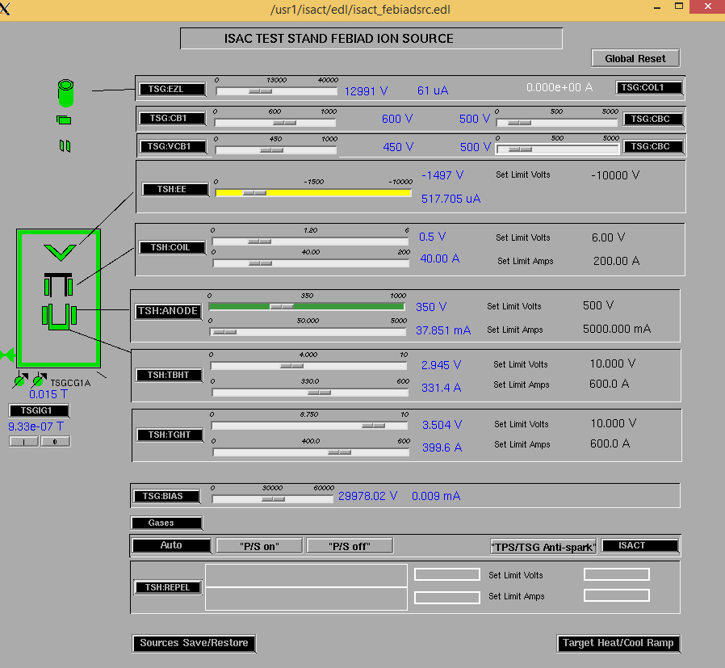

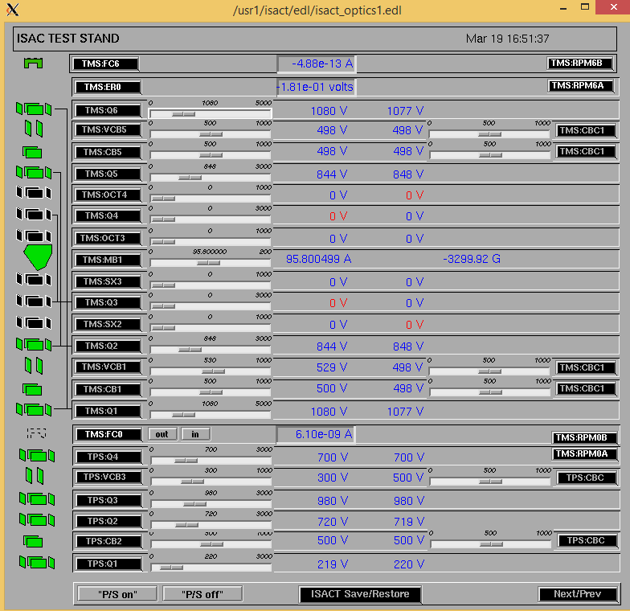

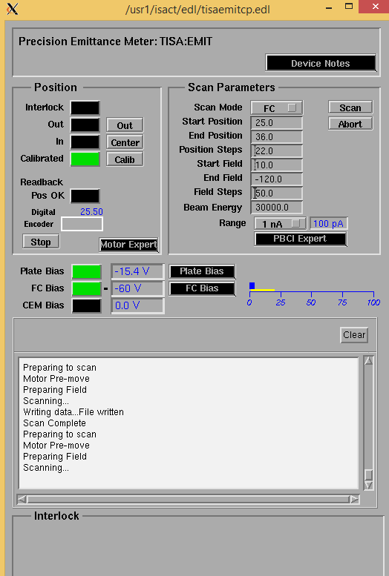

Standard emittance meter results:

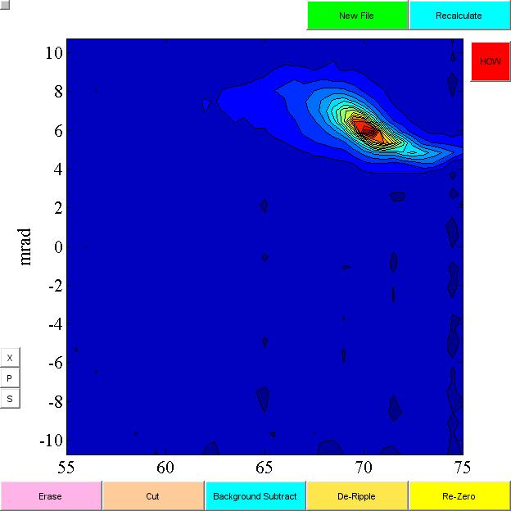

New emittance meter results (note both position and angle are flipped relative to the standard meter, and angle calculation seems to be wrong, probably because there are errors in the header of the file that is output.):

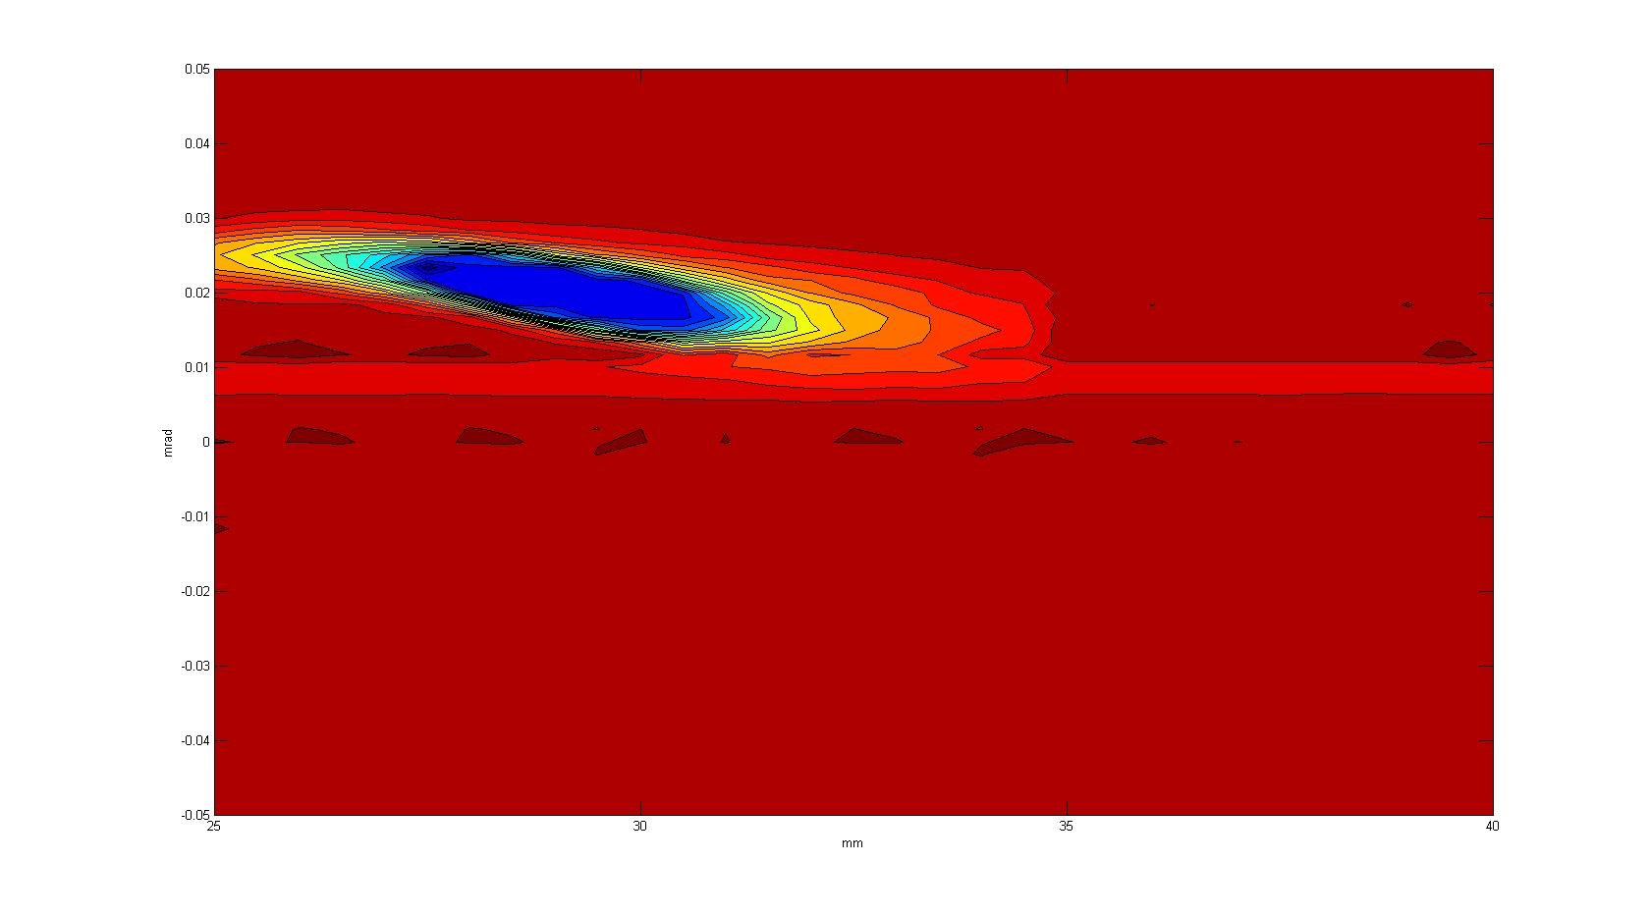

Emittance meter #2:

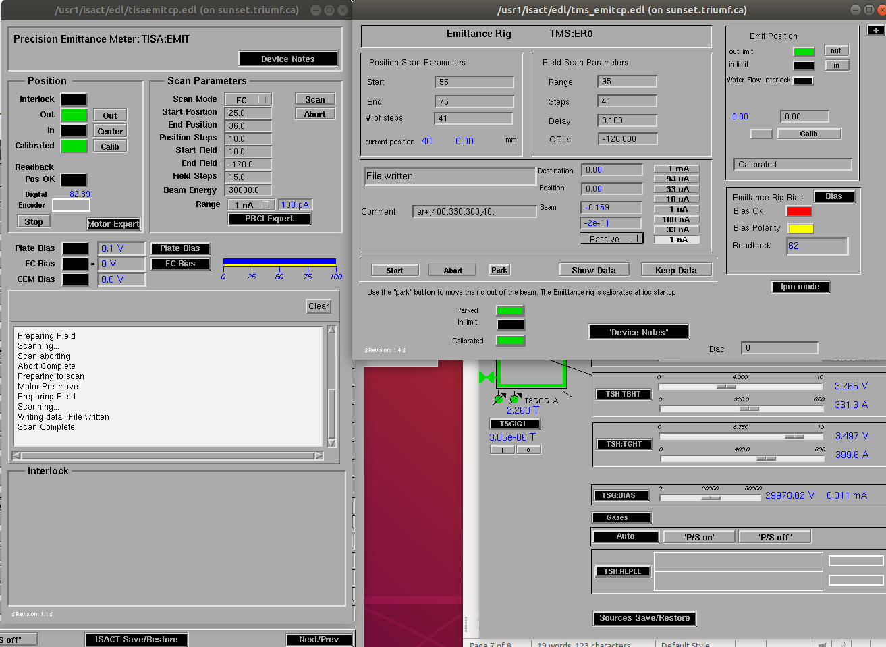

original settings for both emittance meters

beam is moved on the test stand emittance meter quite a bit:

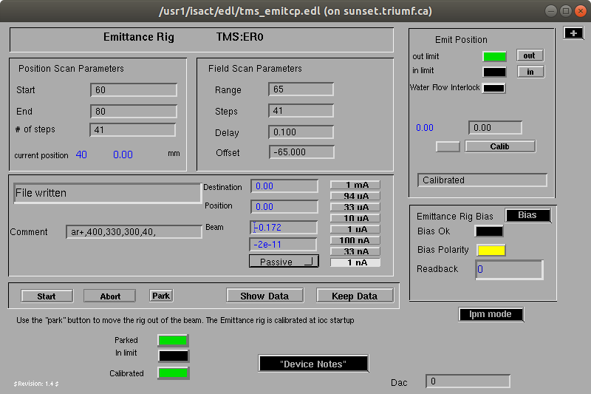

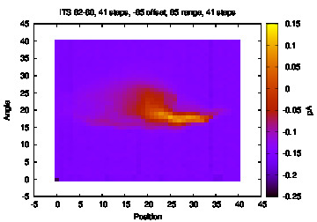

See above for working params for ITS emittance rig and results in graph. Slit length -5 to 45 max.

Saturday April 3:

Beam seems kind of back to normal position after centering all steerers. Most recent emittance scan on ITS emit rig (emittancemeter2/ITSemit5.eps) looks normal. Zoom in is ITSemit6.eps.

And yet still no beam seen in FC mode on the TISA emittance meter….

Trying to figure out if this is because the head is slightly twisted relative to the beam line. Some hand wavy estimations using an protractor make me think that it is off by 5-10 degrees. Using the emittance meter lengths and estimating the FC to be about 3mm from the slit, I calculate it would have to be off by 25 degrees to miss the slit and FC altogether, so that is probably not the reason.

Second possibility: Looking at the previous scans, there doesn’t appear to be any beam at 0V on the plates. I did see this beam with emit meter #1 in FC mode, though the change was quite small. But now I don’t see it at all. I suppose if the beam is shifted orientation or focusing slightly I wouldn’t find it this way.

Going back to scanning mode. If I don’t find it this way, will have to wait until Tuesday for Mike to put it back into FC mode.

Everything went off – snapshot:

