Conditioning Report

|  |  |  |
| --- | --- | --- |
| Target material and number | | Nb#9 |
| Target WO-SN | | 44508-2 |
| Operator name | | Aaron Schmidt |
|  | |  |
| Heating start date and time | | 2020-11-09 06:39 |
| BIAS | |  |
| Voltage [kV] | | 30 |
| Current [µA] | | 12 |
| Extraction Electrode (EE) | |  |
| Voltage [kV] | | -1.5 |
| Current [µA] | | 508 |
| TGHT | |  |
| Current [A] | | 580.2 |
| Voltage [V] | | 7.072 |
| TBHT | |  |
| Current [A] | | 229.0 |
| Voltage [V] | | 2.596 |
| FEBIAD ANODE | |  |
| Voltage [V] | | - |
| Current [mA] | | - |
| FEBIAD COIL | |  |
| Current [A] | | - |
| Voltage [V] | | - |
| Flow and Temperature HS + MSP | | 23.96 |
| Flow [lpm] | | 5.15 |
| Temperature increase [C] | | 1.31 |
| FC6 currents [A] | | 2.31E-07 |
| SIS | 7Li | 1.17E-09 |
| FEBIAD | 20Ne | - |
| SIS | 23Na | 4.64E-09 |
| SIS | 39K | 1.19E-09 |
| SIS | 85Rb | 1.14E-09 |
| SIS | 133Cs | 1.48E-09 |
| Heating end date and time | | 2020-11-10 06:58 |

Comments

-Additional endplate parasitic target and PEEK assembly bracket added.

-Previously conditioned <https://elog.triumf.ca/TIS/Test-Stand/817>

Plots

8h Vacuum Pump Down

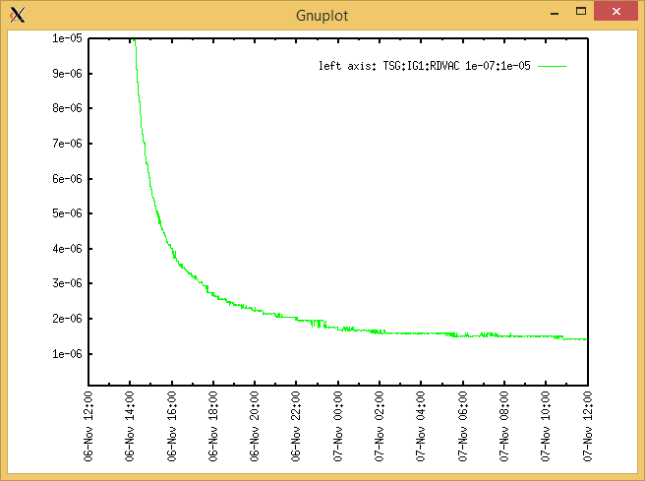

Target Heat Sequence Setup

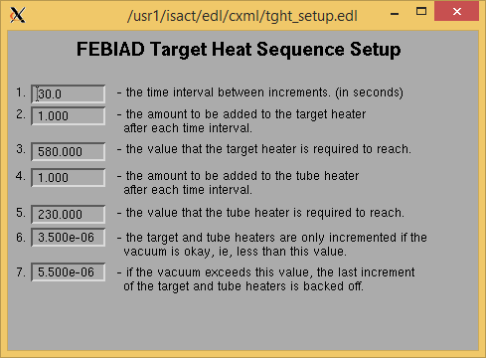

Source Tuning

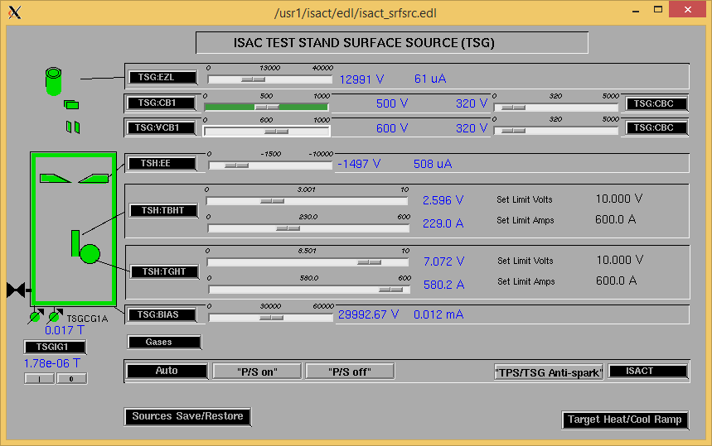

Wire Scanners RPM0A and RPM0B

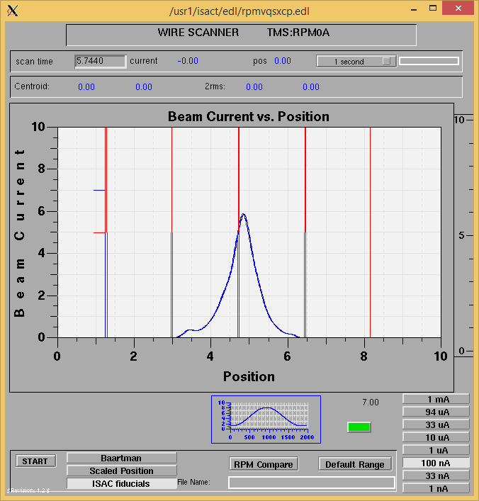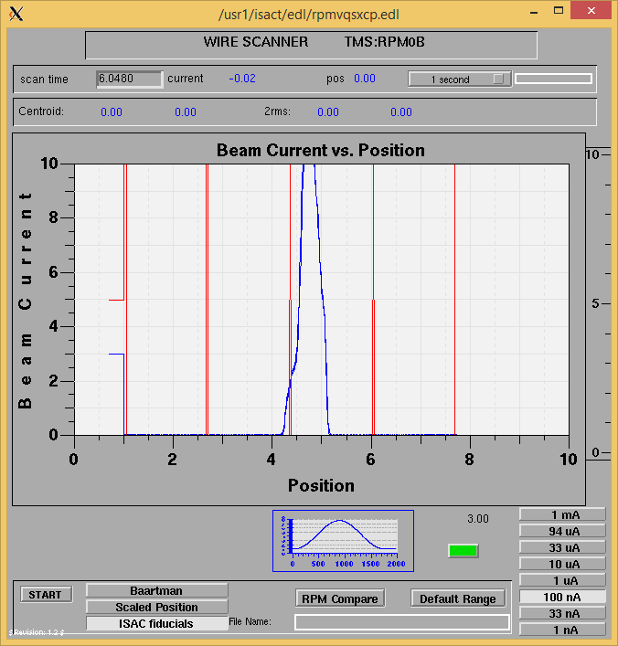

Optics Tuning

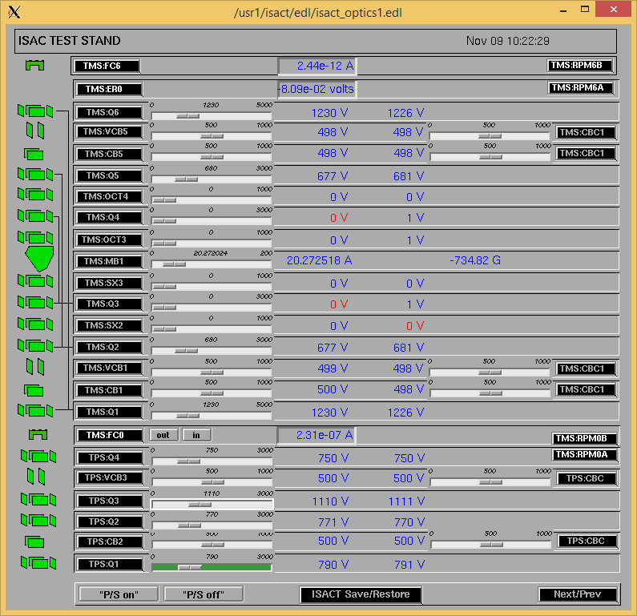

Wire Scanners RPM6A and RPM6B

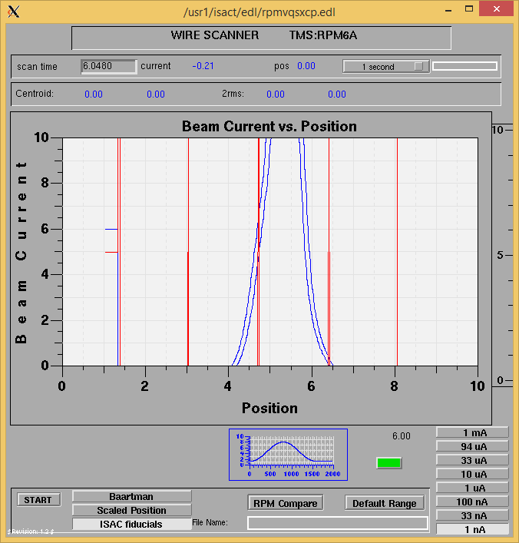

Mass 7

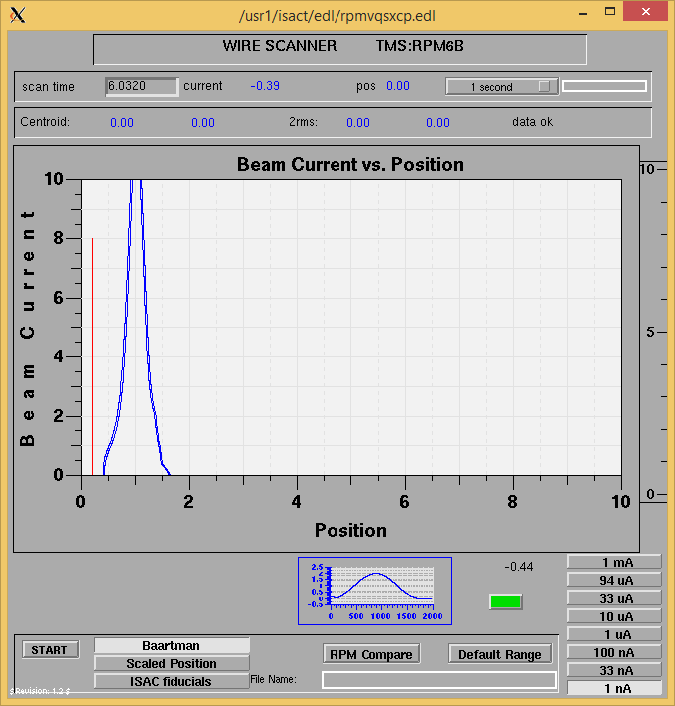

Mass 7

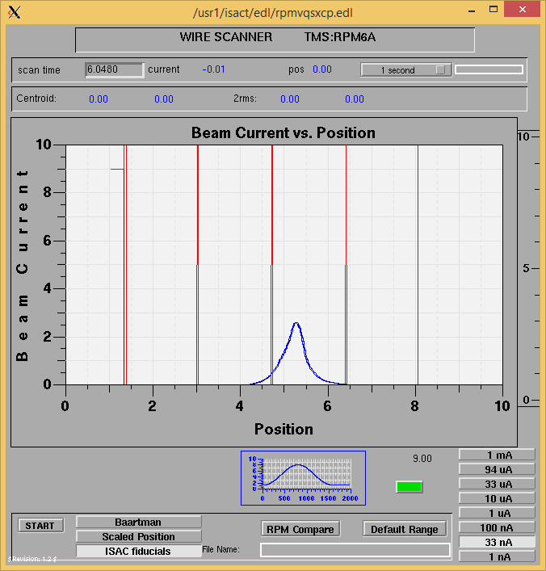

Mass 23

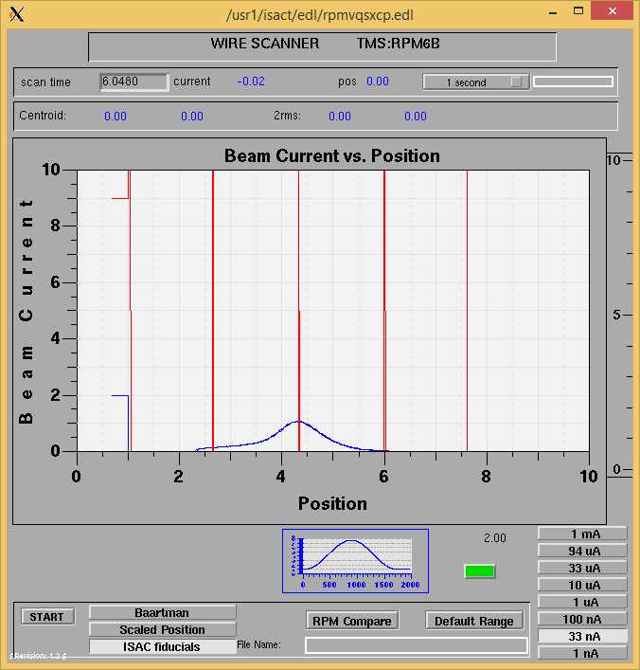

Mass 23

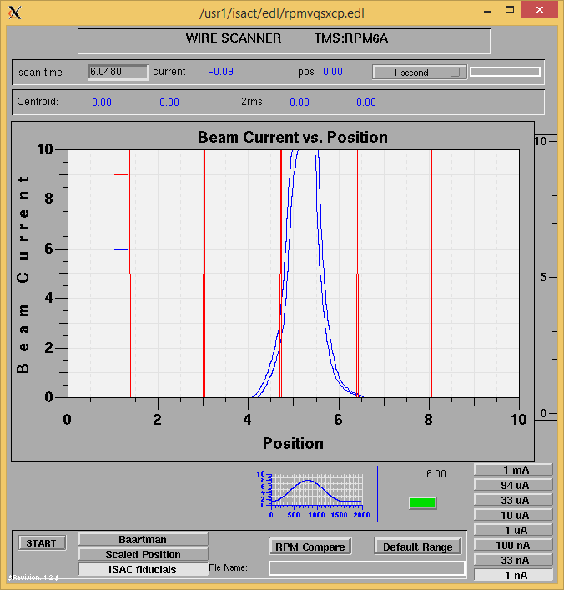

Mass 39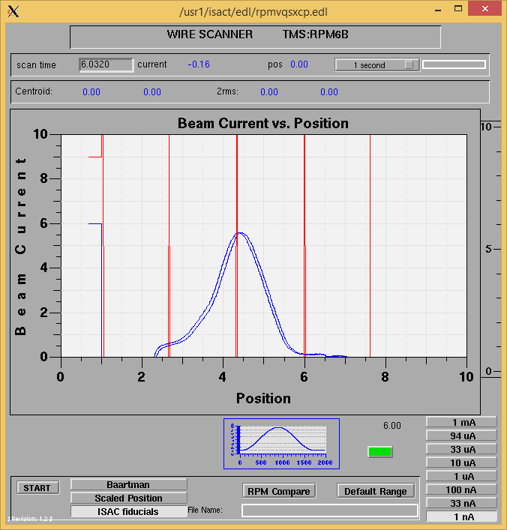

Mass 39

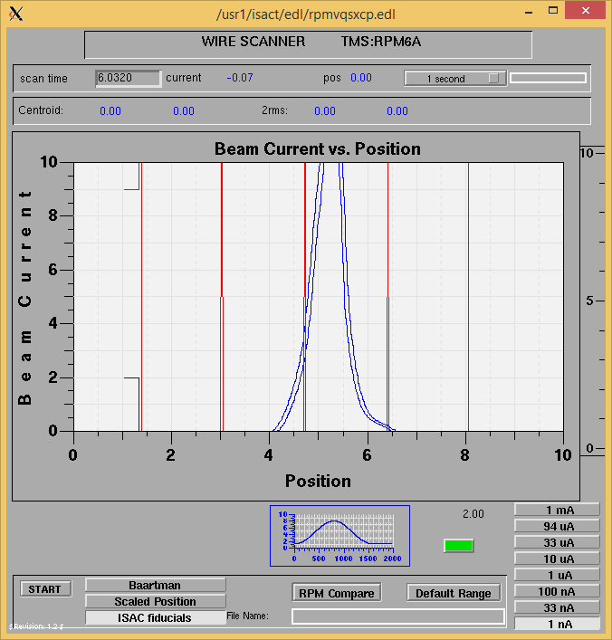

Mass 83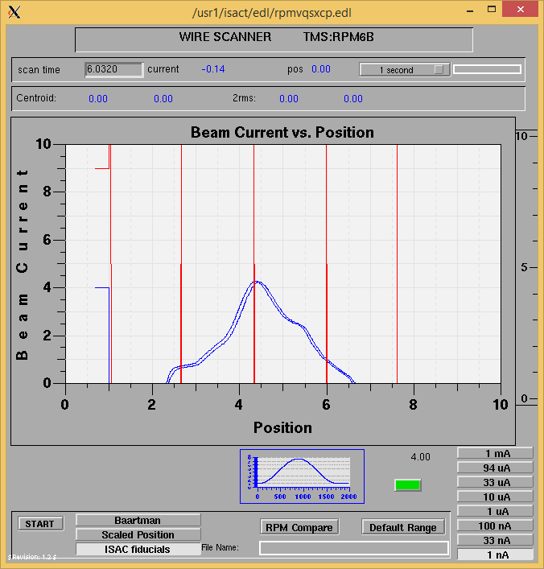

Mass 83

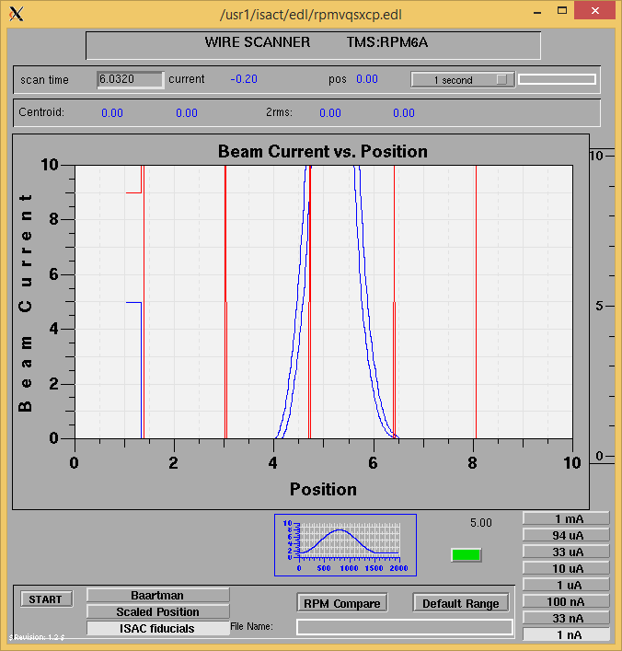

Mass 130

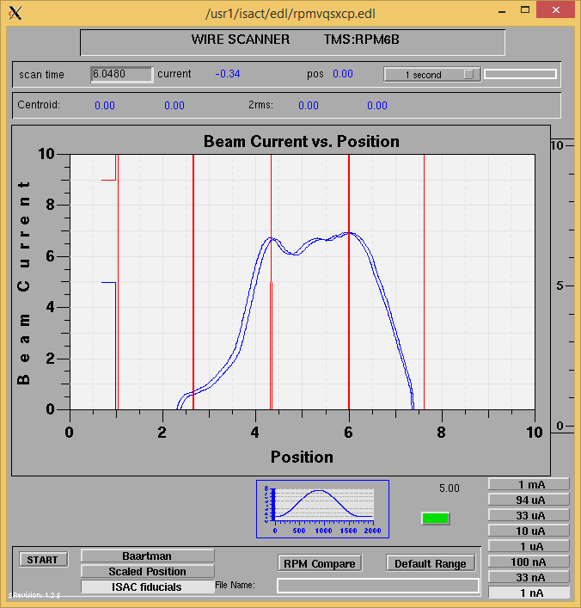

Mass 130

Mass Scan

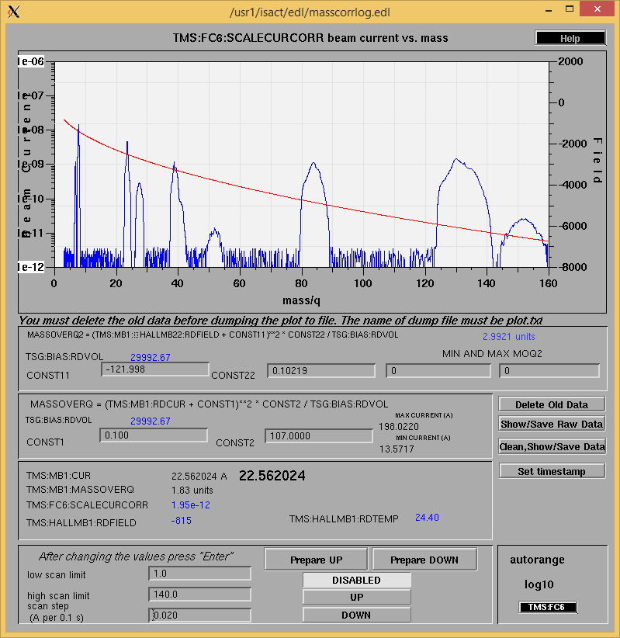

<http://isacwserv.triumf.ca/onlylocal/isactdata/save_restore/masscorr/2020-11-09-10-46%20Nb%239>

Cooling Parameters

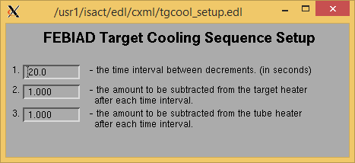

Overview Plots

Vacuum and FC0

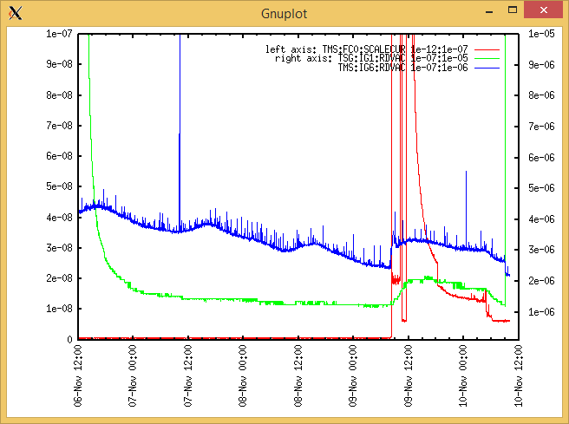

Heating, EE and BIAS

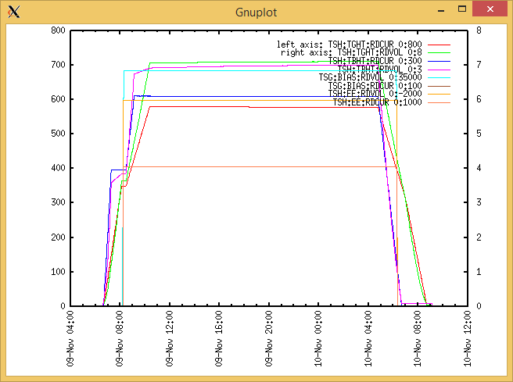

TGHT and TBHT Voltage

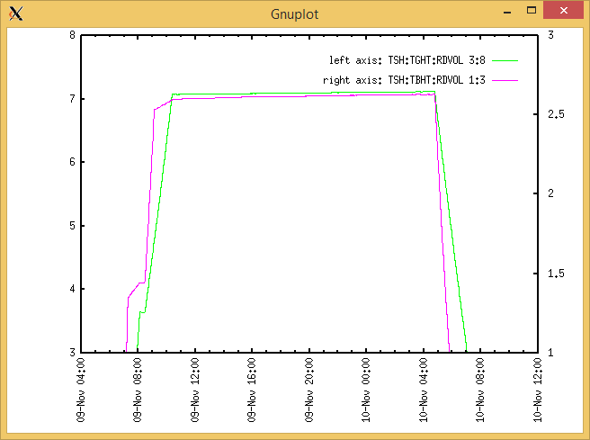

Flow and cooling water temperatures

Monday, October 19, 2020, 08:03:

|  |  |  |
| --- | --- | --- |
| **Device** | **Temp [C]** | **Flow [lpm]** |
| HS + MSP | 23.96 | 5.15 |
| TBHT | 23.78 | 8.02 |
| COIL + EE | 23.67 | 2.39 |
| TGHT | 23.77 | 6.19 |

Tuesday, October 20, 2020, 14:17:

|  |  |  |
| --- | --- | --- |
| **Device** | **Temp [C]** | **Flow [lpm]** |
| HS + MSP | 25.27 | 7.12 |
| TBHT | 24.88 | 9.73 |
| COIL + EE | 24.65 | 3.26 |
| TGHT | 24.88 | 7.05 |

RGA

N/A

Emittance Scan

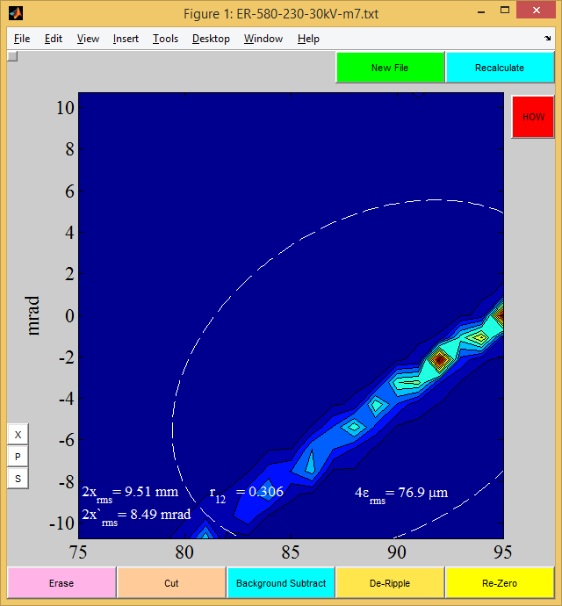

Mass 7

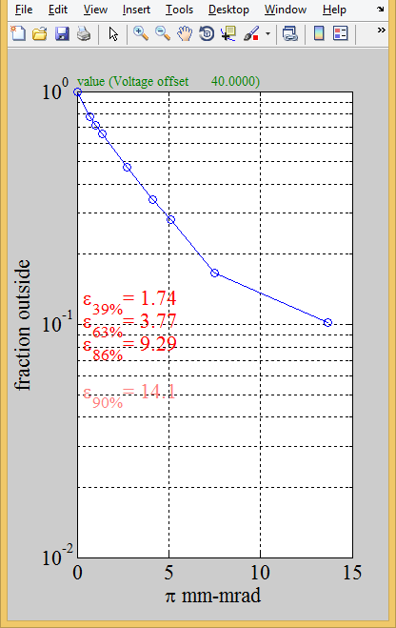Mass 7

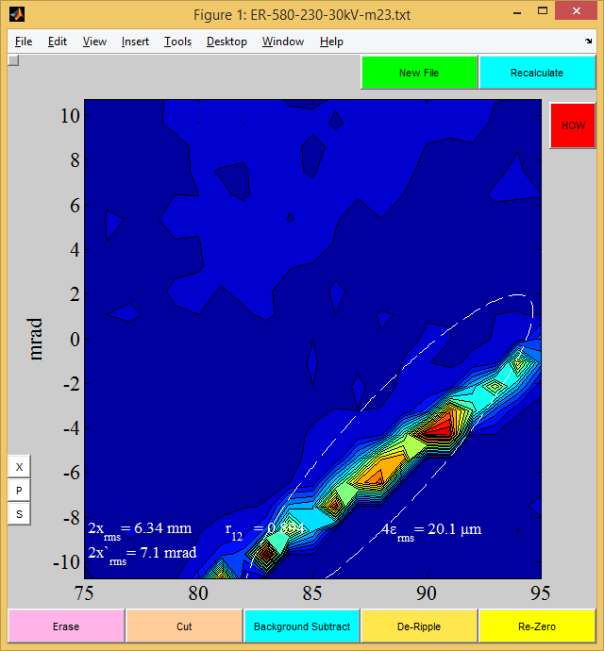Mass 23

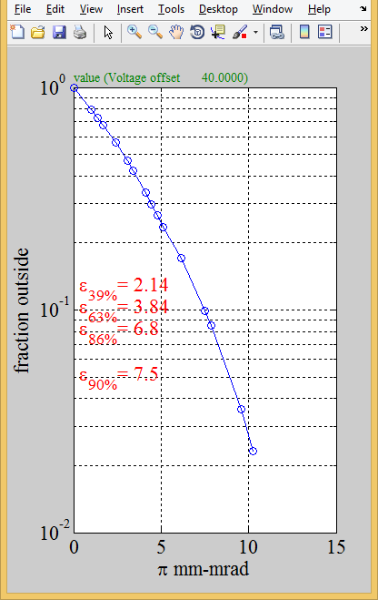Mass 23

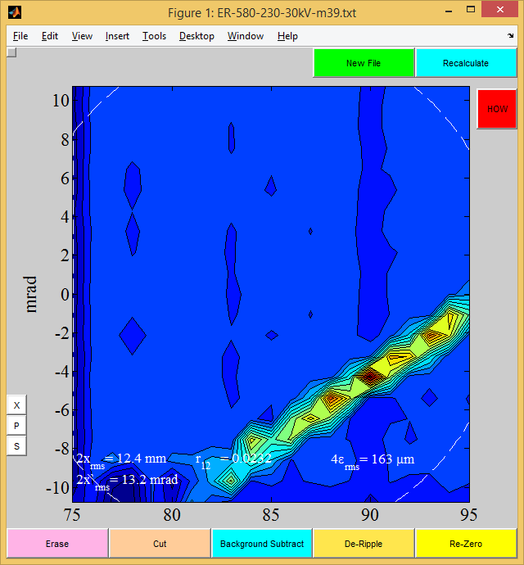Mass 39

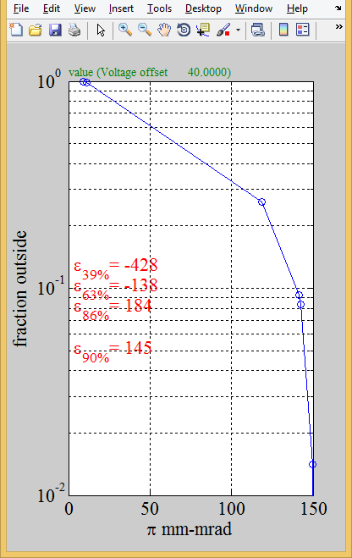Mass 39

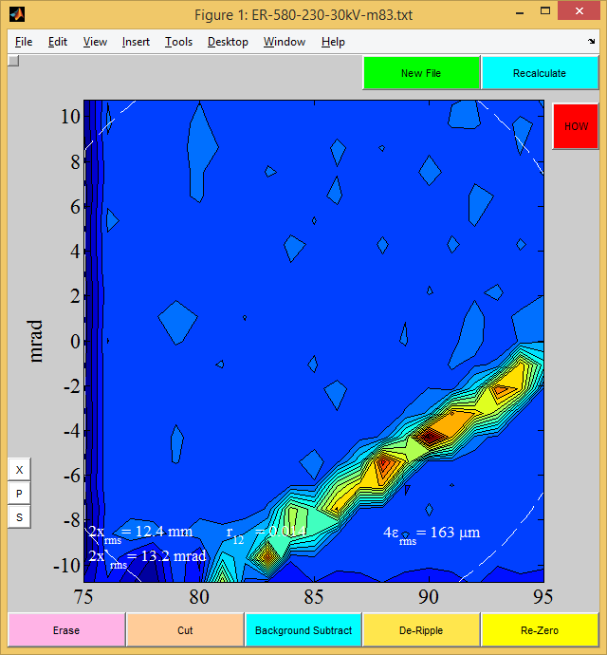mass 83

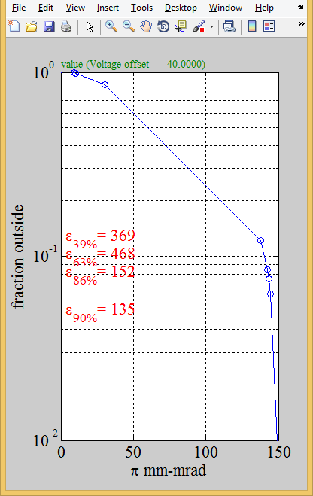Mass 83

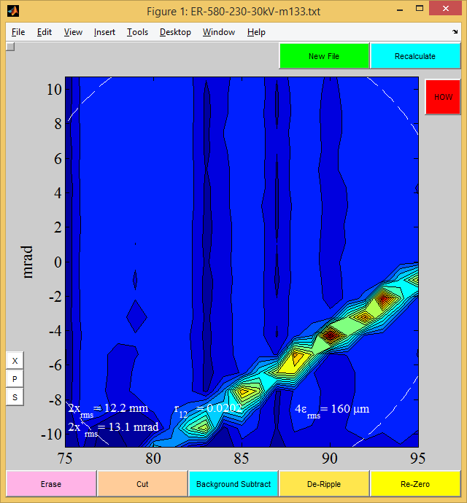

Mass 130

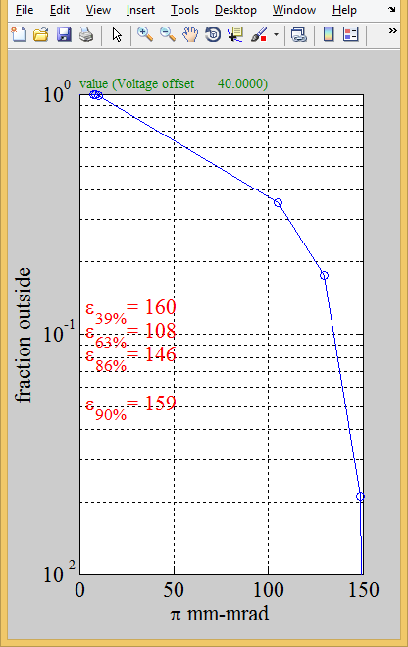Mass 130