Conditioning Report

|  |  |  |
| --- | --- | --- |
| Target material and number | | Ta#61 |
| Target WO-SN | | 44508-1 |
| Operator name | | Aaron Schmidt |
|  | |  |
| Heating start date and time | | 2020-10-19 08:02 |
| BIAS | |  |
| Voltage [kV] | | 30 |
| Current [µA] | | 12 |
| Extraction Electrode (EE) | |  |
| Voltage [kV] | | -1.5 |
| Current [µA] | | 505 |
| TGHT | |  |
| Current [A] | | 580.2 |
| Voltage [V] | | 7.387 |
| TBHT | |  |
| Current [A] | | 229.0 |
| Voltage [V] | | 2.747 |
| FEBIAD ANODE | |  |
| Voltage [V] | | - |
| Current [mA] | | - |
| FEBIAD COIL | |  |
| Current [A] | | - |
| Voltage [V] | | - |
| Flow and Temperature HS + MSP | | 23.43 |
| Flow [lpm] | | 5.86 |
| Temperature increase [C] | | 1.05 |
| FC6 currents [A] | | 1.26E-07 |
| SIS | 7Li | 5.03E-11 |
| FEBIAD | 20Ne | - |
| SIS | 23Na | 8.93E-11 |
| SIS | 39K | 8.57E-10 |
| SIS | 85Rb | 4.68E-11 |
| SIS | 133Cs | 6.01E-09 |
| Heating end date and time | | 2020-10-22 11:36 |

Comments

RGA unavailable

Plots

8h Vacuum Pump Down

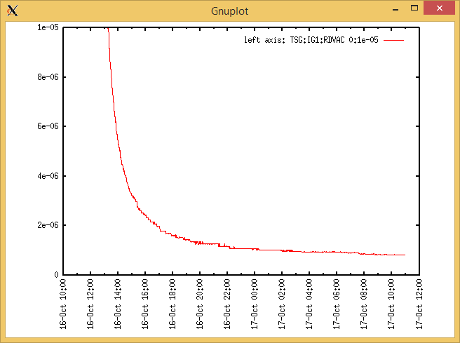

Target Heat Sequence Setup

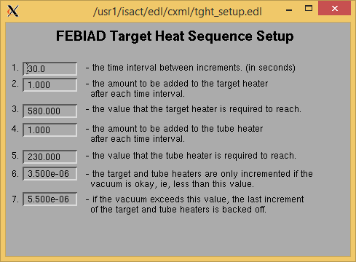

Source Tuning

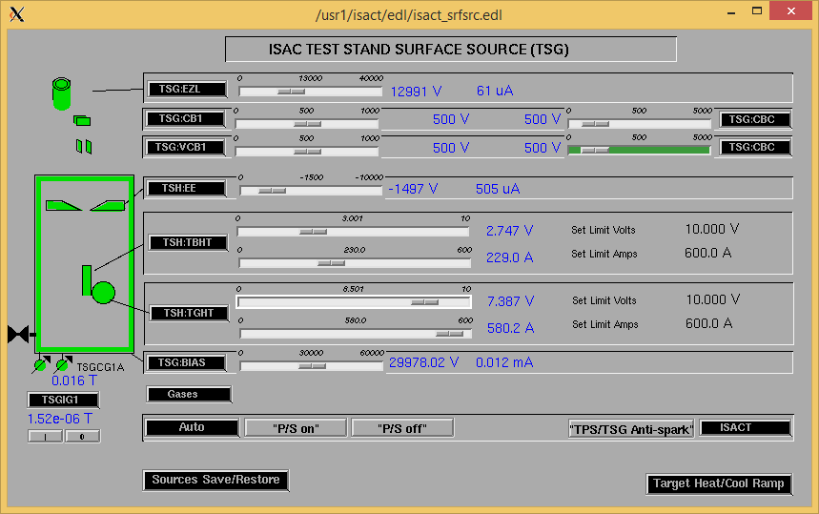

Wire Scanners RPM0A and RPM0B

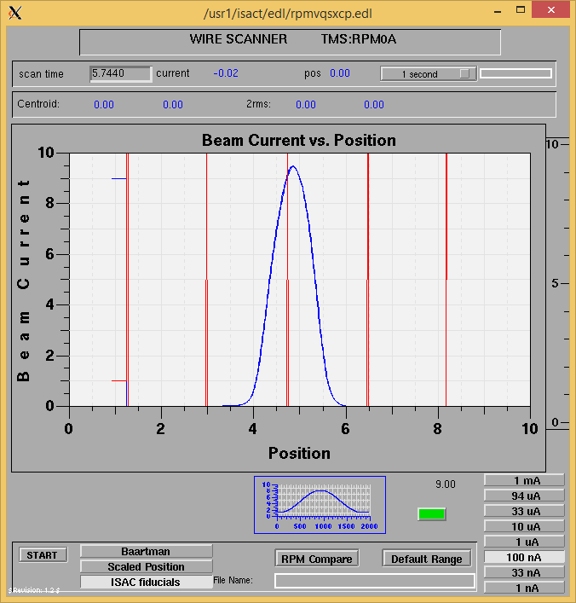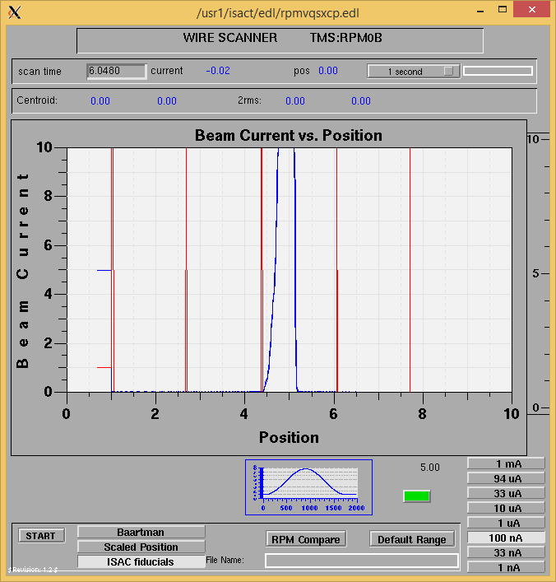

Optics Tuning

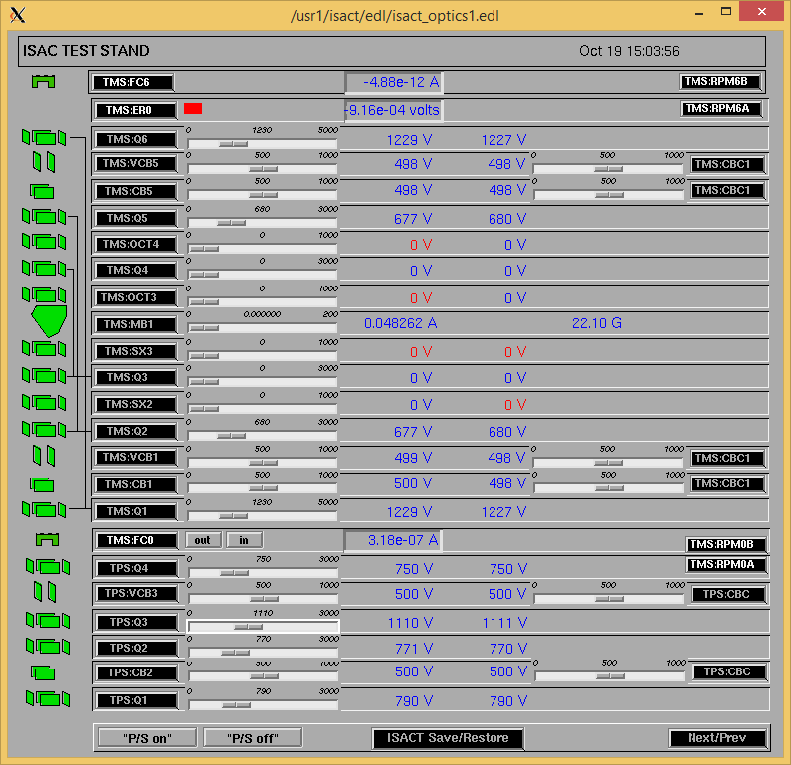

Wire Scanners RPM6A and RPM6B

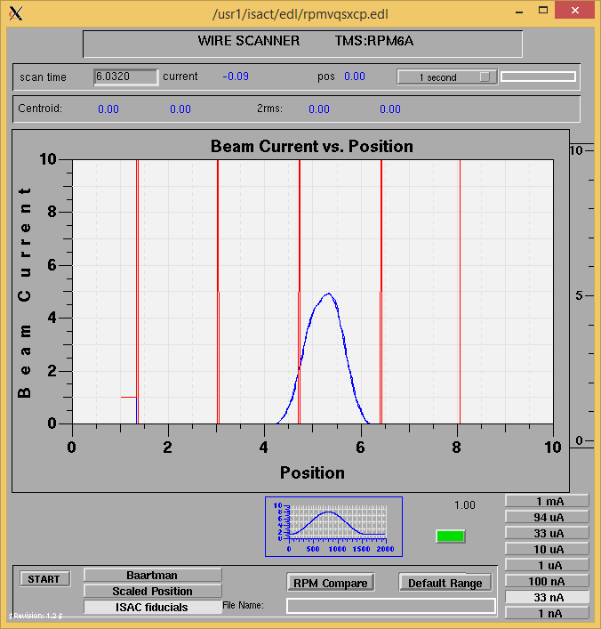

Mass 28

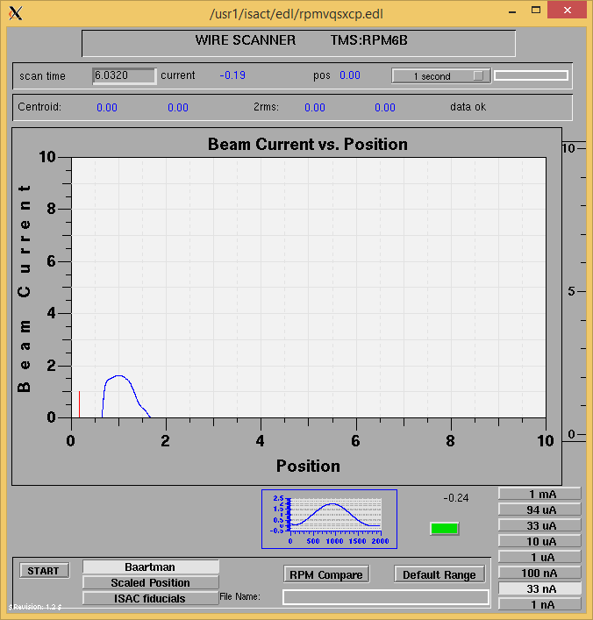

Mass 28

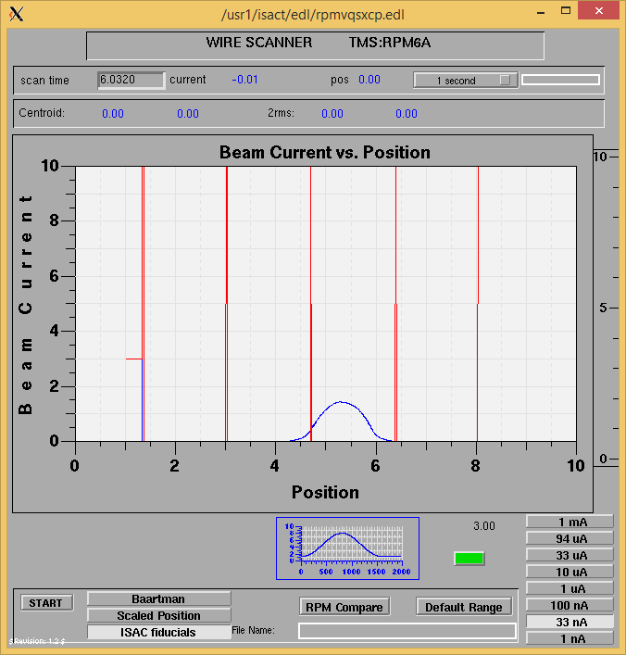

Mass 133

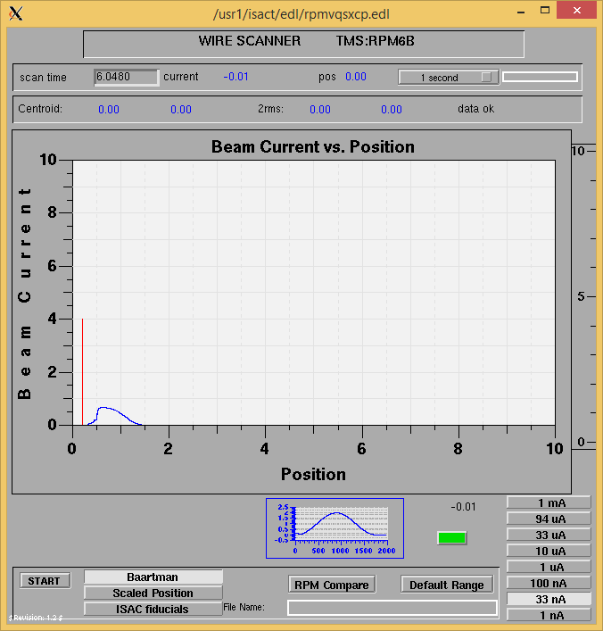

Mass 133

Mass Scan

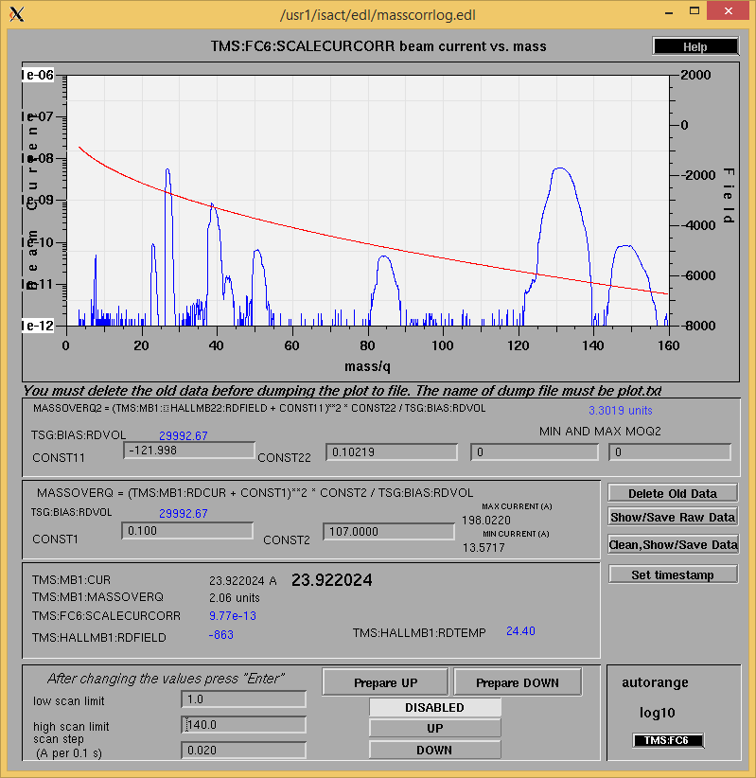

<http://isacwserv.triumf.ca/onlylocal/isactdata/save_restore/masscorr/2020-10-20-15-30%20Ta%2361>

Cooling Parameters

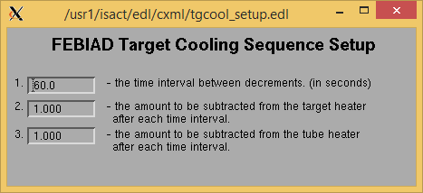

Overview Plots

Vacuum and FC0

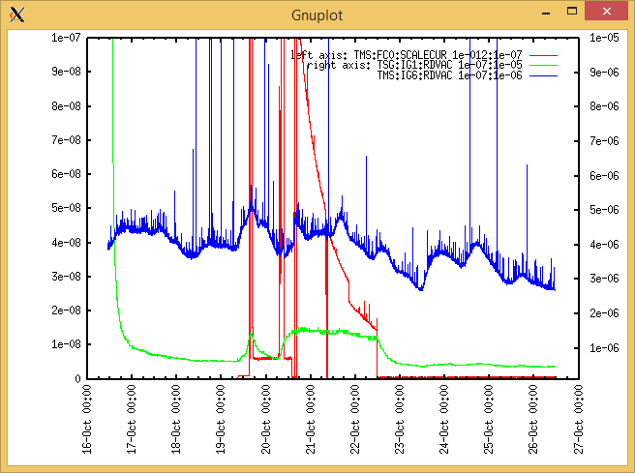

Heating, EE and BIAS

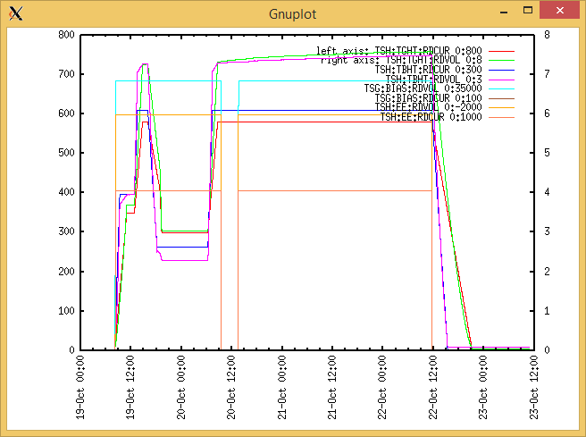

TGHT and TBHT Voltage

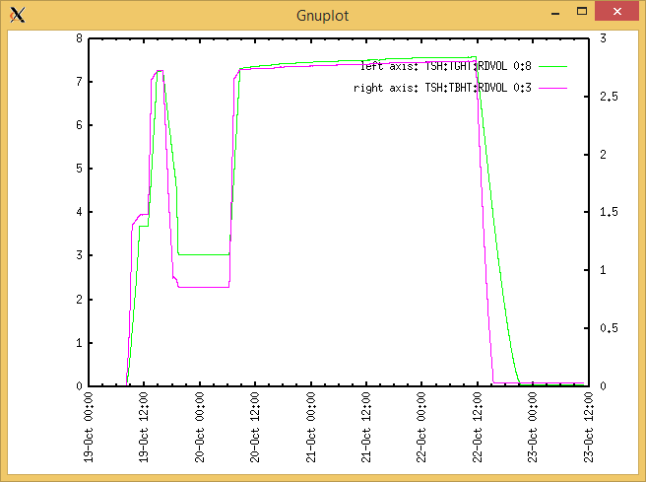

Flow and cooling water temperatures

Monday, October 19, 2020, 08:03:

|  |  |  |
| --- | --- | --- |
| **Device** | **Temp [C]** | **Flow [lpm]** |
| HS + MSP | 23.43 | 5.86 |
| TBHT | 23.34 | 8.52 |
| COIL + EE | 23.36 | 2.65 |
| TGHT | 23.27 | 6.45 |

Tuesday, October 20, 2020, 14:17:

|  |  |  |
| --- | --- | --- |
| **Device** | **Temp [C]** | **Flow [lpm]** |
| HS + MSP | 24.64 | 5.87 |
| TBHT | 24.29 | 8.76 |
| COIL + EE | 24.07 | 2.71 |
| TGHT | 24.25 | 6.54 |

RGA

N/A

Emittance Scan

Mass 28

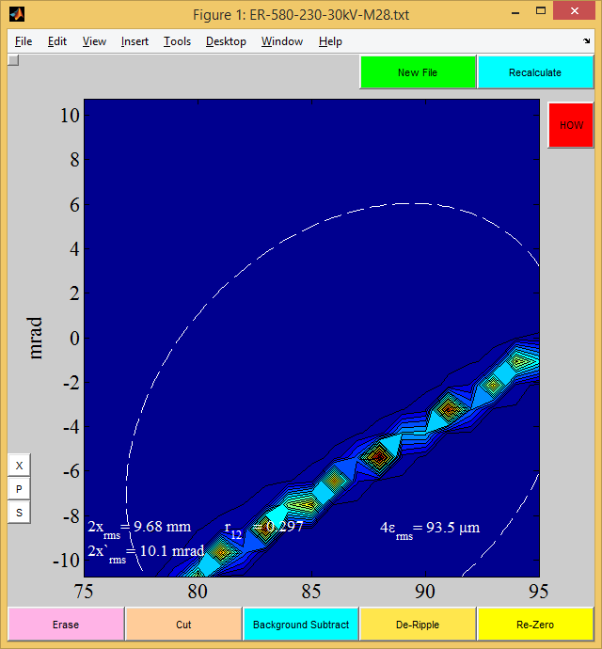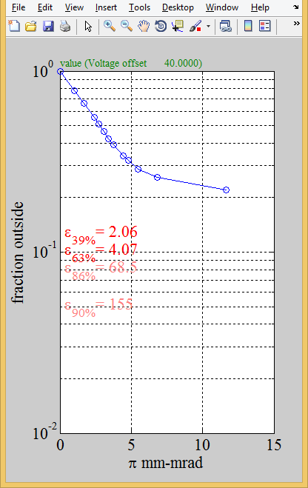

Mass 28

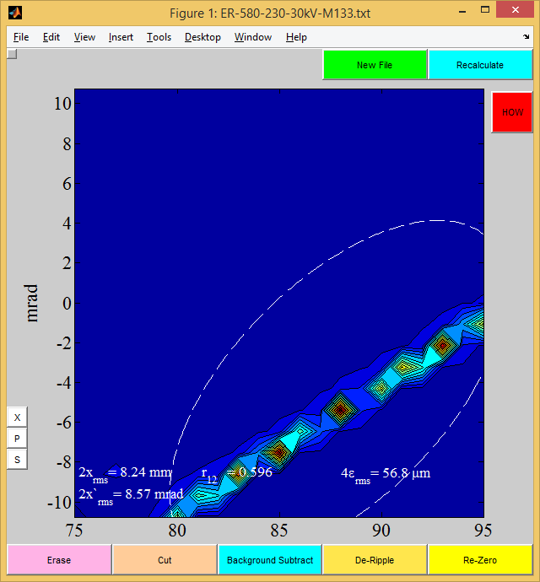

m133

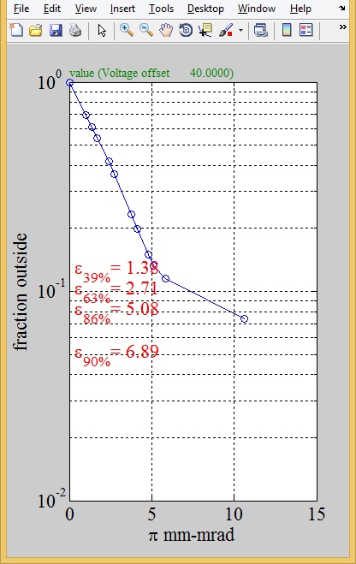

m133