Conditioning Report

|  |  |  |
| --- | --- | --- |
| Target material and number | | C#2 |
| Target WO-SN | | 44139-9 |
| Operator name | | Aaron Schmidt |
|  | |  |
| Heating start date and time | | 2020-10-1 05:27 |
| BIAS | |  |
| Voltage [kV] | | 30 |
| Current [µA] | | 17 |
| Extraction Electrode (EE) | |  |
| Voltage [kV] | | -1.5 |
| Current [µA] | | 505 |
| TGHT | |  |
| Current [A] | | 580.4 |
| Voltage [V] | | 7.475 |
| TBHT | |  |
| Current [A] | | 228.9 |
| Voltage [V] | | 2.713 |
| FEBIAD ANODE | |  |
| Voltage [V] | | - |
| Current [mA] | | - |
| FEBIAD COIL | |  |
| Current [A] | | - |
| Voltage [V] | | - |
| Flow and Temperature HS + MSP | | - |
| Flow [lpm] | | - |
| Temperature increase [C] | | - |
| FC6 currents [A] | | 6.65e-08 |
| SIS | 7Li | - |
| FEBIAD | 20Ne | - |
| SIS | 23Na | - |
| SIS | 39K | - |
| SIS | 85Rb | - |
| SIS | 133Cs | - |
| Heating end date and time | | 2020-06-22 11:07 |

Comments

RGA unavailable

-MB1 / Mass scans unavailable. (PS Issue)

Plots

8h Vacuum Pump Down

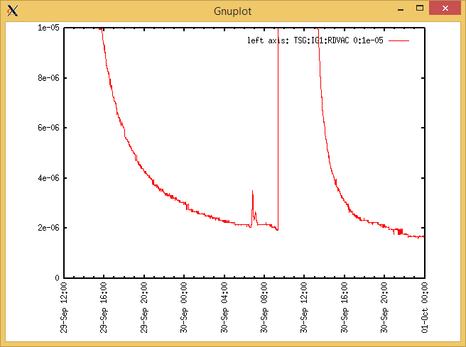

Target Heat Sequence Setup

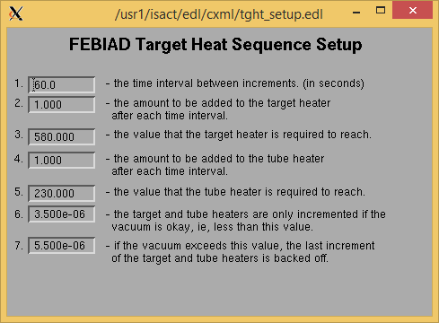

Source Tuning

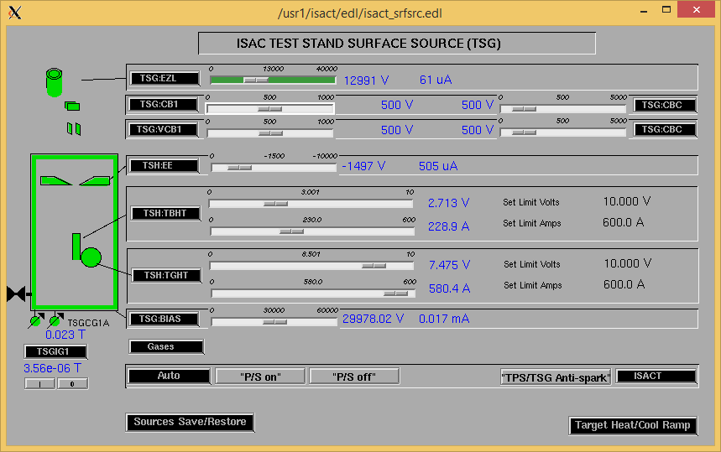

Wire Scanners RPM0A and RPM0B

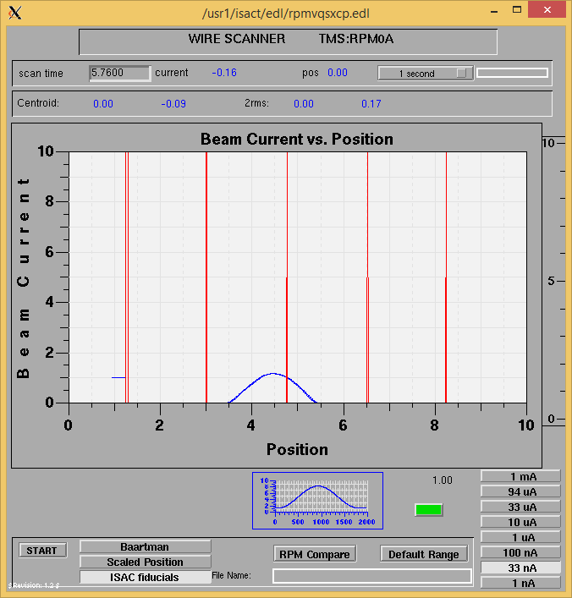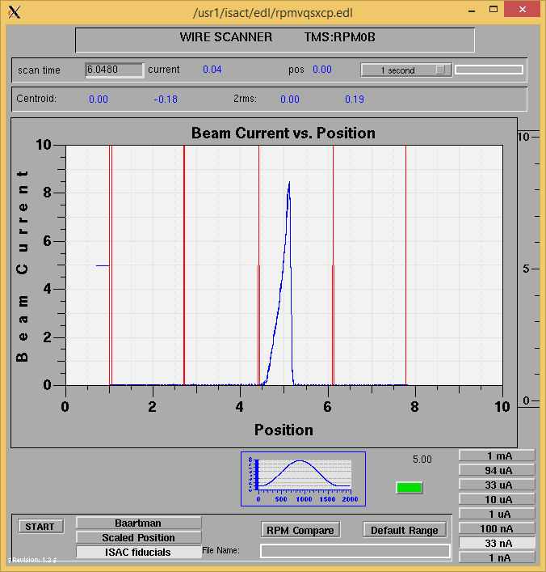

Optics Tuning

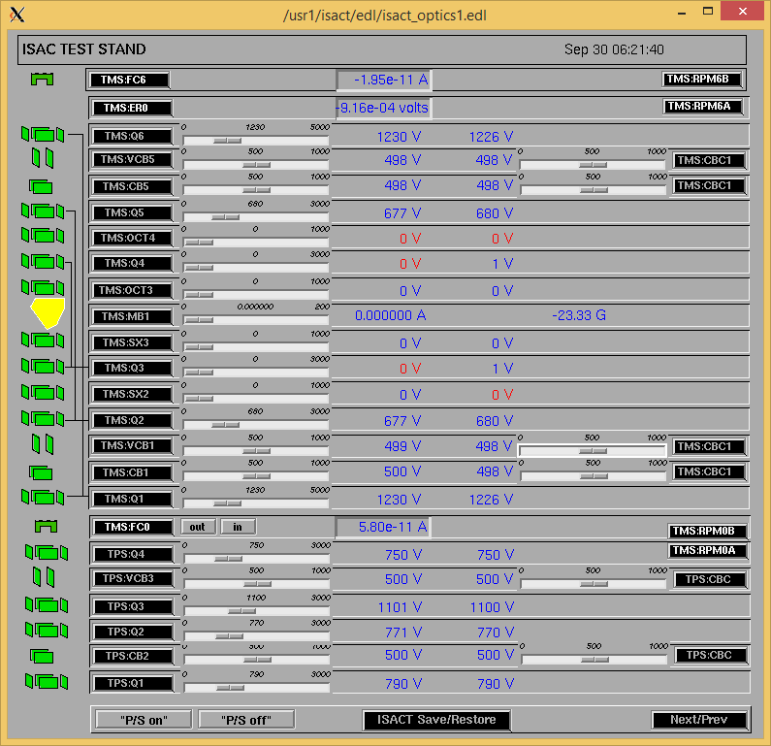

Wire Scanners RPM6A and RPM6B

N/A (No MB1)

Mass Scan

N/A (No MB1)

Cooling Parameters

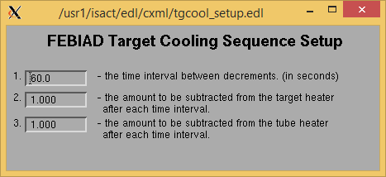

Overview Plots

Vacuum and FC0

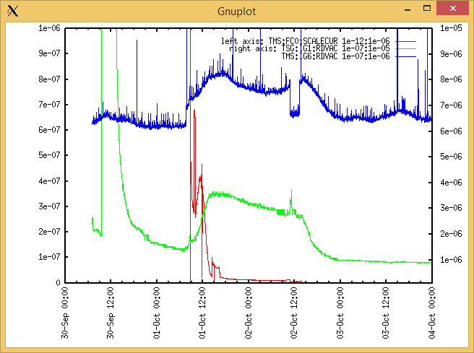

Heating, EE and BIAS

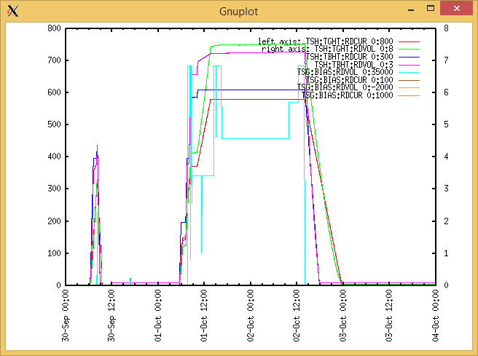

TGHT and TBHT Voltage

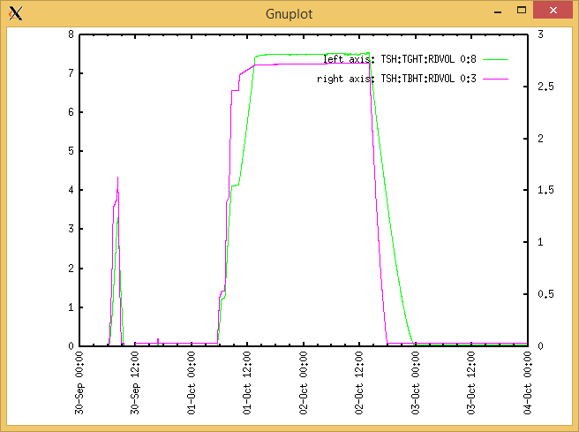

Flow and cooling water temperatures

RGA

N/A

Emittance Scan

N/A