Conditioning Report

|  |  |  |
| --- | --- | --- |
| Target material and number | | Ta#60 |
| Target WO-SN | | 44139-3 |
| Operator name | | Aaron Schmidt |
|  | |  |
| Heating start date and time | | 2020-06-17 07:55 |
| BIAS | |  |
| Voltage [kV] | | 30 |
| Current [µA] | | 20 |
| Extraction Electrode (EE) | |  |
| Voltage [kV] | | -1.5 |
| Current [µA] | | 513 |
| TGHT | |  |
| Current [A] | | 580.2 |
| Voltage [V] | | 7.358 |
| TBHT | |  |
| Current [A] | | 228.9 |
| Voltage [V] | | 2.718 |
| FEBIAD ANODE | |  |
| Voltage [V] | | - |
| Current [mA] | | - |
| FEBIAD COIL | |  |
| Current [A] | | - |
| Voltage [V] | | - |
| Flow and Temperature HS + MSP | | 28.28 |
| Flow [lpm] | | 8.11 |
| Temperature increase [C] | | 0.39 |
| FC6 currents [A] | |  |
| SIS | 7Li | 3.67E-10 |
| FEBIAD | 20Ne | - |
| SIS | 23Na | 1.04E-09 |
| SIS | 39K | 9.15E-10 |
| SIS | 85Rb | 4.28E-10 |
| SIS | 133Cs | 6.67E-10 |
| Heating end date and time | | 2020-06-22 11:07 |

Comments

RGA unavailable

-Trip* Wednesday, June 17, 2020, 12:50

Recovered after.

Plots

8h Vacuum Pump Down

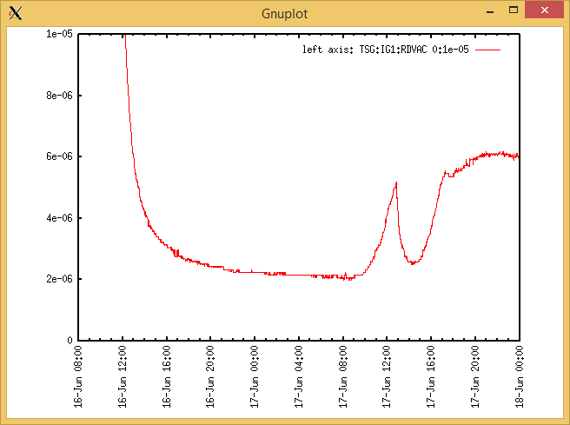

Target Heat Sequence Setup

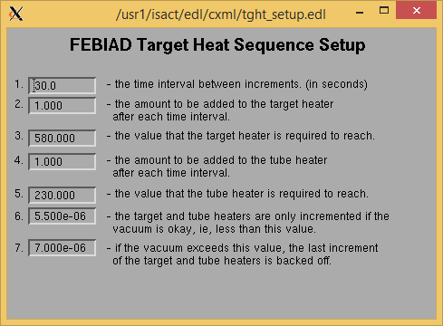

Source Tuning

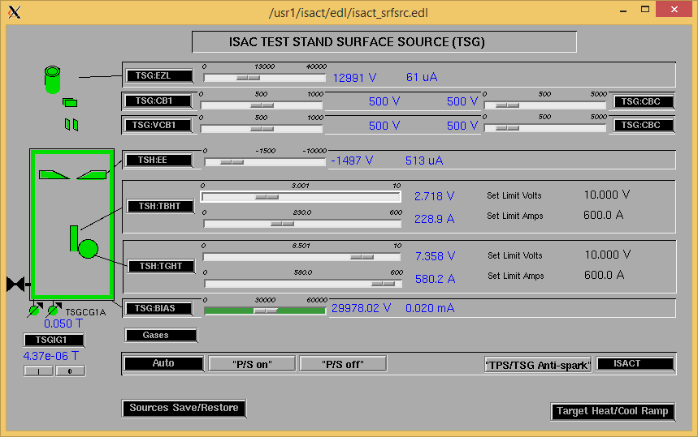

Wire Scanners RPM0A and RPM0B

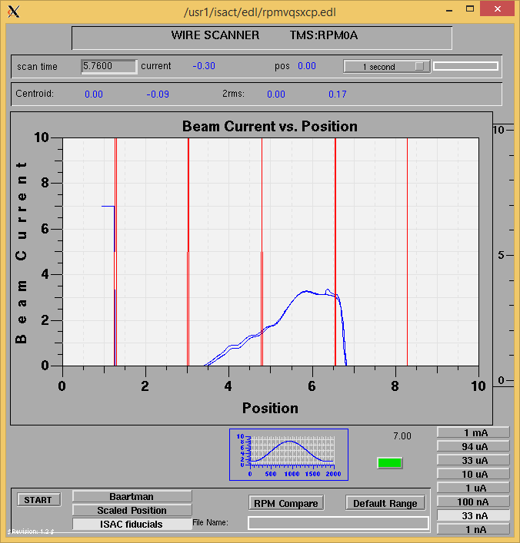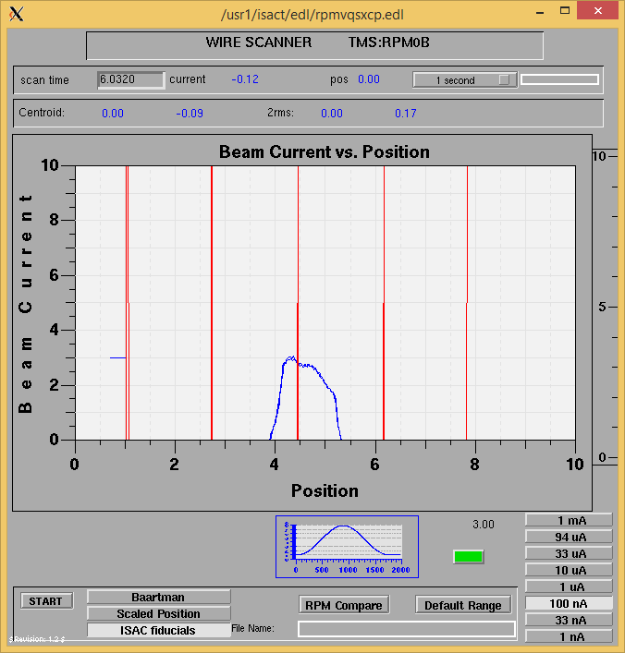

Optics Tuning

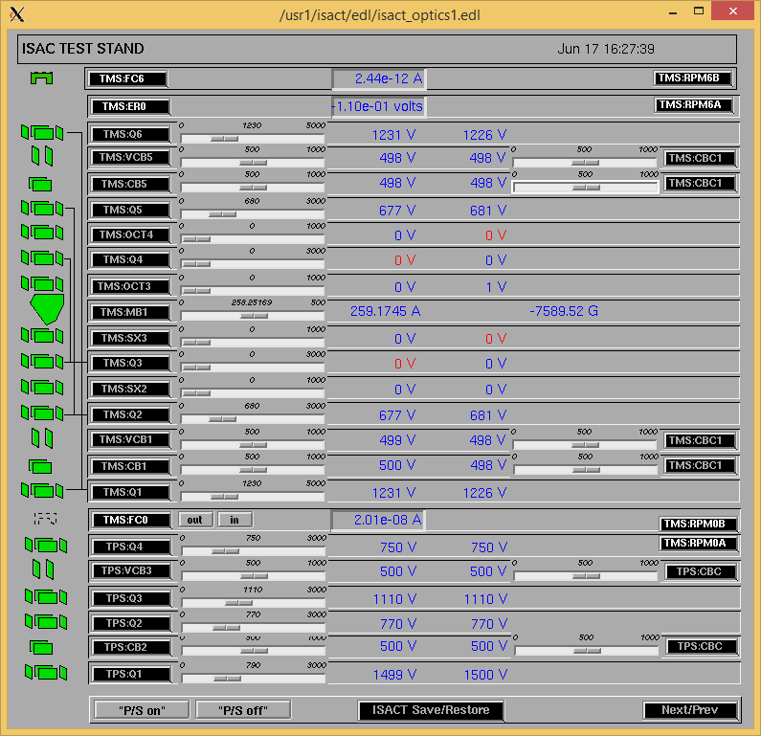

Wire Scanners RPM6A and RPM6B

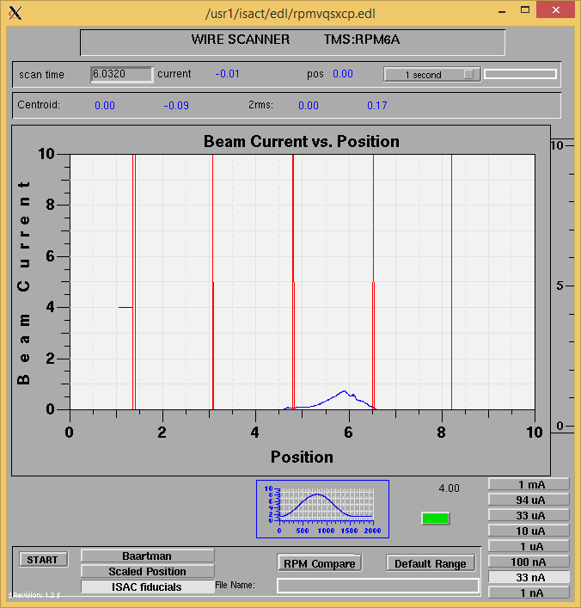

Mass 8

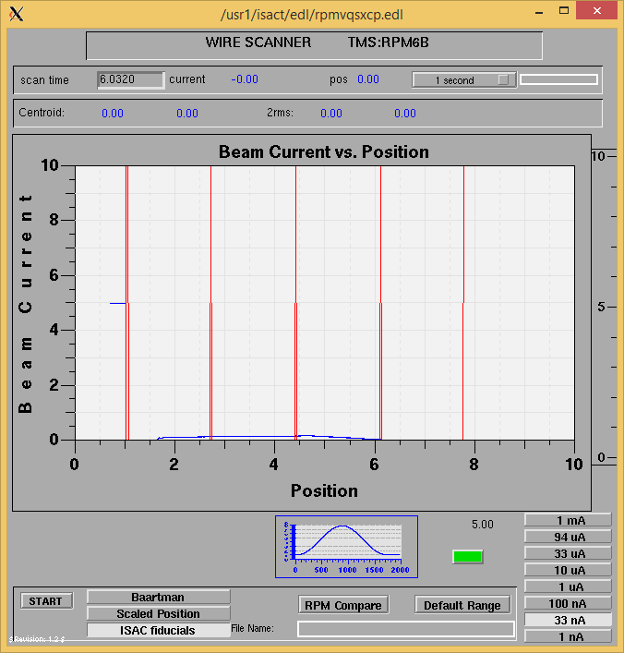

Mass 8

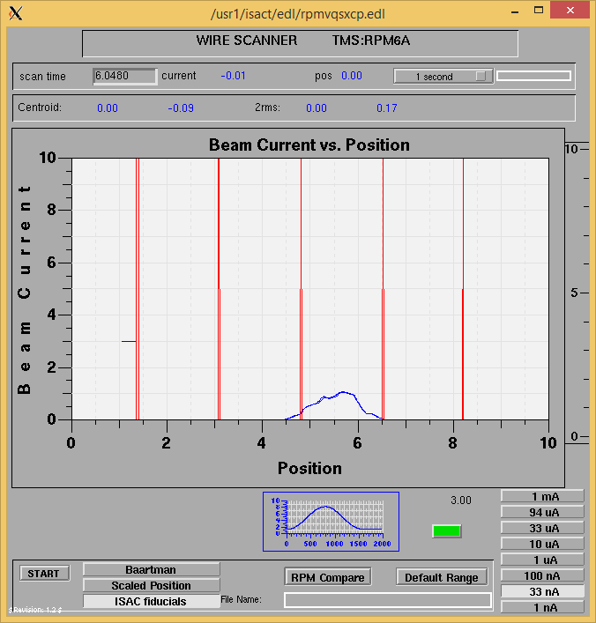

Mass 40

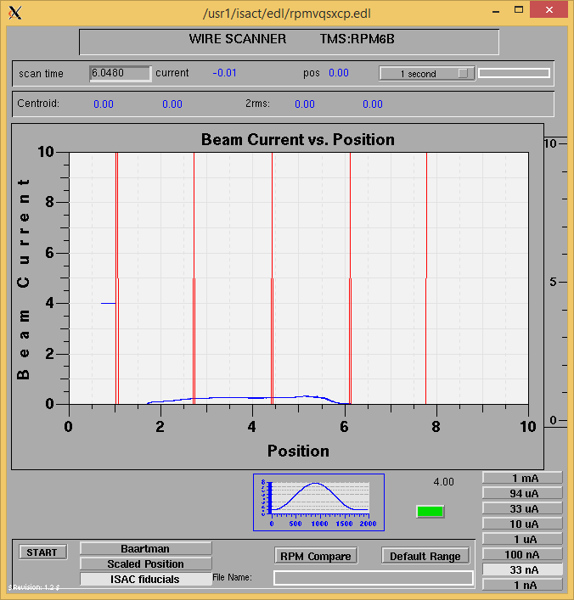

Mass 40

Mass Scan

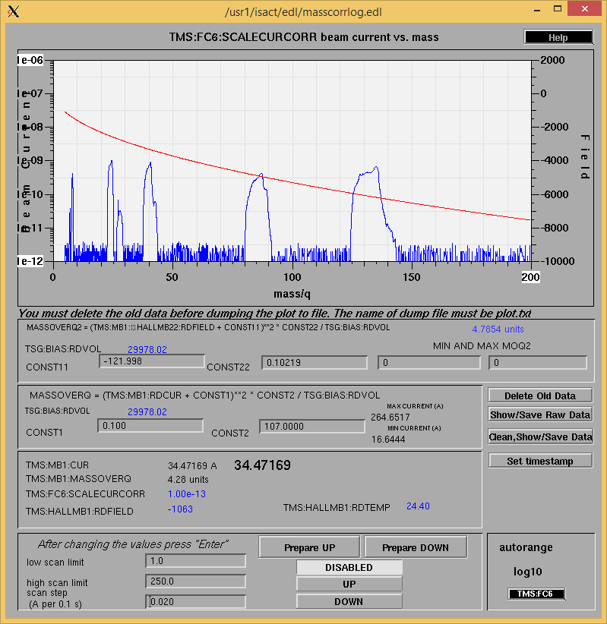http://isacwserv.triumf.ca/onlylocal/isactdata/save_restore/masscorr/2020-06-17-16-50%20Ta%2360

Cooling Parameters

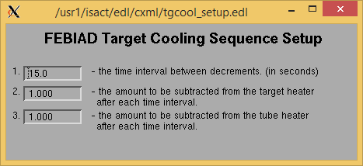

Overview Plots

Vacuum and FC0

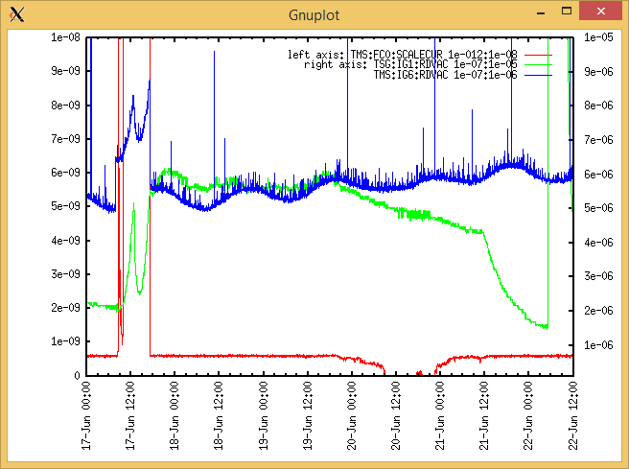

Heating, EE and BIAS

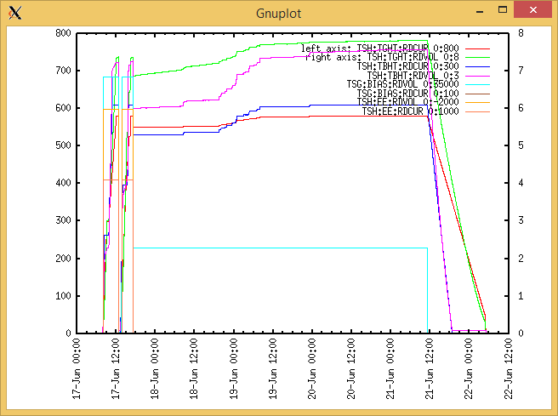

TGHT and TBHT Voltage

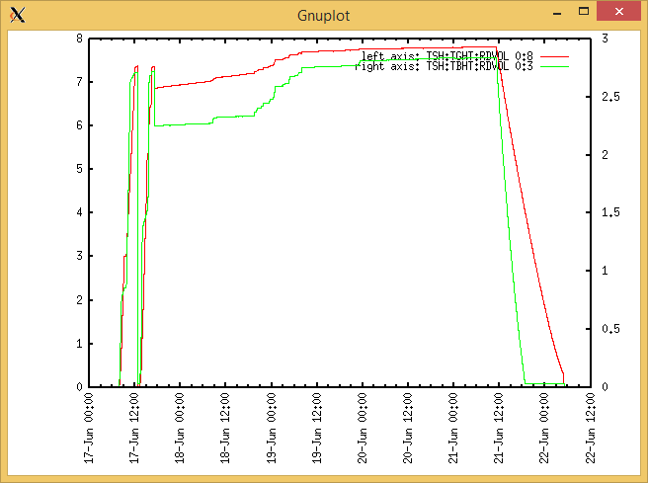

Flow and cooling water temperatures

Wednesday, June 17, 2020, 07:52:

|  |  |  |
| --- | --- | --- |
| **Device** | **Temp [C]** | **Flow [lpm]** |
| HS + MSP | 27.89 | 6.17 |
| TBHT | 27.73 | 8.71 |
| COIL + EE | 27.66 | 2.82 |
| TGHT | 27.74 | 6.68 |

Wednesday, June 17, 2020, 17:03: Scans complete

|  |  |  |
| --- | --- | --- |
| **Device** | **Temp [C]** | **Flow [lpm]** |
| HS + MSP | 28.28 | 8.11 |
| TBHT | 27.92 | 10.78 |
| COIL + EE | 27.75 | 3.76 |
| TGHT | 27.92 | 7.57 |

RGA

N/A

Emittance Scan

Mass 40

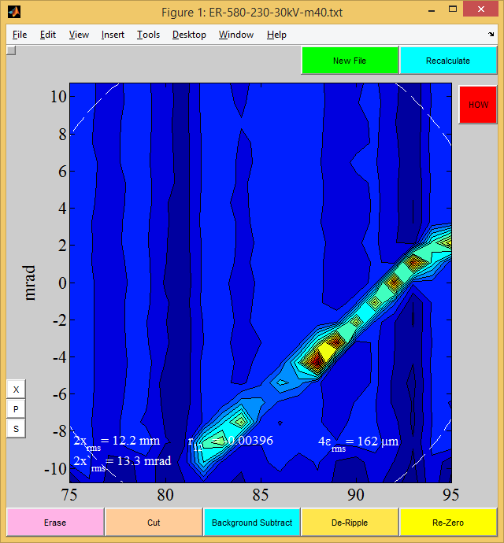

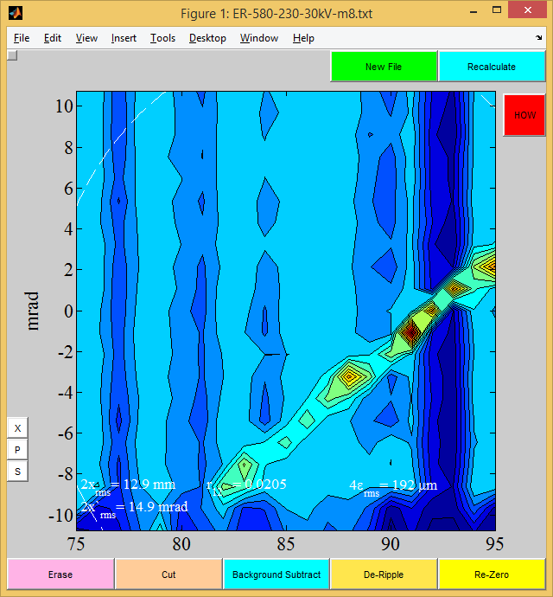

Mass 8

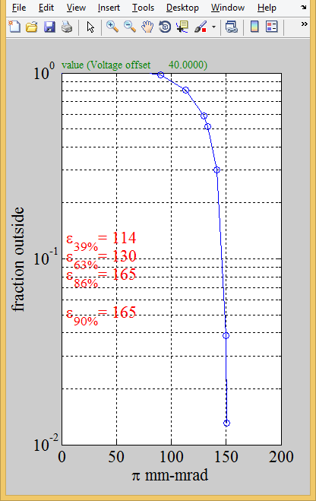

Mass 8