Conditioning Report

|  |  |  |
| --- | --- | --- |
| Target material and number | | SiC#40 |
| Target WO-SN | | 42218-8 |
| Operator name | | Aaron Schmidt |
|  | |  |
| Heating start date and time | | 2020-03-18 04:43 |
| BIAS | |  |
| Voltage [kV] | | 30 |
| Current [µA] | | 10 |
| Extraction Electrode (EE) | |  |
| Voltage [kV] | | 1.5 |
| Current [µA] | | 515 |
| TGHT | |  |
| Current [A] | | 580.2 |
| Voltage [V] | | 5.697 |
| TBHT | |  |
| Current [A] | | 229.0 |
| Voltage [V] | | 2.203 |
| FEBIAD ANODE | |  |
| Voltage [V] | | - |
| Current [mA] | | - |
| FEBIAD COIL | |  |
| Current [A] | | - |
| Voltage [V] | | - |
| Flow and Temperature HS + MSP | | 25.76 |
| Flow [lpm] | | 5.0 |
| Temperature increase [C] | | 1.34 |
| FC6 currents [A] | | 2.66E-07 |
| SIS | 7Li | 1.25e-09 |
| FEBIAD | 20Ne | - |
| SIS | 23Na | 1.40e-08 |
| SIS | 39K | 6.24e-10 (Trace) |
| SIS | 85Rb | - |
| SIS | 133Cs | - |
| Heating end date and time | | 2020-03-19 11:41 |

Comments

Plots

8h Vacuum Pump Down

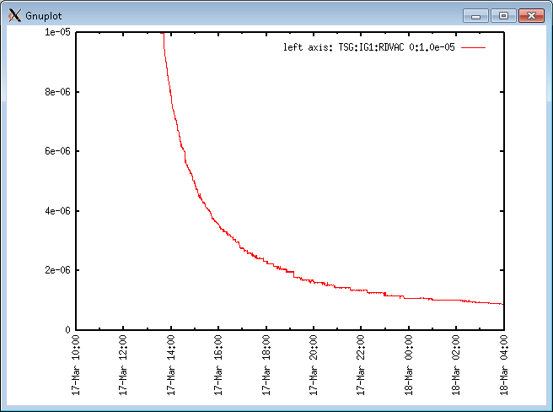

Target Heat Sequence Setup

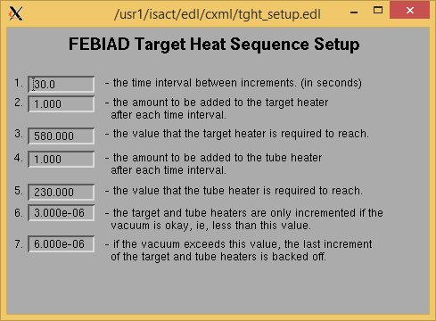

Source Tuning

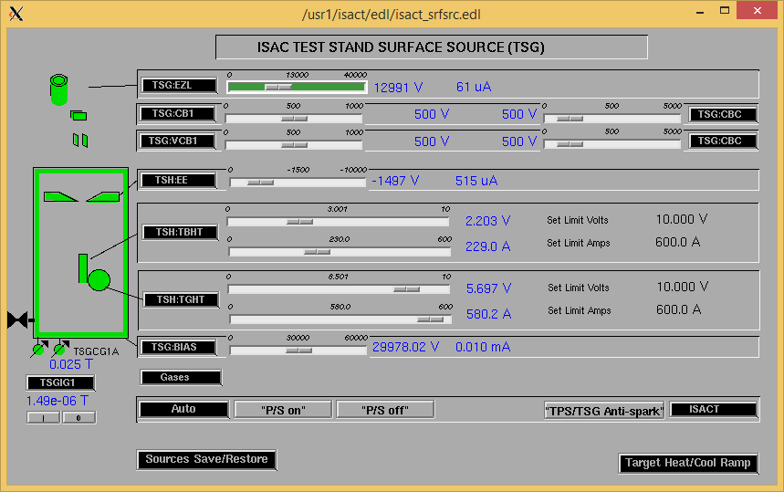

Wire Scanners RPM0A and RPM0B

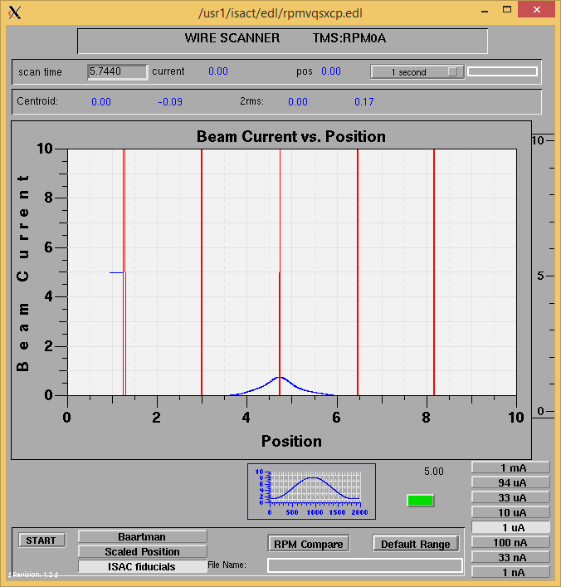

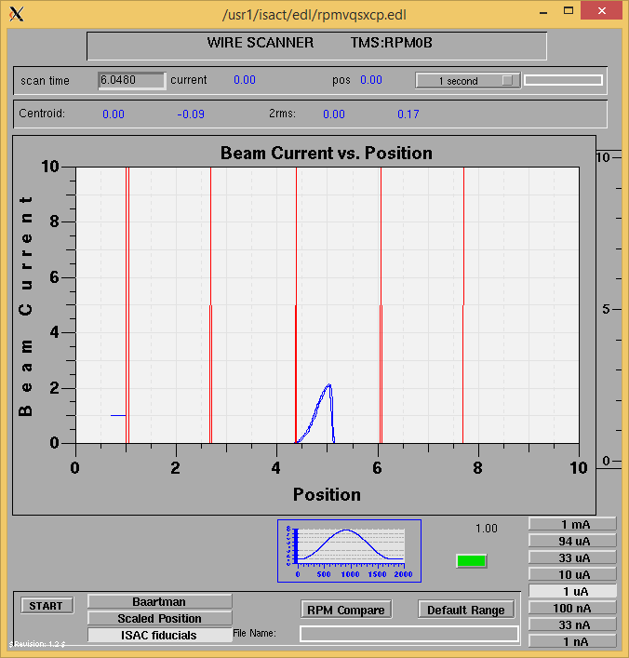

Optics Tuning

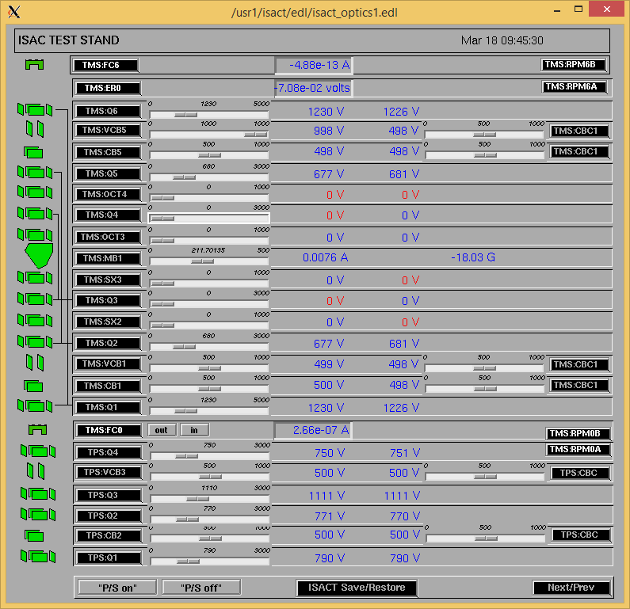

Wire Scanners RPM6A and RPM6B

Mass 7

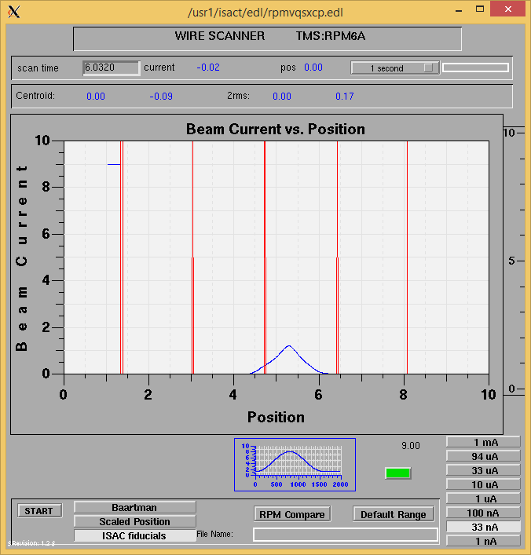

Mass 7

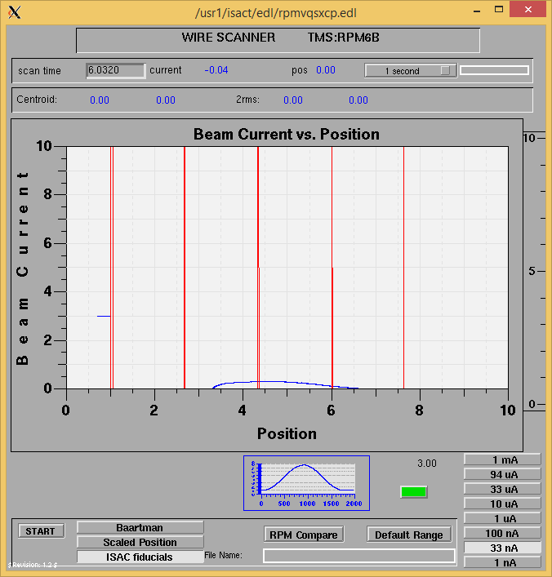

Mass Scan

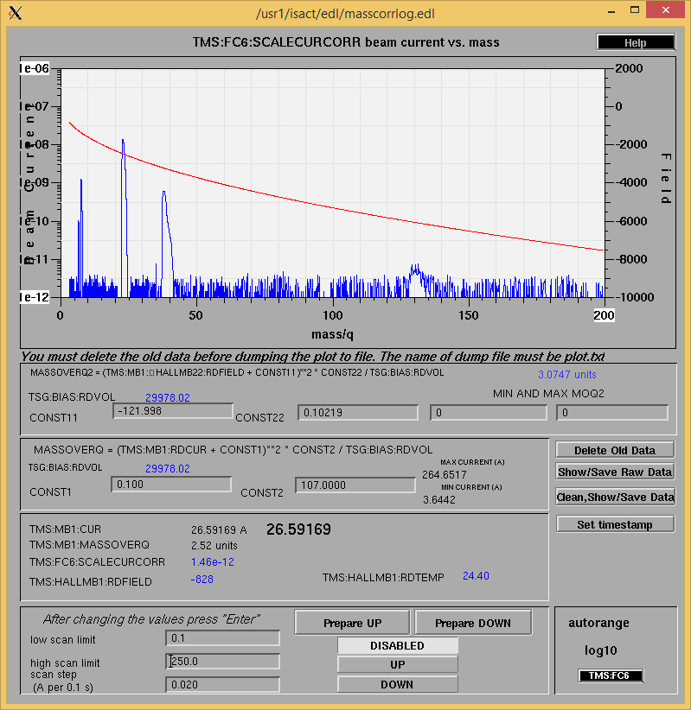

<http://isacwserv.triumf.ca/onlylocal/isactdata/save_restore/masscorr/2020-03-18-10-12%20SiC%2340>

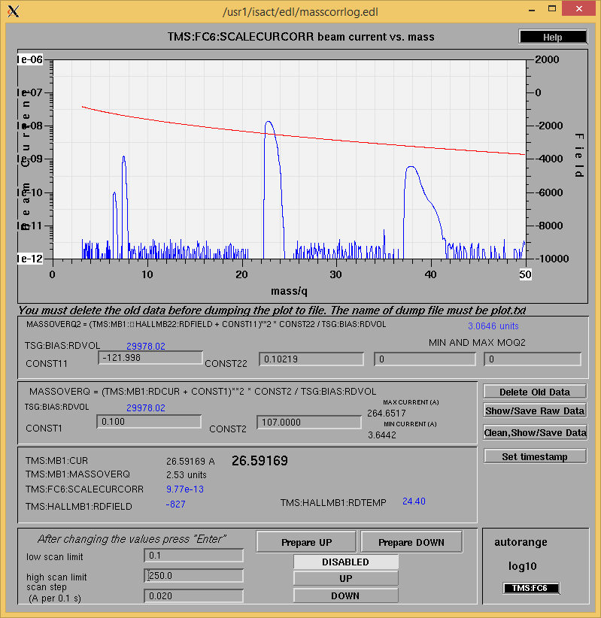

Cooling Parameters

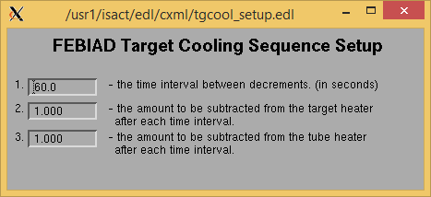

Overview Plots

Vacuum and FC0

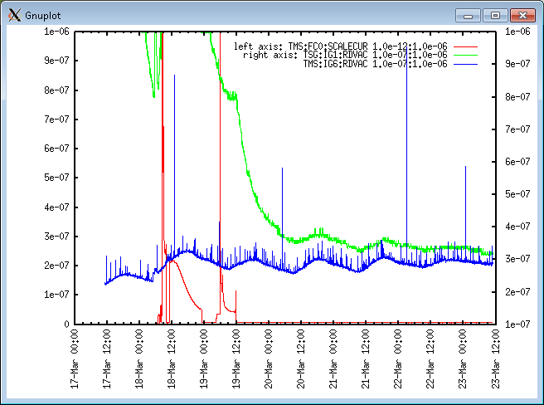

Heating, EE and BIAS

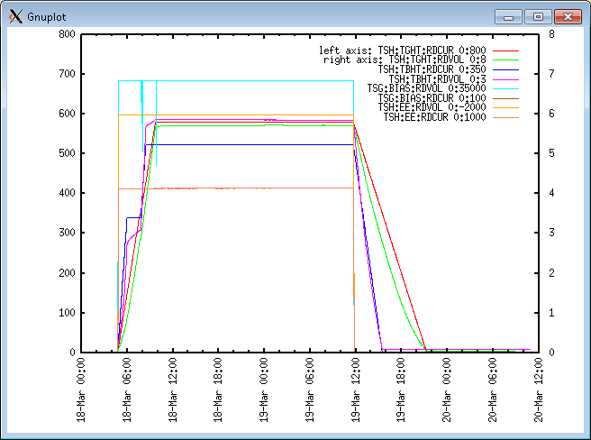

TGHT and TBHT Voltage

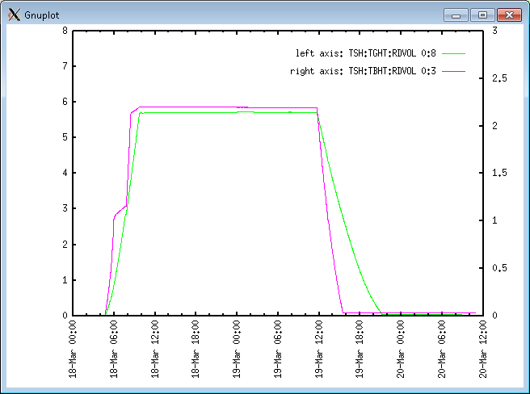

Flow and cooling water temperatures

Wednesday, March 18, 2020, 04:40: Power / Sources on.

|  |  |  |
| --- | --- | --- |
| **Device** | **Temp [C]** | **Flow [lpm]** |
| HS + MSP | 24.42 | 4.04 |
| TBHT | 24.39 | 6.72 |
| COIL + EE | 24.21 | 1.63 |
| TGHT | 24.30 | 5.76 |

Wednesday, March 18, 2020, 09:51:

|  |  |  |
| --- | --- | --- |
| **Device** | **Temp [C]** | **Flow [lpm]** |
| HS + MSP | 25.76 | 5.00 |
| TBHT | 25.49 | 7.61 |
| COIL + EE | 25.35 | 2.04 |
| TGHT | 25.32 | 6.14 |

RGA

N/A, The communication chip is currently burnt out.

Emittance Scan

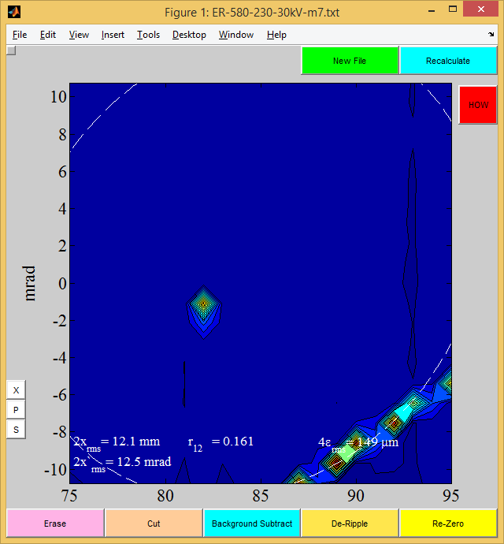

Mass 7

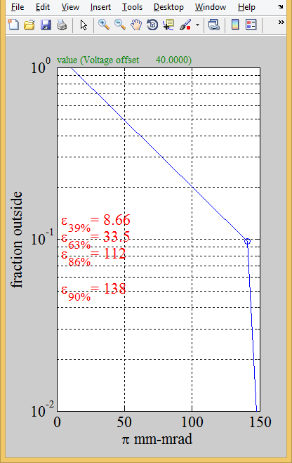

M7

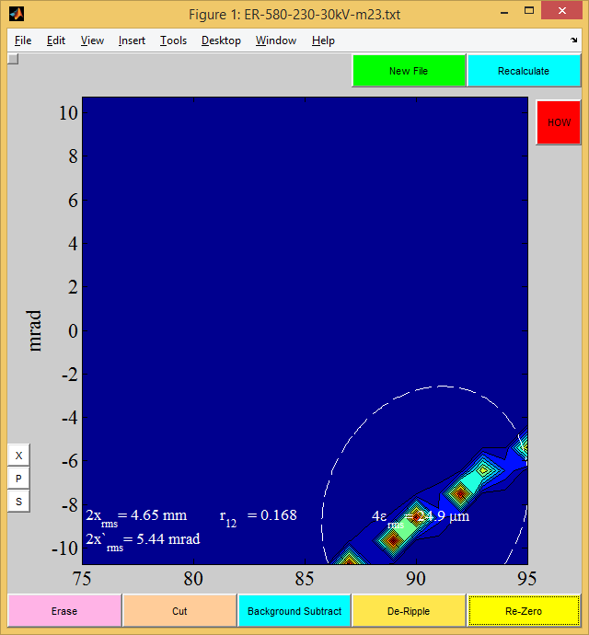

Mass 23

Mass 38:

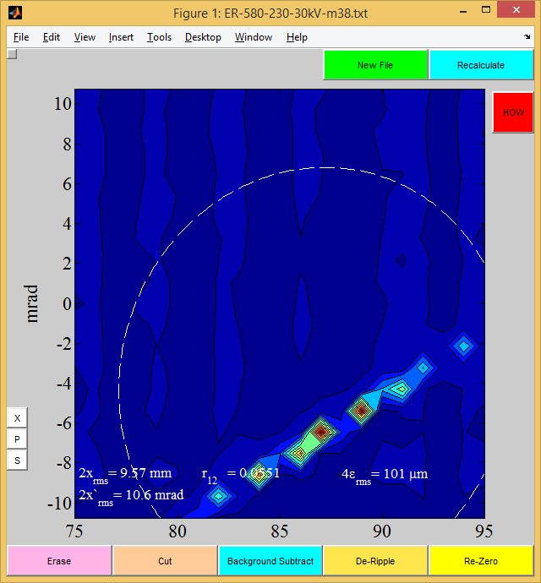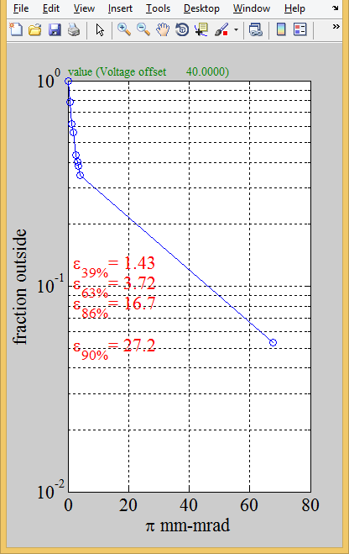

Mass 38