Conditioning Report

|  |  |  |
| --- | --- | --- |
| Target material and number | | SiC#38 |
| Target WO-SN | | 42464-4 |
| Operator name | | Aaron S. & Fernando M. |
|  | |  |
| Heating start date and time | | 2019-10-29-10:54 |
| BIAS | |  |
| Voltage [kV] | | 30 |
| Current [µA] | | 13 |
| Extraction Electrode (EE) | |  |
| Voltage [kV] | | -1.5 |
| Current [µA] | | 508 |
| TGHT | |  |
| Current [A] | | 580 |
| Voltage [V] | | 5.6 |
| TBHT | |  |
| Current [A] | | 290 |
| Voltage [V] | | 2.3 |
| FEBIAD ANODE | |  |
| Voltage [V] | | 200 |
| Current [mA] | | 0 |
| FEBIAD COIL | |  |
| Current [A] | | 30 |
| Voltage [V] | | *n/a |
| Flow and Temperature HS + MSP | | 22.56 |
| Flow [lpm] | | 5.23 |
| Temperature increase [C] | | * |
| FC6 currents [A] | | 8.70E-07 |
| SIS | 7Li | - |
| FEBIAD | 20Ne | 2.44E-12* |
| SIS | 23Na | - |
| SIS | 39K | - |
| SIS | 85Rb | - |
| SIS | 133Cs | - |
| Heating end date and time | | 2019-11-01 12:09 |

Comments

FM

Monday, October 28, 2019, 09:10: Magnet leak repaired on Friday.  Checked by Anders. The polarity might need to be reversed.

Monday, October 28, 2019, 09:20: Vacuum gauges checked and reconnected ( see elog 765)

*20Ne current / plot may not have had old data deleted?

*HS flow & temp unknown.

Plots

8h Vacuum Pump Down

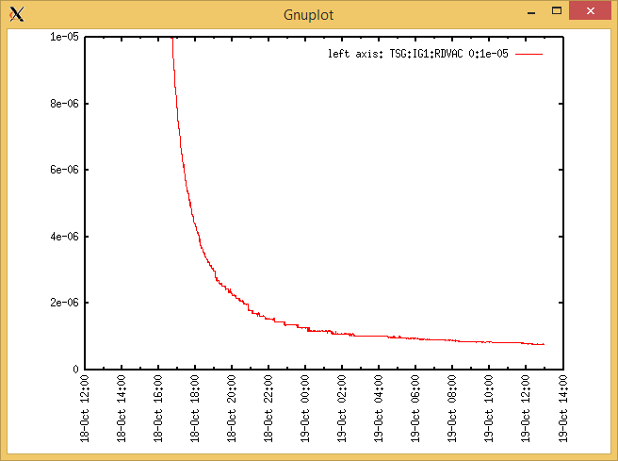

Target Heat Sequence Setup

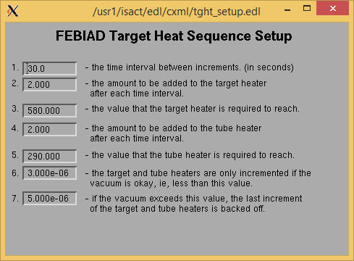

Source Tuning

No full sources screenshot available

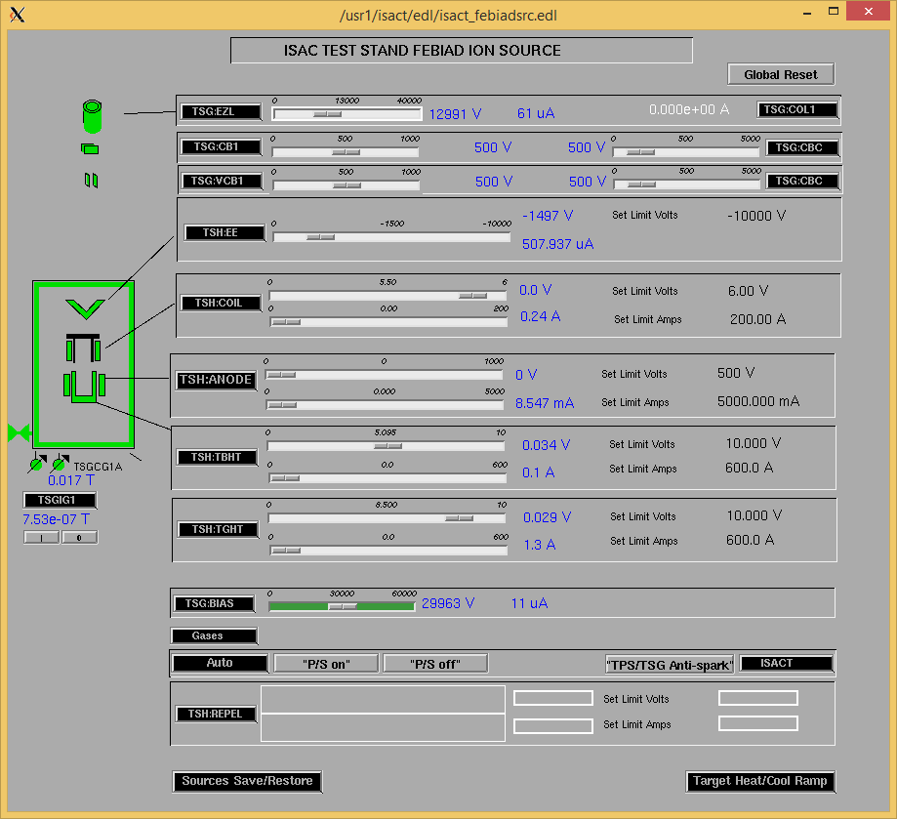

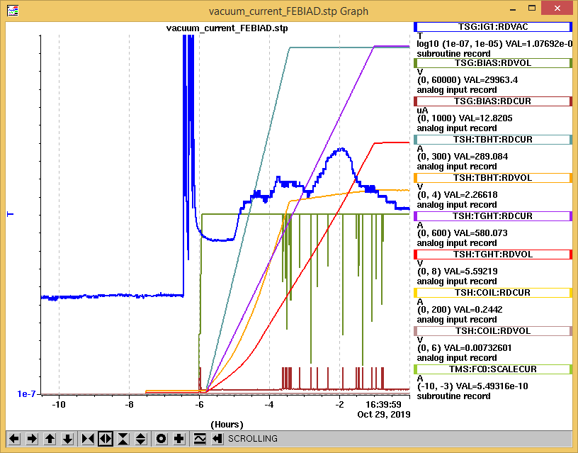

Wire Scanners RPM0A and RPM0B

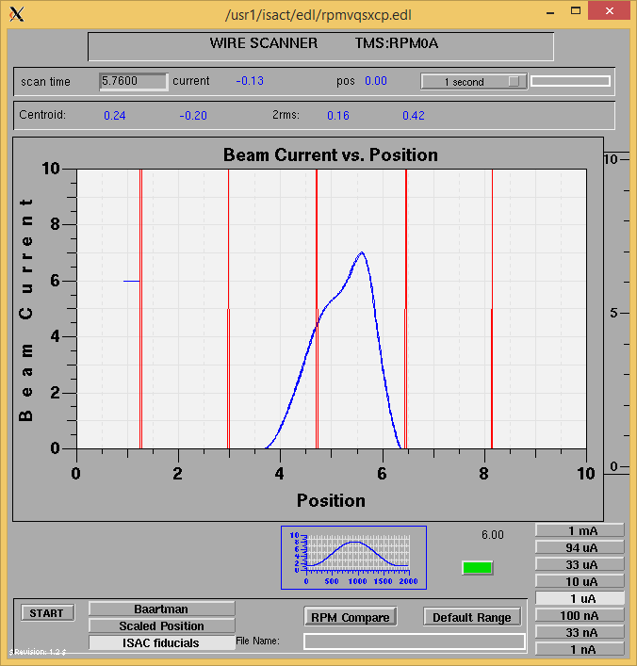

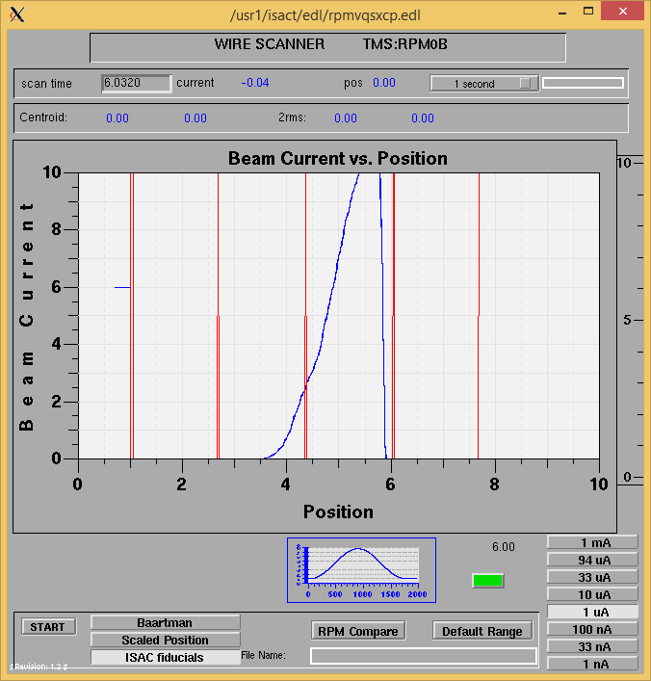

Optics Tuning

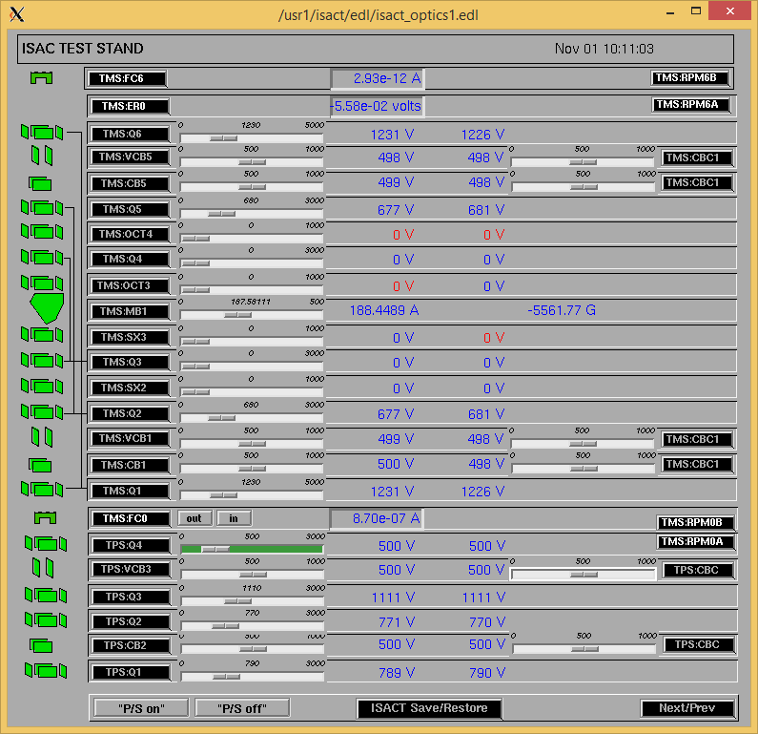

Wire Scanners RPM6A and RPM6B

Mass 28

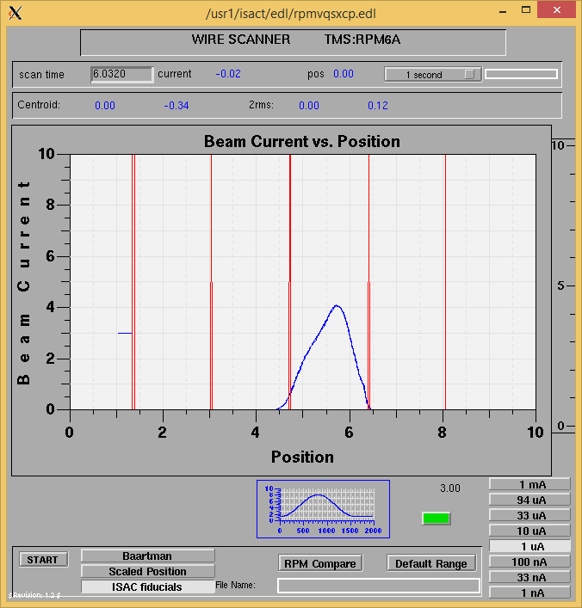

Mass 28

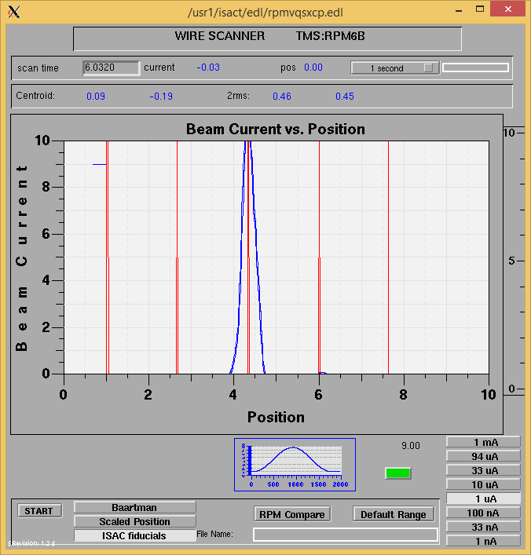

Mass Scan

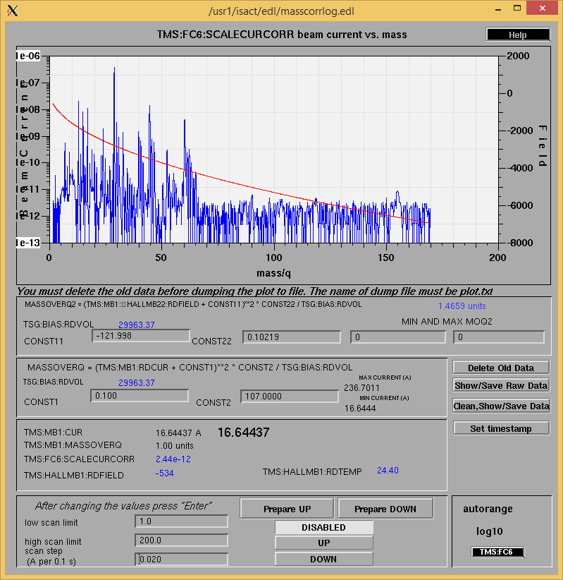

<http://isacwserv.triumf.ca/onlylocal/isactdata/save_restore/masscorr/2019-11-01-10-32%20SiC%2338>

Cooling Parameters

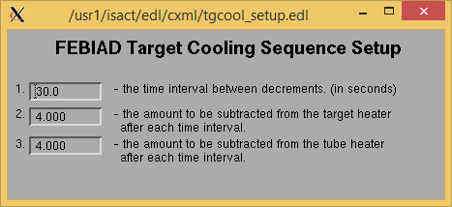

Overview Plots

Vacuum and FC0

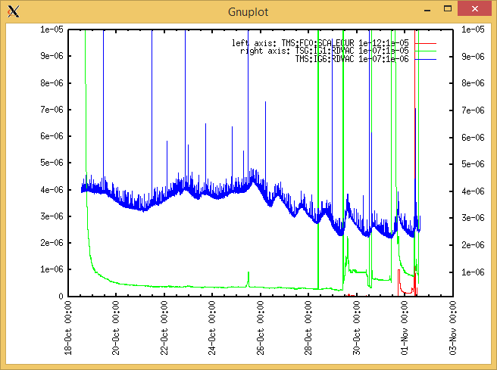

Heating, EE and BIAS

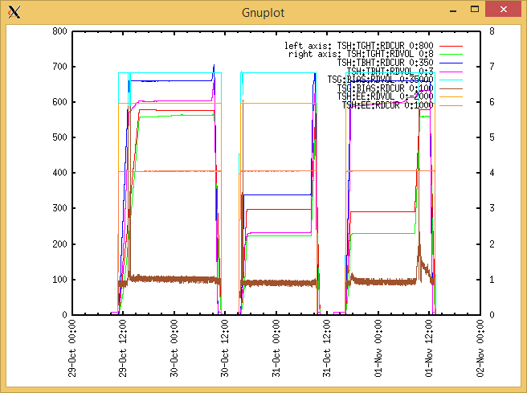

TGHT and TBHT Voltage

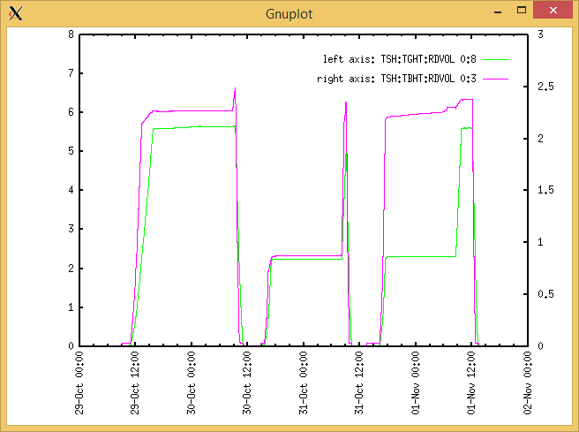

Flow and cooling water temperatures

Tuesday, October 29, 2019, 10:29 :

|  |  |  |
| --- | --- | --- |
| **Device** | **Temp [C]** | **Flow [lpm]** |
| HS + MSP | 22.56 | 5.23 |
| TBHT | 22.35 | 8.03 |
| COIL + EE | 22.30 | 2.17 |
| TGHT | 22.40 | 6.29 |

RGA

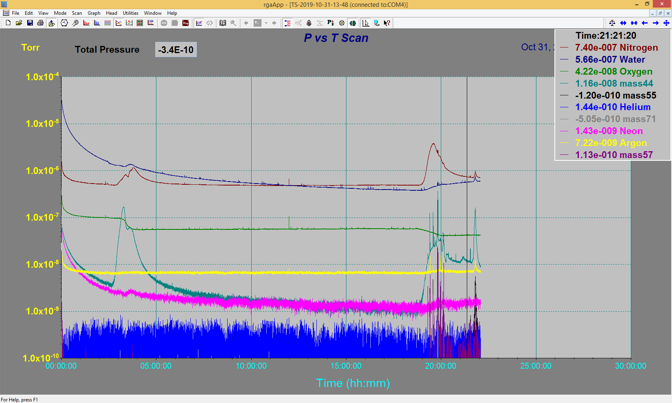

Emittance Scan

