Conditioning Report

|  |  |  |
| --- | --- | --- |
| Target material and number | | Ta#59 |
| Target WO-SN | | 44062-5 |
| Operator name | | Aaron Schmidt |
|  | |  |
| Heating start date and time | | 2019-09-25 07:30 |
| BIAS | |  |
| Voltage [kV] | | 30 |
| Current [µA] | | 17 |
| Extraction Electrode (EE) | |  |
| Voltage [kV] | | 1.5 |
| Current [µA] | | 505 |
| TGHT | |  |
| Current [A] | | 578.2 |
| Voltage [V] | | 7.802 |
| TBHT | |  |
| Current [A] | | 228.9 |
| Voltage [V] | | 2.733 |
| FEBIAD ANODE | |  |
| Voltage [V] | | - |
| Current [mA] | | - |
| FEBIAD COIL | |  |
| Current [A] | | - |
| Voltage [V] | | - |
| Flow and Temperature HS + MSP | | 28.33 |
| Flow [lpm] | | 7.59 |
| Temperature increase [C] | | -1.10 |
| FC6 currents [A] | |  |
| SIS | 7Li | 2.64E-10 |
| FEBIAD | 20Ne | - |
| SIS | 23Na | 1.96E-10 |
| SIS | 39K | 8.03E-10 |
| SIS | 85Rb | 3.87E-10 |
| SIS | 133Cs | 1.69E-08 |
| Heating end date and time | | 2019-09-26 14:28 |

Comments

Initial attempts to heat & run w/ HV resulted in a lot of sparks. Spark* knocked out TSG:CB1 during RPM6A wire scan. Controls notified.

-After investigation with controls, replacement of the control board to TSG:CB1 was req'd. The control board to TSG:CB1 was removed and replaced. Sparks gone after.

Thursday, September 26, 2019, 12:31: Mass, wire, & emittance scans successful

Plots

8h Vacuum Pump Down

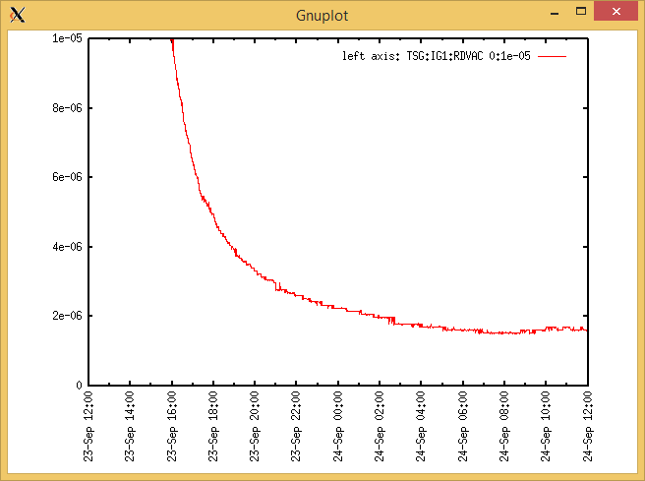

Target Heat Sequence Setup

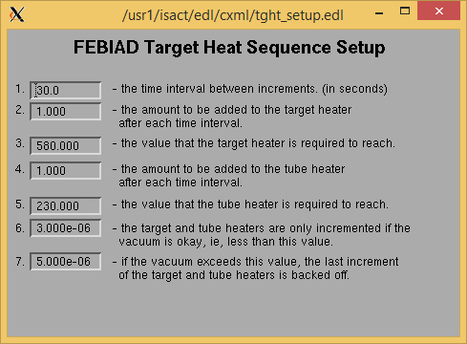

Source Tuning

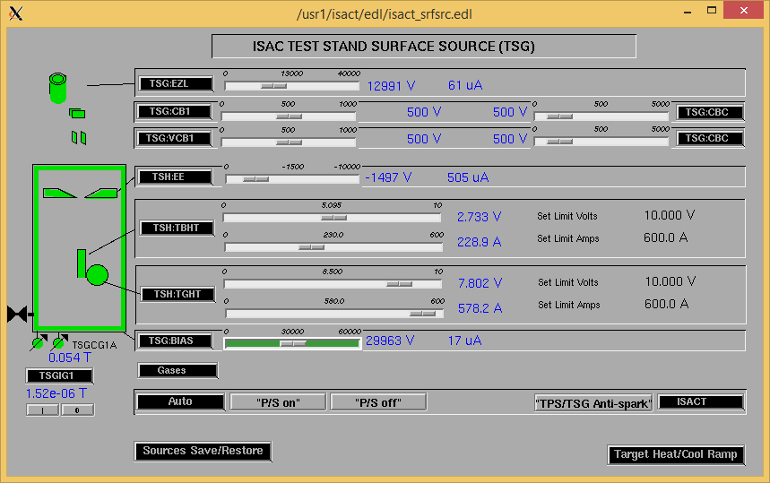

Wire Scanners RPM0A and RPM0B

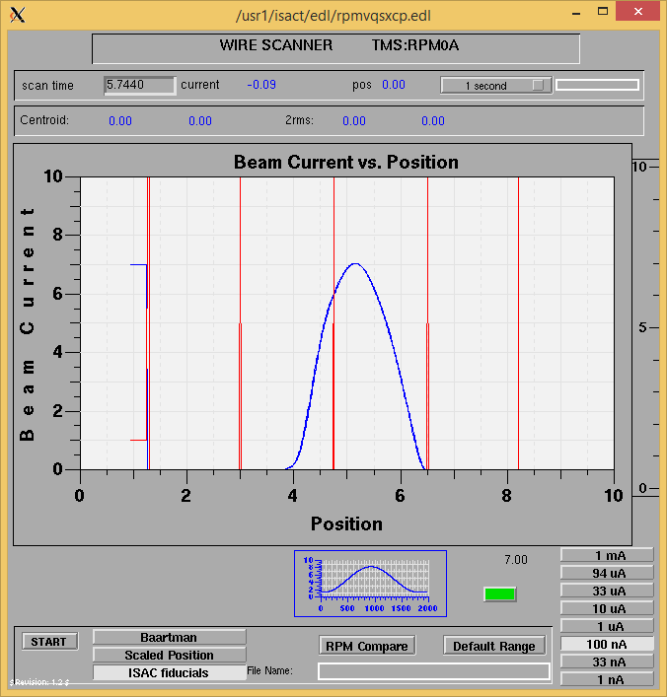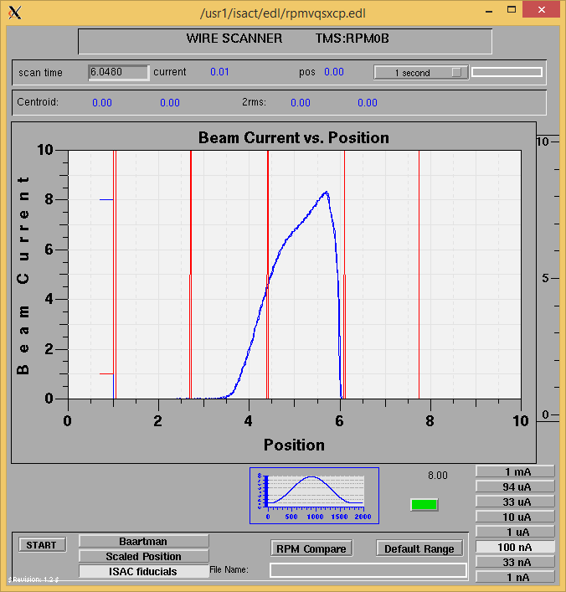

Optics Tuning

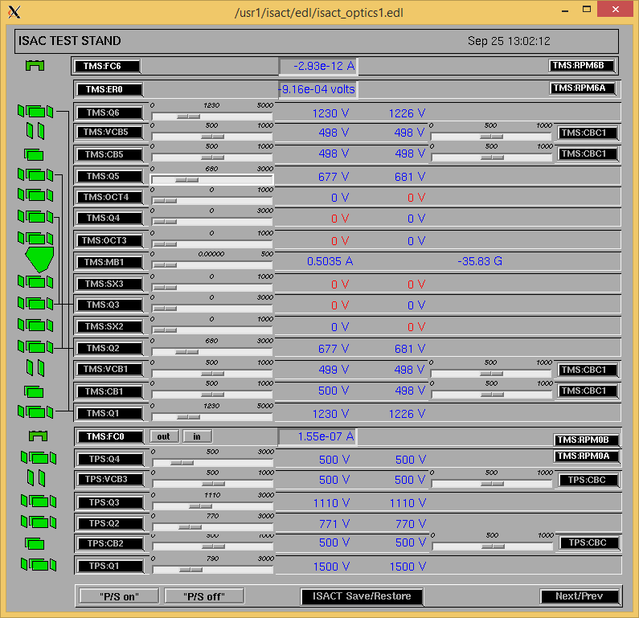

Wire Scanners RPM6A and RPM6B

Mass 136

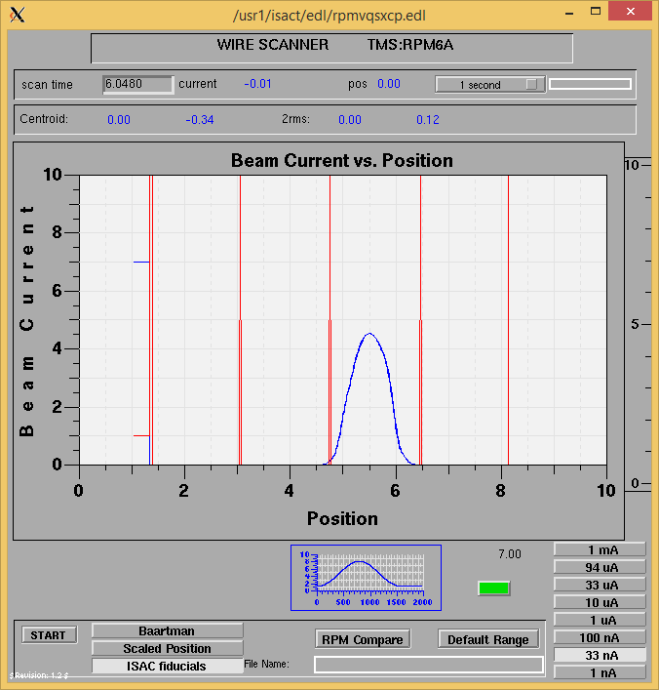

Mass 136

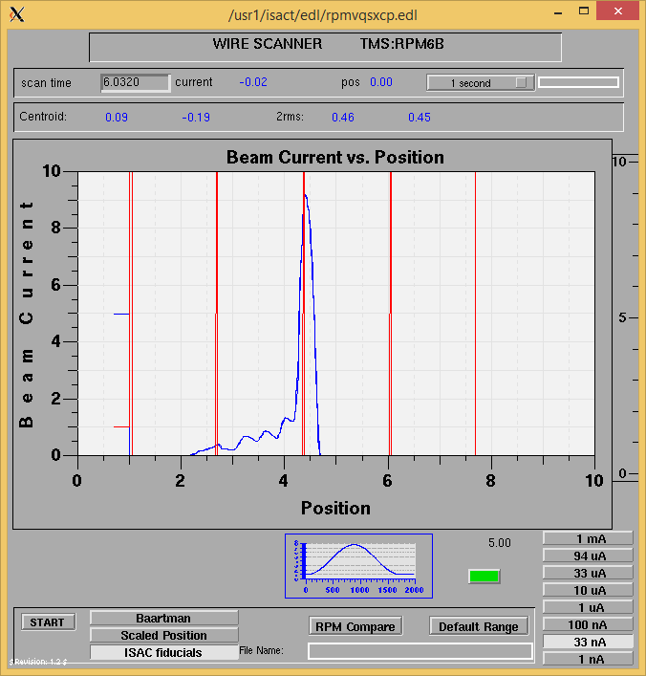

Mass Scan

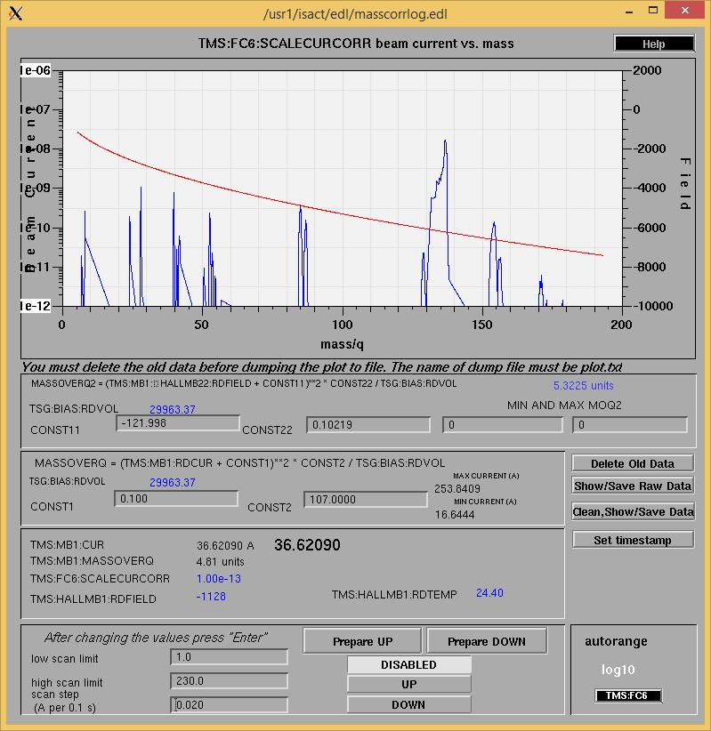http://isacwserv.triumf.ca/onlylocal/isactdata/save_restore/masscorr/2019-09-26-12-06%20Ta%2359

Cooling Parameters

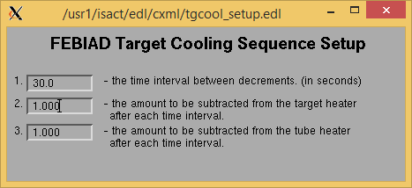

Overview Plots

Vacuum and FC0

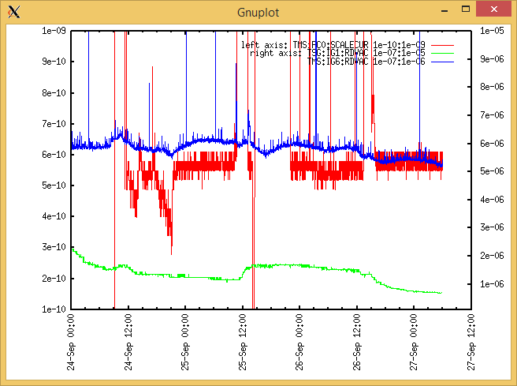

Heating, EE and BIAS

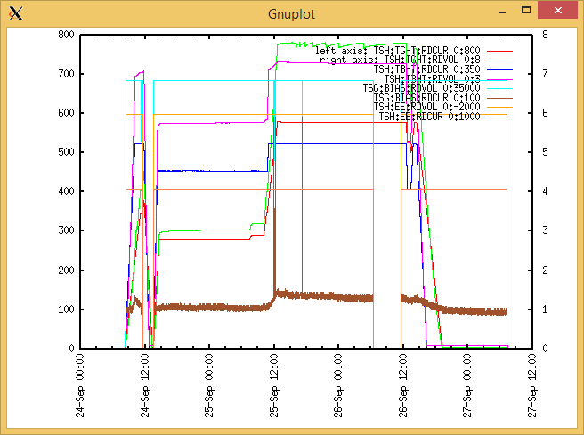

TGHT and TBHT Voltage

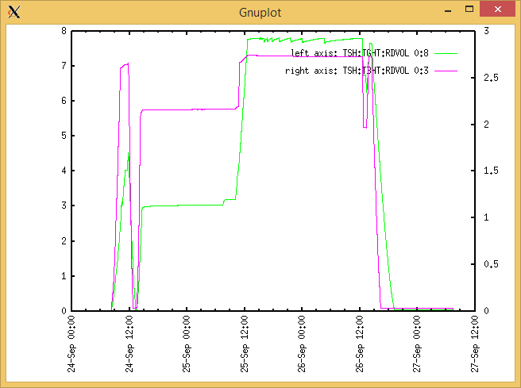

Flow and cooling water temperatures

Tuesday, September 24, 2019, 08:20:

|  |  |  |
| --- | --- | --- |
| **Device** | **Temp [C]** | **Flow [lpm]** |
| HS + MSP | 28.33 | 5.00 |
| TBHT | 28.19 | 7.75 |
| COIL + EE | 28.08 | 2.13 |
| TGHT | 28.18 | 6.15 |

Monday, May 06, 2019, 14:48 :

|  |  |  |
| --- | --- | --- |
| **Device** | **Temp [C]** | **Flow [lpm]** |
| HS + MSP | 27.23 | 7.59 |
| TBHT | 26.86 | 10.02 |
| COIL + EE | 26.65 | 3.27 |
| TGHT | 26.89 | 7.29 |

RGA

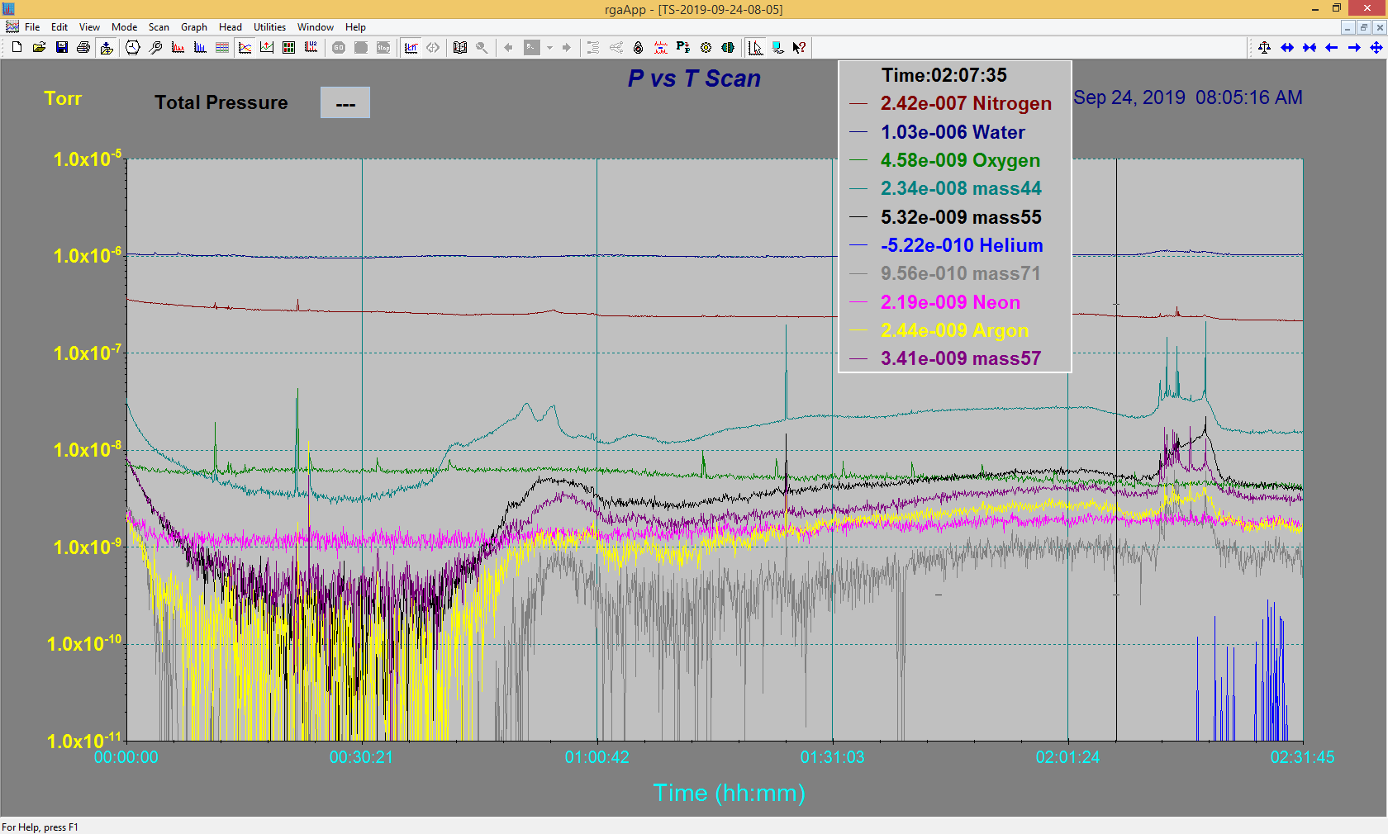

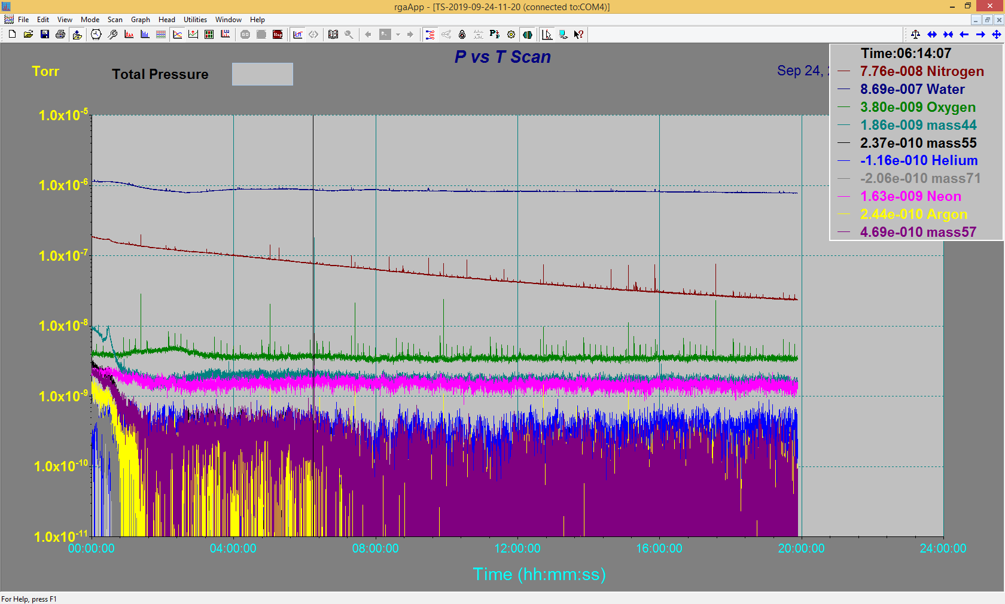

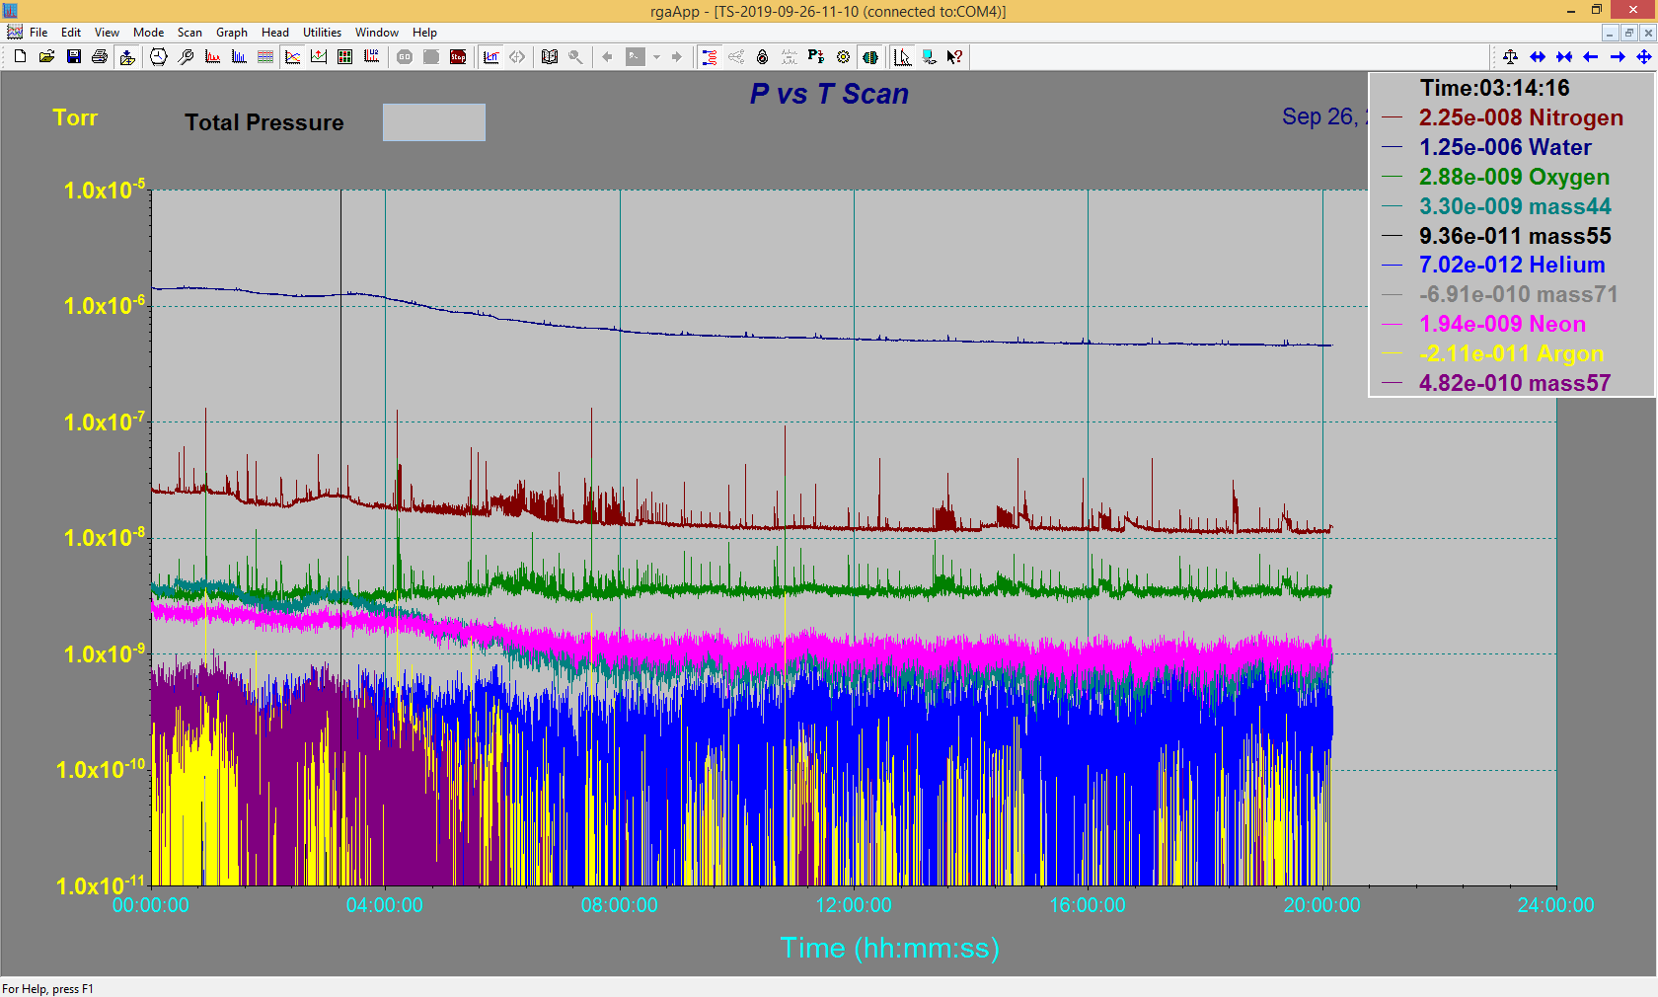

Emittance Scan

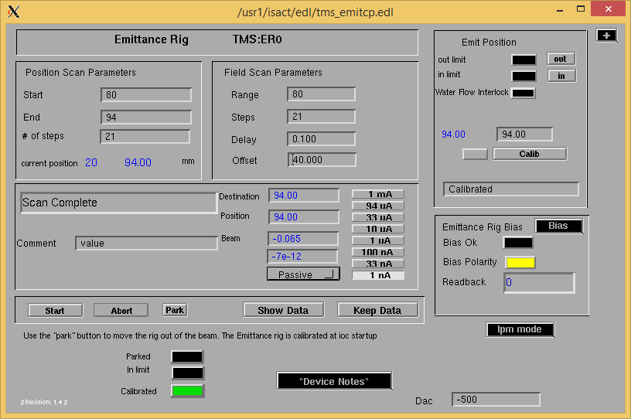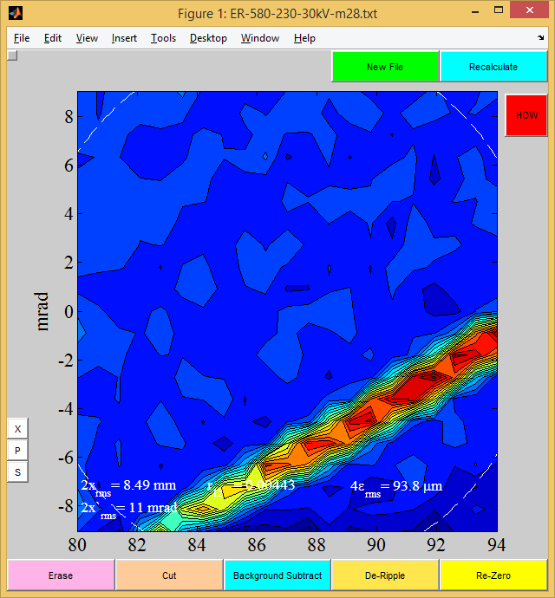

Mass 28

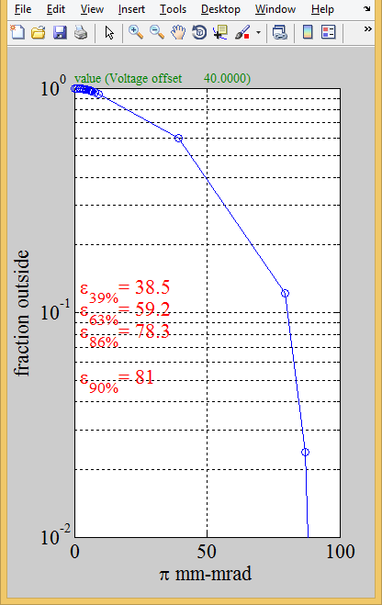

Mass 28

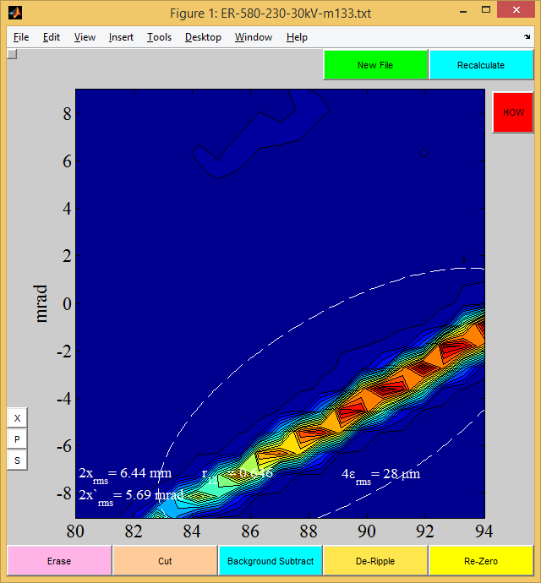

Mass 133

