Conditioning Report

|  |  |  |
| --- | --- | --- |
| Target material and number | | ZrC#8 |
| Target WO-SN | | 43044-5 |
| Operator name | | Aaron Schmidt |
|  | |  |
| Heating start date and time | | 2019-05-15 09:00 |
| BIAS | |  |
| Voltage [kV] | | 30 |
| Current [µA] | | 29 |
| Extraction Electrode (EE) | |  |
| Voltage [kV] | | 1.5 |
| Current [µA] | | 518 |
| TGHT | |  |
| Current [A] | | 579.9 |
| Voltage [V] | | 8.051 |
| TBHT | |  |
| Current [A] | | 228.9 |
| Voltage [V] | | 2.628 |
| FEBIAD ANODE | |  |
| Voltage [V] | | - |
| Current [mA] | | - |
| FEBIAD COIL | |  |
| Current [A] | | - |
| Voltage [V] | | - |
| Flow and Temperature HS + MSP | | 26.34 |
| Flow [lpm] | | 5.24 |
| Temperature increase [C] | | N/A |
| FC6 currents [A] | | 1.22E-08 |
| SIS | 7Li | 9.81E-10 |
| FEBIAD | 20Ne | - |
| SIS | 23Na | 8.42E-10 |
| SIS | 39K | 8.15E-10 |
| SIS | 85Rb | 3.57E-10 |
| SIS | 133Cs | 1.68E-08 |
| Heating end date and time | | 2019-05-22 18:30 |

Comments

Noticed a discrepancy on the initial mass scans. The mass peaks appear to have moved further along the mass / q. They are identical to what we used to see on previous scans, just further down the line. The magnet was calibrated at a later date – May 22

Plots

8h Vacuum Pump Down

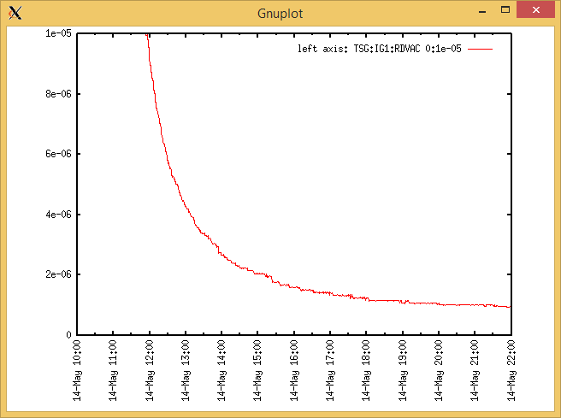

Target Heat Sequence Setup

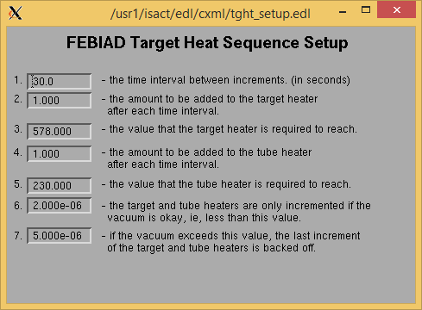

Source Tuning

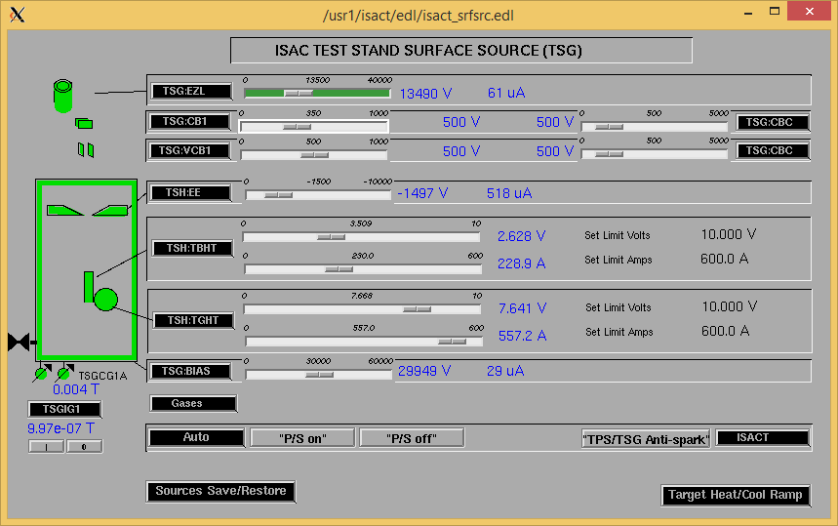Wednesday, May 22, 2019, 07:09: TGHT was at voltage limit. The limit was increased. Auto-ramping TGHT / TBHT to 578 (580) / 230 A @ 2A per min.

Wednesday, May 22, 2019, 07:32: TGHT 579.9 A / 8.051 V.

Wire Scanners RPM0A and RPM0B

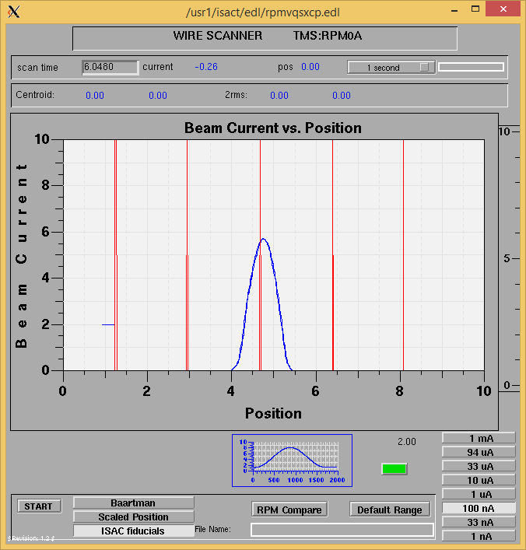

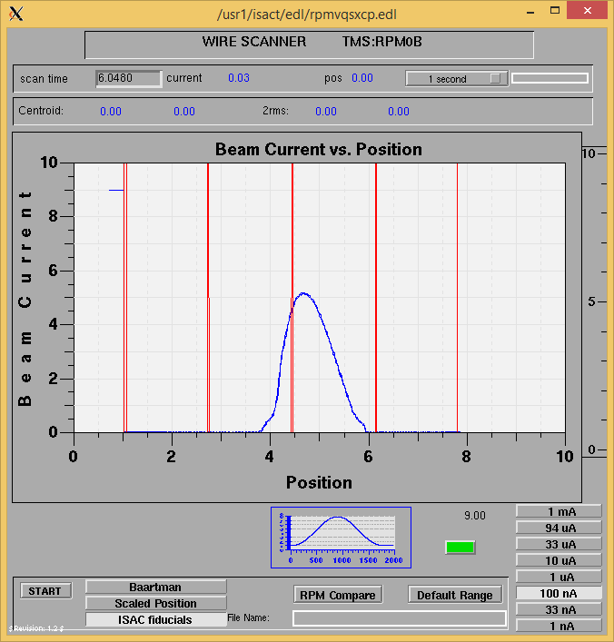

Optics Tuning

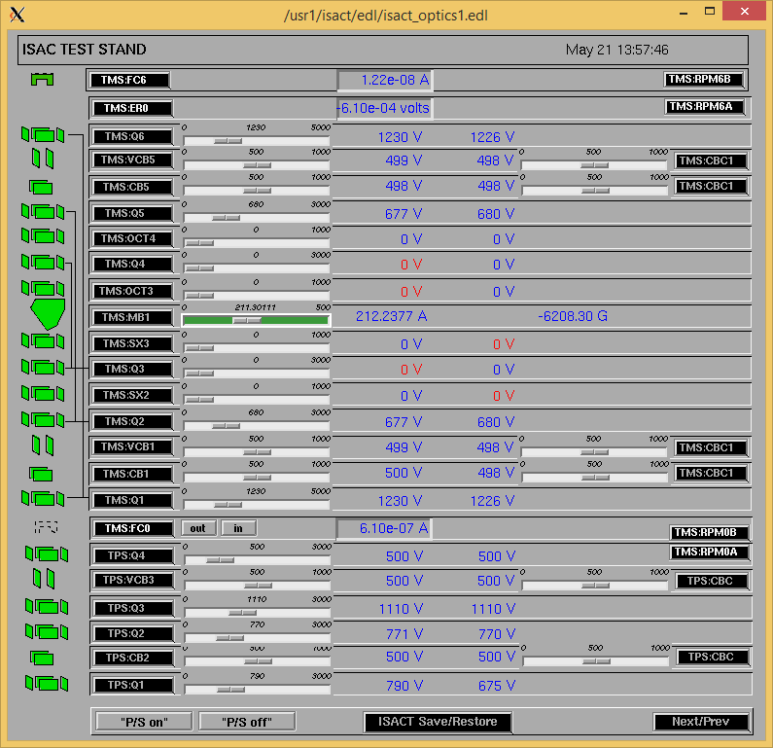

Wire Scanners RPM6A and RPM6B

Mass 47 (Mass 39 pre-calibration)

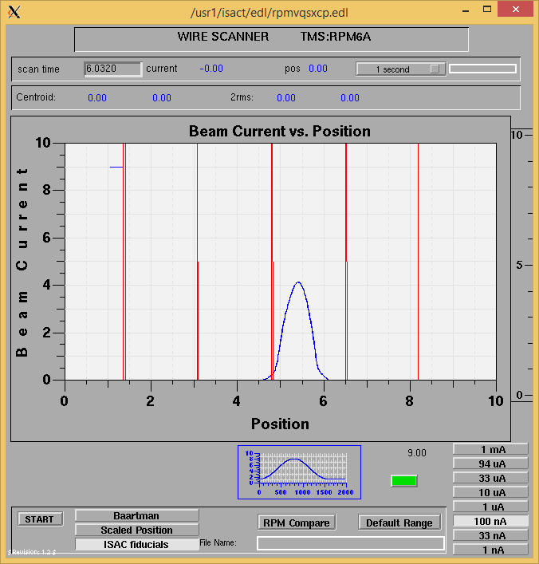

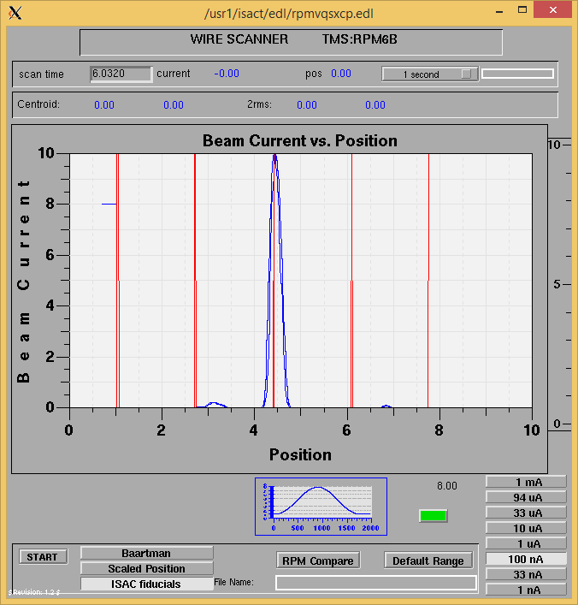

Mass 47 (Assuming mass 39 approx)

Mass Scan

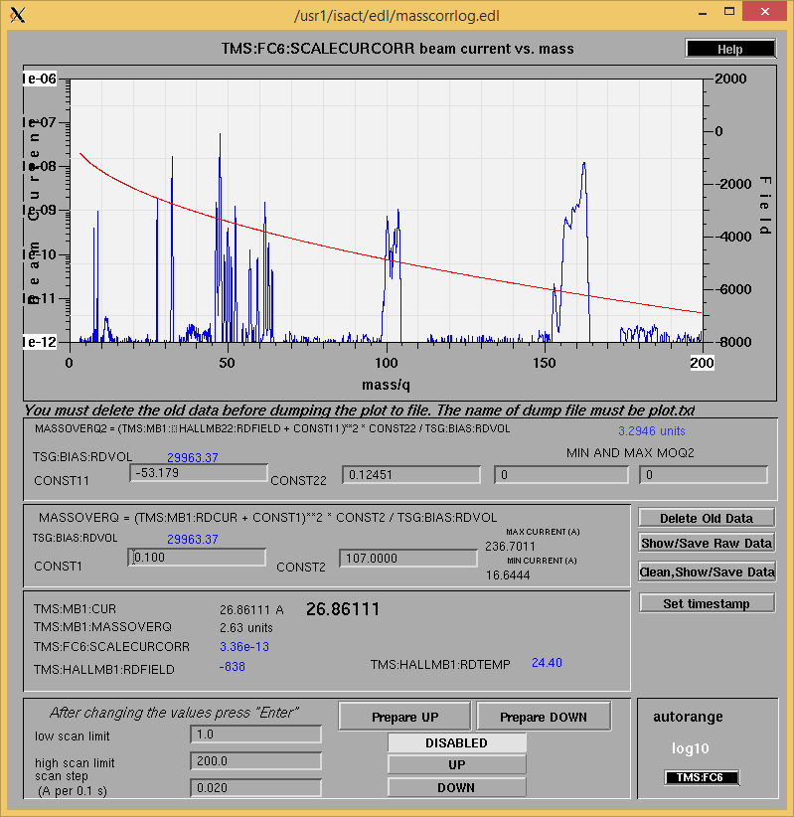http://isacwserv.triumf.ca/onlylocal/isactdata/save_restore/masscorr/2019-05-21-13-48%20ZrC%238

Pre-calibration

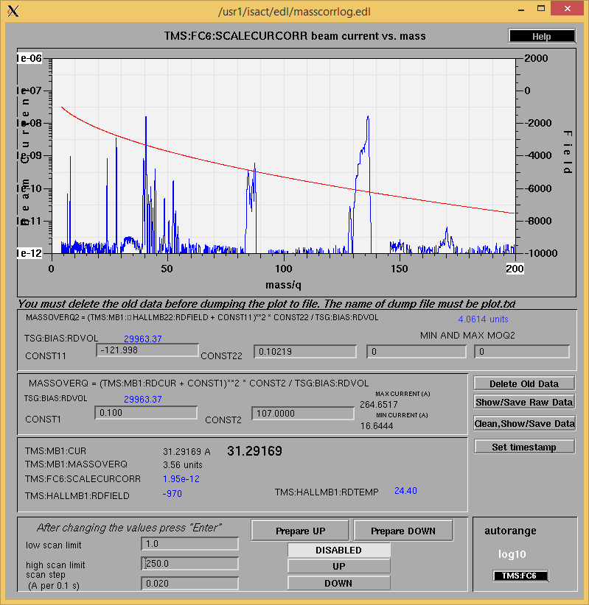 <http://isacwserv.triumf.ca/onlylocal/isactdata/save_restore/masscorr/2019-05-22-13-42%20ZrC%238>

Post calibration

Cooling Parameters

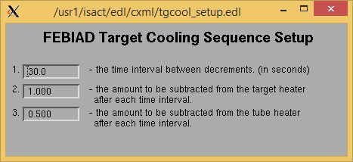

Overview Plots

Vacuum and FC0

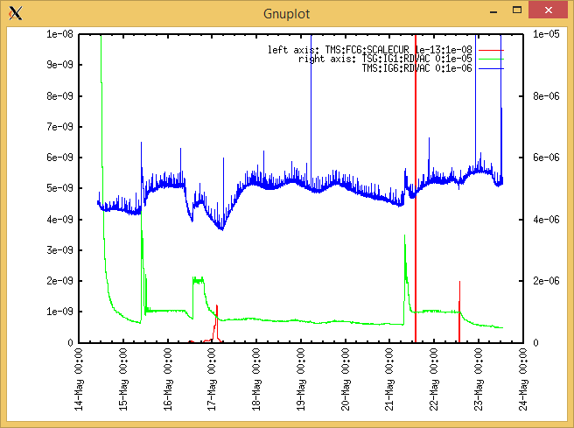

Heating, EE and BIAS

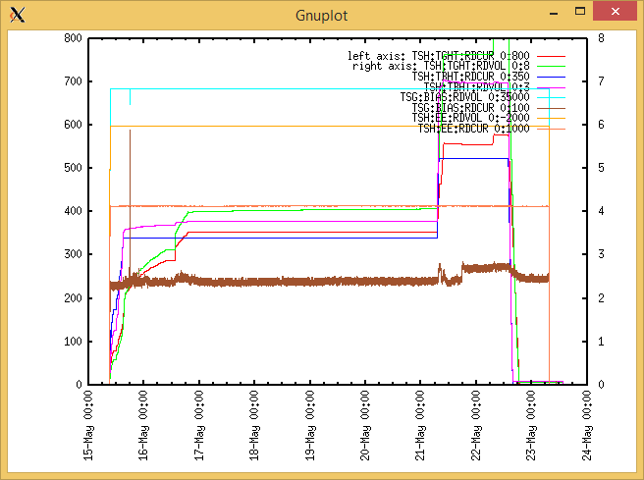

TGHT and TBHT Voltage

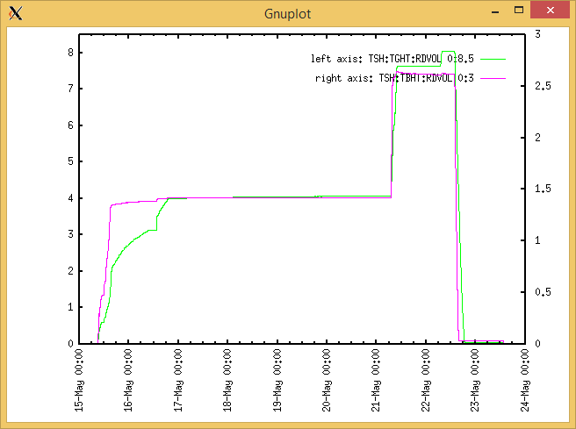

Flow and cooling water temperatures

Wednesday, May 15, 2019, 09:10:

|  |  |  |
| --- | --- | --- |
| **Device** | **Temp [C]** | **Flow [lpm]** |
| HS + MSP | 26.34 | 5.24 |
| TBHT | 26.28 | 8.23 |
| COIL + EE | 26.11 | 2.18 |
| TGHT | 26.21 | 6.44 |

RGA

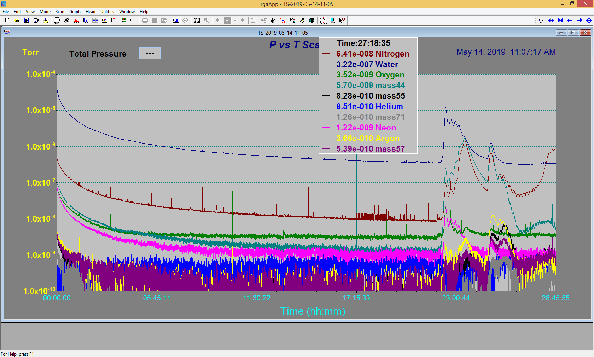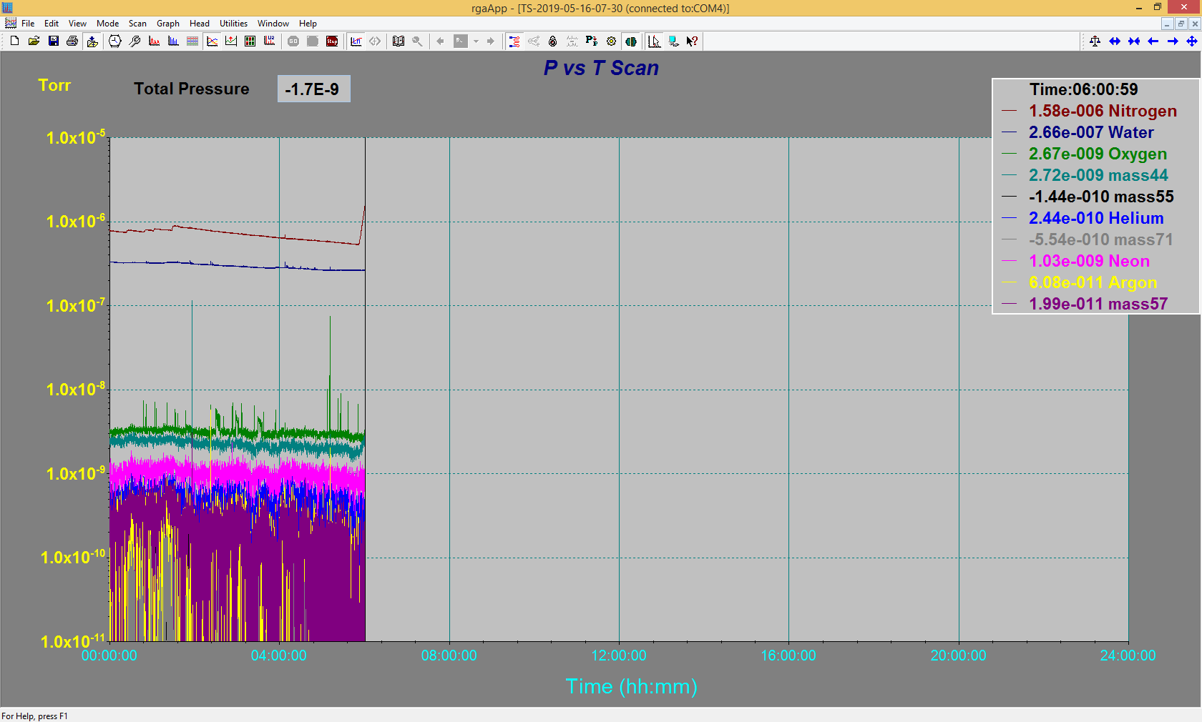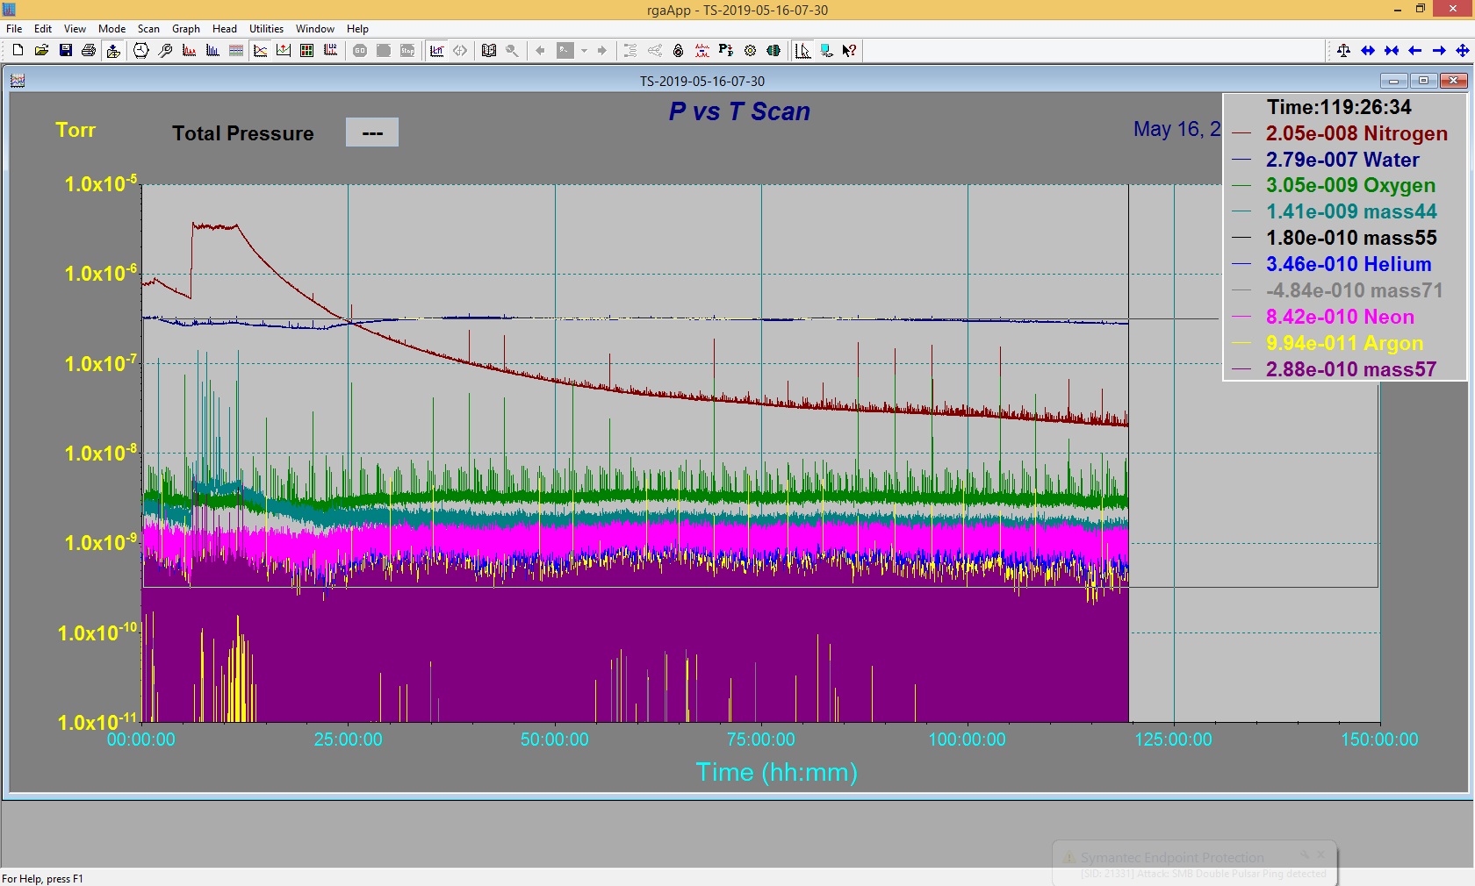

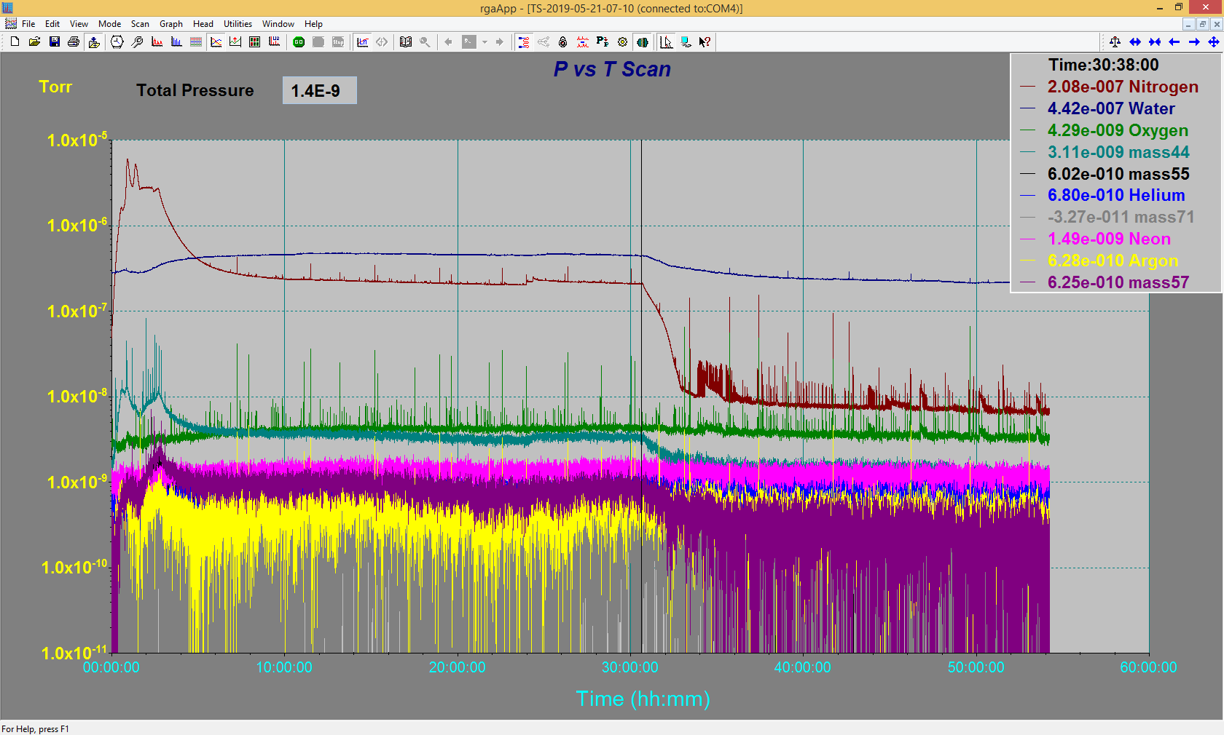

Emittance Scan

N/A