Conditioning Report

|  |  |  |
| --- | --- | --- |
| Target material and number | | Ta#58 |
| Target WO-SN | | 43044-4 |
| Operator name | | Aaron Schmidt |
|  | |  |
| Heating start date and time | | 2019-05-06 07:23 |
| BIAS | |  |
| Voltage [kV] | | 30 |
| Current [µA] | | 30 |
| Extraction Electrode (EE) | |  |
| Voltage [kV] | | 1.5 |
| Current [µA] | | 518 |
| TGHT | |  |
| Current [A] | | 578.2 |
| Voltage [V] | | 7.182 |
| TBHT | |  |
| Current [A] | | 228.9 |
| Voltage [V] | | 2.589 |
| FEBIAD ANODE | |  |
| Voltage [V] | | - |
| Current [mA] | | - |
| FEBIAD COIL | |  |
| Current [A] | | - |
| Voltage [V] | | - |
| Flow and Temperature HS + MSP | | 25.8 |
| Flow [lpm] | | 7.78 |
| Temperature increase [C] | | 1.6 |
| FC6 currents [A] | | 8.65E-10 |
| SIS | 7Li | 1.04E-10 |
| FEBIAD | 20Ne | - |
| SIS | 23Na | 9.86E-10 |
| SIS | 39K | 7.49E-10 |
| SIS | 85Rb | 2.79E-10 |
| SIS | 133Cs | 8.61E-10 |
| Heating end date and time | | 2019-05-07 12:45 |

Comments

Noticed a discrepancy on the mass scan. The mass peaks appear to have moved further along the mass / q. They are identical to what we used to see on previous scans, just further down the line. A calibration / scaling may be appropriate.

|  |  |  |  |
| --- | --- | --- | --- |
| Element | Mass | Mass/q | Beam Current |
| Lithium | 6.941 | 7.508 | 1.04401e-10 |
| Sodium | 22.9897 | 27.556 | 9.85687e-10 |
| Mass 27 (Al) | 26.9815 | 32.2943 | 2.97834e-08 |
| Potassium | 39.0983 | 46.3293 | 7.49146e-10 |
|  | (peak 2) | 47.6191 | 1.568e-10 |
| Rubidium | 85.4678 | 100.355 | 2.79327e-10 |
|  | (peak 2) | 102.904 | 1.04431e-10 |
| Cesium | 132.9055 | 156.6 | 8.6103e-10 |
|  | (peak 2) | 162.532 | 2.4408e-10 |

The discrepancy appears to get larger the further we move along the masses. (The magnet was calibrated at a later date – May 22)

Plots

8h Vacuum Pump Down

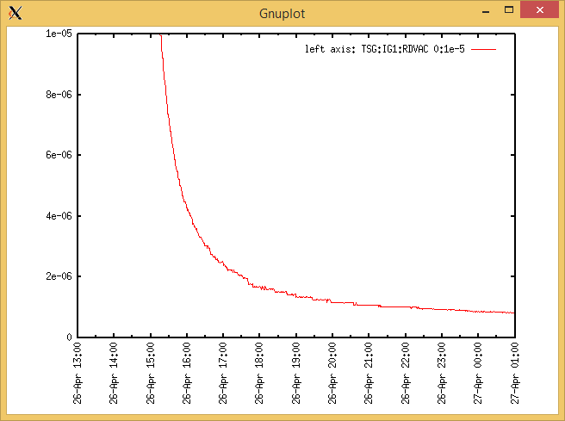

Target Heat Sequence Setup

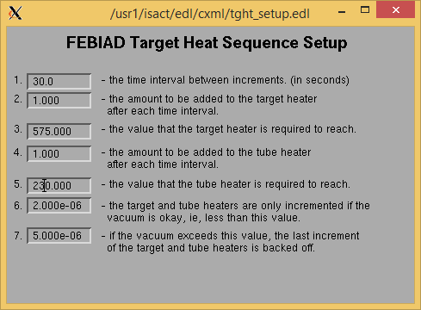

Source Tuning

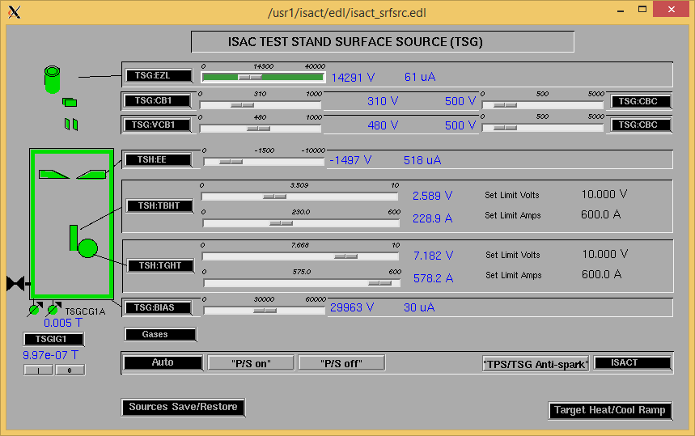

Wire Scanners RPM0A and RPM0B

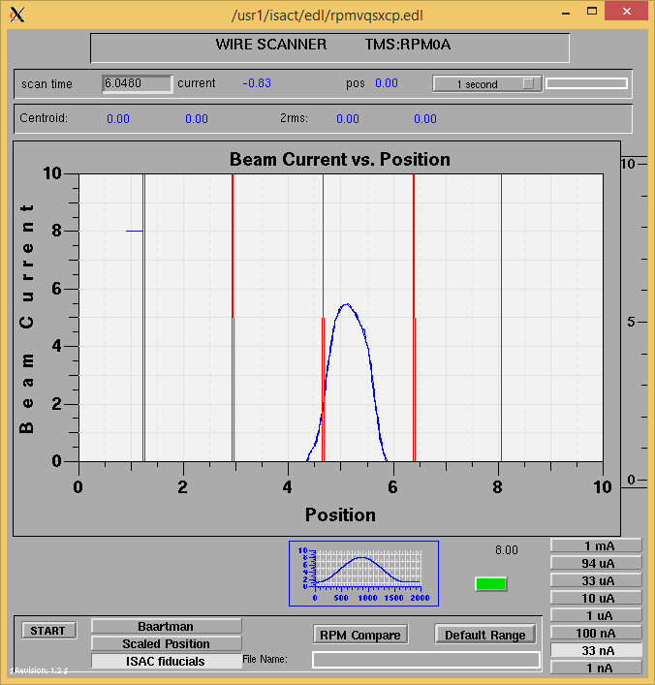

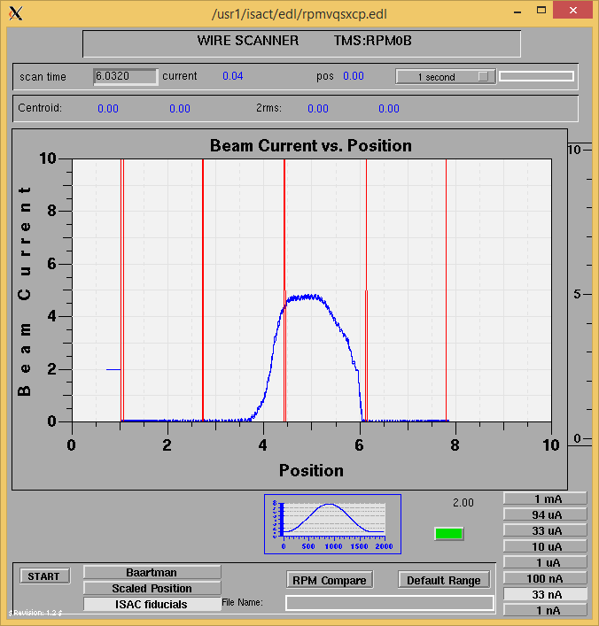

Optics Tuning

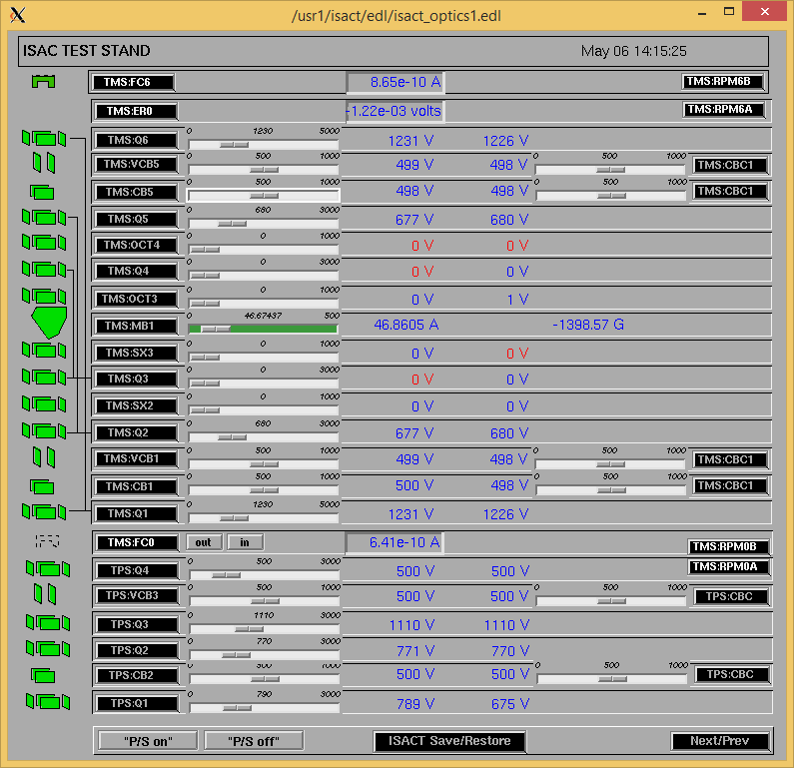

Wire Scanners RPM6A and RPM6B

Mass 8

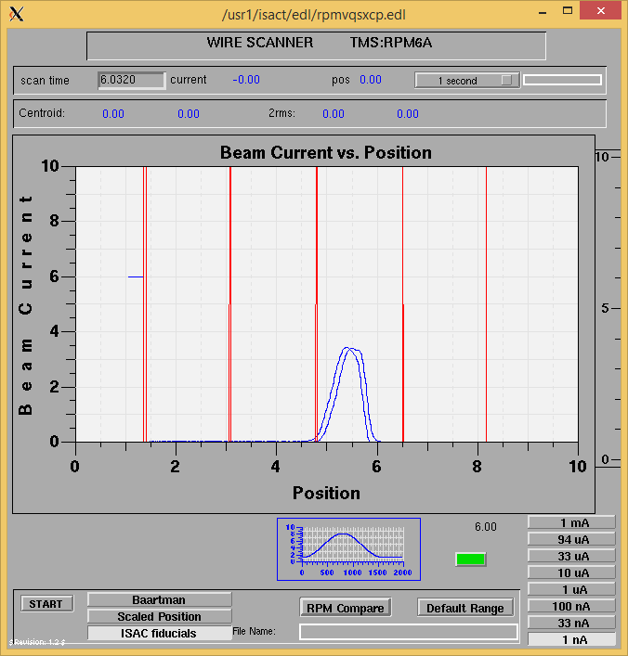

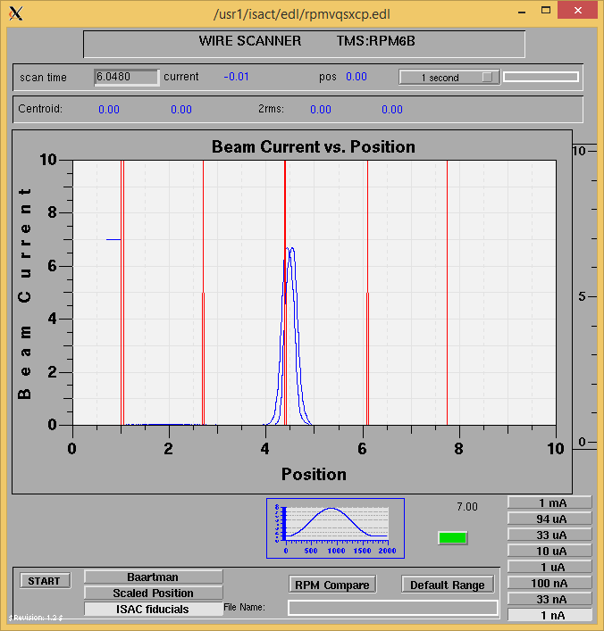

Mass 8

Mass Scan

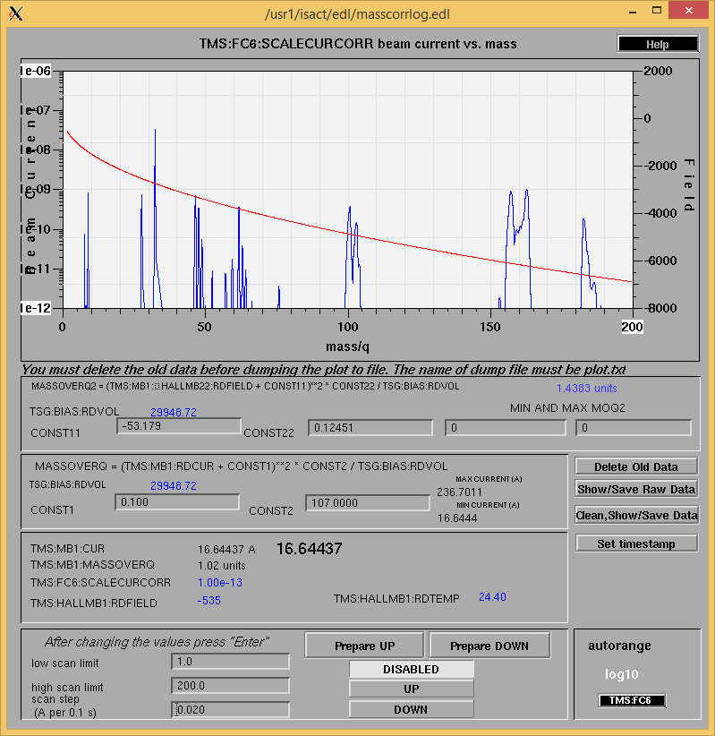

<http://isacwserv.triumf.ca/onlylocal/isactdata/save_restore/masscorr/2019-05-06-14-07%20Ta%2358>

Cooling Parameters

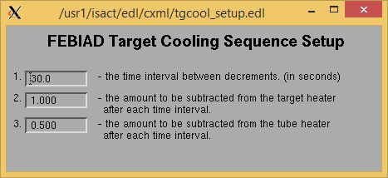

Overview Plots

Vacuum and FC0

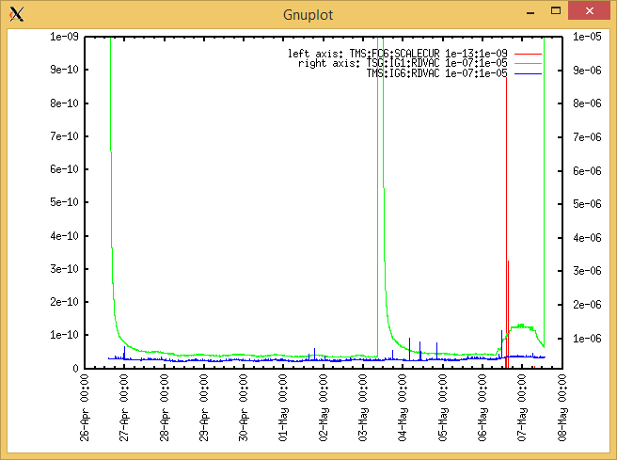

Heating, EE and BIAS

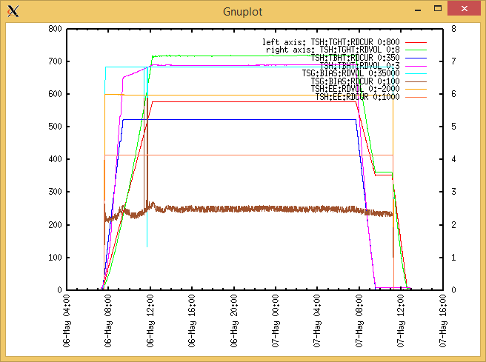

TGHT and TBHT Voltage

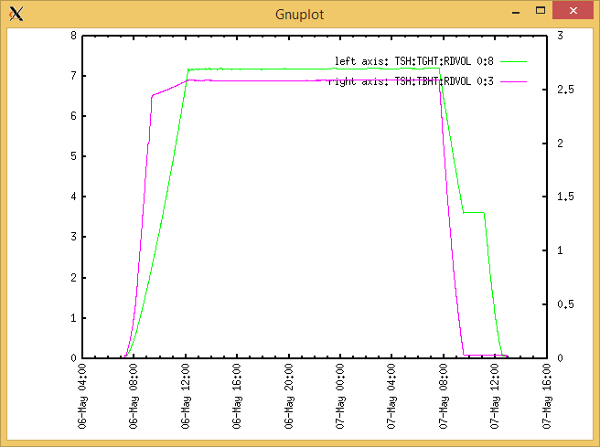

Flow and cooling water temperatures

Monday, May 06, 2019, 07:57: Reset DaqPro. Ref data sheet.

|  |  |  |
| --- | --- | --- |
| **Device** | **Temp [C]** | **Flow [lpm]** |
| HS + MSP | 25.8 | 5.52 |
| TBHT | 25.7 | 7.93 |
| COIL + EE | 25.6 | 1.92 |
| TGHT | 25.70 | 6.29 |

Monday, May 06, 2019, 14:48 :

|  |  |  |
| --- | --- | --- |
| **Device** | **Temp [C]** | **Flow [lpm]** |
| HS + MSP | 27.4 | 7.78 |
| TBHT | 27.0 | 10.30 |
| COIL + EE | 26.8 | 3.01 |
| TGHT | 27.1 | 7.09 |

RGA

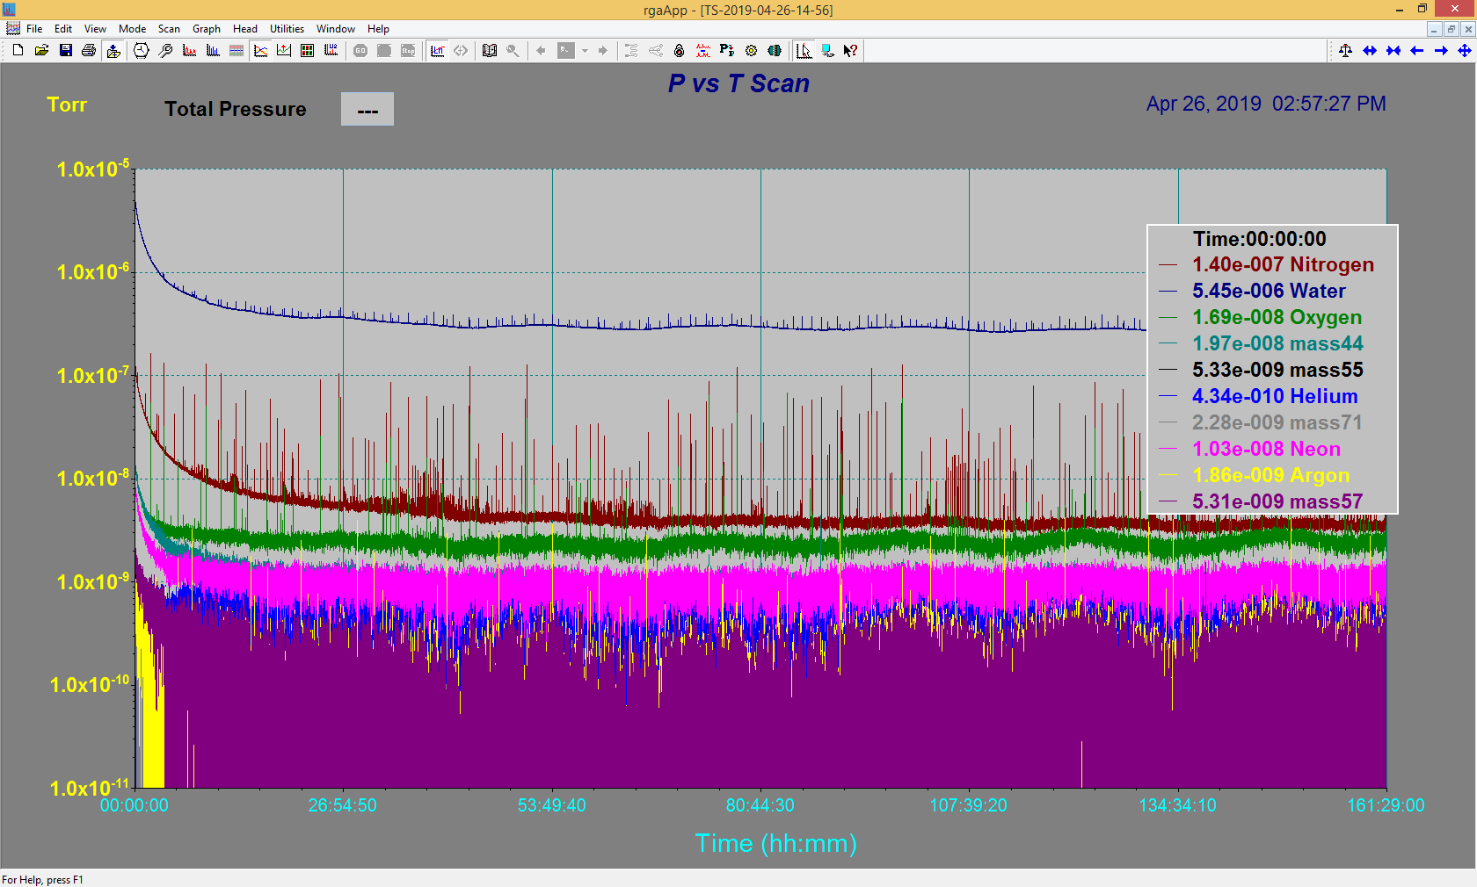

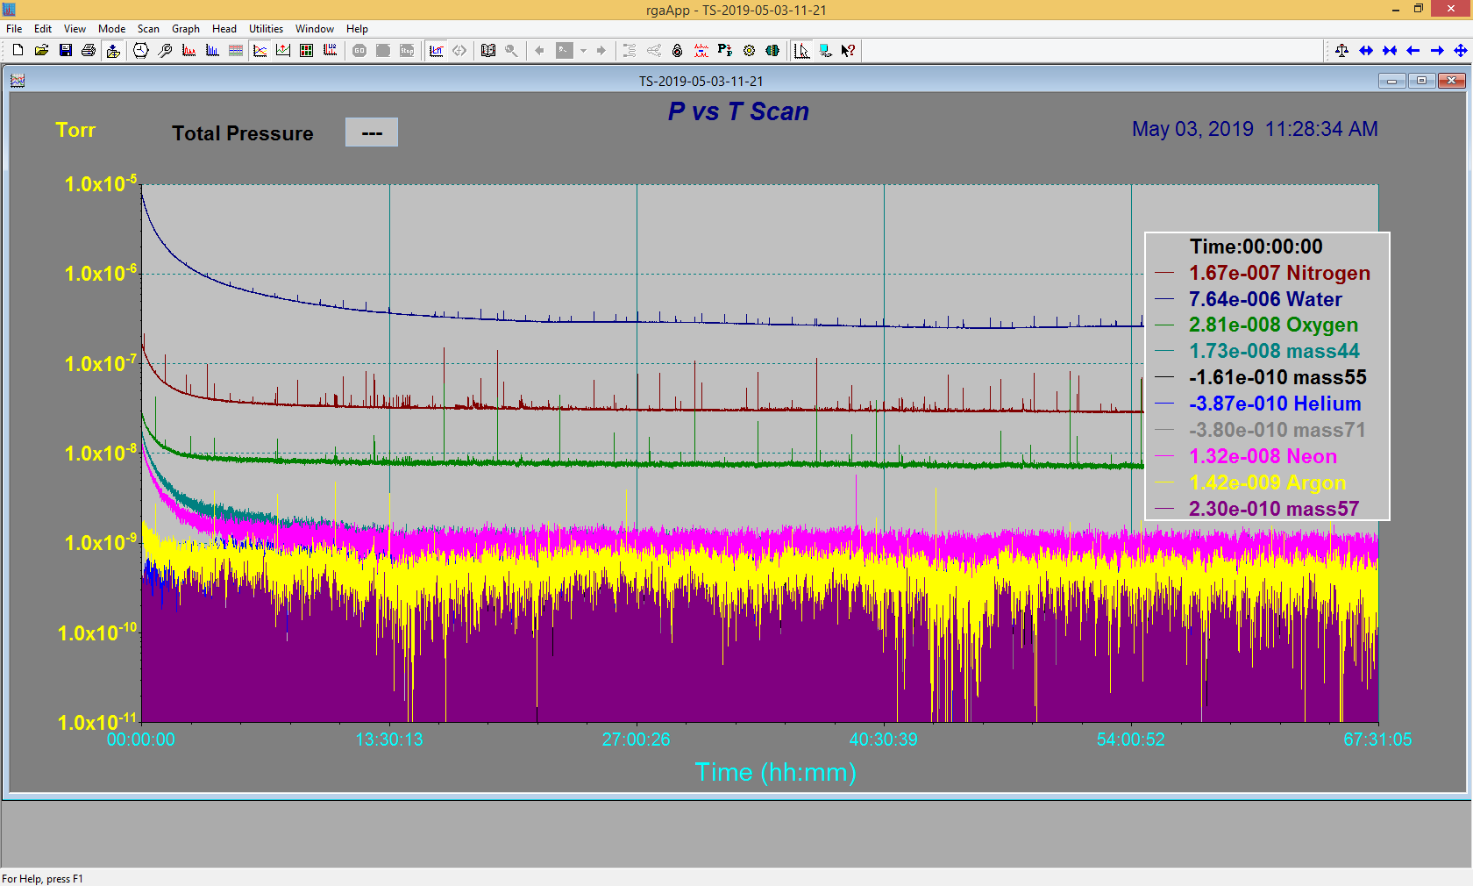

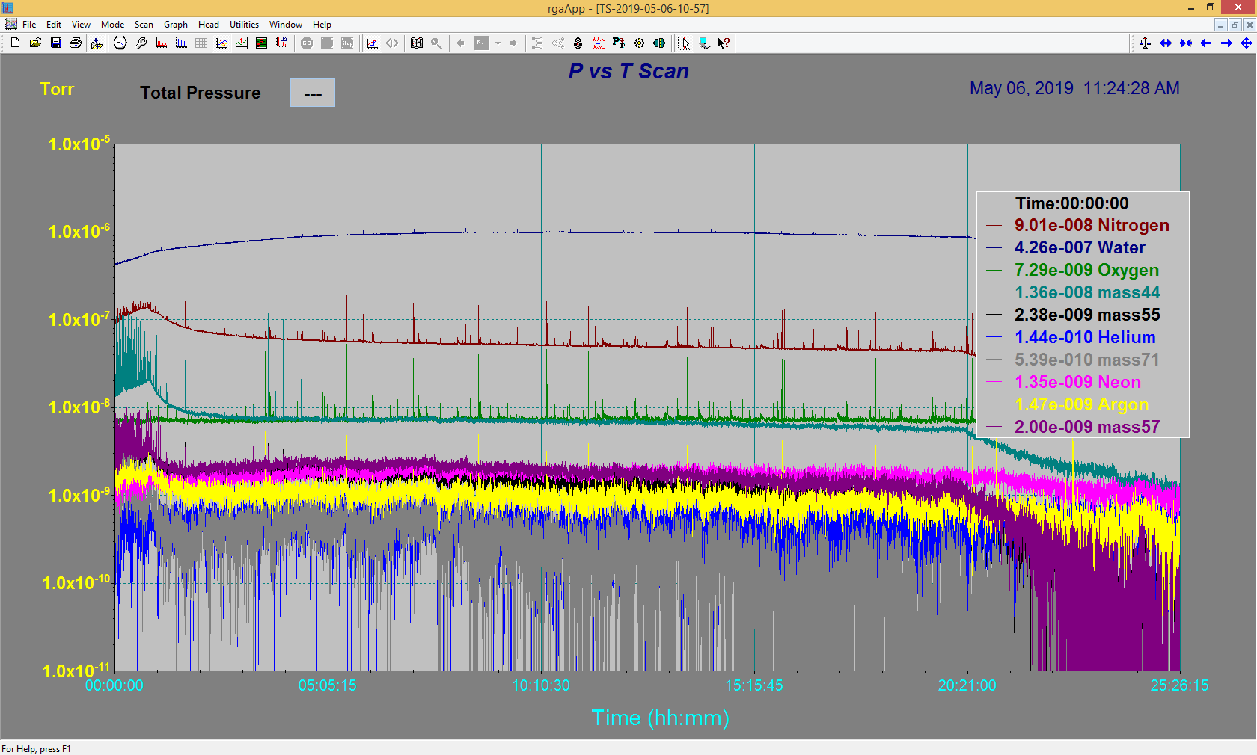

Emittance Scan

N/A