Conditioning Report

|  |  |  |
| --- | --- | --- |
| Target material and number | | Ta#57 |
| Target WO-SN | | 41177-3 |
| Operator name | | Aaron Schmidt |
|  | |  |
| Heating start date and time | | 2018-09-13 07:37 |
| BIAS | |  |
| Voltage [kV] | | 30 |
| Current [µA] | | 48 |
| Extraction Electrode (EE) | |  |
| Voltage [kV] | | 1.5 |
| Current [µA] | | 508 |
| TGHT | |  |
| Current [A] | | 582 |
| Voltage [V] | | 6.96 |
| TBHT | |  |
| Current [A] | | 229 |
| Voltage [V] | | 2.315 |
| FEBIAD ANODE | |  |
| Voltage [V] | | - |
| Current [mA] | | - |
| FEBIAD COIL | |  |
| Current [A] | | - |
| Voltage [V] | | - |
| Flow and Temperature HS + MSP | | 33.7 |
| Flow [lpm] | | 3.12 |
| Temperature increase [C] | | 9.1 |
| FC6 currents [A] | | 1.63e-07 |
| SIS | 7Li | 9.2e-09 |
| FEBIAD | 20Ne | - |
| SIS | 23Na | 3.49e-09 |
| SIS | 39K | 7.50e-09 |
| SIS | 85Rb | 4.12e-09 |
| SIS | 133Cs | 1.09e-08 |
| Heating end date and time | | 2018-09-17 19:35 |

Comments

8h Vacuum Pump Down

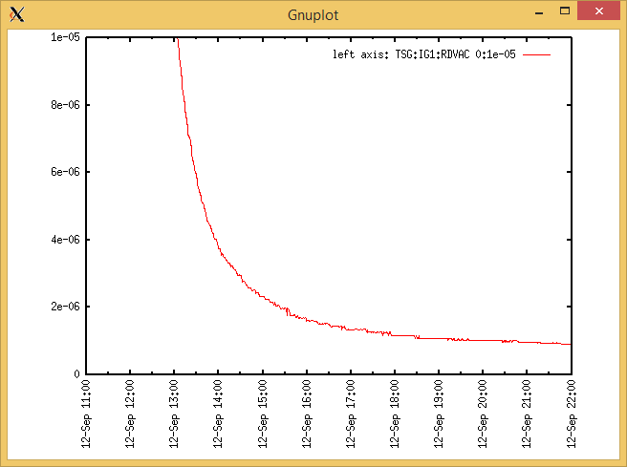

Target Heat Sequence Setup

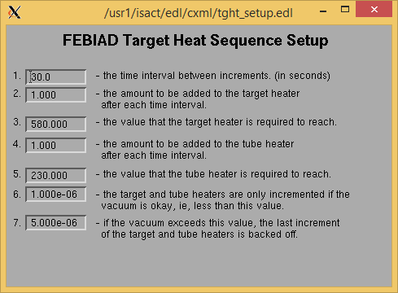

Source Tuning

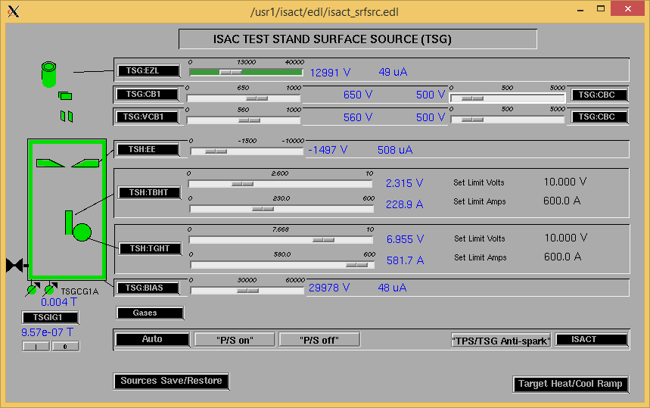

Wire Scanners RPM0A and RPM0B

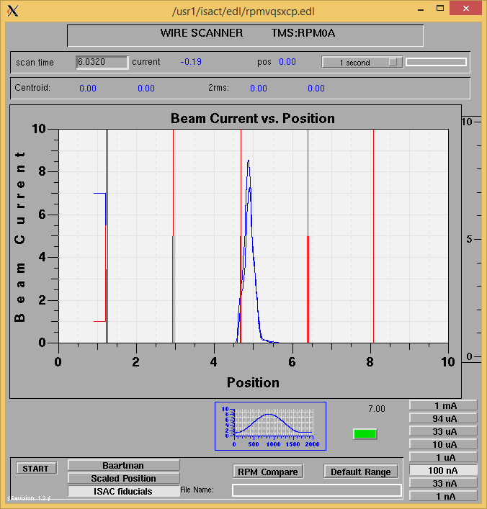

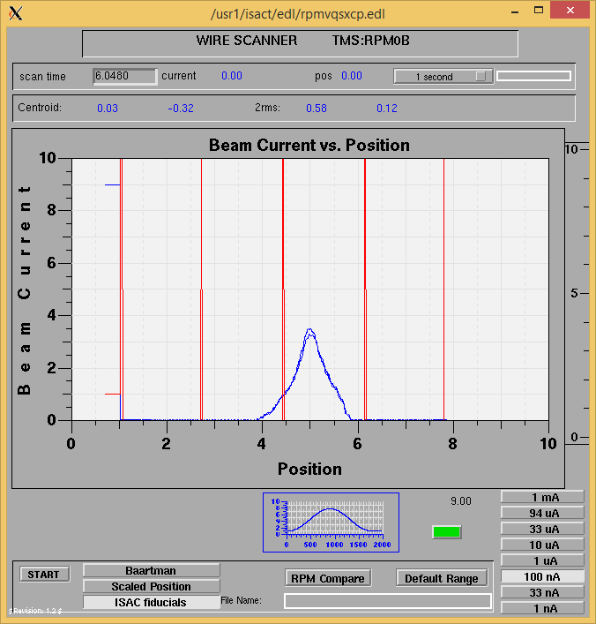

Optics Tuning

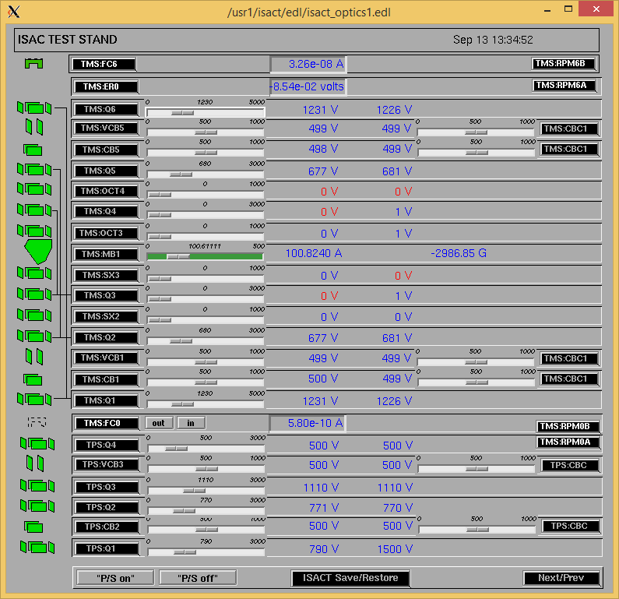

Mass 38

Wire Scanners RPM6A and RPM6B

Mass 38

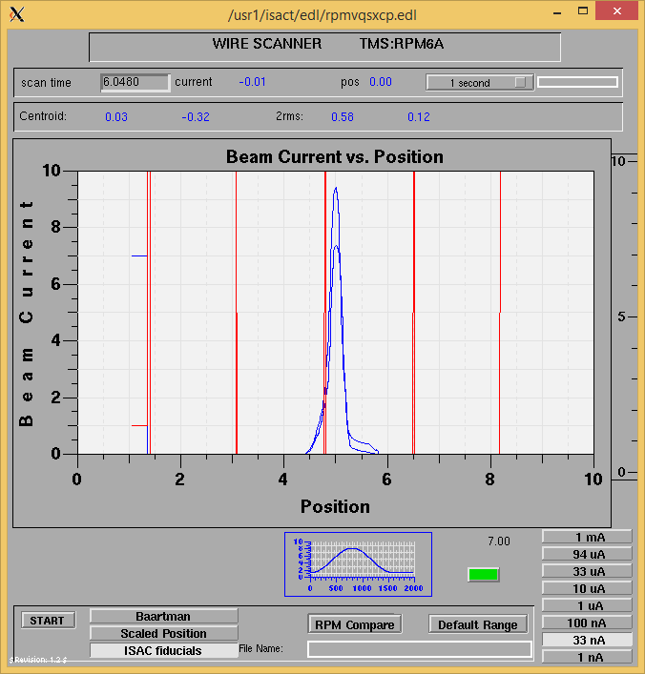

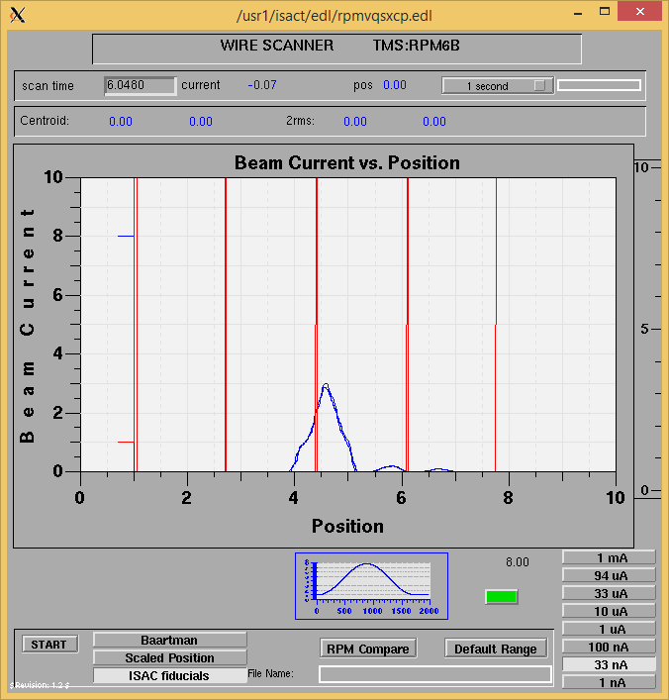

Mass 38

Mass Scan

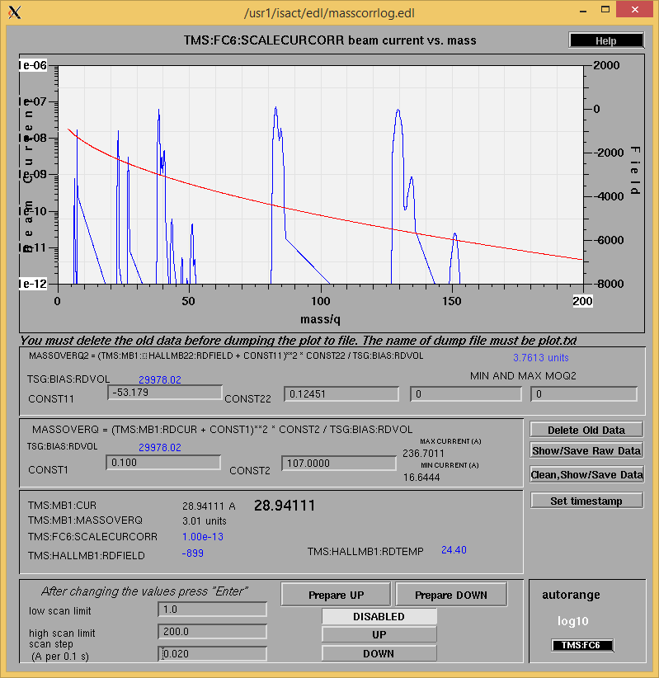

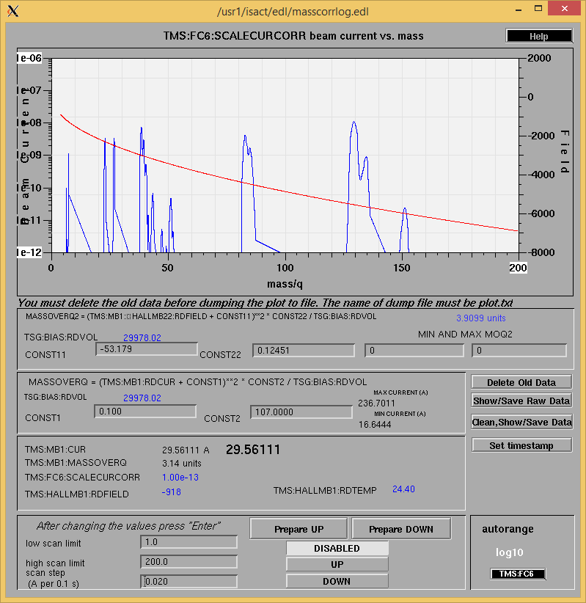

<http://isacwserv.triumf.ca/onlylocal/isactdata/save_restore/masscorr/2018-09-13-14-21%20Ta%2357>

Cooling Parameters

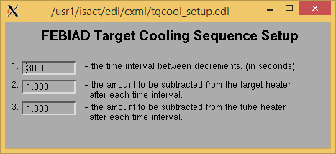

Overview Plots

Vacuum and FC0

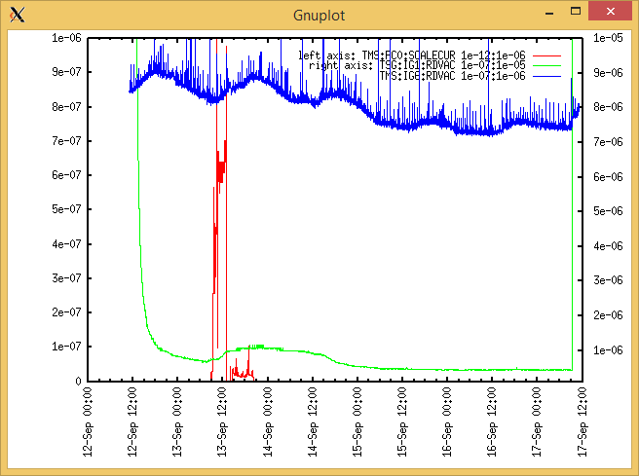

Heating, EE and BIAS

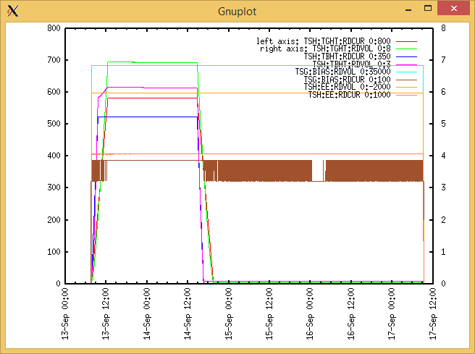

TGHT and TBHT Voltage

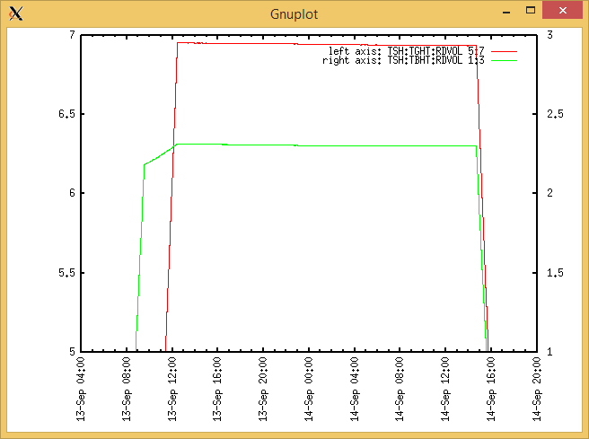

Flow and cooling water temperatures

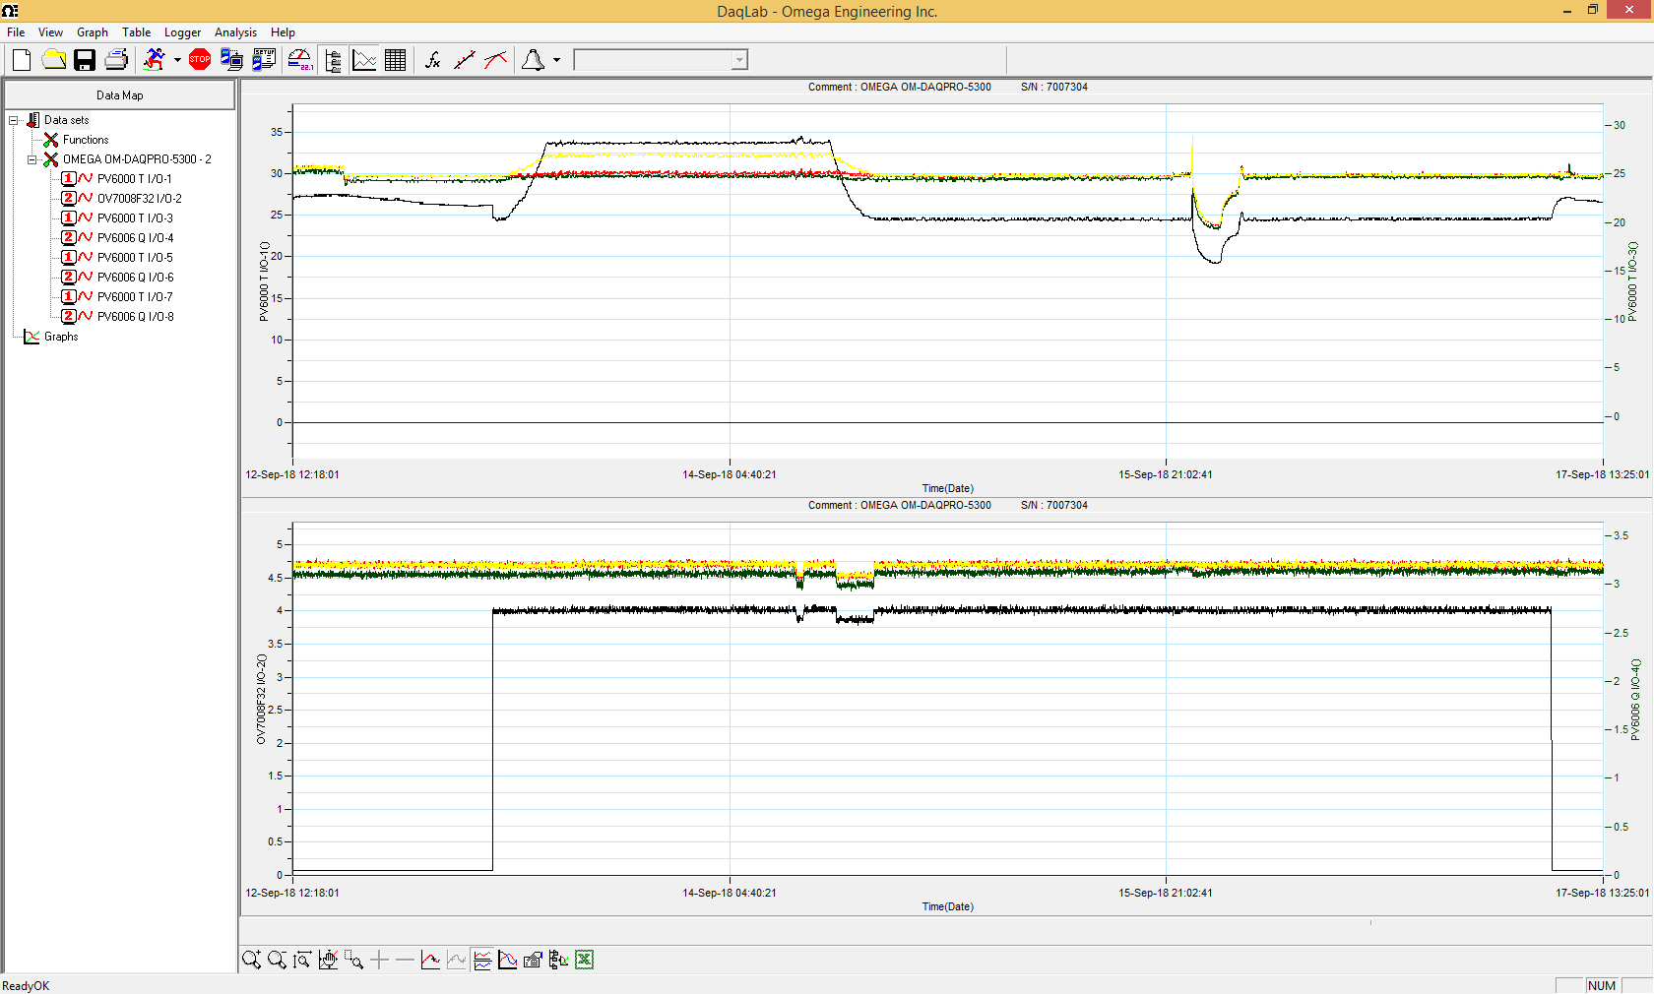

RGA

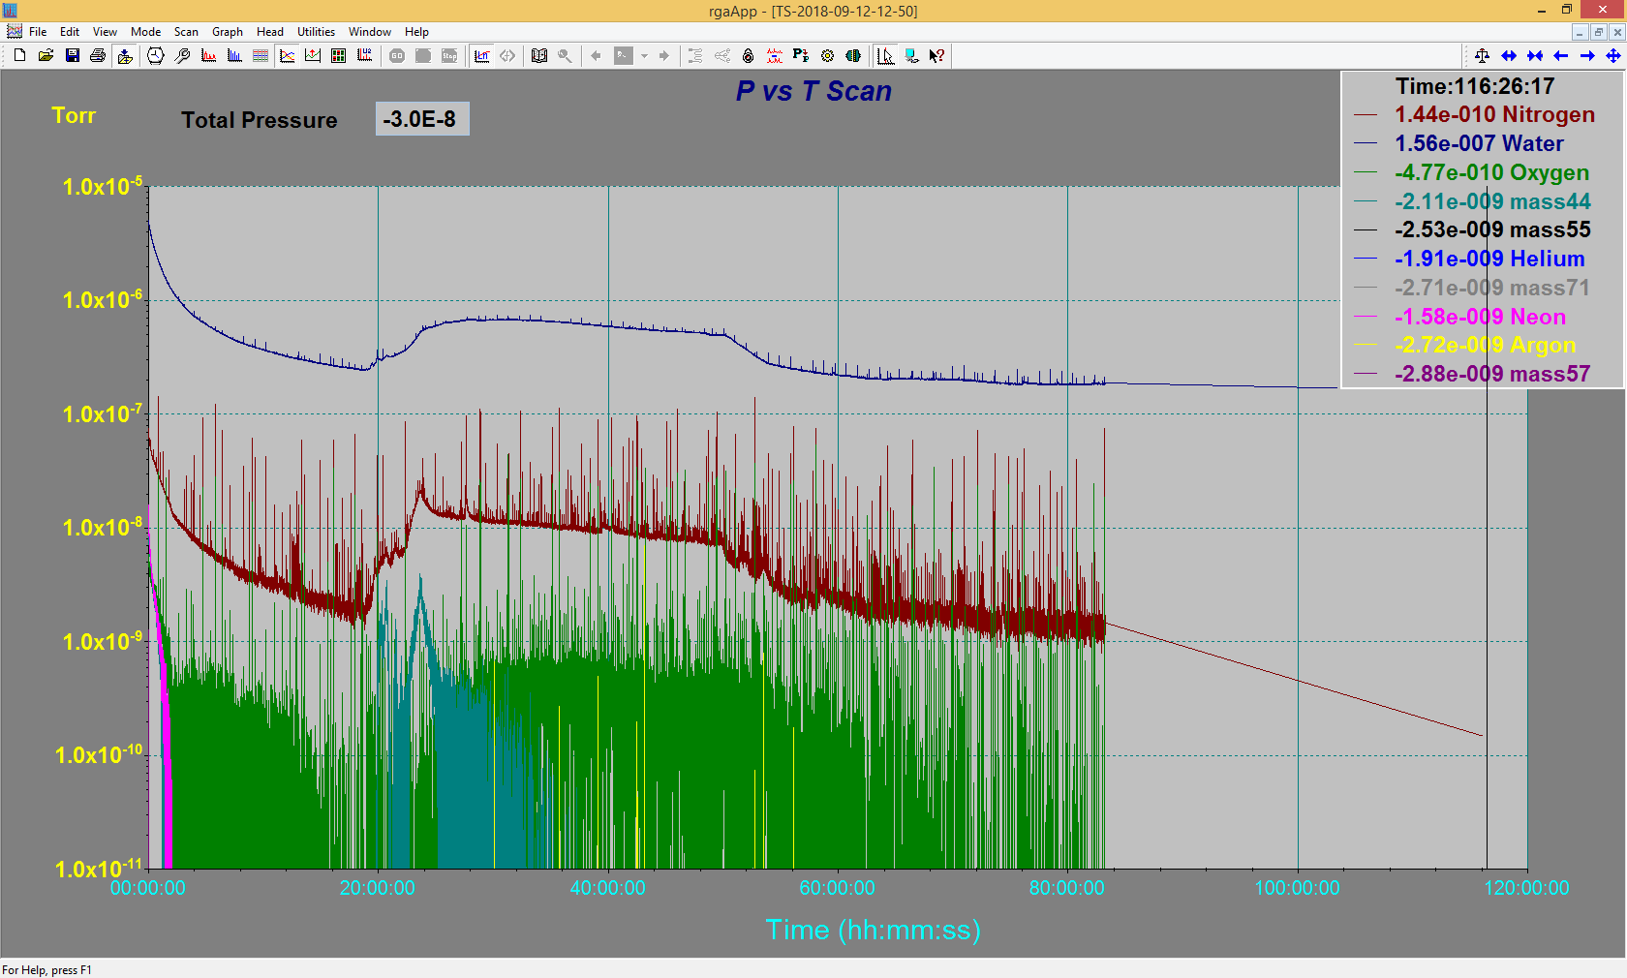

Emittance Scan

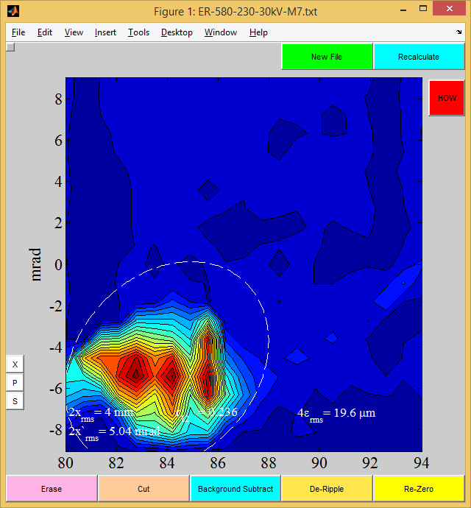

Mass 7

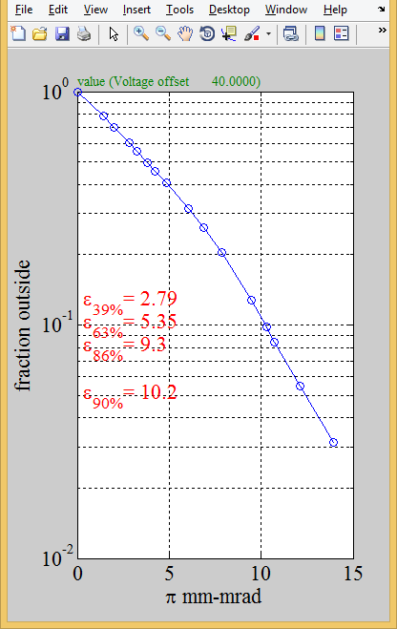

Mass 7

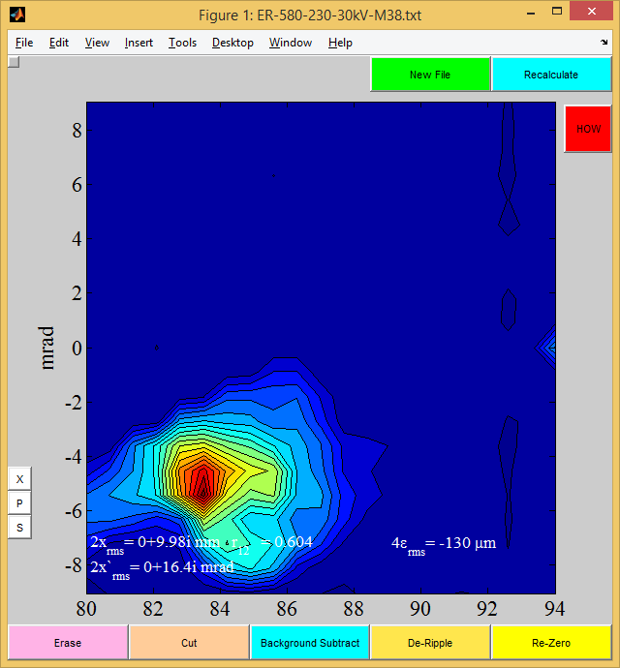

Mass 38

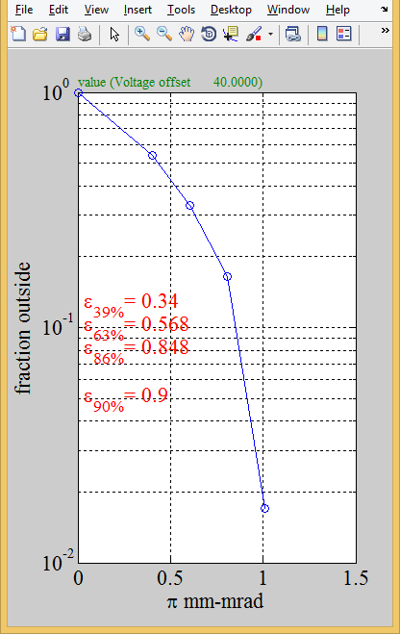

Mass 38

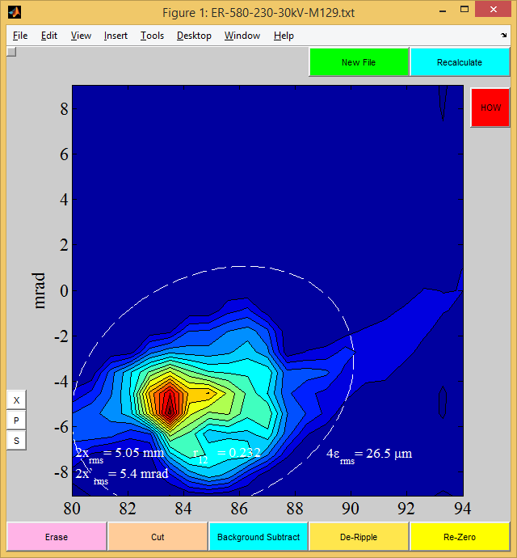

Mass 129

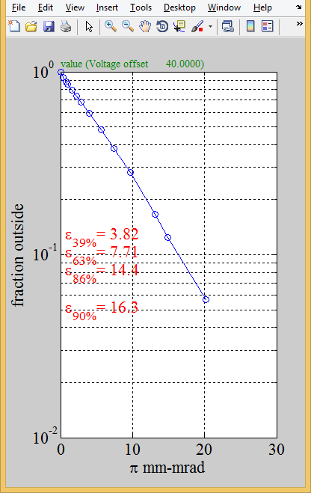

Mass 129