Conditioning Report

|  |  |  |
| --- | --- | --- |
| Target material and number | | Nb#08 |
| Target WO-SN | | 38817-2 |
| Operator name | | Aaron Schmidt |
|  | |  |
| Heating start date and time | | 2018-03-19 06:51 |
| BIAS | |  |
| Voltage [kV] | | 30 |
| Current [µA] | | 40 |
| Extraction Electrode (EE) | |  |
| Voltage [kV] | | 1.5 |
| Current [µA] | | 518 |
| TGHT | |  |
| Current [A] | | 582 |
| Voltage [V] | | 5.6 |
| TBHT | |  |
| Current [A] | | 208 |
| Voltage [V] | | 1.9 |
| FEBIAD ANODE | |  |
| Voltage [V] | | - |
| Current [mA] | | - |
| FEBIAD COIL | |  |
| Current [A] | | - |
| Voltage [V] | | - |
| Flow and Temperature HS + MSP | | 21.6 |
| Flow [lpm] | | 3.82 |
| Temperature increase [C] | | 7.4 |
| FC6 currents [A] | | 1.90e-06 |
| SIS | 7Li | 7.73e-08 |
| FEBIAD | 20Ne | - |
| SIS | 23Na | 2.32E-08 |
| SIS | 39K | 5.32E-08 |
| SIS | 85Rb | 1.62E-09 |
| SIS | 133Cs | 3.96E-09 |
| Heating end date and time | | 2018-03-21 11:00 |

Comments

*TMS:Q5 & TMS:Q2 had issues during the run and required repair.

8h Vacuum Pump Down

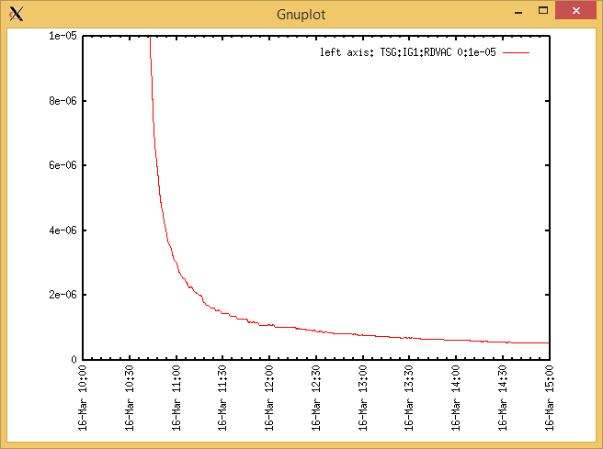

Target Heat Sequence Setup

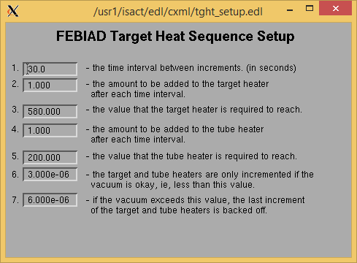

Source Tuning

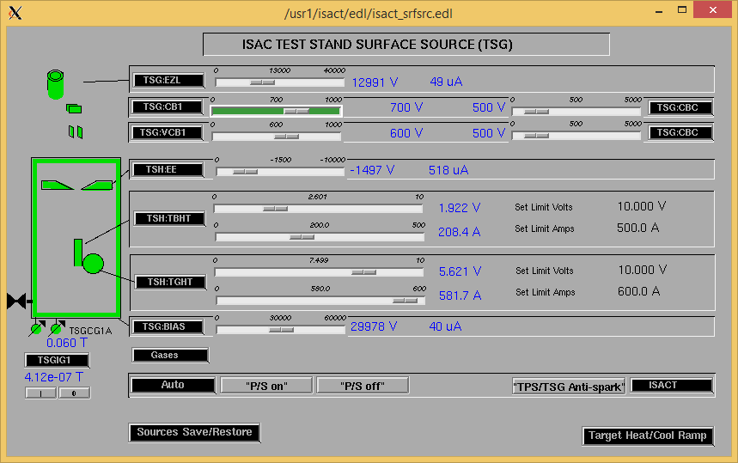

Wire Scanners RPM0A and RPM0B

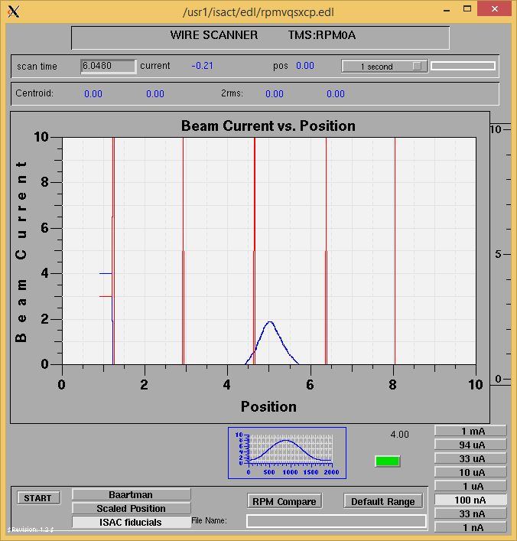

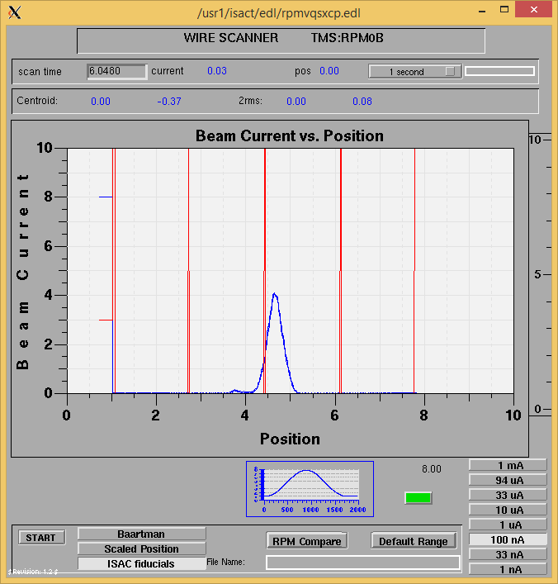

Optics Tuning

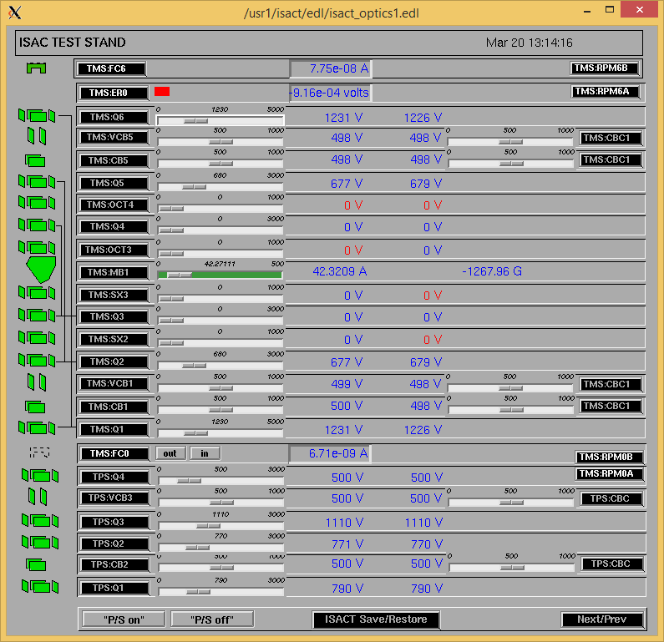

Mass 7

Wire Scanners RPM6A and RPM6B

Mass 7

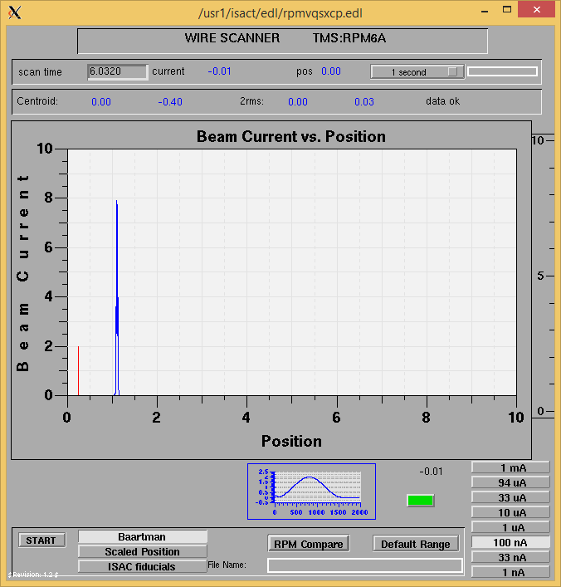

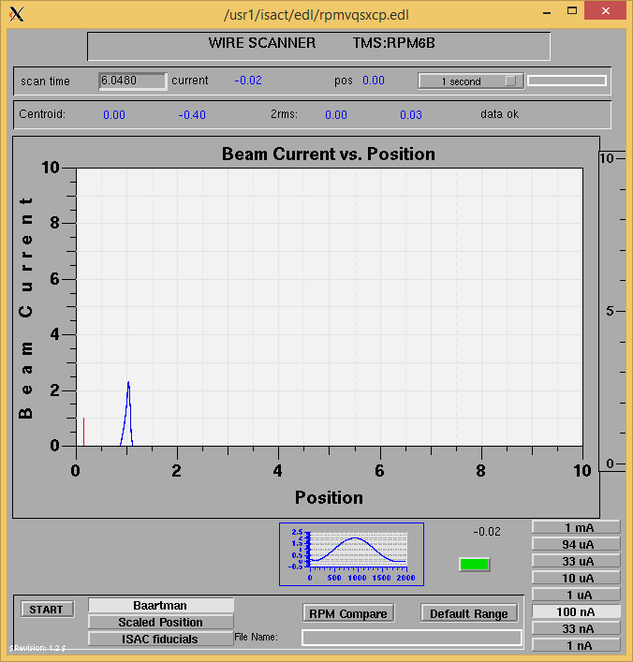

Mass 7

Mass Scan

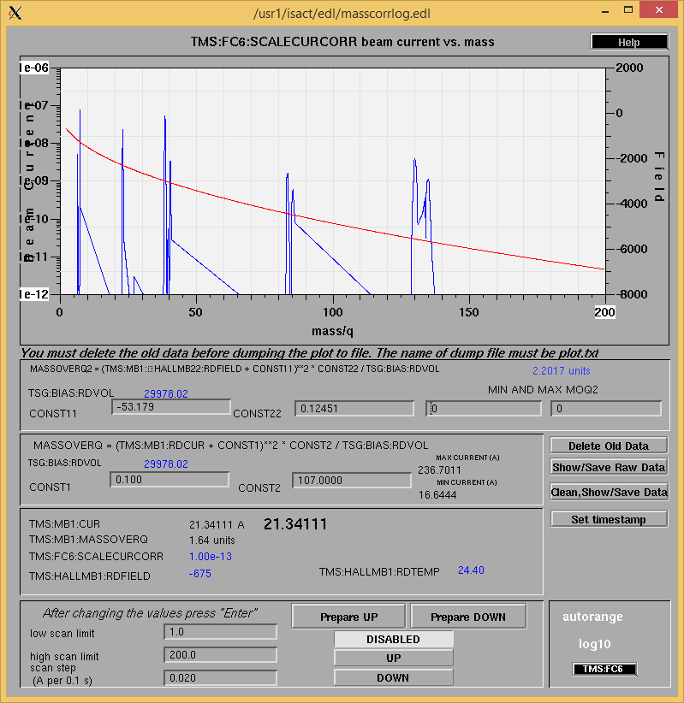

<http://isacwserv.triumf.ca/onlylocal/isactdata/save_restore/masscorr/2018-03-20-13-10%20Nb%2308>

Cooling Parameters

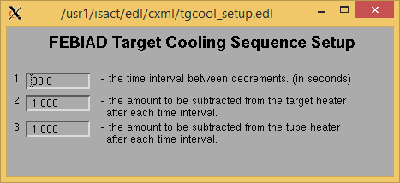

Overview Plots

Vacuum and FC0

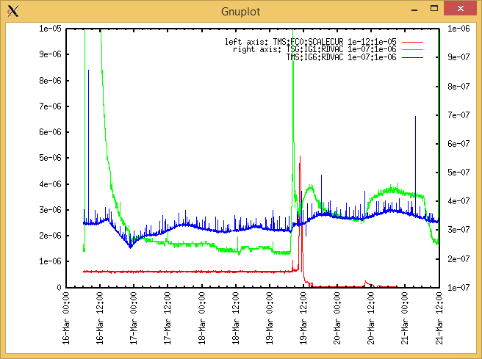

Heating, EE and BIAS

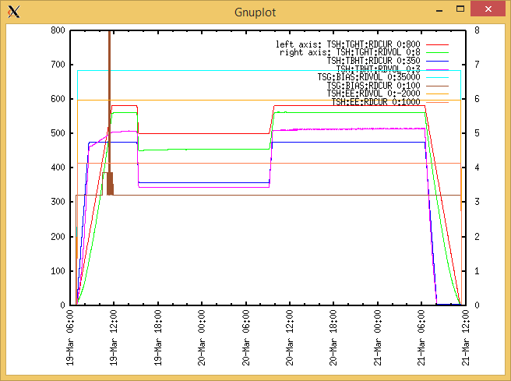

TGHT and TBHT Voltage

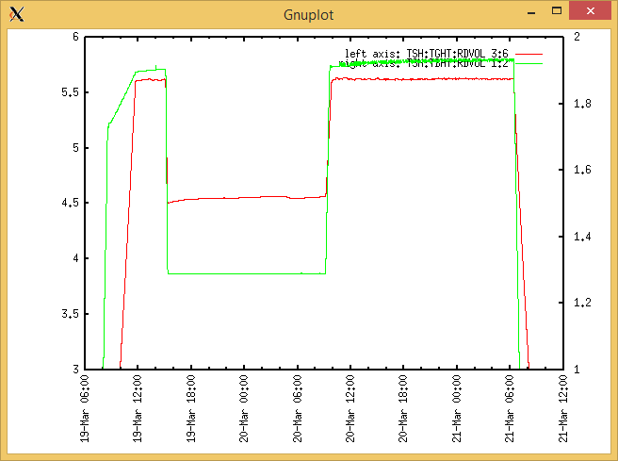

Flow and cooling water temperatures

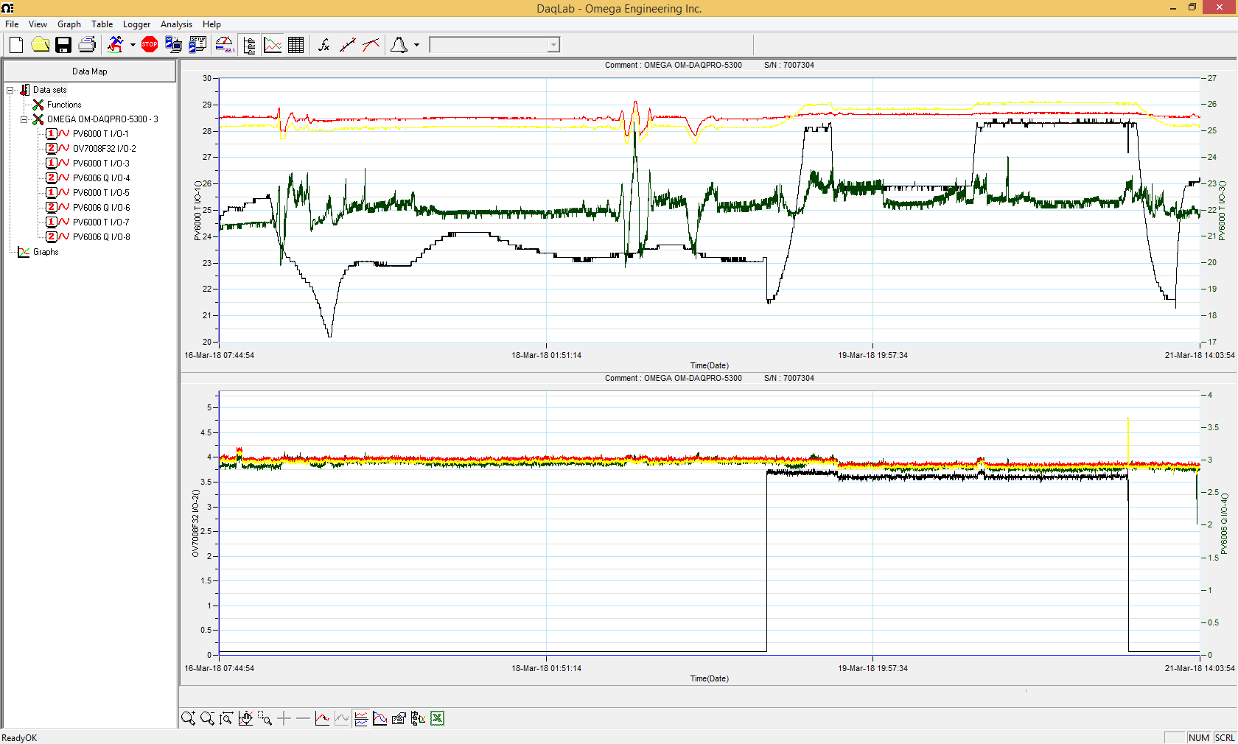

RGA

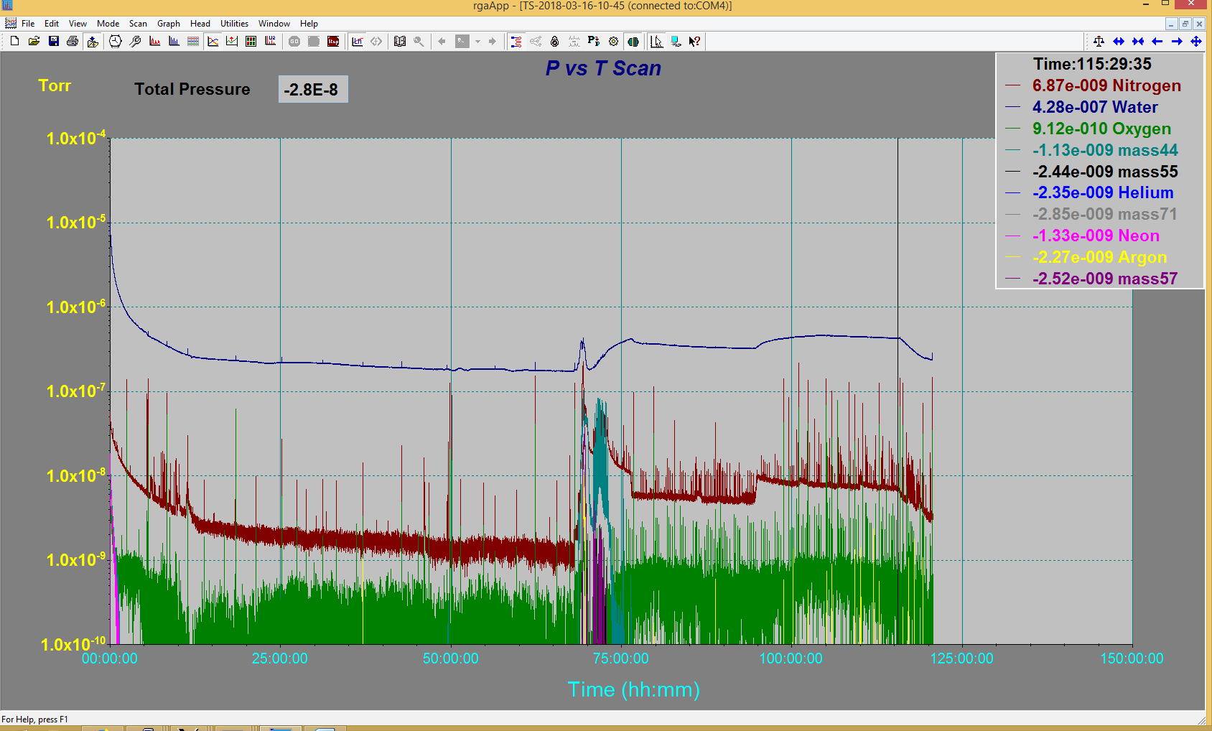

Emittance Scan

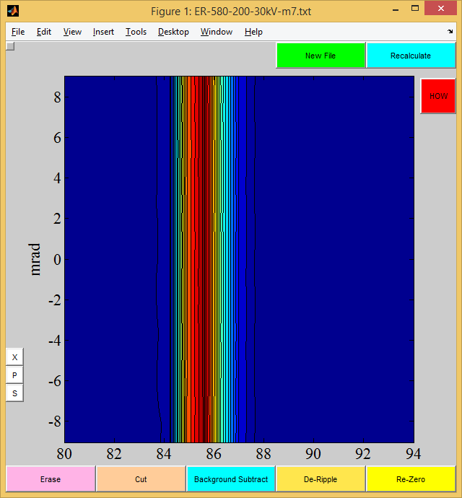

Mass 7

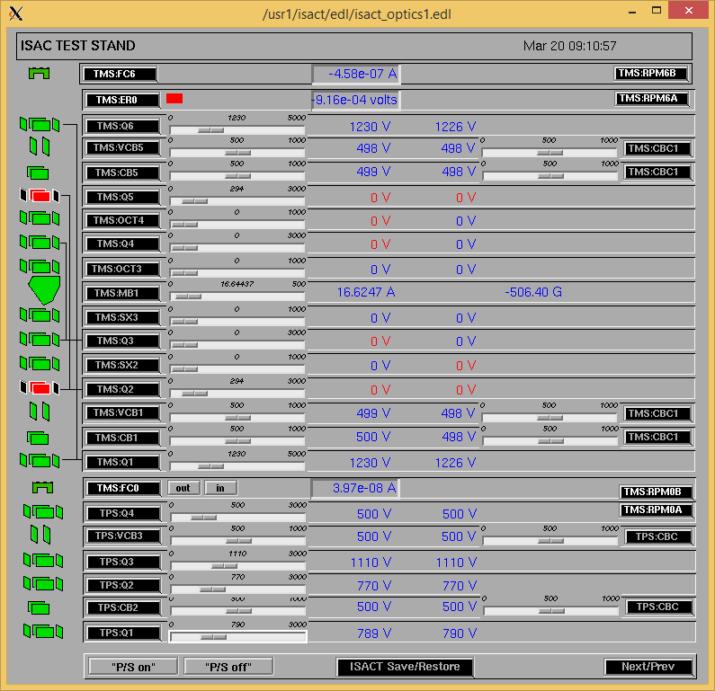

Controller Q5 & Q2 require repair. (Repaired after)