Conditioning Report

|  |  |  |
| --- | --- | --- |
| Target material and number | | nSiC#1 |
| Target WO-SN | | 43044-1 |
| Operator name | | Aaron Schmidt |
|  | |  |
| Heating start date and time | | 2018-09-06 07:30 |
| BIAS | |  |
| Voltage [kV] | | 30 |
| Current [µA] | | 48 |
| Extraction Electrode (EE) | |  |
| Voltage [kV] | | 1.5 |
| Current [µA] | | 510 |
| TGHT | |  |
| Current [A] | | 451.1 |
| Voltage [V] | | 4.97 |
| TBHT | |  |
| Current [A] | | 226.4 |
| Voltage [V] | | 2.52 |
| FEBIAD ANODE | |  |
| Voltage [V] | | - |
| Current [mA] | | - |
| FEBIAD COIL | |  |
| Current [A] | | - |
| Voltage [V] | | - |
| Flow and Temperature HS + MSP | | 25.6 |
| Flow [lpm] | | 3.85 |
| Temperature increase [C] | | 0 |
| FC6 currents [A] | | 1.22E-06 |
| SIS | 7Li | 6.55e-09 |
| FEBIAD | 20Ne | - |
| SIS | 23Na | 5.47e-09 |
| SIS | 39K | 2.11e-09 |
| SIS | 85Rb | 2.73e-11 |
| SIS | 133Cs | 1.81e-10 |
| Heating end date and time | | 2018-09-07 19:00 |

Comments

*Only Li salts added.

Plots

8h Vacuum Pump Down

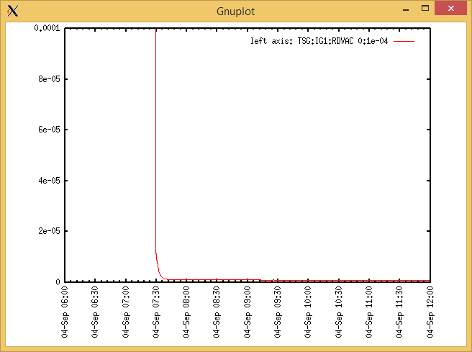

(Switched on later)

Target Heat Sequence Setup

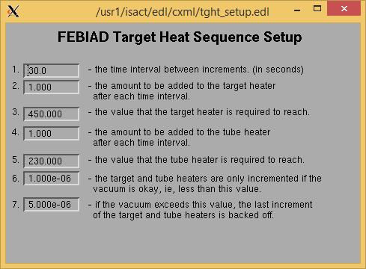

Source Tuning

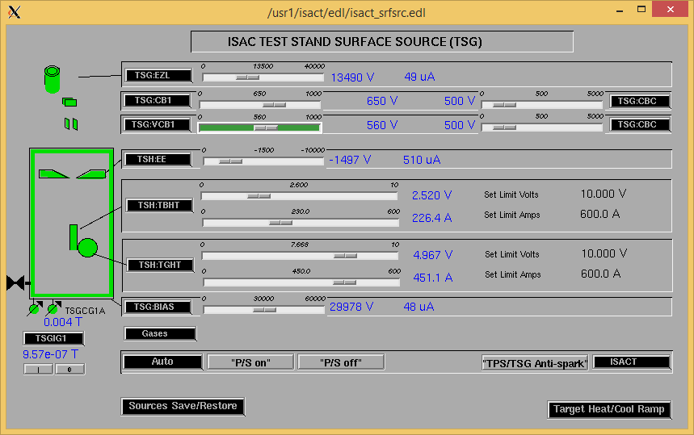

Wire Scanners RPM0A and RPM0B

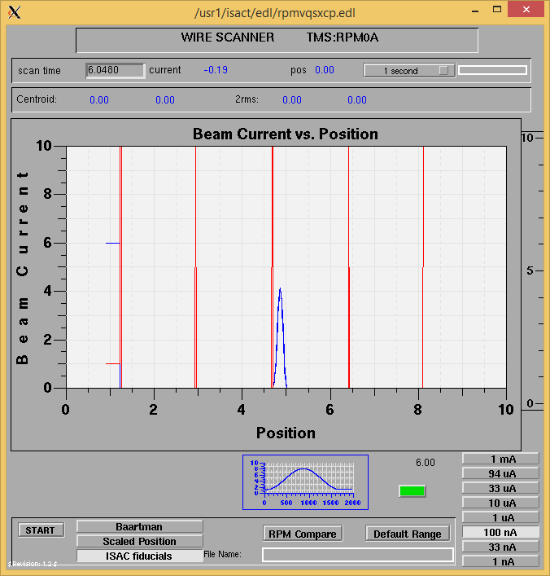

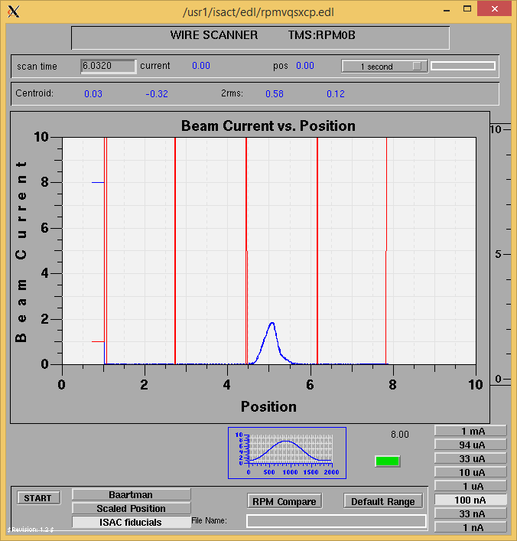

Optics Tuning

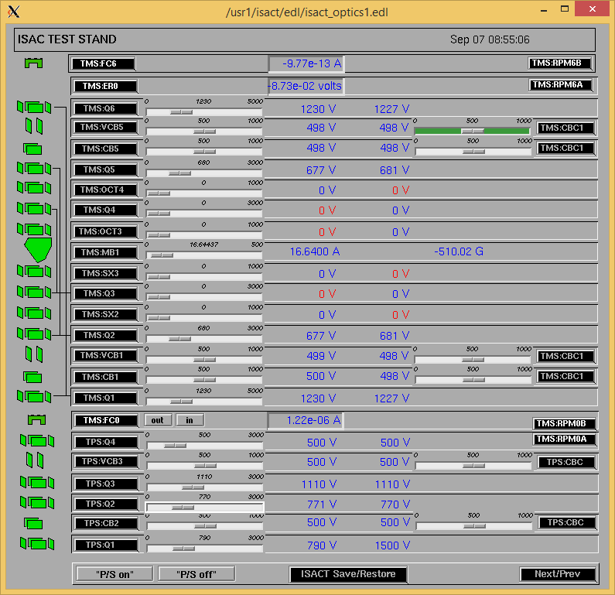

Wire Scanners RPM6A and RPM6B

Mass 7

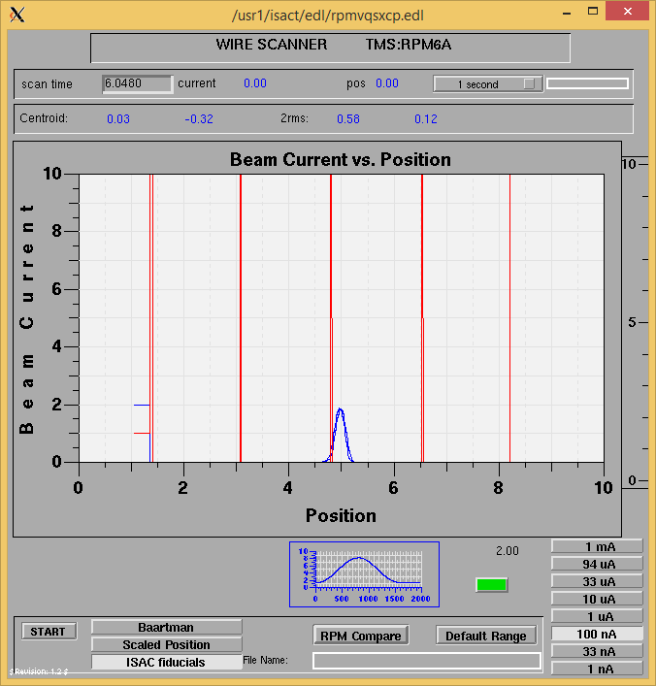

Mass 7

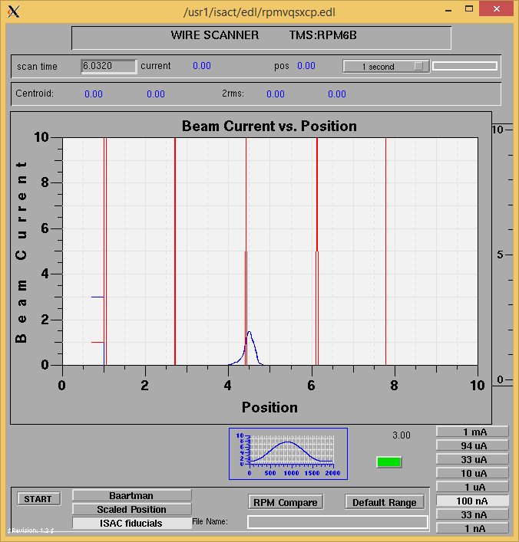

Mass Scan

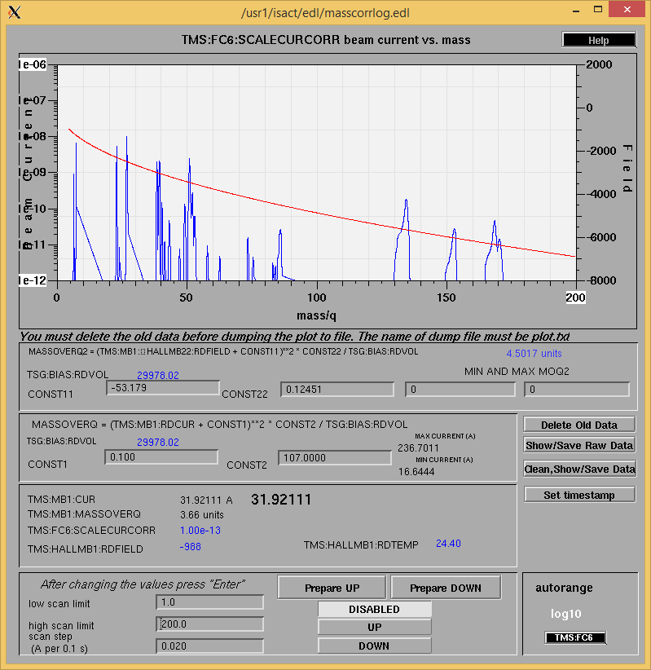

<http://isacwserv.triumf.ca/onlylocal/isactdata/save_restore/masscorr/2018-09-07-13-10%20nSiC%231%20Scan%203>

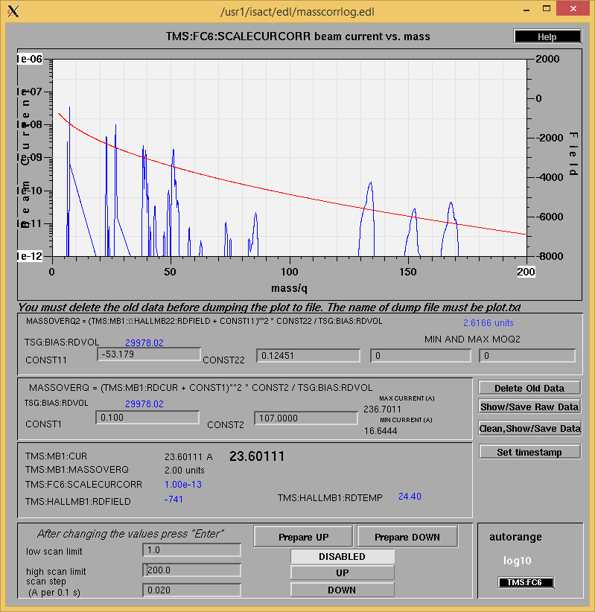

Cooling Parameters

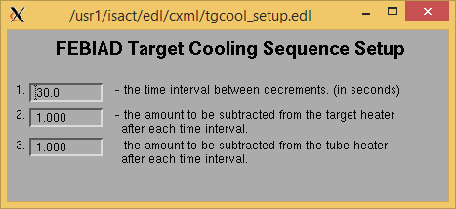

Overview Plots

Vacuum and FC0

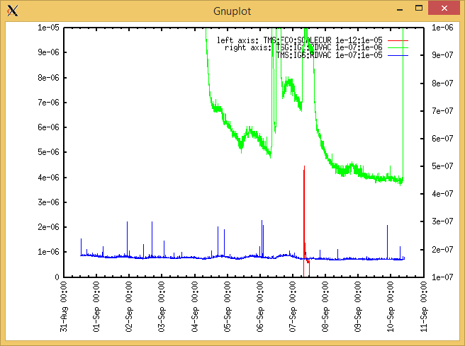

Heating, EE and BIAS

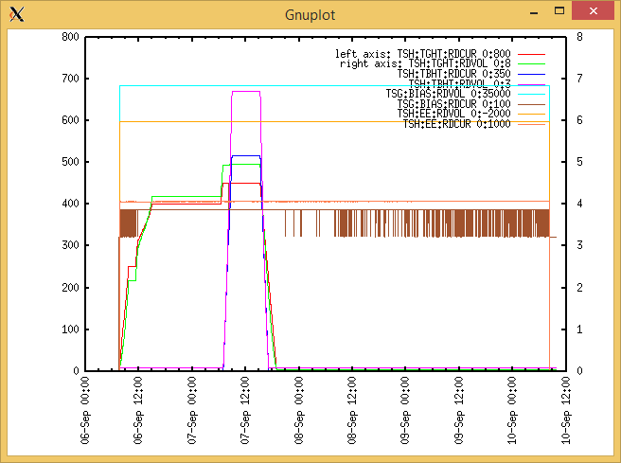

TGHT and TBHT Voltage

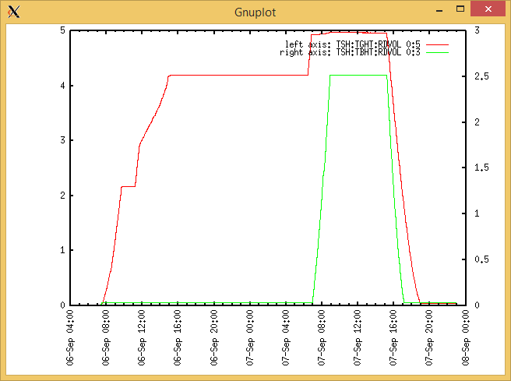

Flow and cooling water temperatures

Thursday, September 06, 2018, 07:39:

|  |  |  |
| --- | --- | --- |
| **Device** | **Temp [C]** | **Flow [lpm]** |
| HS + MSP | 25.6 | 3.85 |
| TBHT | 26.8 | 3.12 |
| COIL + EE | 25.4 | 4.99 |
| TGHT | 25.5 | 5.64 |

Friday, September 07, 2018, 06:55:

|  |  |  |
| --- | --- | --- |
| **Device** | **Temp [C]** | **Flow [lpm]** |
| HS + MSP | 25.6 | 3.85 |
| TBHT | 26.8 | 3.12 |
| COIL + EE | 25.5 | 4.99 |
| TGHT | 27.0 | 5.64 |

RGA

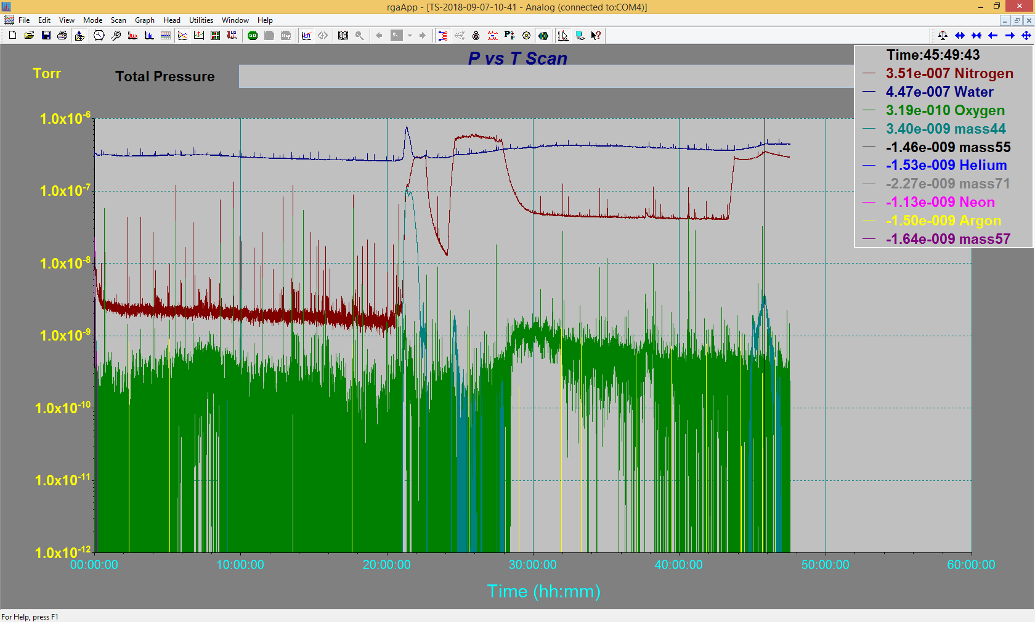

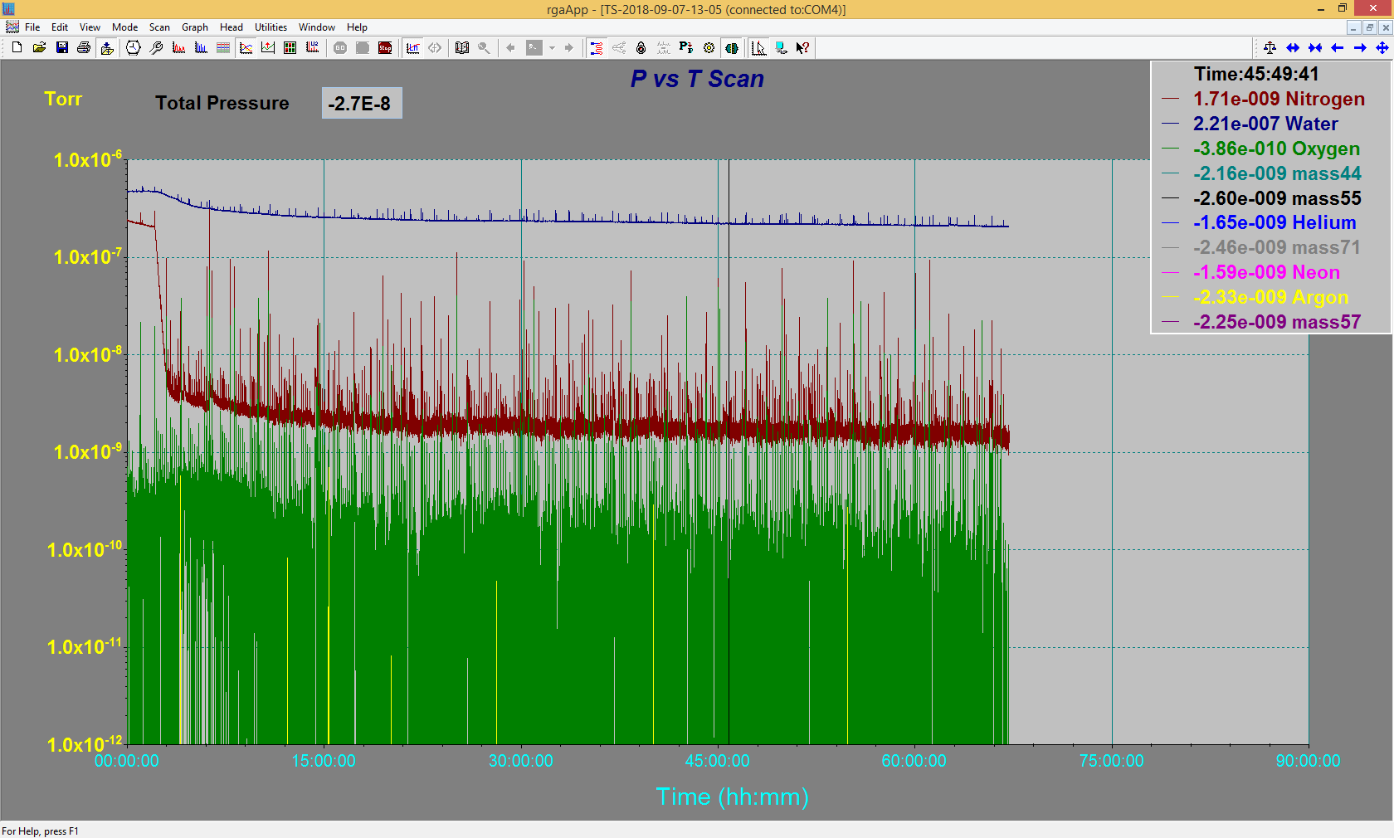

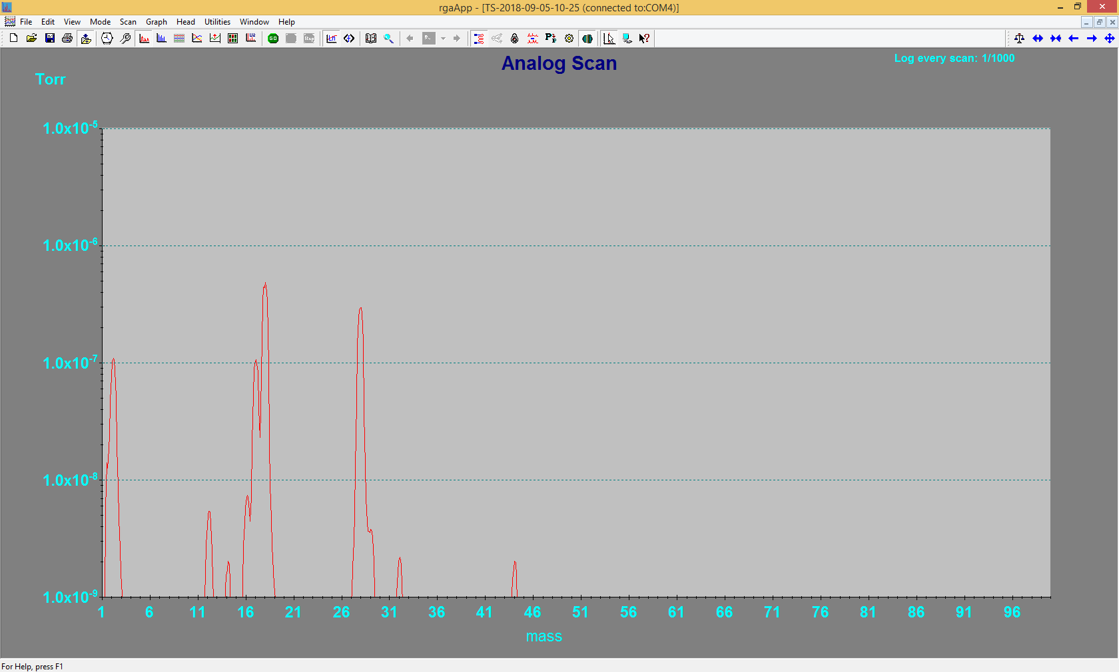

Emittance Scan

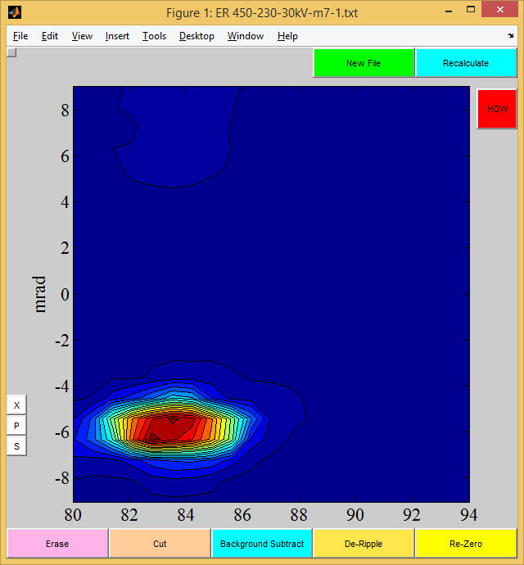

Mass 7

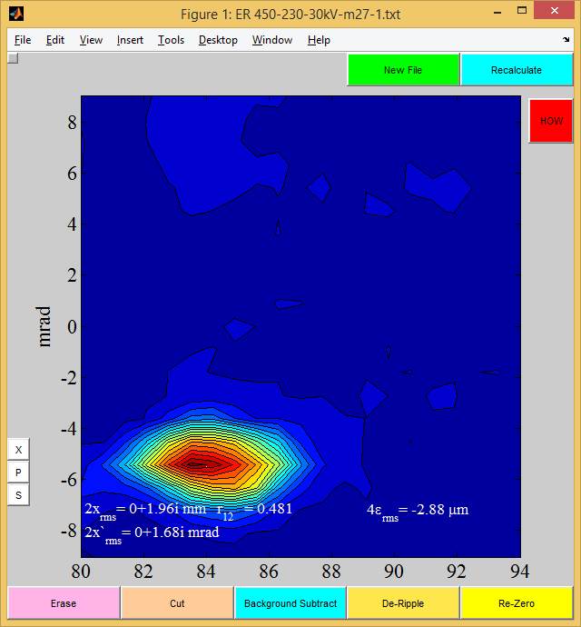

Mass 27

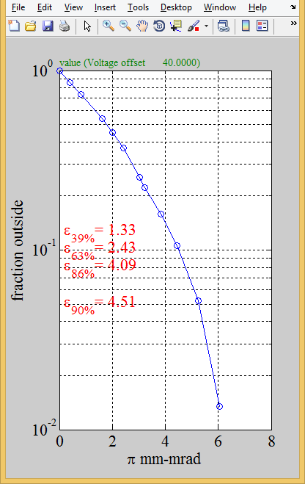

Mass 27