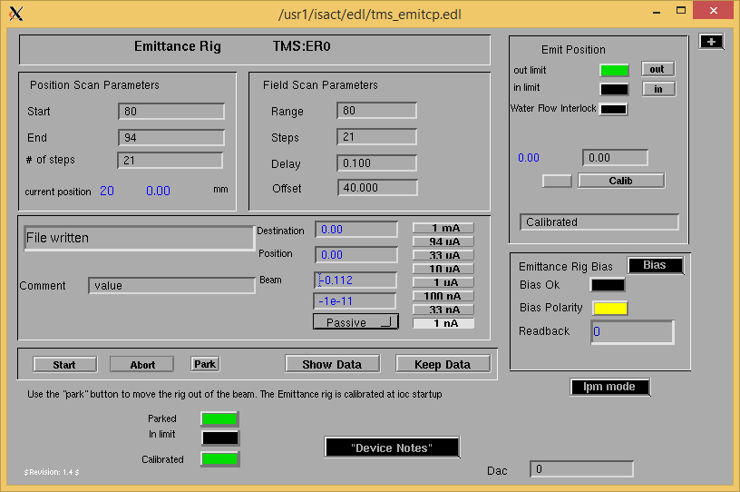

When the E-rig states that the file is written, the dat is supposed to go to the online link below @ emit.dat

However, instead an error message appears.

If I click show data on the e-rig, it will show updated data, but it does not show in the emit.dat link.

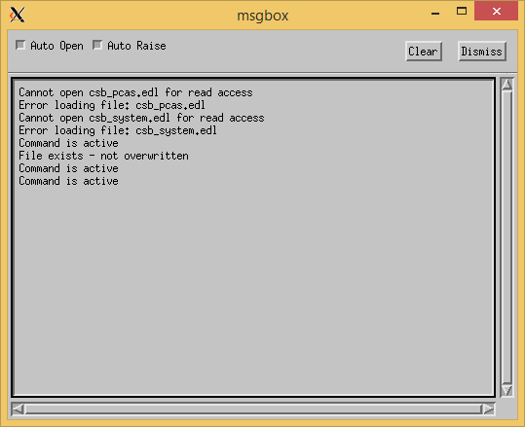

<http://isacwserv.triumf.ca/onlylocal/isactdata/emit.dat>