# TM2 Source Tray Test in ISAC Test Stand June 2018

|  |  |  |  |
| --- | --- | --- | --- |
| **What to test** | **Observe** | **Criteria** | **Results** |
| Vacuum cleanliness | IG1 (before heating) | < 5 E-7 Torr | 9.15e-07T after pumping down 70 hrs |
| Water lines, brazing, soldering, c-seals | IG1 | No increase in vacuum when water is switched on | IG1 ok. Vacuum @ 9.15e-07T. Pass |
| RGA (if operational) | No increase in mass 18 when water is switched on | Pass |
| Flow meters | HS + MSP > 4 lpm  TGHT > 5.5 lpm  TBHT > 5.5 lpm  COIL > 5 lpm | 4.09 lpm – 34.2 C  2.93 lpm – 25.3 C  4.86 lpm – 25.0 C  5.44 lpm – 27.6 C |
| High voltage BIAS | BIAS I @ 55 kV | < 60 µA | 55kV – 48.35 uA |
|  | # sparks @ 55 kV | < 1/ 10 min | 20 minutes apart (3 per hr) |
| High voltage EINZEL | EZL I @ 30 kV | < 125 µA | 30 kV – 110 uA |
| # sparks @ 30 kV | < 1/60 min | 90 minutes @ 30 kV (cold). No spark |
| Voltage Extraction Electrode | EE I @ 2 kV | < 700 µA | 2 kV – 688.25 uA |
| Voltage Anode/Cathode | ANODE I @ 300 V (cold source) | = 0 A | 200 V (hot) – 8.55 mA |
| High current | TGHT U @ 580 A | <7.2 V | 581.7 A – 7.570 V |
| TBHT U @ 320 A | < 2.4 V | 320.8 A – 2.364 V |
| COIL U @ 50 A | < 0.5 V | 50.06 A – 0.4 V |
| Beam transport | Steerers | Confirm steering horizontal  Confirm steering vertical | Confirmed |
| Einzel lens | Confirm focusing | Confirmed |
| Ion Source (FEBIAD) | Extracted beam | Confirm Ne beam on FC6  > 1E-9 A | No gas input used. Out gassed Ions formed FEBIAD beam. |
| Mass spectrum | Record mass spectrum from source | Compare with previous data | ok |
| Emittance | Emittance | Compare with previous data | E-rig malfunction. Emittance unavailable. |

## e-log entries

<https://elog.triumf.ca/TIS/Test-Stand/664>

## Notes

Sparks* Tuesday, June 05, 2018, 13:06: BIAS / EZL / EE @ 55 / 24 / 2.8 kV. SPARK* knocked out optics, magnet & Turbos TMS:TP6. IV4 closed/opened/reset. Turbo/optics restarted. Magnet still off. Anode @ 200V (reads 9V, shorted)

The mass separator magnet had to have its controller replaced after it was fried by a spark.

The emittance rig required an IOC soft start which was done once the test stand was cool. The Anode was shorted near the end after a spark.

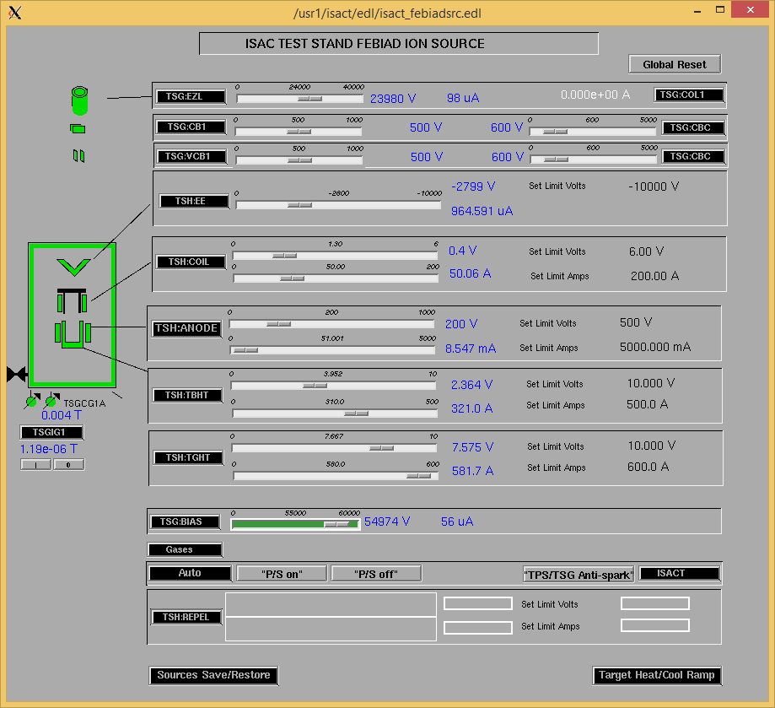

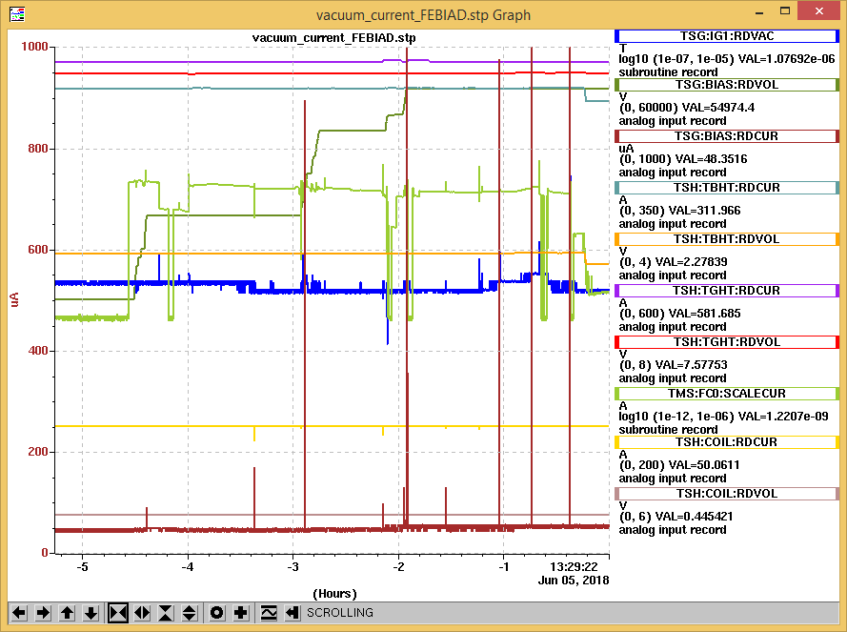 Spark rate at 55 kV

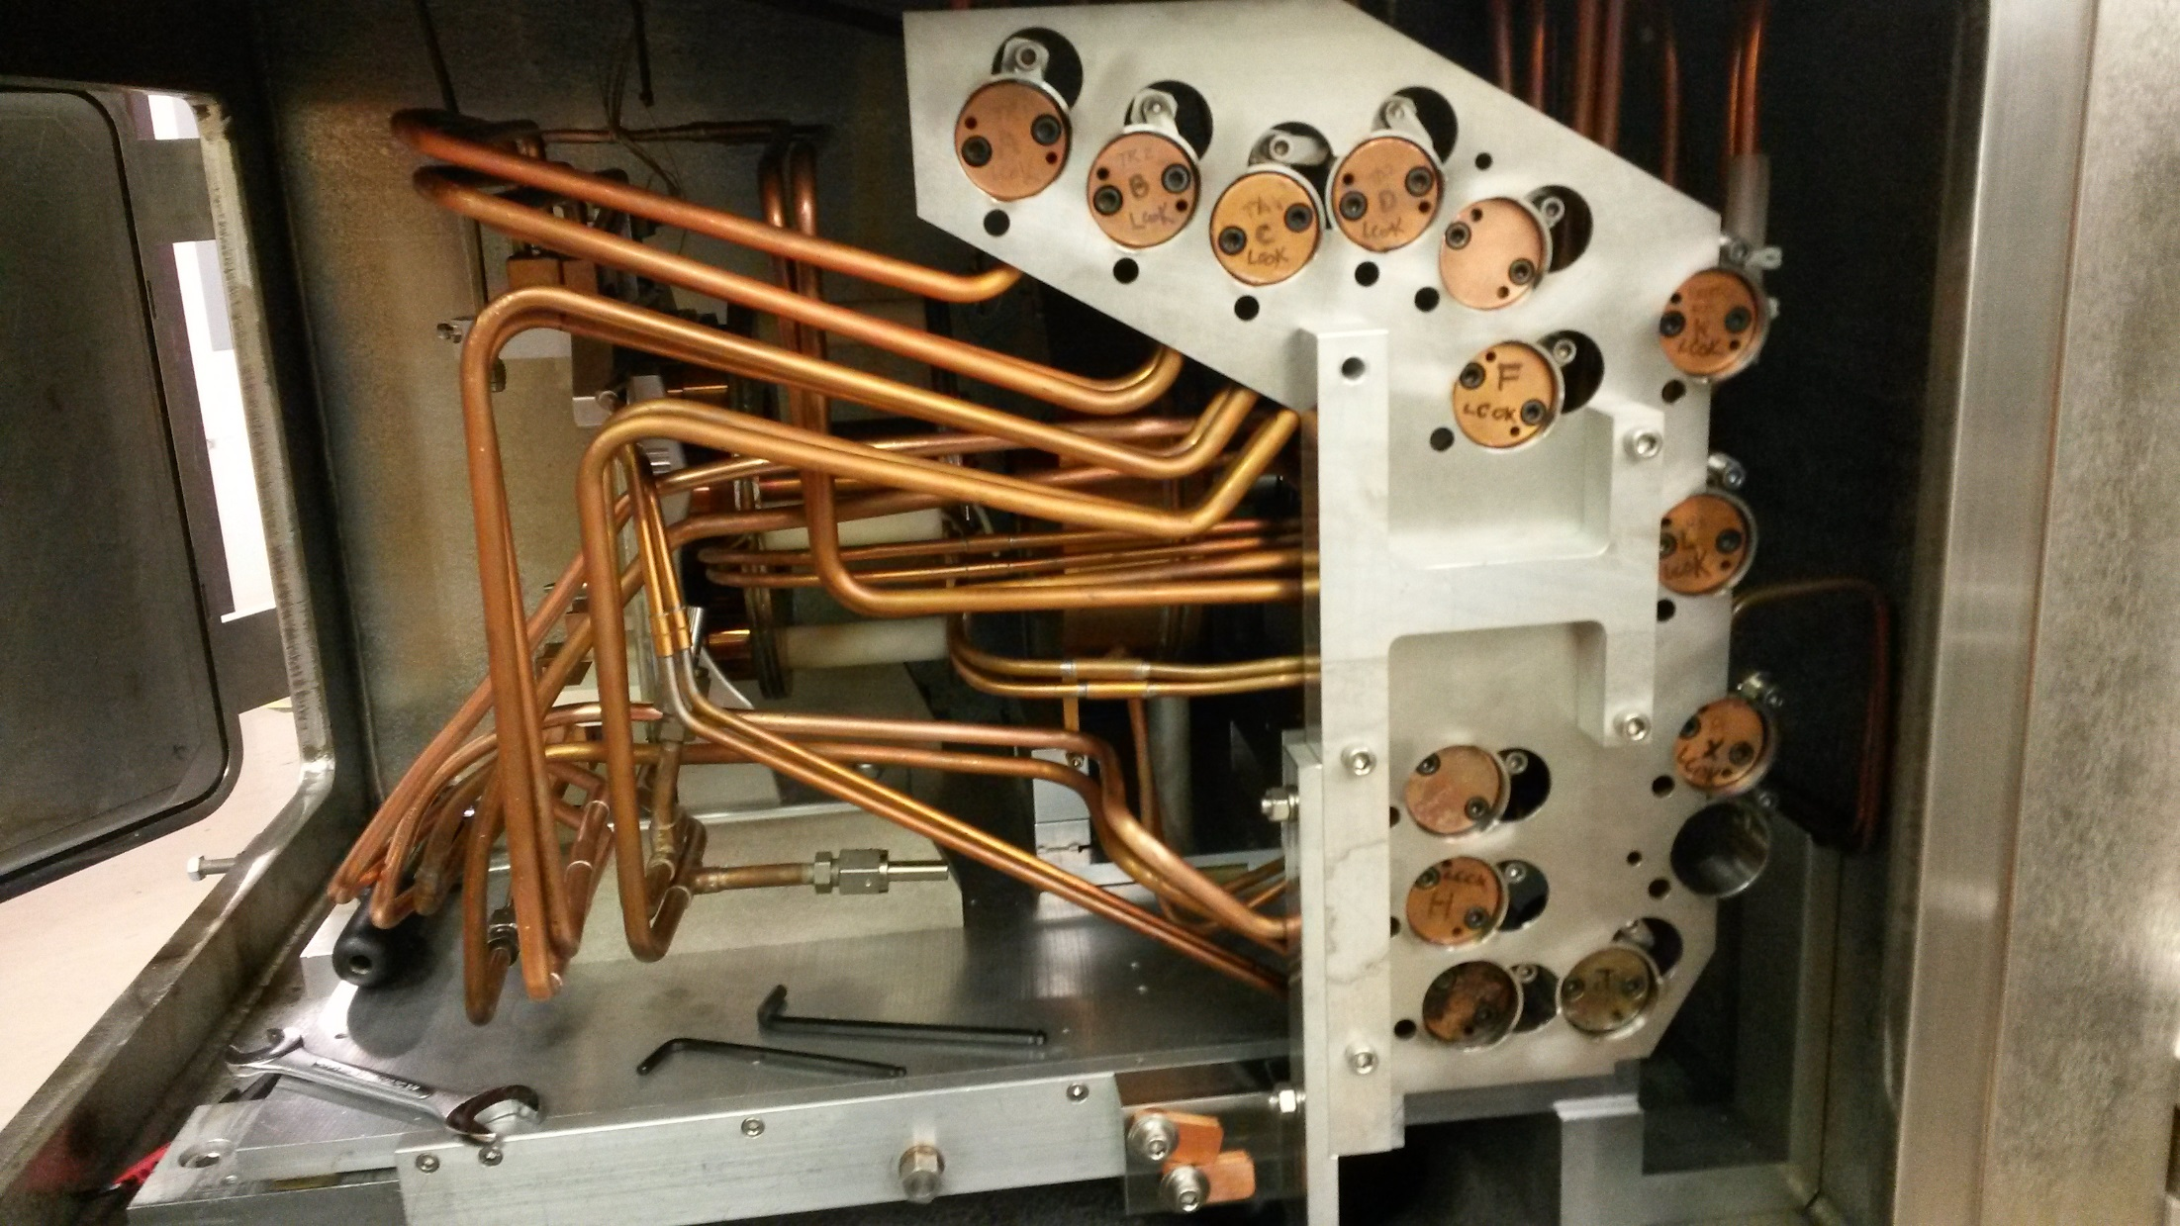

The original ISAC Test Stand source tray

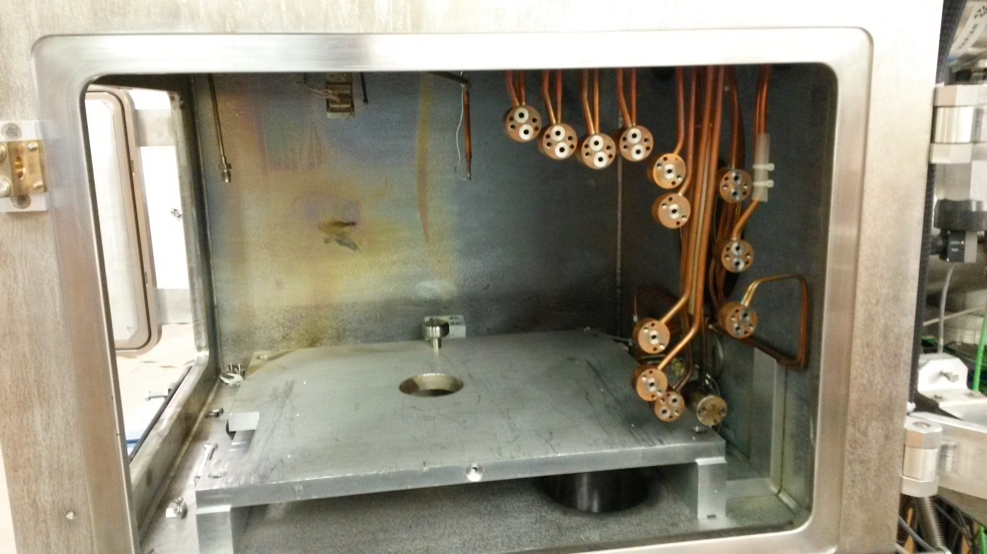ISAC Test Stand Source tray removed

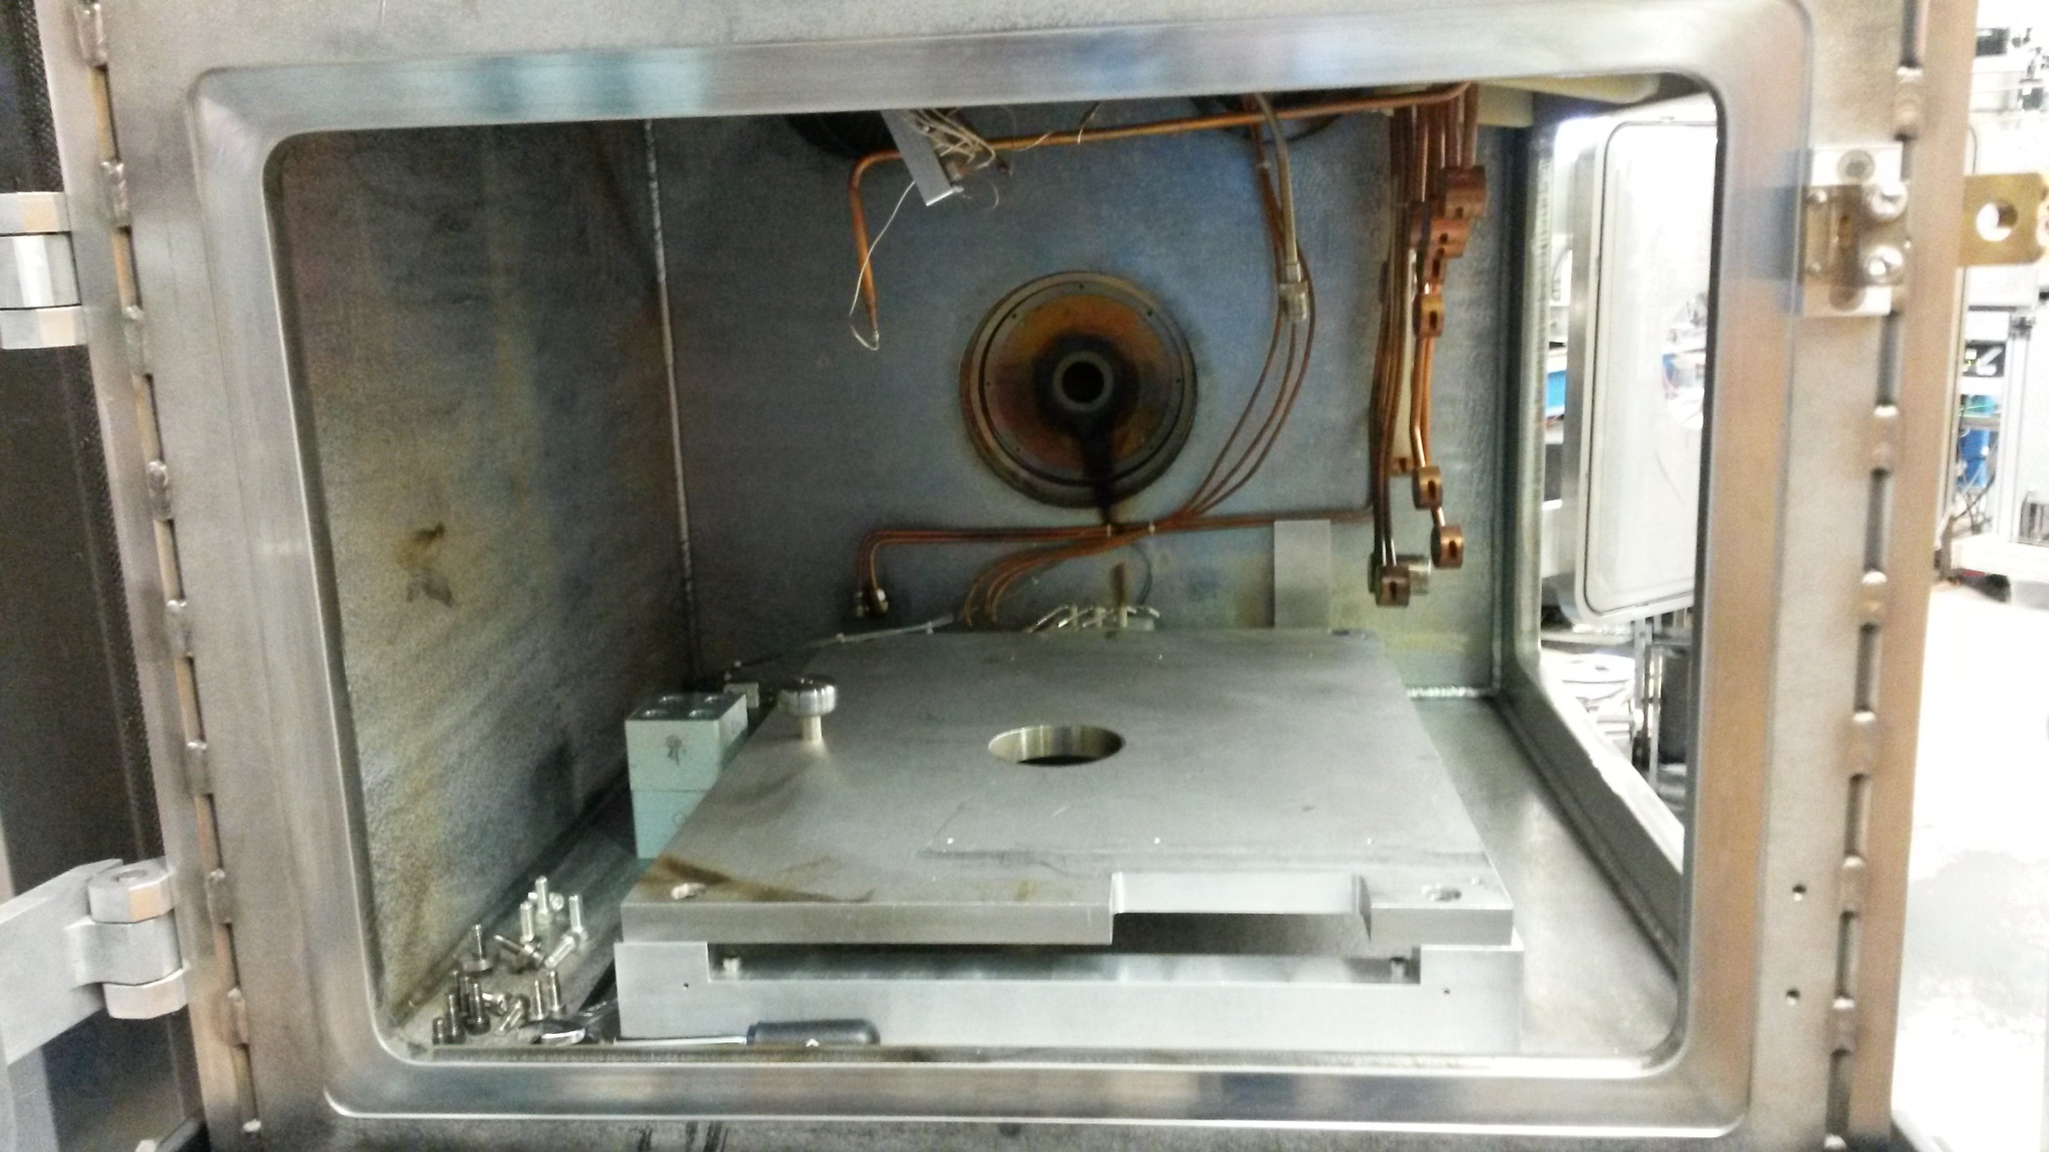

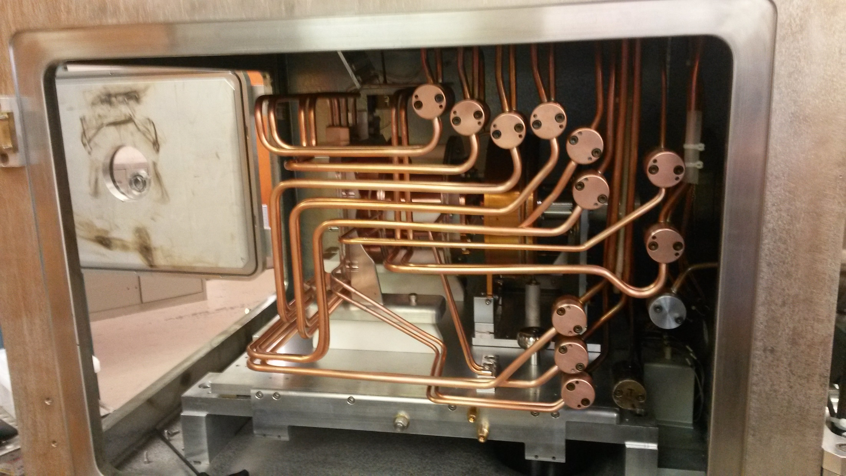

New TM2 Source Tray installed with the ISAC Test Stand Optics Tray

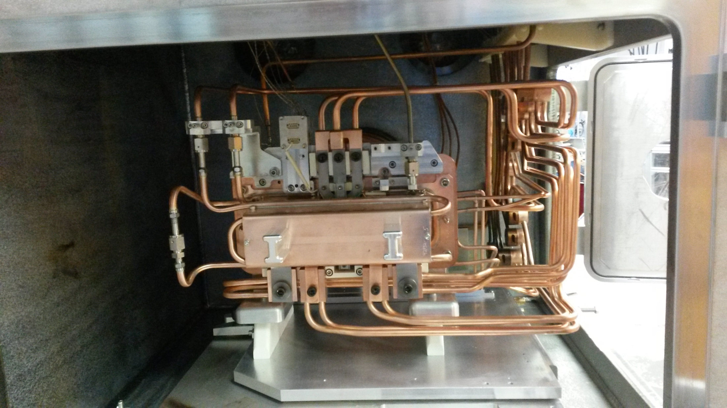

New TM2 Source Tray installed with the ISAC Test Stand Optics Tray w/ a test FEBIAD target assembly.

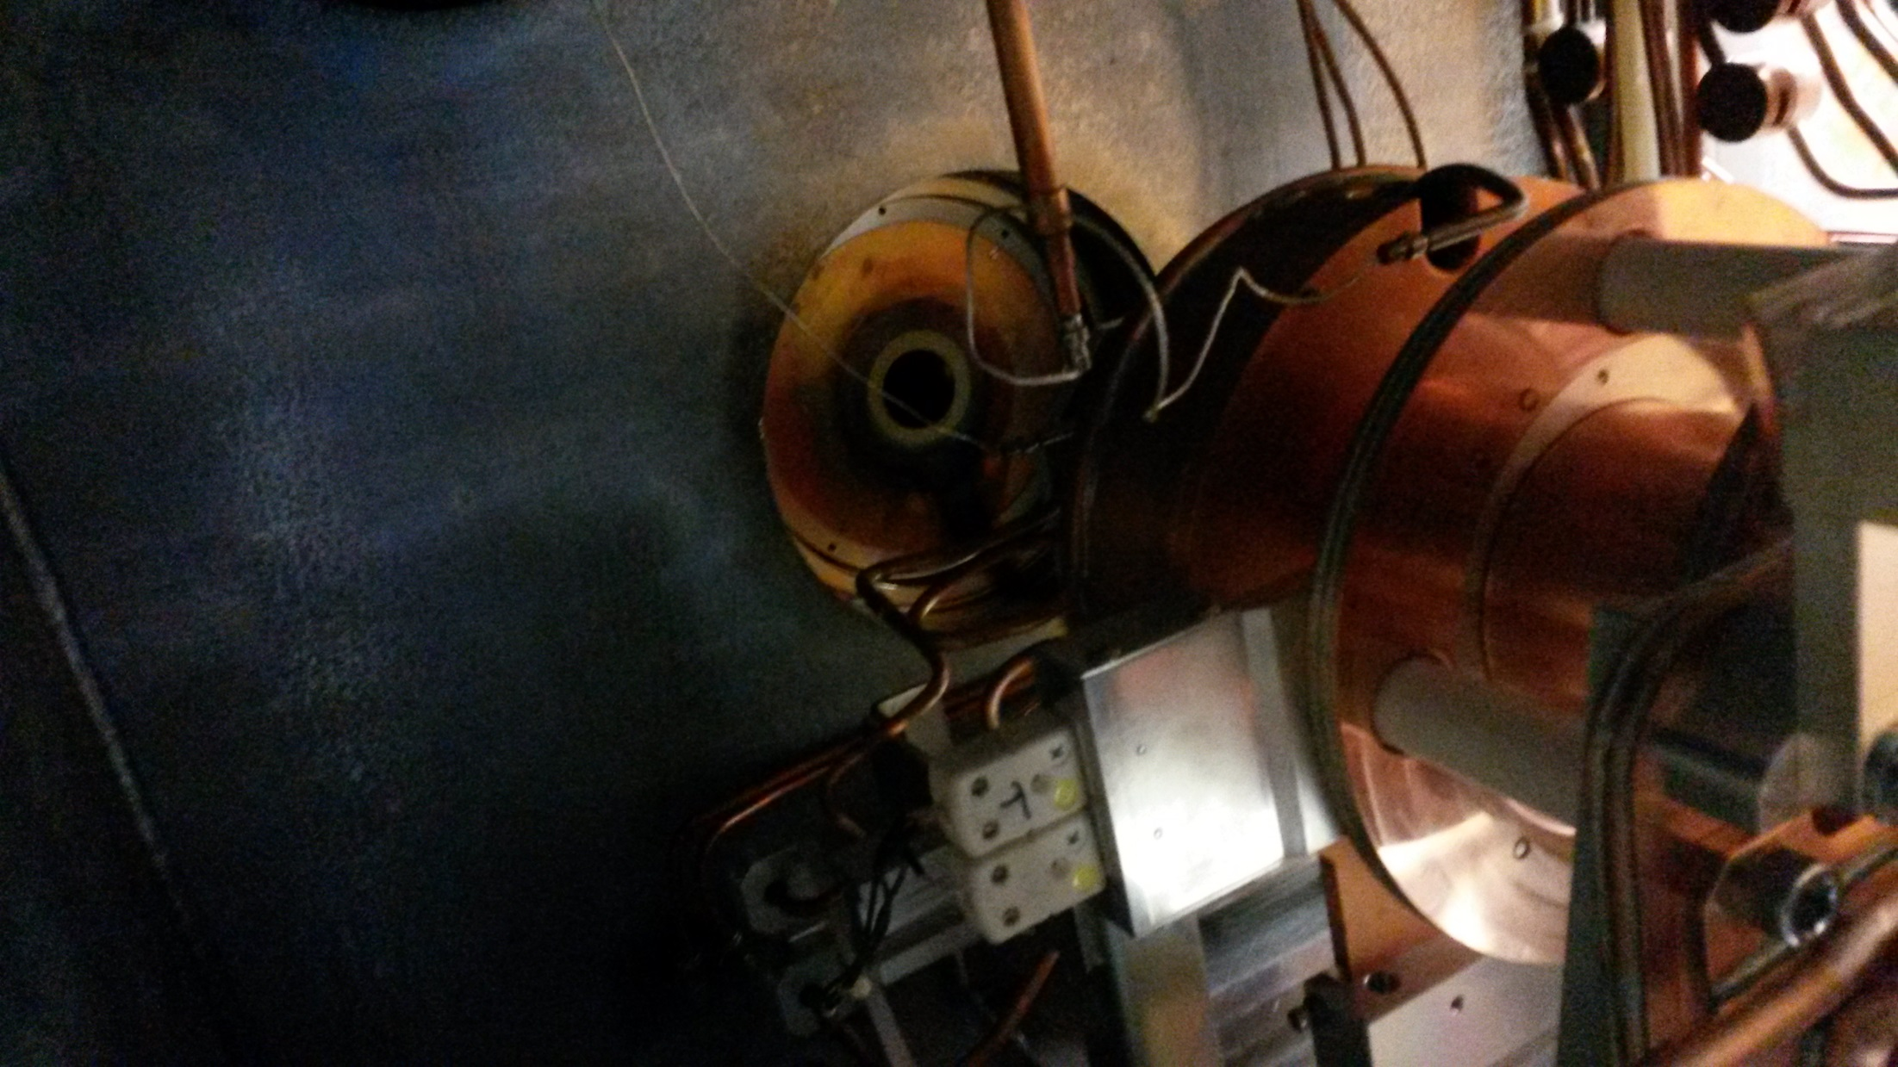

The ISAC Test Stand Optics Tray reinstalled with the new source tray.

Other Notes:

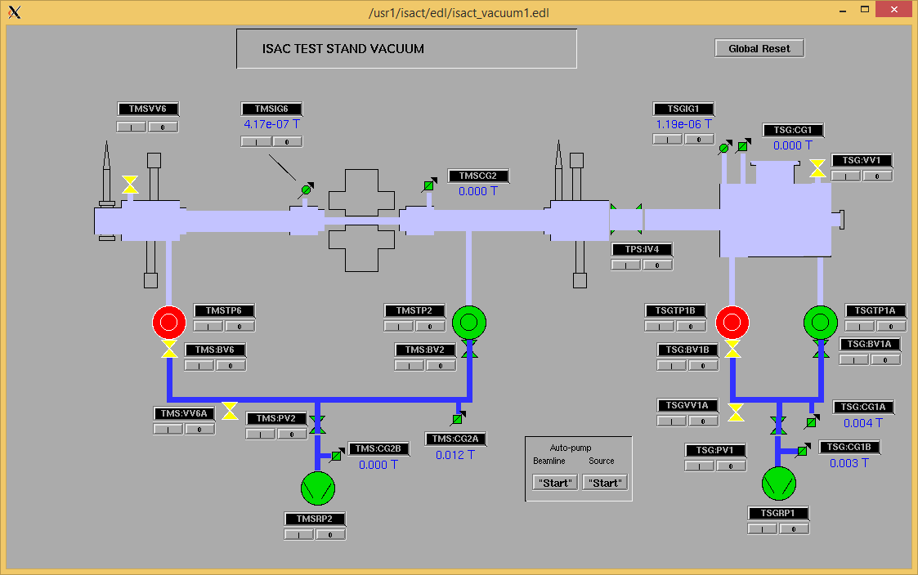Spark Knockout example. Two turbo pumps shut down by a spark.

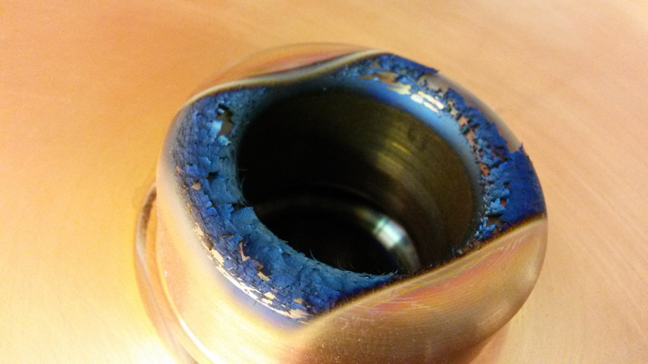

The EZL/Optics tray was quite dirty when it was pulled from the ISAC Test Stand

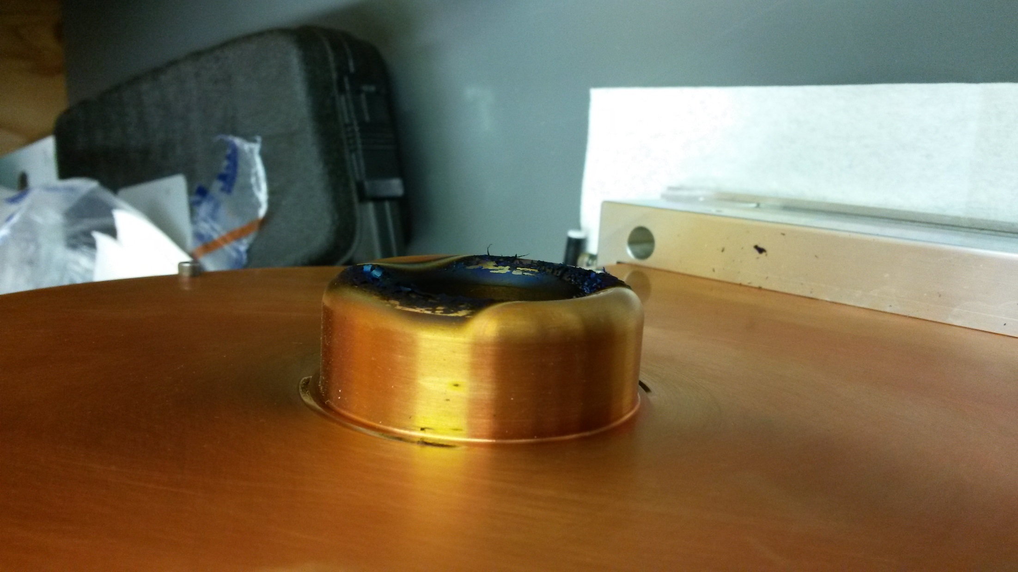

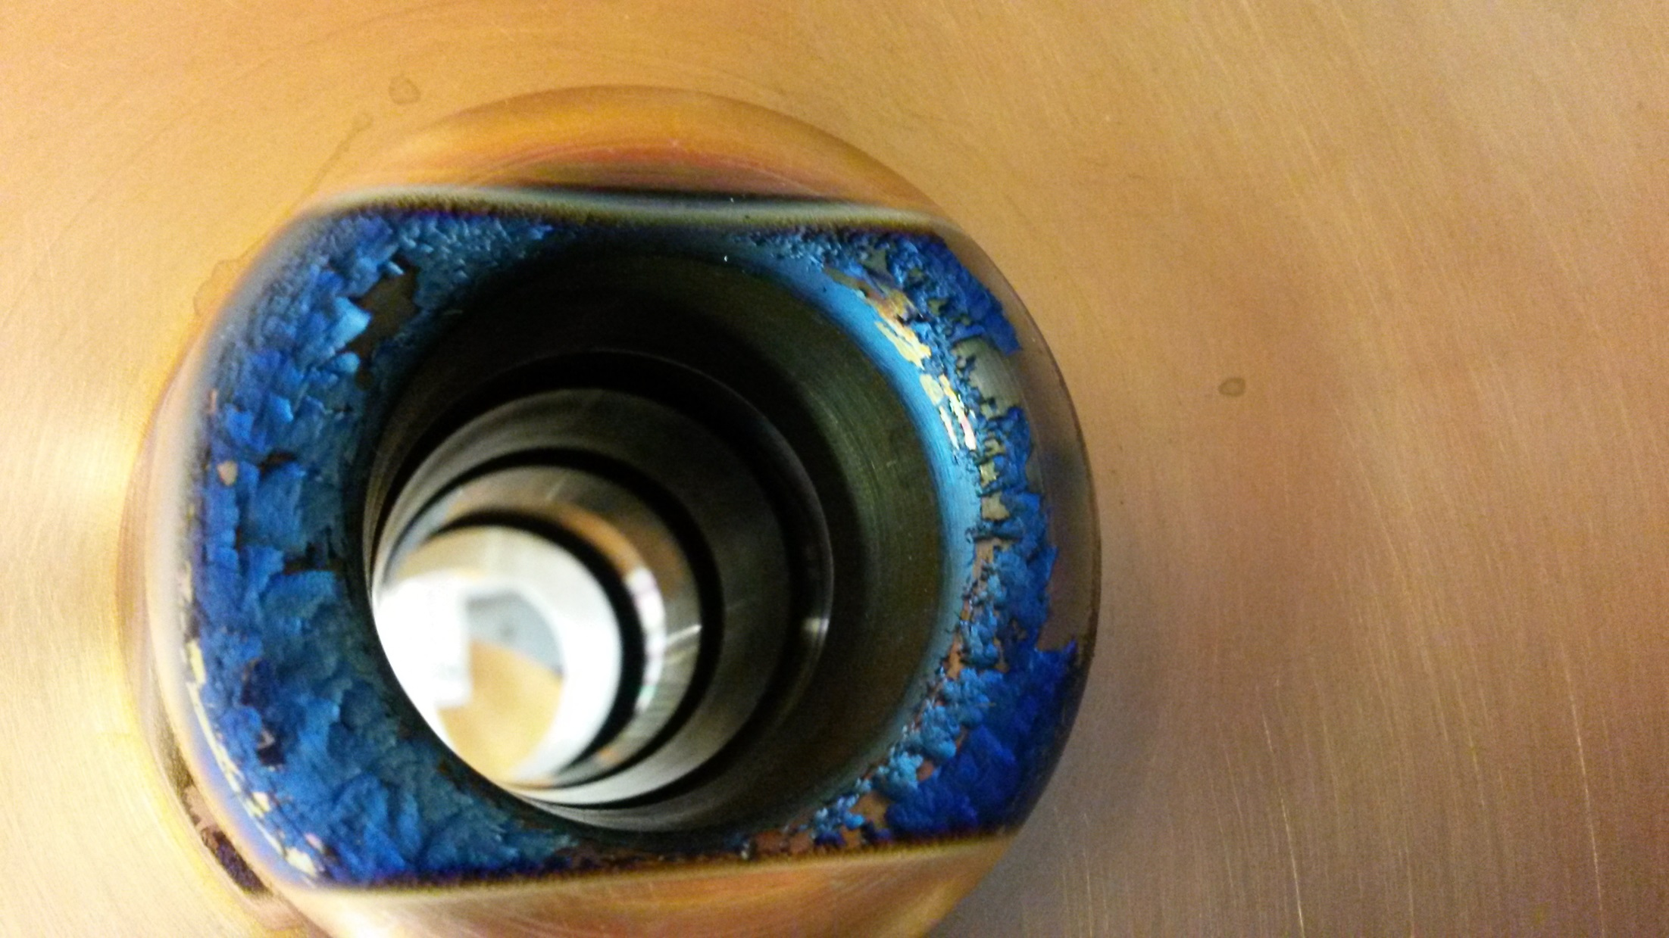

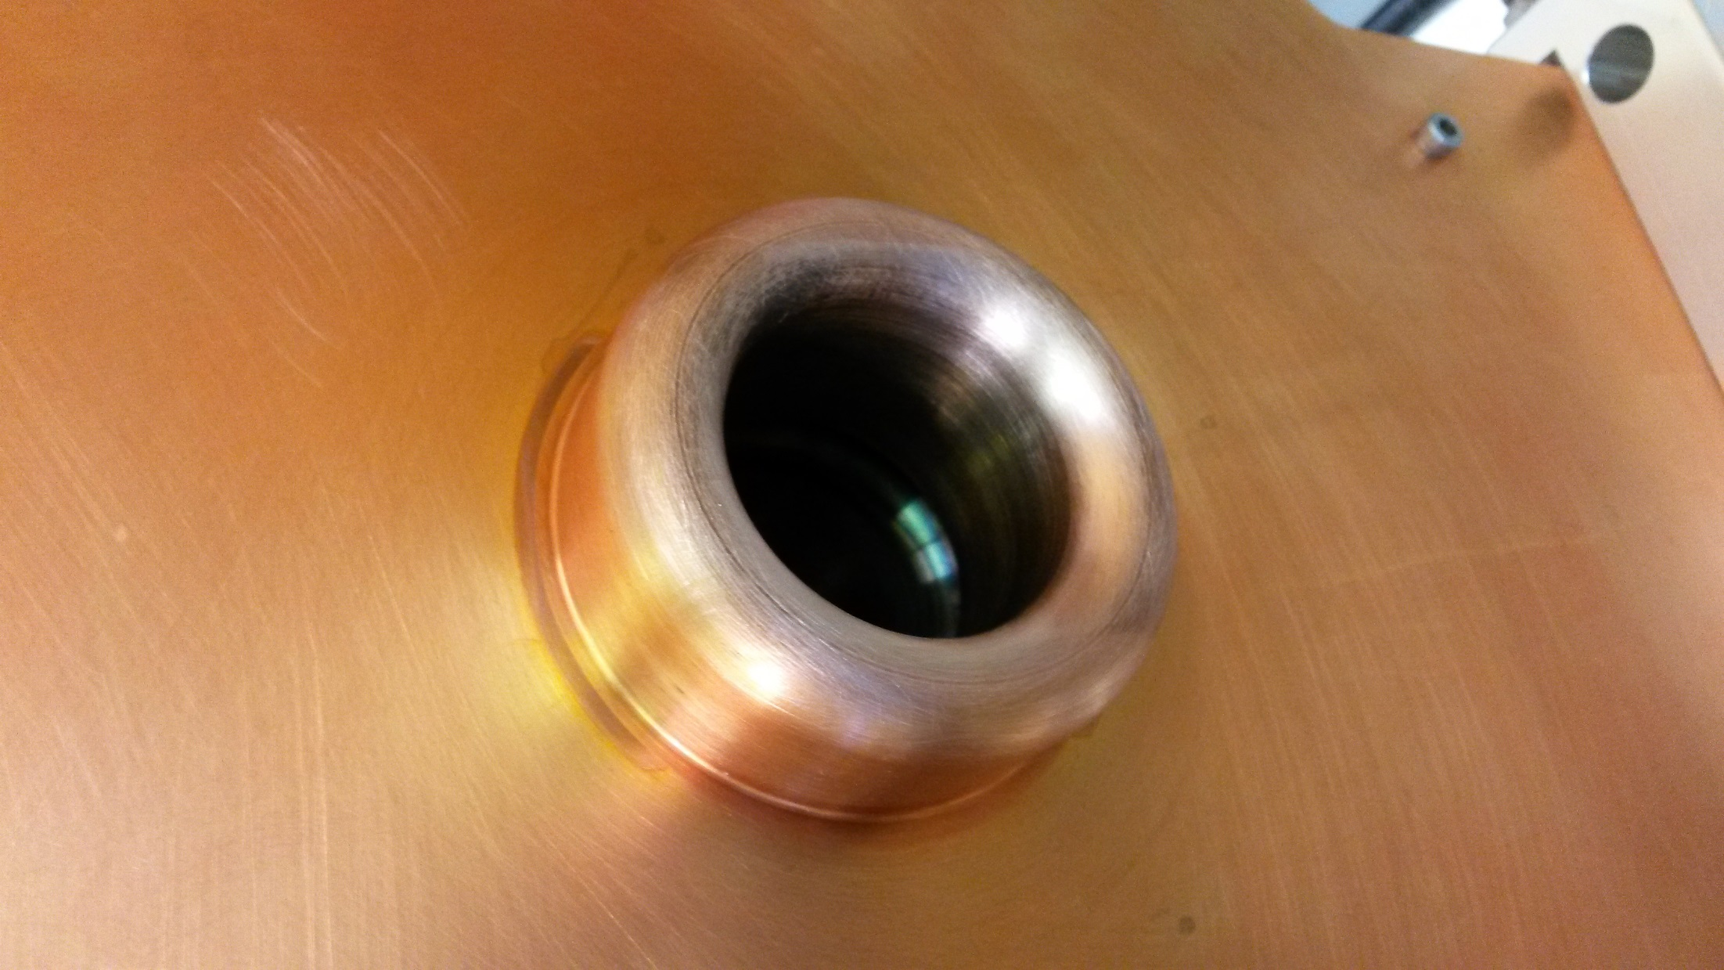

Cleaned before reinstallation.