Conditioning Report

|  |  |  |
| --- | --- | --- |
| Target material and number | | SiC#37 |
| Target WO-SN | | 39530-10 |
| Operator name | | Aaron Schmidt |
|  | |  |
| Heating start date and time | | 2017-10-14 06:43 |
| BIAS | |  |
| Voltage [kV] | | 30 |
| Current [µA] | | 37 |
| Extraction Electrode (EE) | |  |
| Voltage [kV] | | 1.5 |
| Current [µA] | | 510 |
| TGHT | |  |
| Current [A] | | 582 |
| Voltage [V] | | 5.2 |
| TBHT | |  |
| Current [A] | | 322 |
| Voltage [V] | | 2.6 |
| FEBIAD ANODE | |  |
| Voltage [V] | | 200 |
| Current [mA] | | 7.3 |
| FEBIAD COIL | |  |
| Current [A] | | *0.29 |
| Voltage [V] | | *0 |
| Flow and Temperature HS + MSP | | 27.0 |
| Flow [lpm] | | 3.98 |
| Temperature increase [C] | | +6.8 (31.4)* |
| FC6 currents [A] | | 6.93E-07 |
| SIS | 7Li | - |
| FEBIAD | 20Ne | 2.67E-10 |
| SIS | 23Na | - |
| SIS | 39K | - |
| SIS | 85Rb | - |
| SIS | 133Cs | - |
| Heating end date and time | | 2017-10-15 22:30 |

Comments

*Coil was routed on right leg into the HS. The coil was not tested due to SS connections.

*Temperature from first test 10/10/2017

*Short on anode noted in first test, was fixed. The grid clamp was removed and the grid spot welded to the anode chamber

Plots

8h Vacuum Pump Down

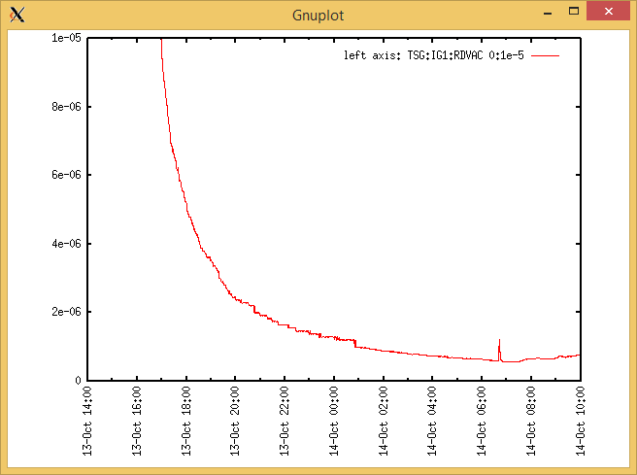

Target Heat Sequence Setup

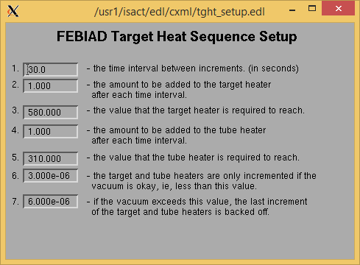

Source Tuning

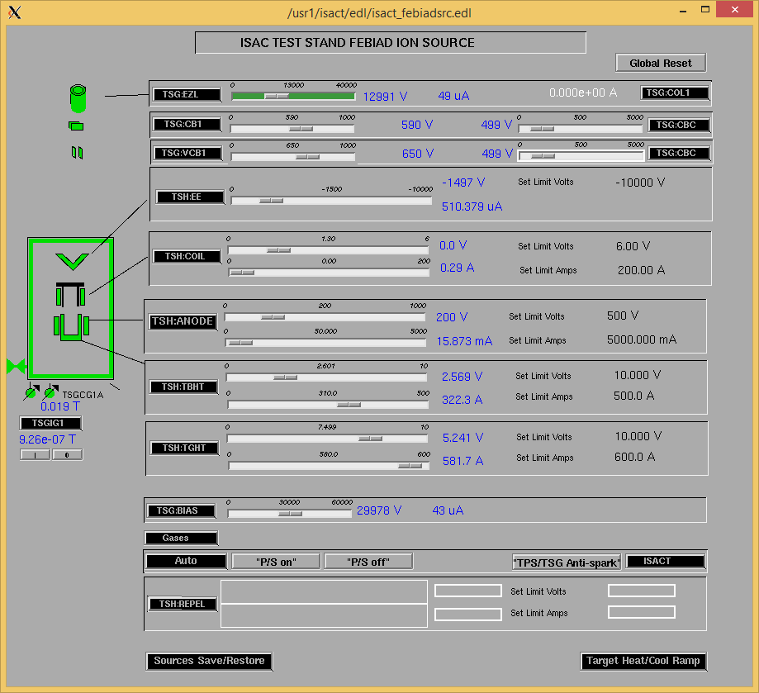

Wire Scanners RPM0A and RPM0B

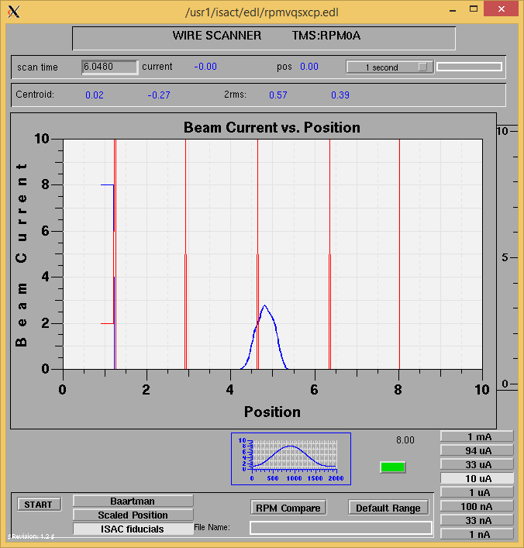

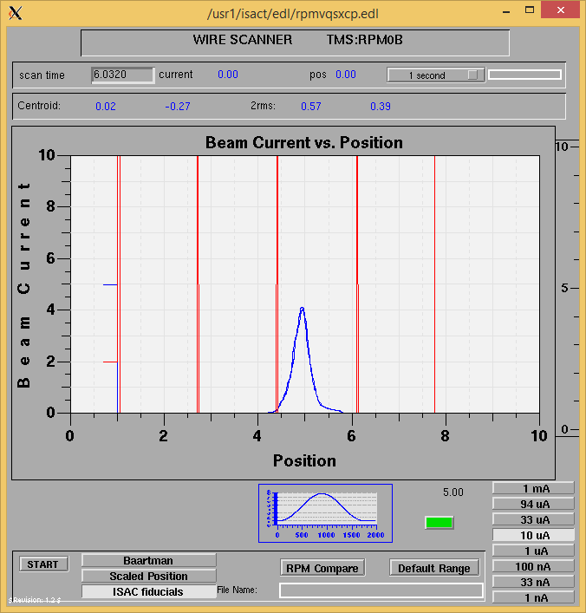

Optics Tuning

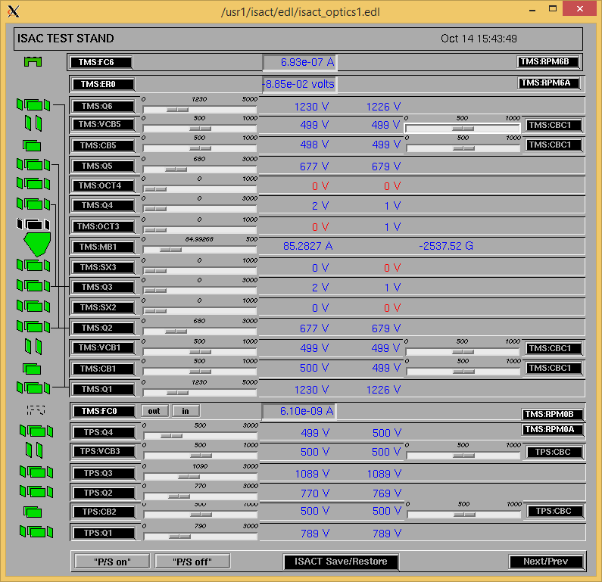

Wire Scanners RPM6A and RPM6B

Mass 28

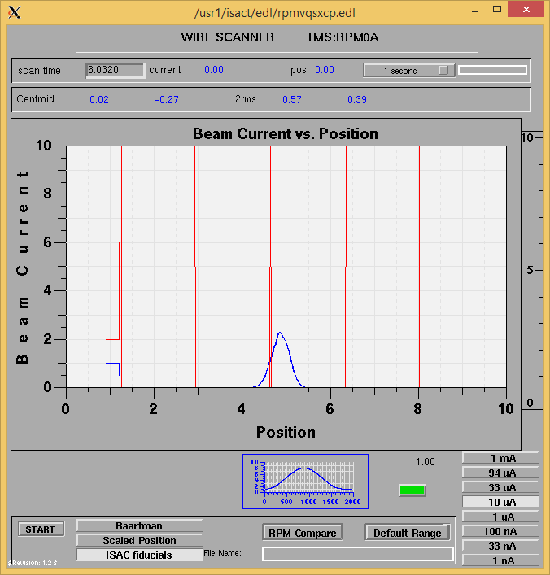

Mass 28

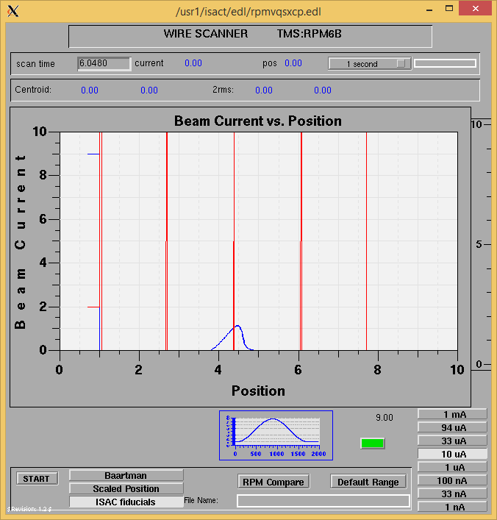

Mass Scan

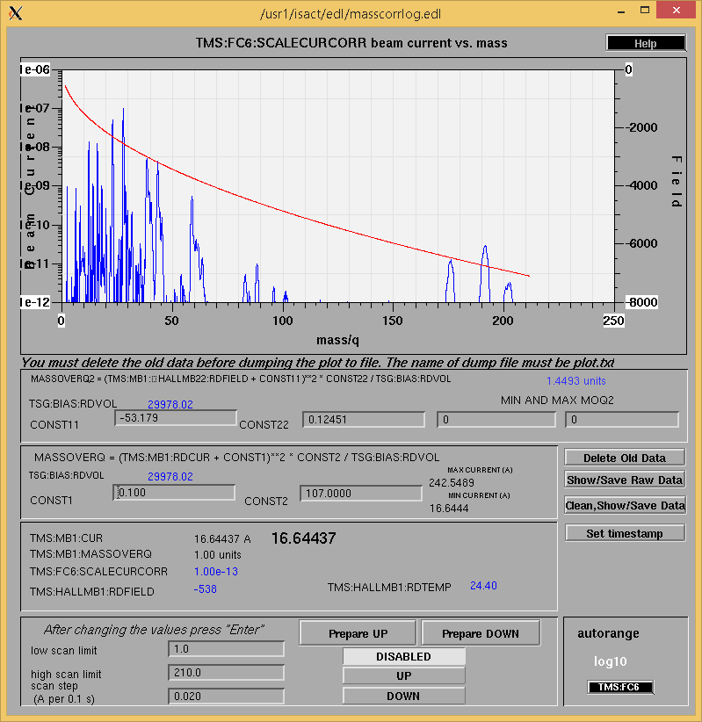

<http://isacwserv.triumf.ca/onlylocal/isactdata/save_restore/masscorr/2017-10-15-06-42%20SiC%2337>

Cooling Parameters

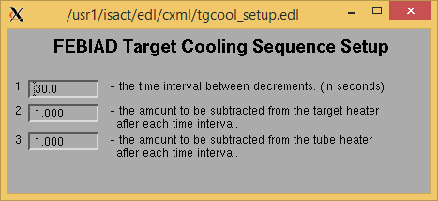

Overview Plots

Vacuum and FC0

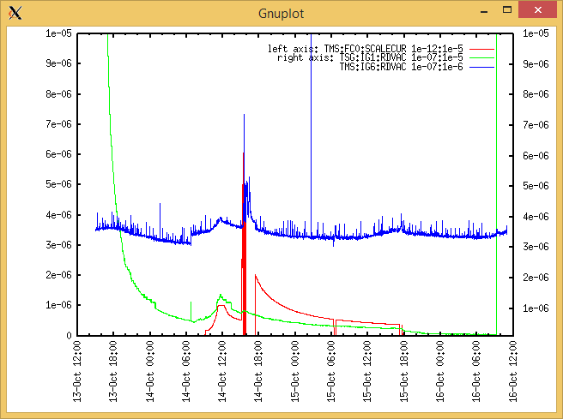

Heating, EE and BIAS

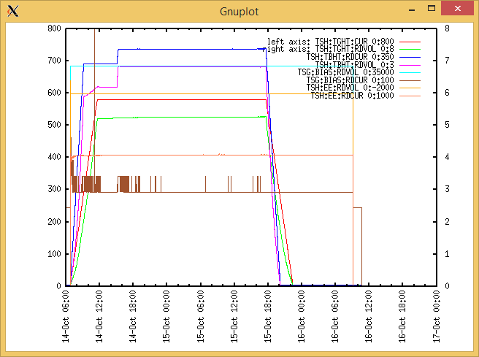

TGHT and TBHT Voltage

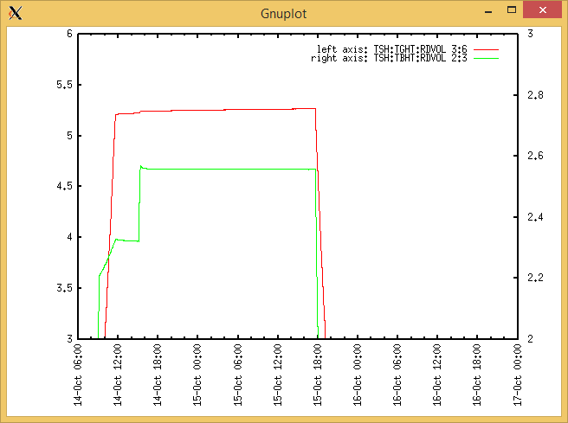

Flow and cooling water temperatures

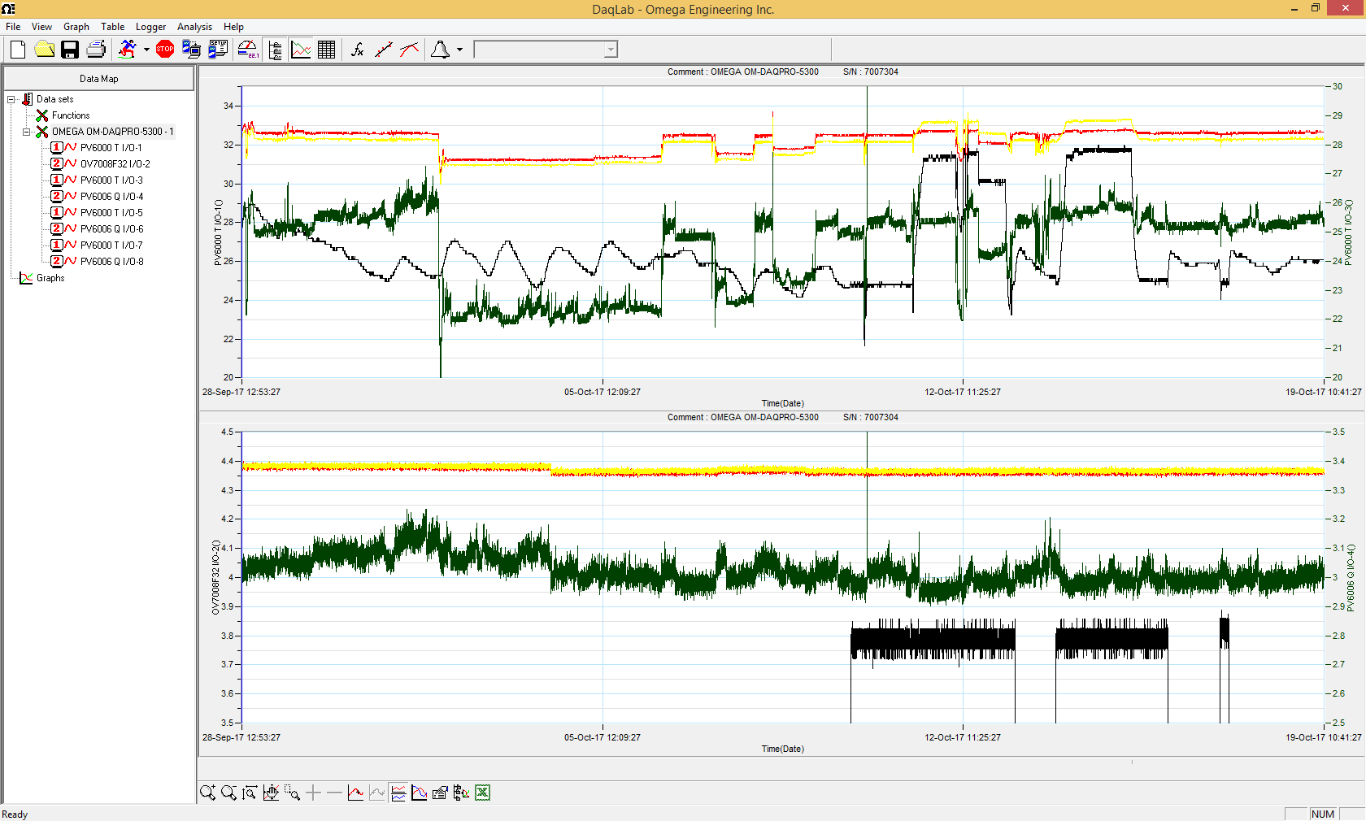

RGA

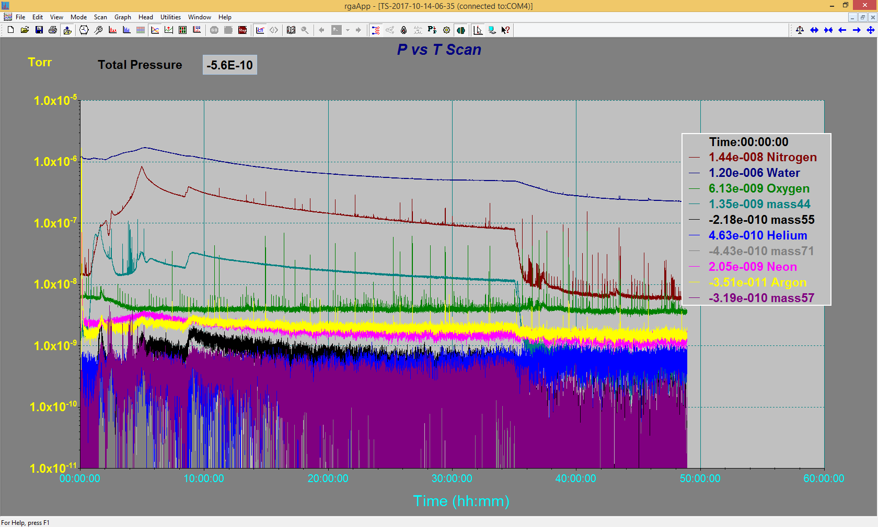

Emittance Scan

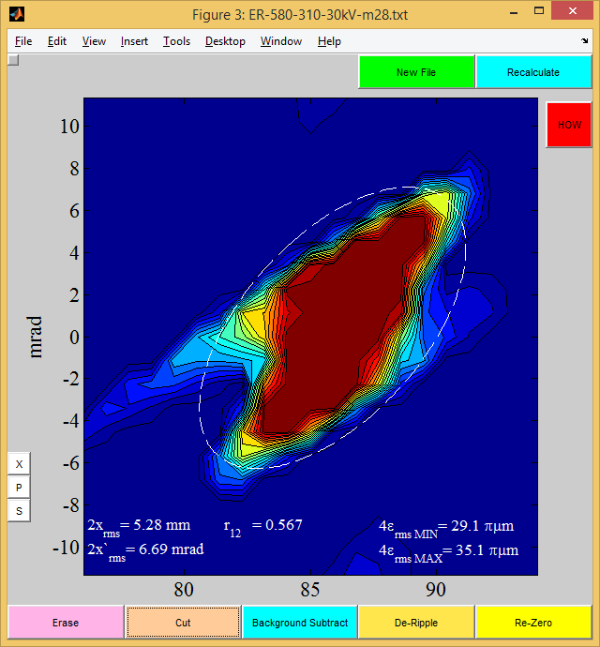

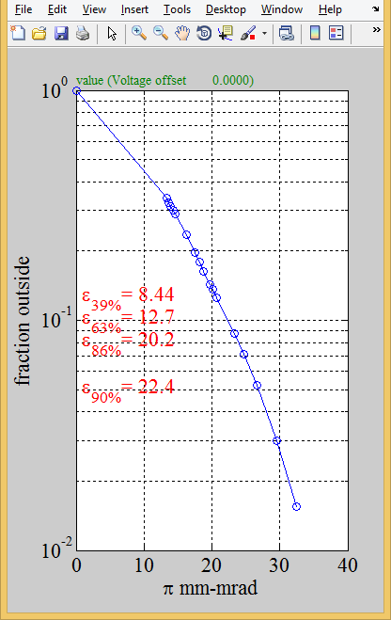

Mass 38

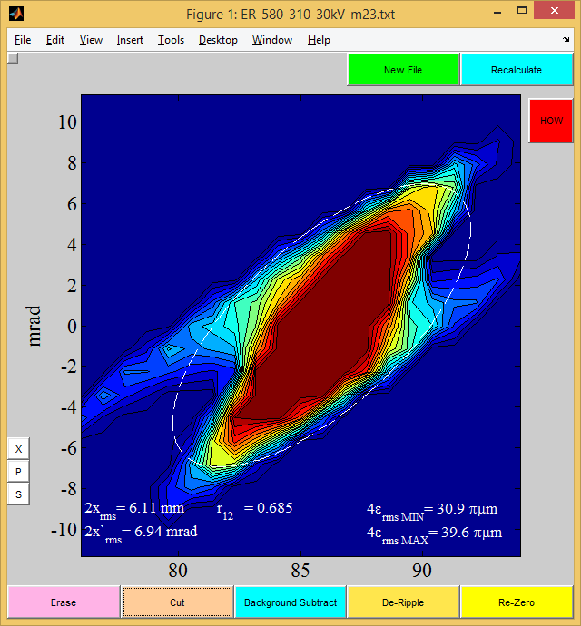

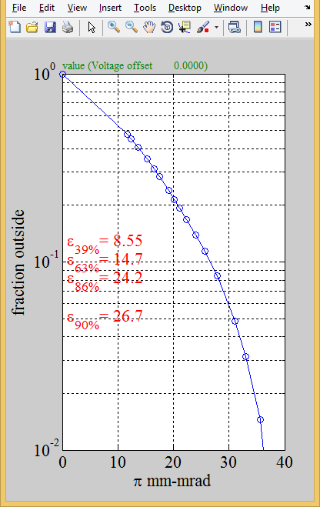

Mass 23