Conditioning Report

|  |  |  |
| --- | --- | --- |
| Target material and number | | Ta#54 |
| Target WO-SN | | 42218-10 |
| Operator name | | Aaron Schmidt |
|  | |  |
| Heating start date and time | | 2017-09-21 09:08 |
| BIAS | |  |
| Voltage [kV] | | 30 |
| Current [µA] | | 37 |
| Extraction Electrode (EE) | |  |
| Voltage [kV] | | 1.5 |
| Current [µA] | | 508 |
| TGHT | |  |
| Current [A] | | 581.7 |
| Voltage [V] | | 5.265 |
| TBHT | |  |
| Current [A] | | 208.4 |
| Voltage [V] | | 1.849 |
| FEBIAD ANODE | |  |
| Voltage [V] | | 50* |
| Current [mA] | | 0* |
| FEBIAD COIL | |  |
| Current [A] | | - |
| Voltage [V] | | - |
| Flow and Temperature HS + MSP | |  |
| Flow [lpm] | | 3.85 |
| Temperature increase [C] | | 8.0 |
| FC6 currents [A] | | 1.90e-07 |
| SIS | 7Li | 4.79-08 |
| FEBIAD | 20Ne | - |
| SIS | 23Na | 5.21e-010 |
| SIS | 39K | 1.34e-08 |
| SIS | 85Rb | 1.44e-08 |
| SIS | 133Cs | 1.38e-07 |
| Heating end date and time | | 2017-07-12 20:30 |

Comments

-FEBIAD Anode brought up to 50 V using FEBIAD TS controls. No current detected. No short detected during heating.

Plots

8h Vacuum Pump Down

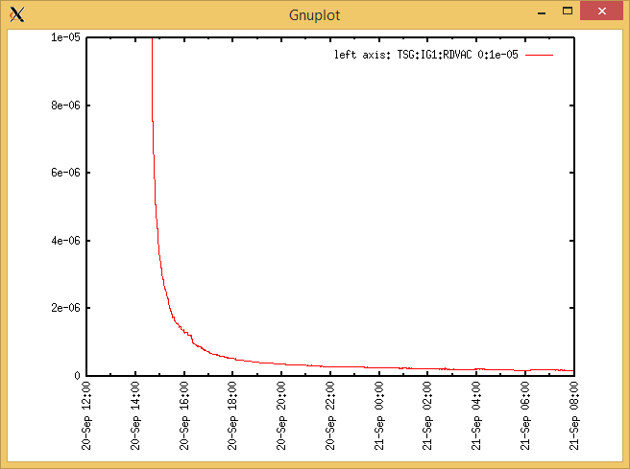

Target Heat Sequence Setup

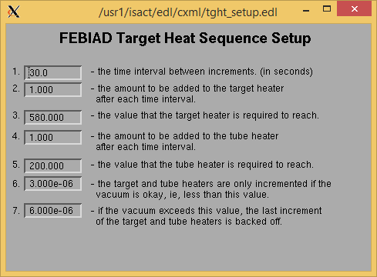

Source Tuning

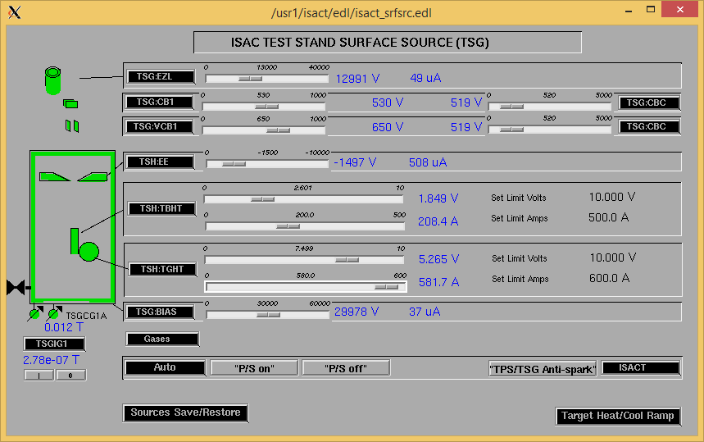Wire Scanners RPM0A and RPM0B

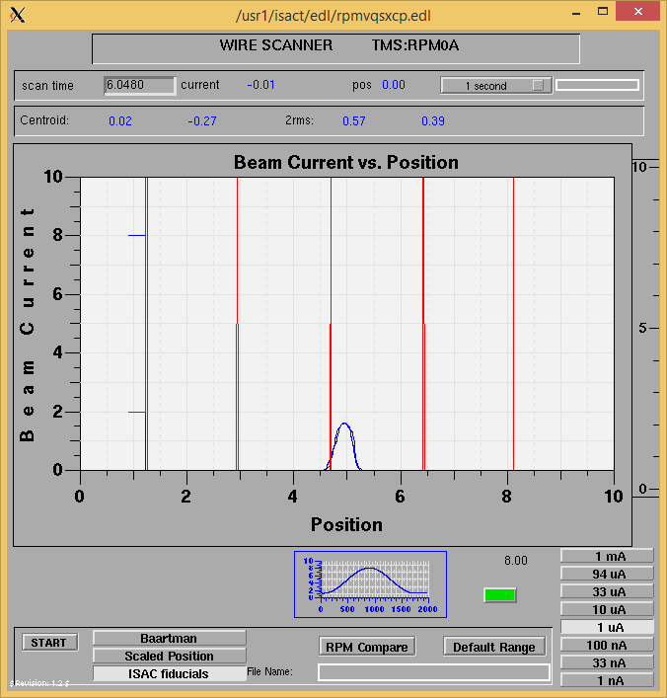

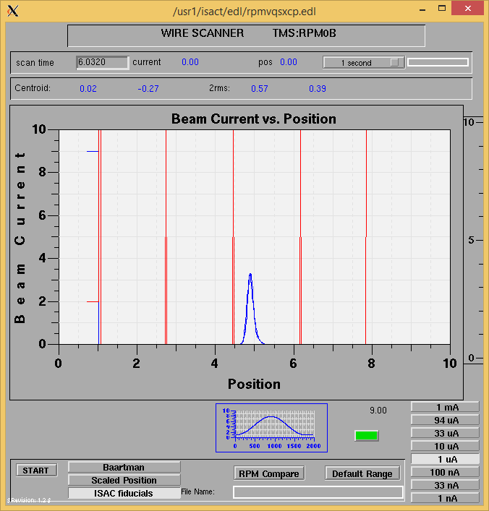

Optics Tuning

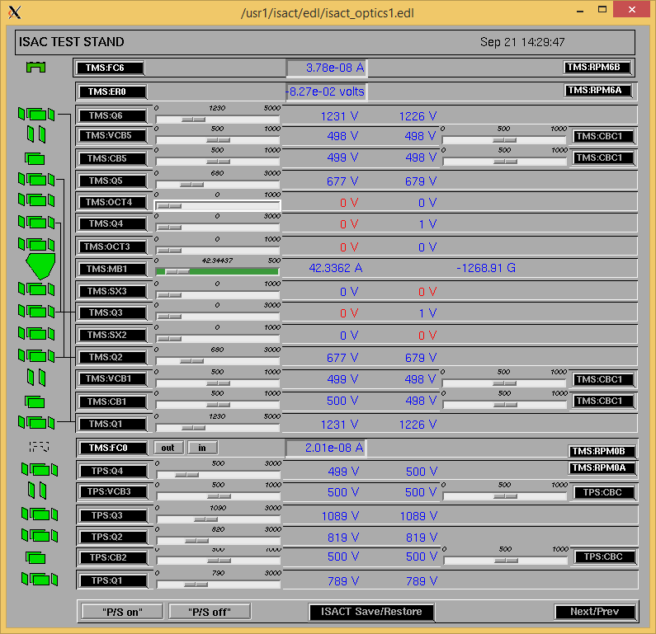

Mass 7

Wire Scanners RPM6A and RPM6B

Mass 7

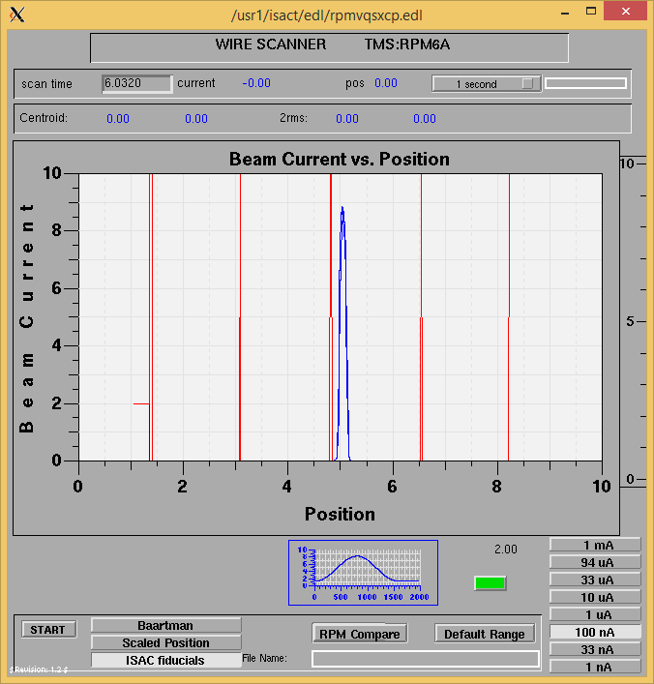

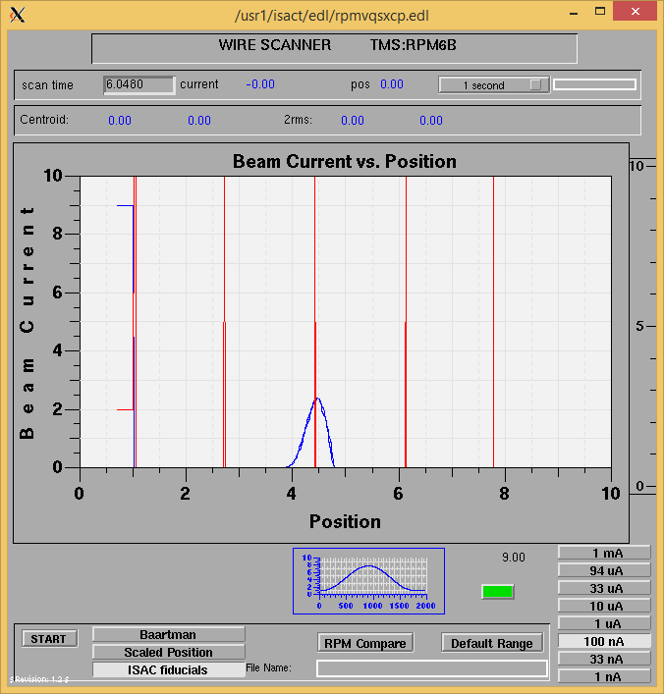

Mass 7

Mass Scan

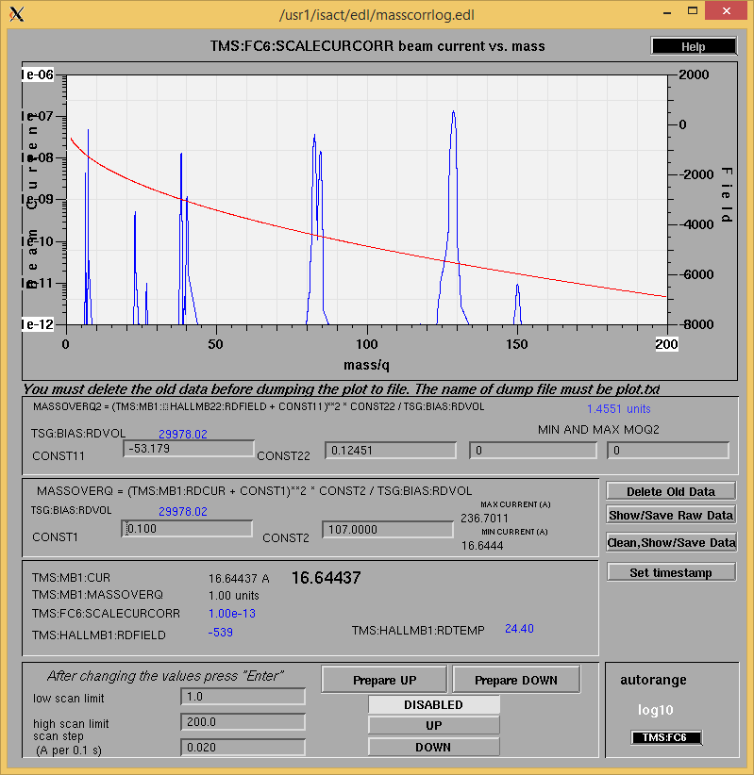

<http://isacwserv.triumf.ca/onlylocal/isactdata/save_restore/masscorr/2017-09-21-14-25%20Ta%2354>

Cooling Parameters

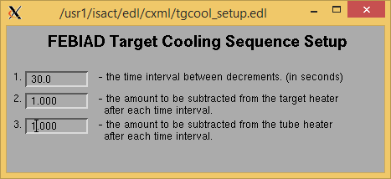

Overview Plots

Vacuum and FC0

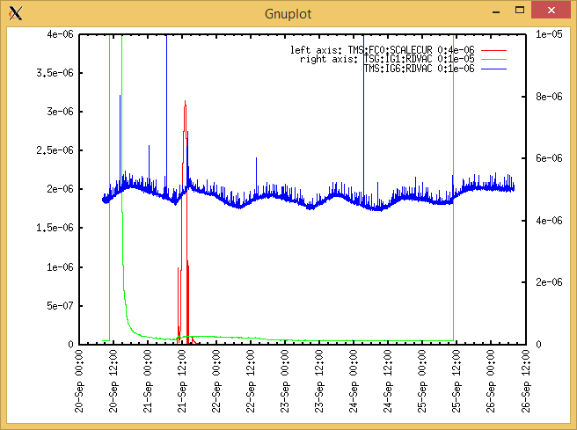

Heating, EE and BIAS

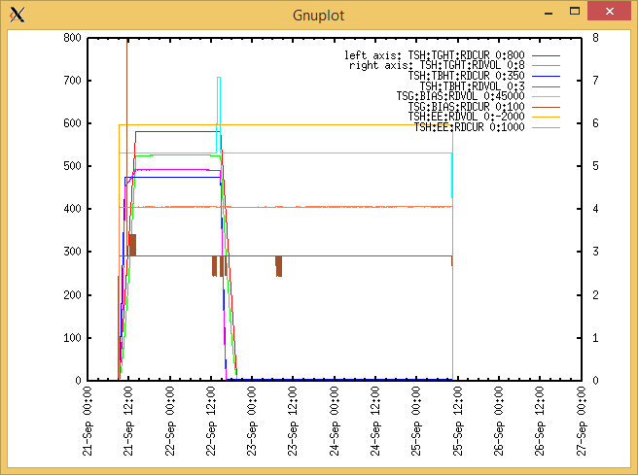

TGHT and TBHT Voltage

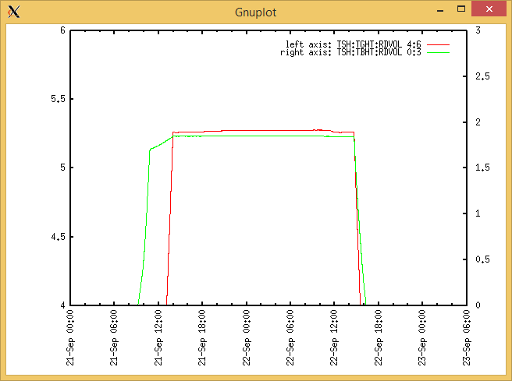

Flow and cooling water temperatures

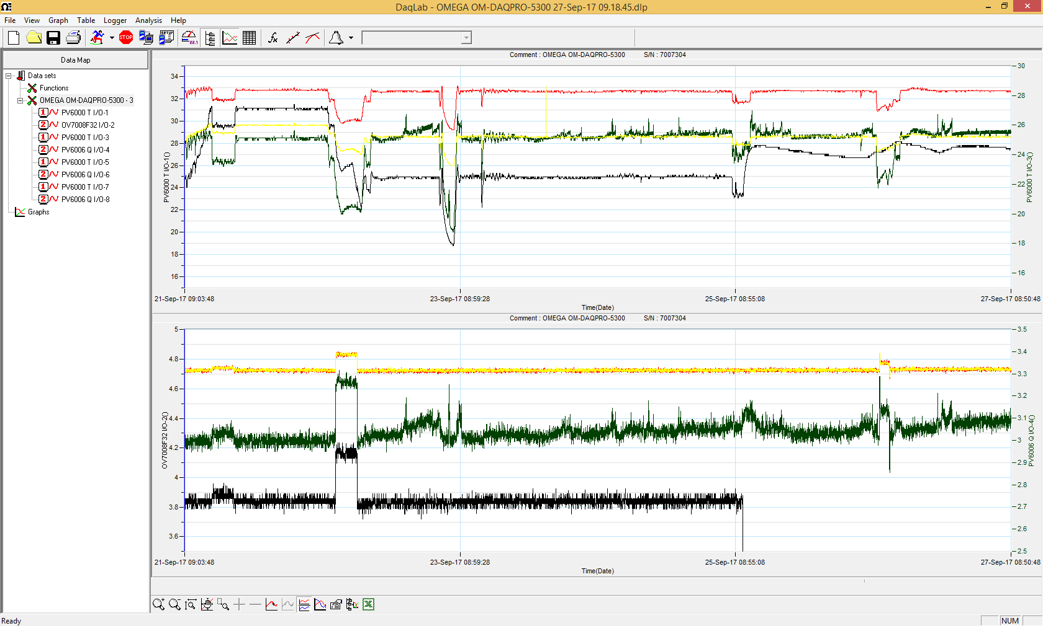

RGA

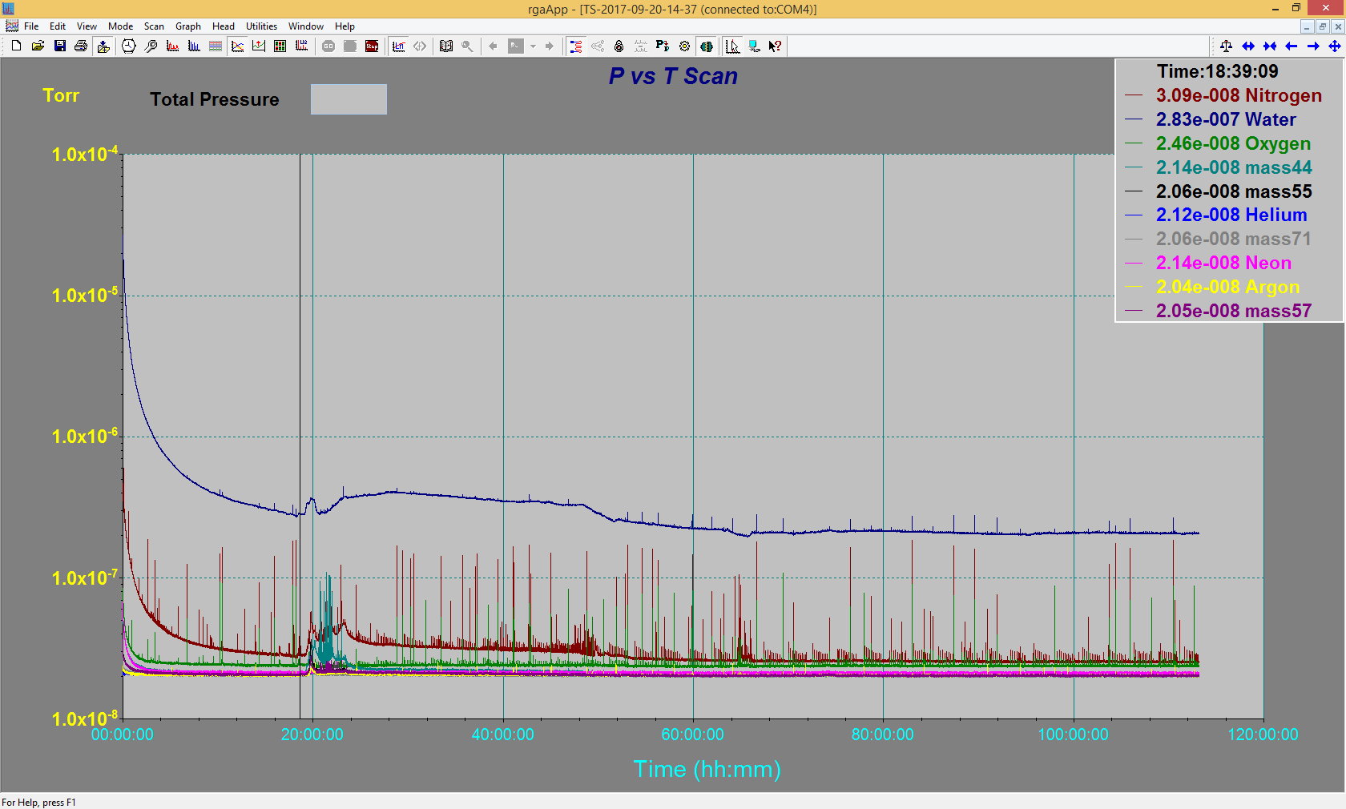

Emittance Scan

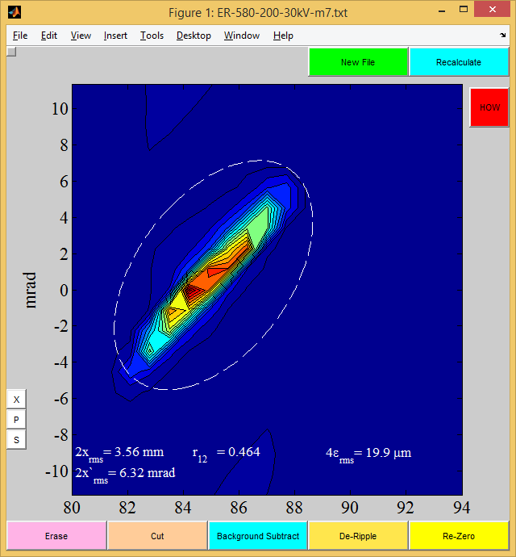

Mass 7

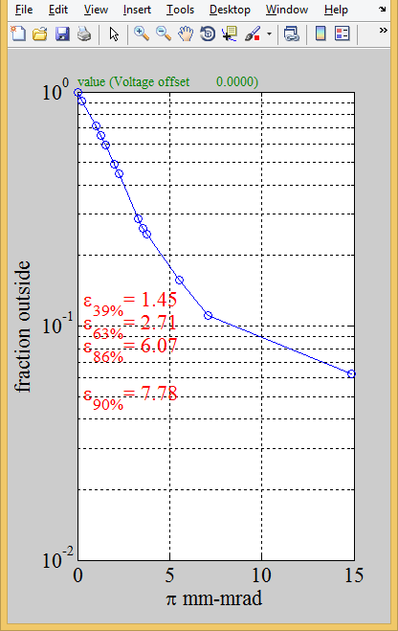

Mass 7