Conditioning Report

|  |  |  |
| --- | --- | --- |
| Target material and number | | Ta#51 |
| Target WO-SN | | 41790-4 |
| Operator name | | Aaron Schmidt |
|  | |  |
| Heating start date and time | | 2017-03-28 13:01 |
| BIAS | |  |
| Voltage [kV] | | 30 |
| Current [µA] | | 49 |
| Extraction Electrode (EE) | |  |
| Voltage [kV] | | 1.5 |
| Current [µA] | | 501 |
| TGHT | |  |
| Current [A] | | 581.7 |
| Voltage [V] | | 7.114 |
| TBHT | |  |
| Current [A] | | 228.9 |
| Voltage [V] | | 2.586 |
| FEBIAD ANODE | |  |
| Voltage [V] | | - |
| Current [mA] | | - |
| FEBIAD COIL | |  |
| Current [A] | | - |
| Voltage [V] | | - |
| Flow and Temperature HS + MSP | |  |
| Flow [lpm] | | 3.82 |
| Temperature increase [C] | | 9.4 |
| FC6 currents [A] | | 5.53e-10 |
| SIS | 7Li | 1.21e-12 |
| FEBIAD | 20Ne | - |
| SIS | 23Na | 3.44e-10 |
| SIS | 39K | 1.17e-09 |
| SIS | 85Rb | 1.75e-10 |
| SIS | 133Cs | 3.31e-10 |
| Heating end date and time | | 2017-03-30 08:42 |

Comments

* Monday, March 27, 2017, 09:50: Troubleshooting: Sources/Optics non-responsive. Controls group fixed : Tuesday, March 28, 2017, 12:57
* Wednesday, March 29, 2017, 15:15: E-rig power supply failed. Pop sound and electrical smoke/smell noticed.

Plots

8h Vacuum Pump Down

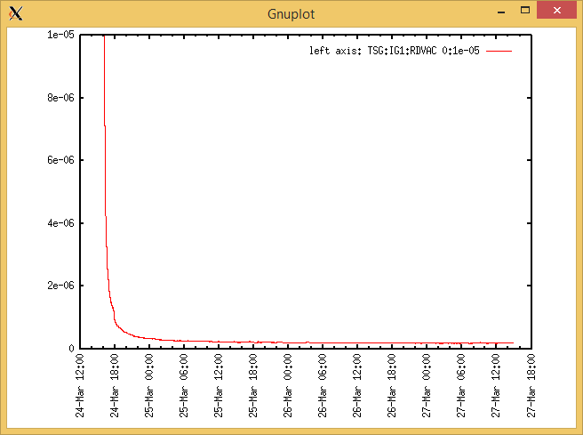

Target Heat Sequence Setup

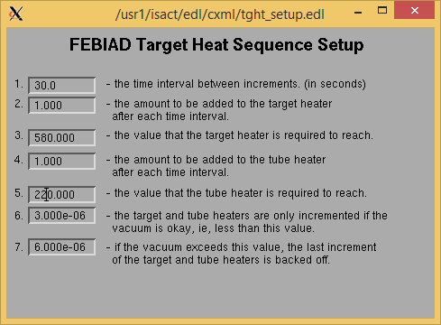

Source Tuning

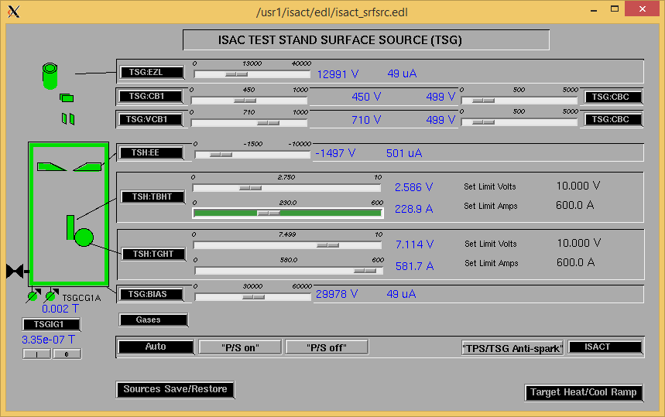

Wire Scanners RPM0A and RPM0B

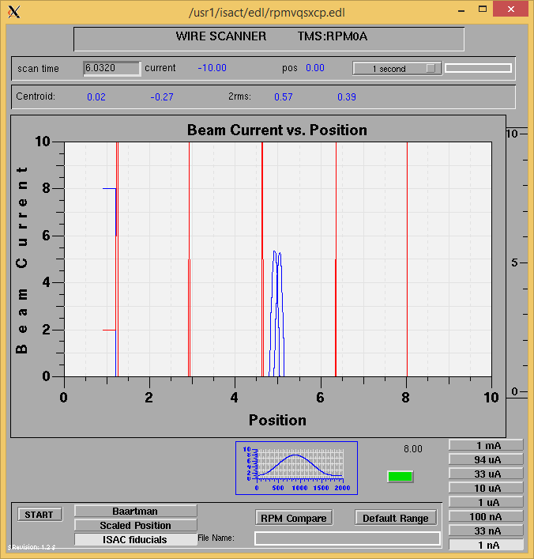

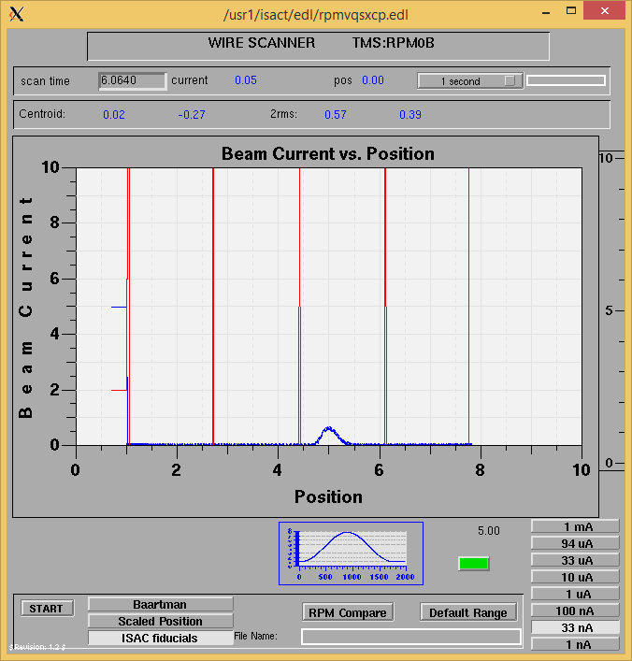

Optics Tuning

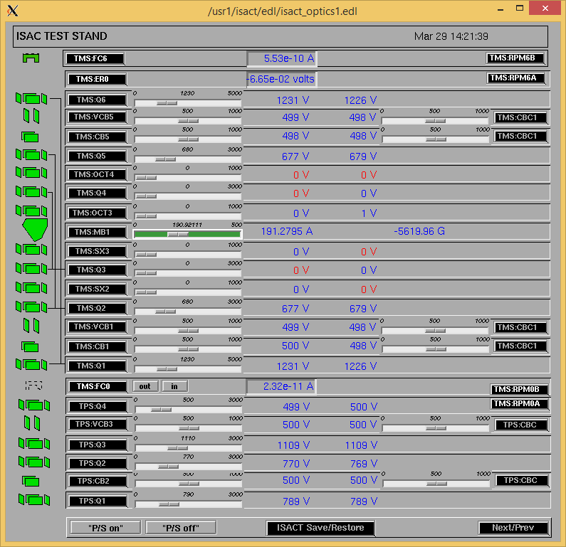

Mass 133

Wire Scanners RPM6A and RPM6B

Mass 133

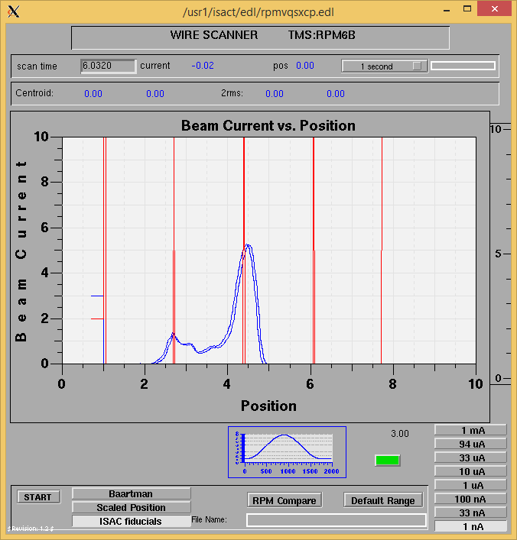

Mass 133

Mass Scan

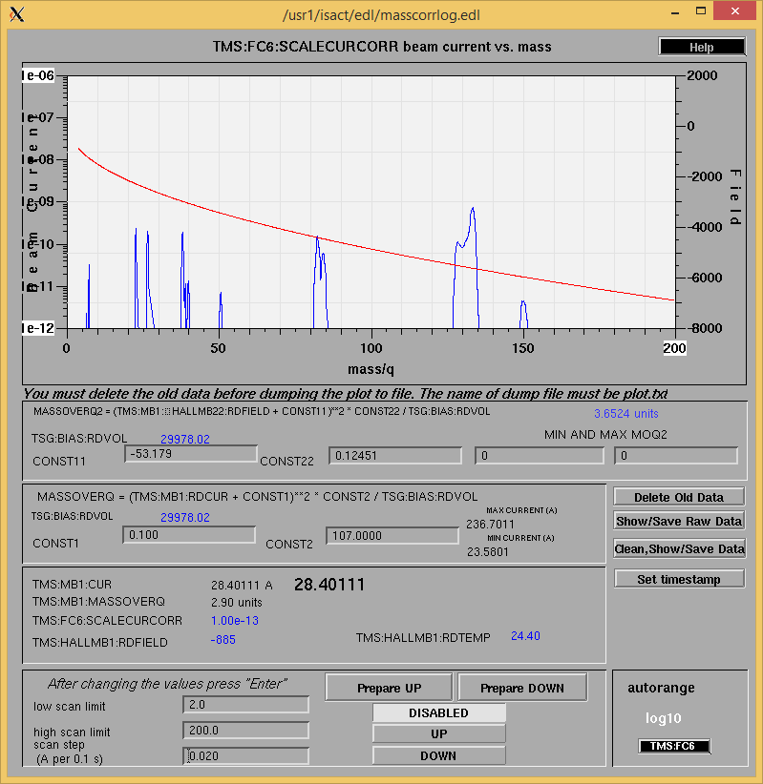

<http://isacwserv.triumf.ca/onlylocal/isactdata/save_restore/masscorr/2017-03-29-13-53%20Ta%2351>

Cooling Parameters

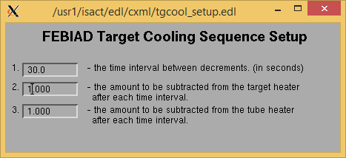

Overview Plots

Vacuum and FC0

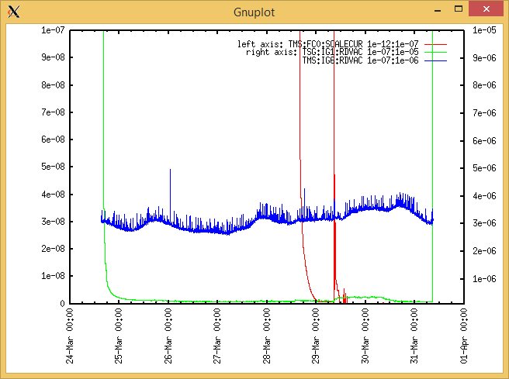

Heating, EE and BIAS

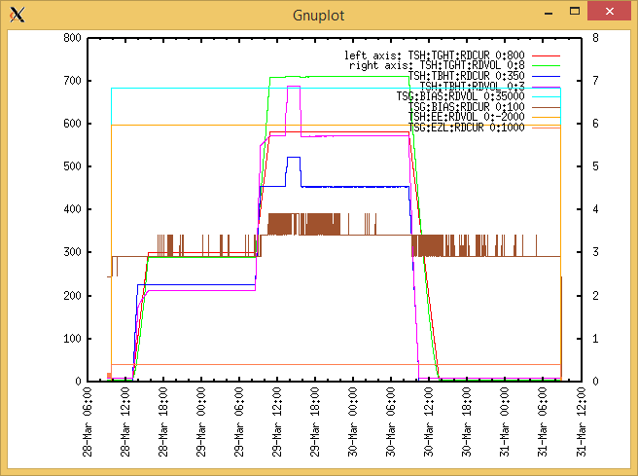

TGHT and TBHT Voltage

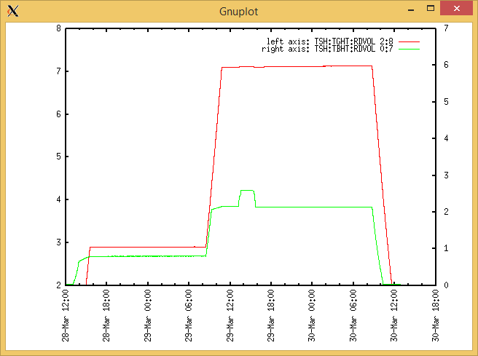

Flow and cooling water temperatures

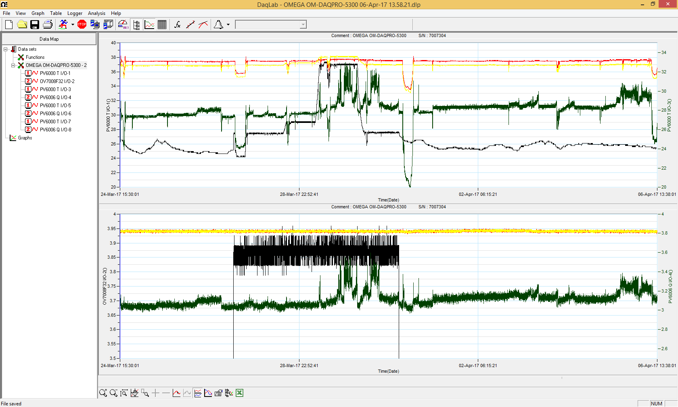

RGA

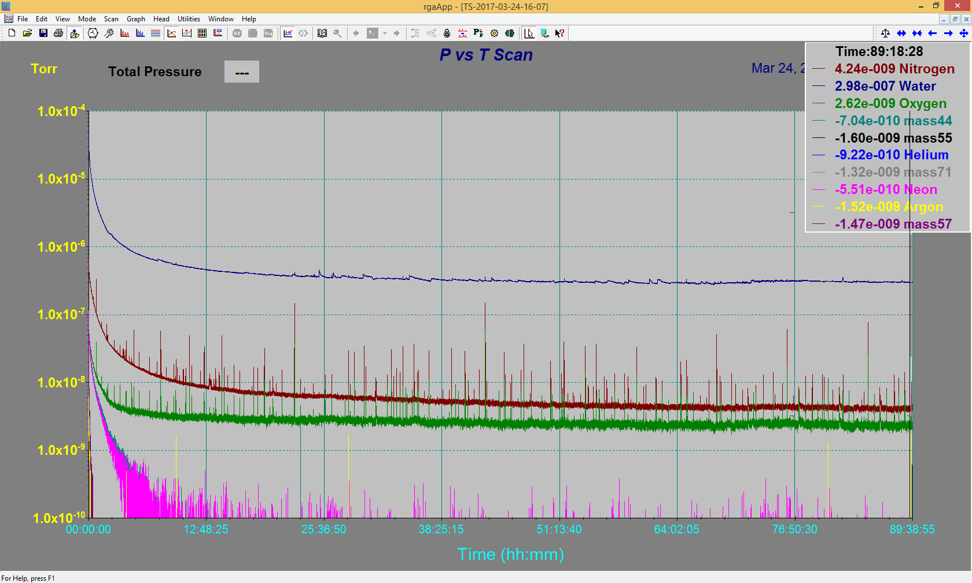

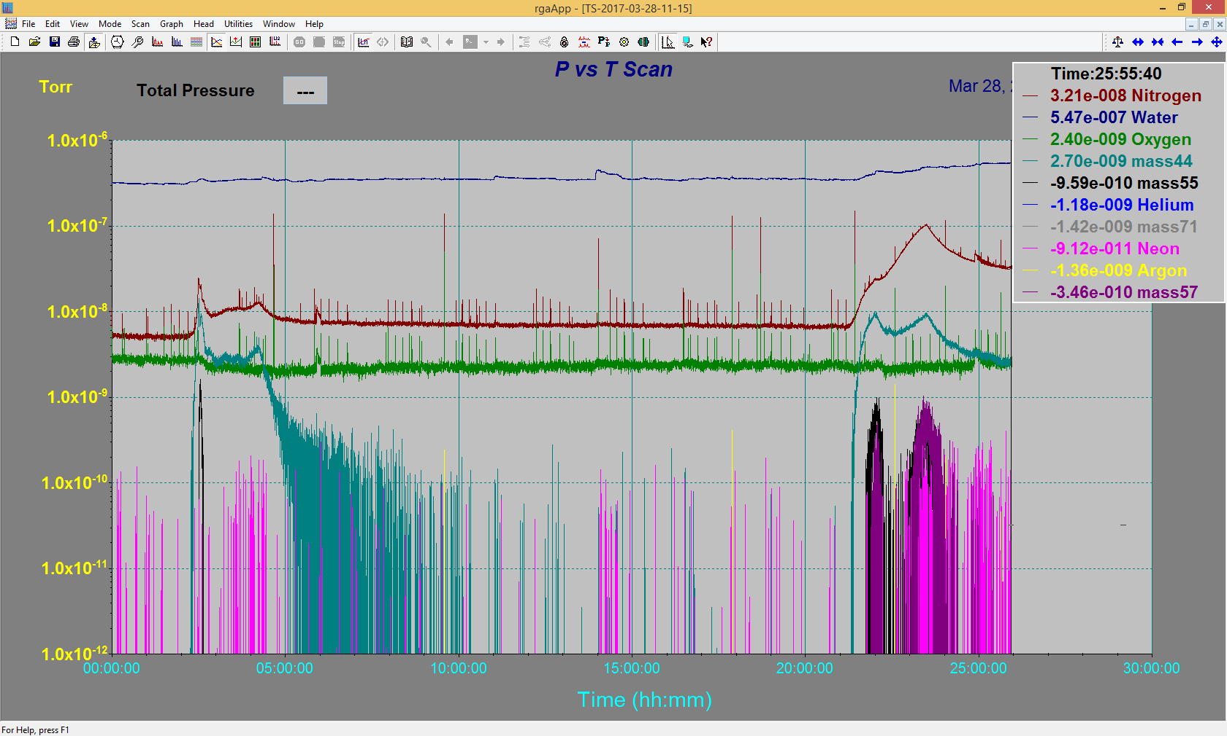

Emittance Scan

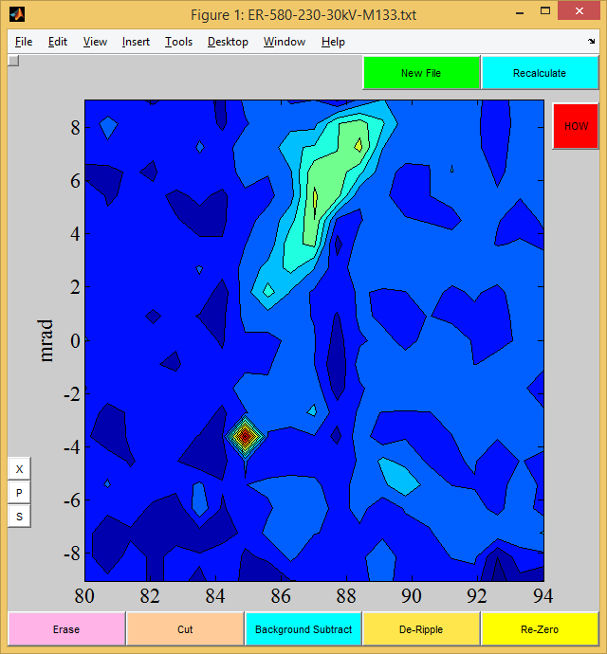

Mass 133

