Conditioning Report

|  |  |  |
| --- | --- | --- |
| Target material and number | | Ta#52 |
| Target WO-SN | | 42218-14 |
| Operator name | | Aaron Schmidt |
|  | |  |
| Heating start date and time | | 2017-06-12 08:18 |
| BIAS | |  |
| Voltage [kV] | | 30 |
| Current [µA] | | 37 |
| Extraction Electrode (EE) | |  |
| Voltage [kV] | | 1.5 |
| Current [µA] | | 518 |
| TGHT | |  |
| Current [A] | | 581.7 |
| Voltage [V] | | 7.048 |
| TBHT | |  |
| Current [A] | | 198.7 |
| Voltage [V] | | 2.190 |
| FEBIAD ANODE | |  |
| Voltage [V] | | - |
| Current [mA] | | - |
| FEBIAD COIL | |  |
| Current [A] | | - |
| Voltage [V] | | - |
| Flow and Temperature HS + MSP | |  |
| Flow [lpm] | | 3.78 |
| Temperature increase [C] | | 9.90 |
| FC6 currents [A] | | 6.41e-09 |
| SIS | 7Li | -Comment* |
| FEBIAD | 20Ne | - |
| SIS | 23Na | -* |
| SIS | 39K | -* |
| SIS | 85Rb | -* |
| SIS | 133Cs | -* |
| Heating end date and time | | 2017-06-13 14:50 |

Comments

-The Mass Correlations data was not properly dumped to file and saved. However there were multiple screenshots made of various mass scans throughout Ta#52’s conditioning providing a visual representation of the data.

Plots

8h Vacuum Pump Down

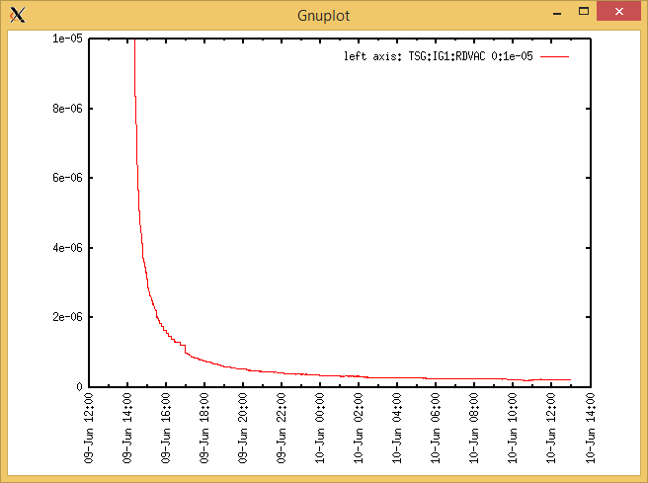

Target Heat Sequence Setup

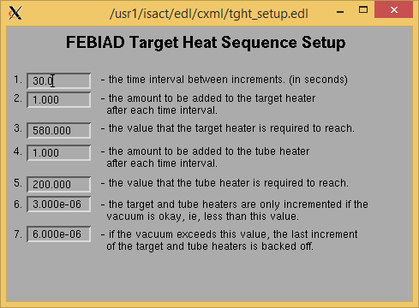

Source Tuning

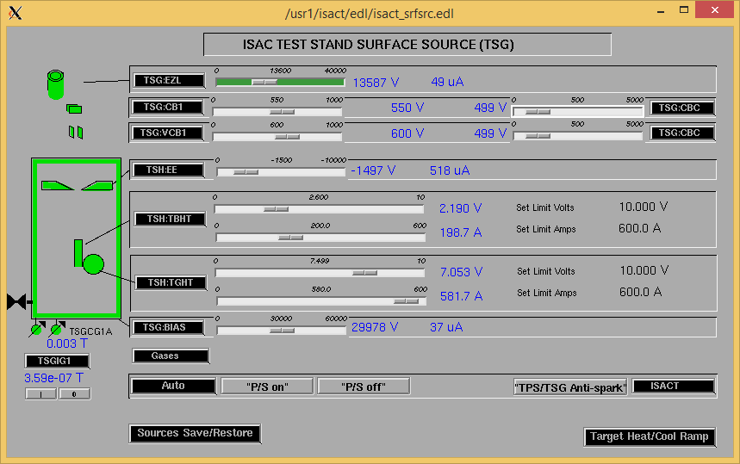

Wire Scanners RPM0A and RPM0B

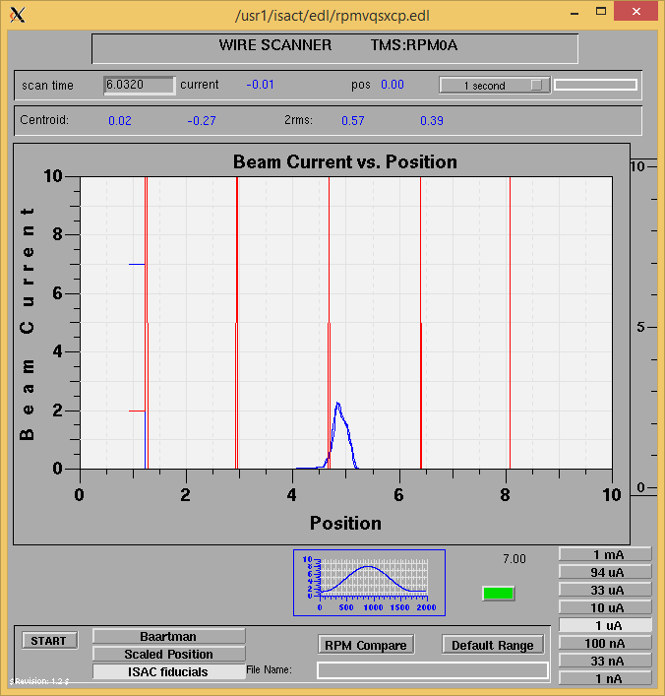

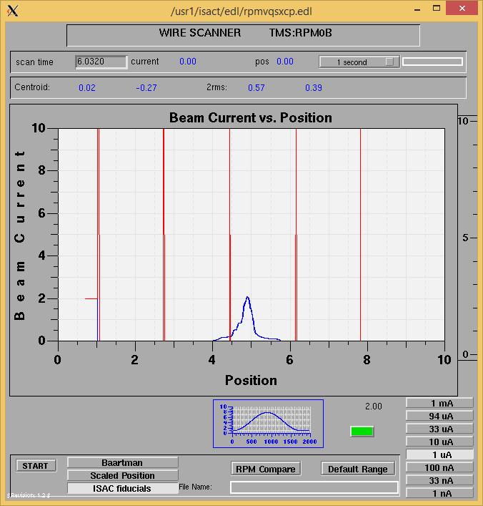

Optics Tuning

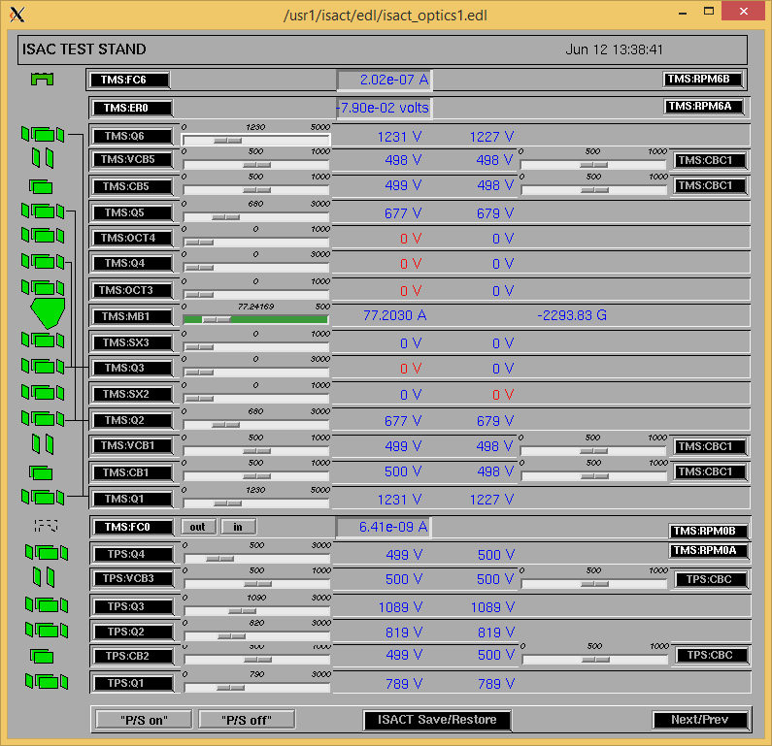

Mass 23

Wire Scanners RPM6A and RPM6B

Mass 23

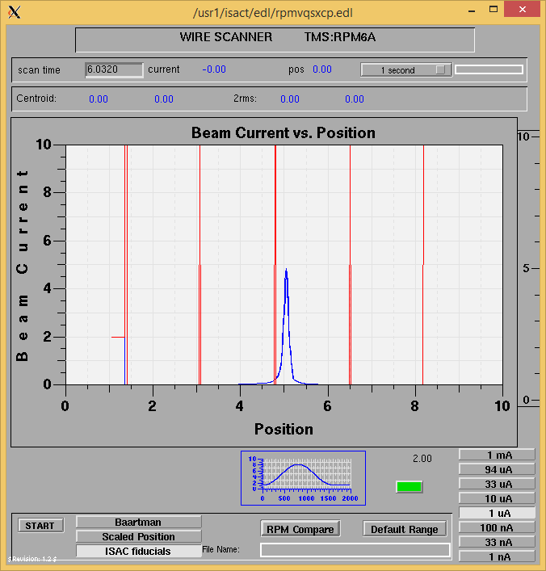

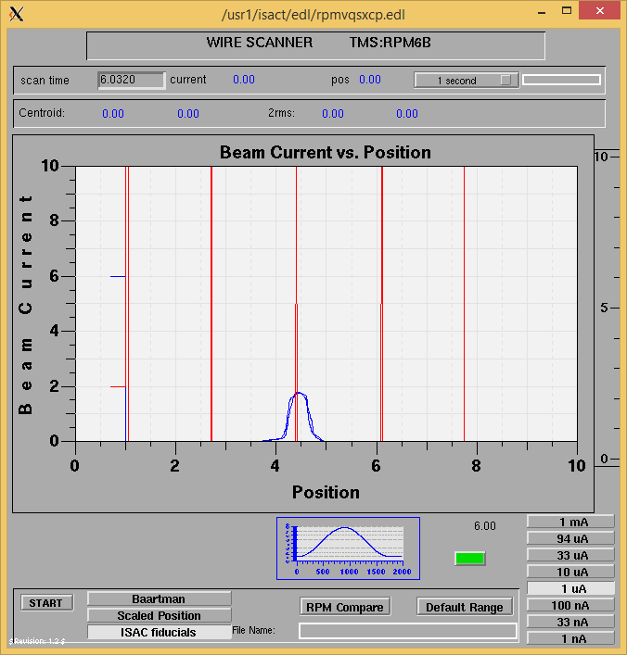

Mass 23

Mass Scan

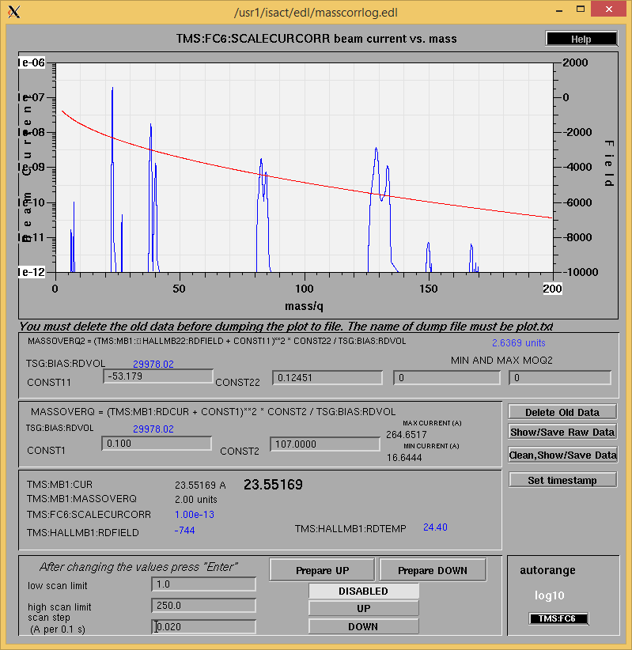

June 12, 2017, 13:15

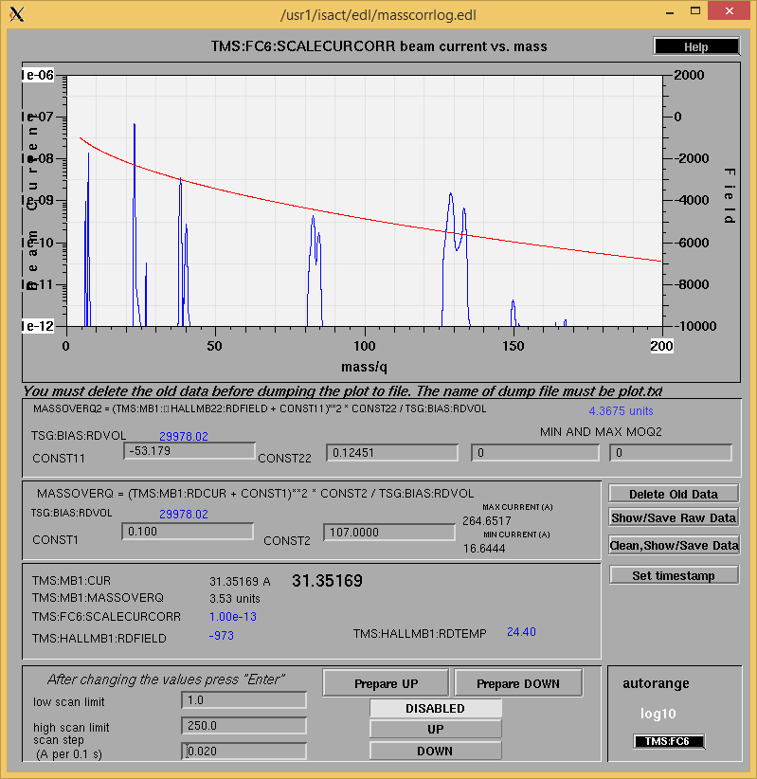

June 12, 2017, 14:30

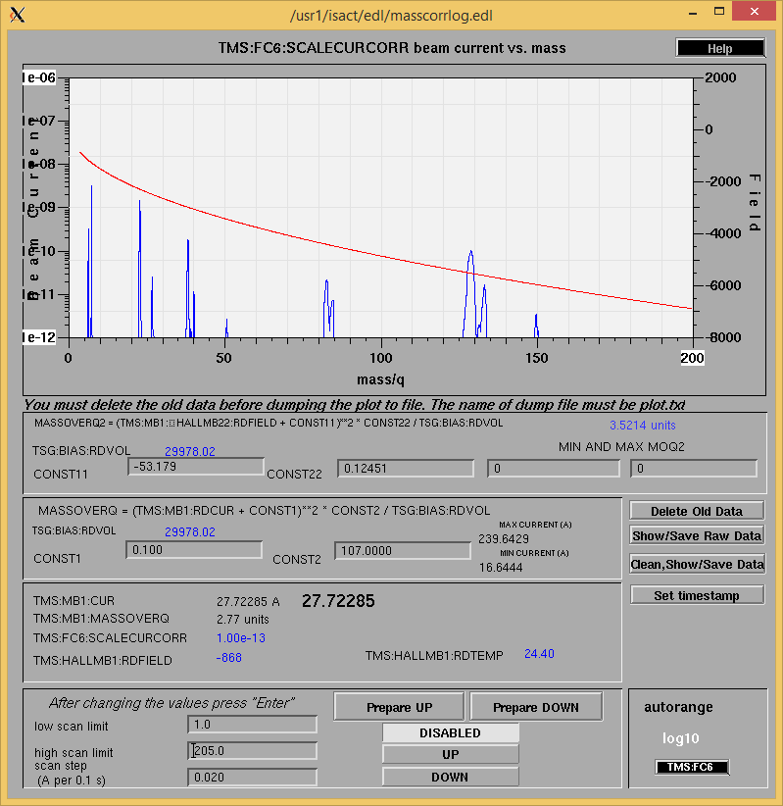

June 13, 2017, 8:23

Cooling Parameters

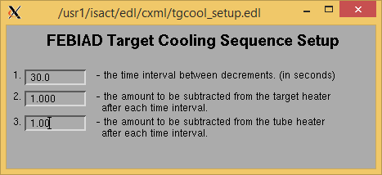

Overview Plots

Vacuum and FC0

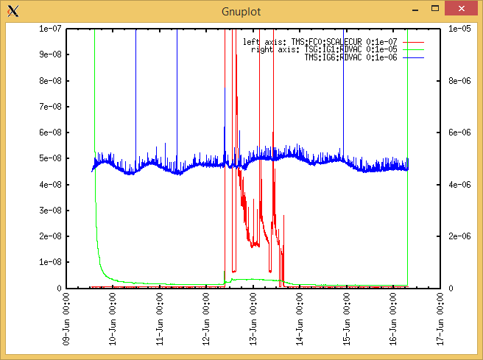

Heating, EE and BIAS

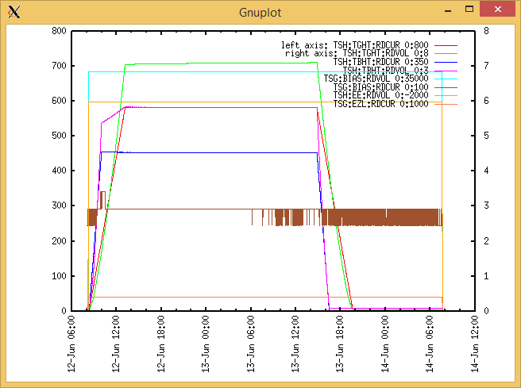

TGHT and TBHT Voltage

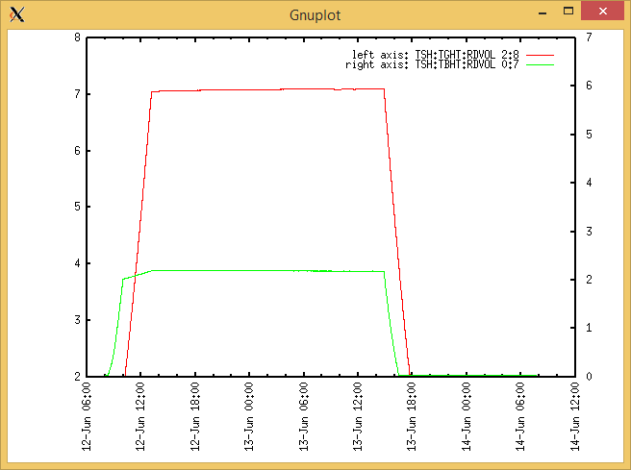

Flow and cooling water temperatures

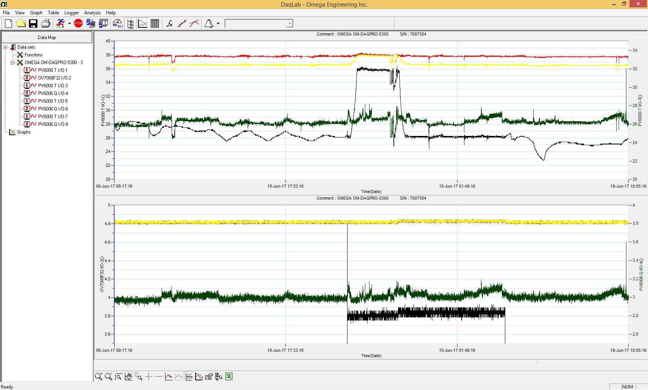

RGA

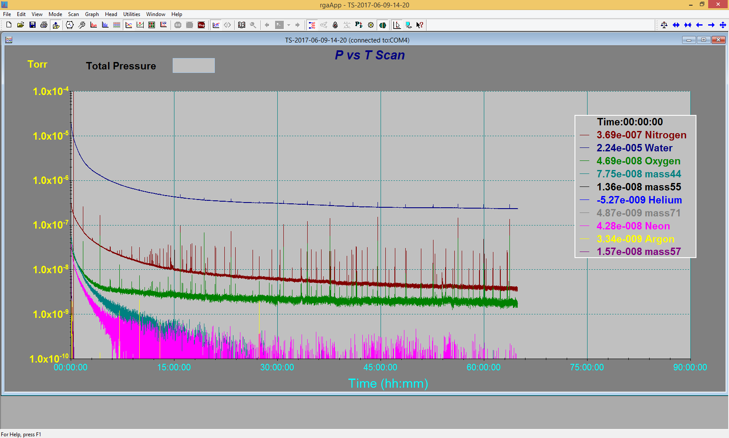

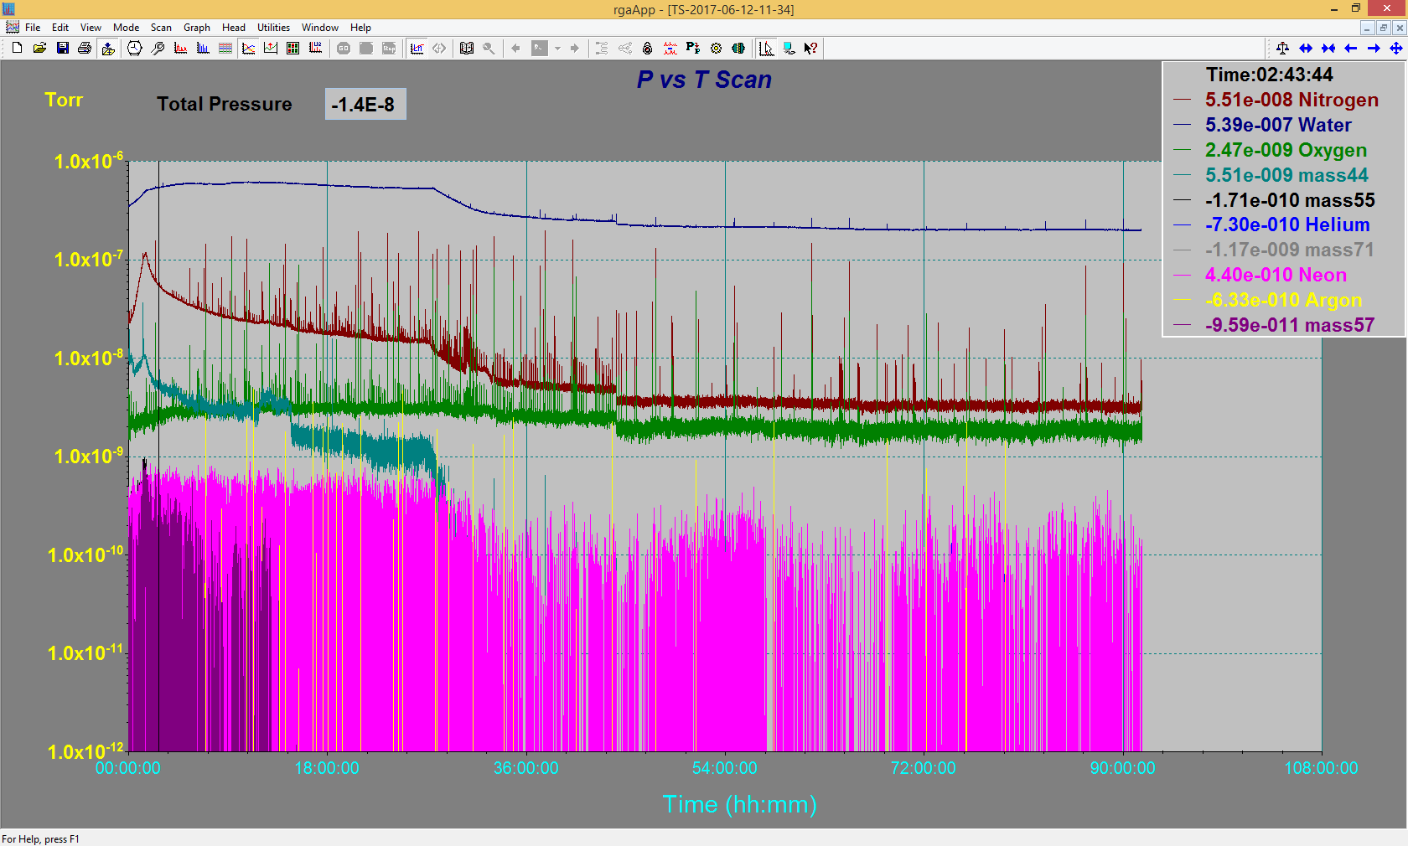

Emittance Scan

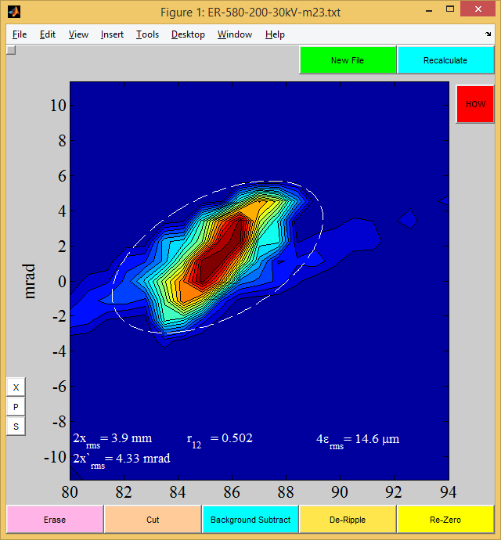

Mass 23

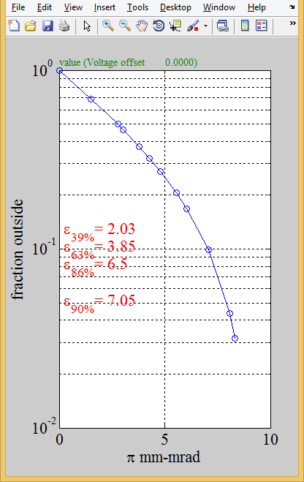

Mass 23

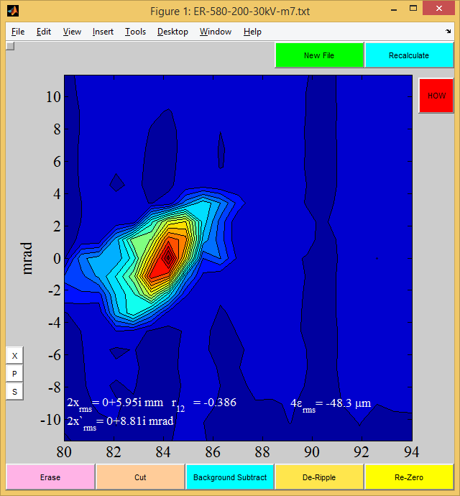

Mass 7

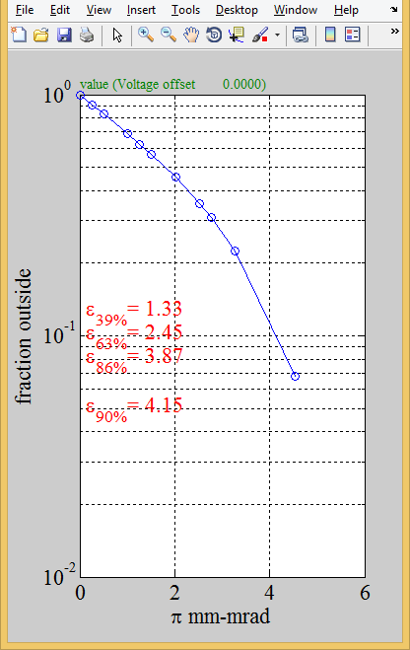

Mass 7