Issues

-TSG:TP1B & TSG:BV1B tripped

-Leak on FS#3 COIL and EE

-Vacuum Leak on front door of ISAC Test stand. (Fixed) 4/10/2017

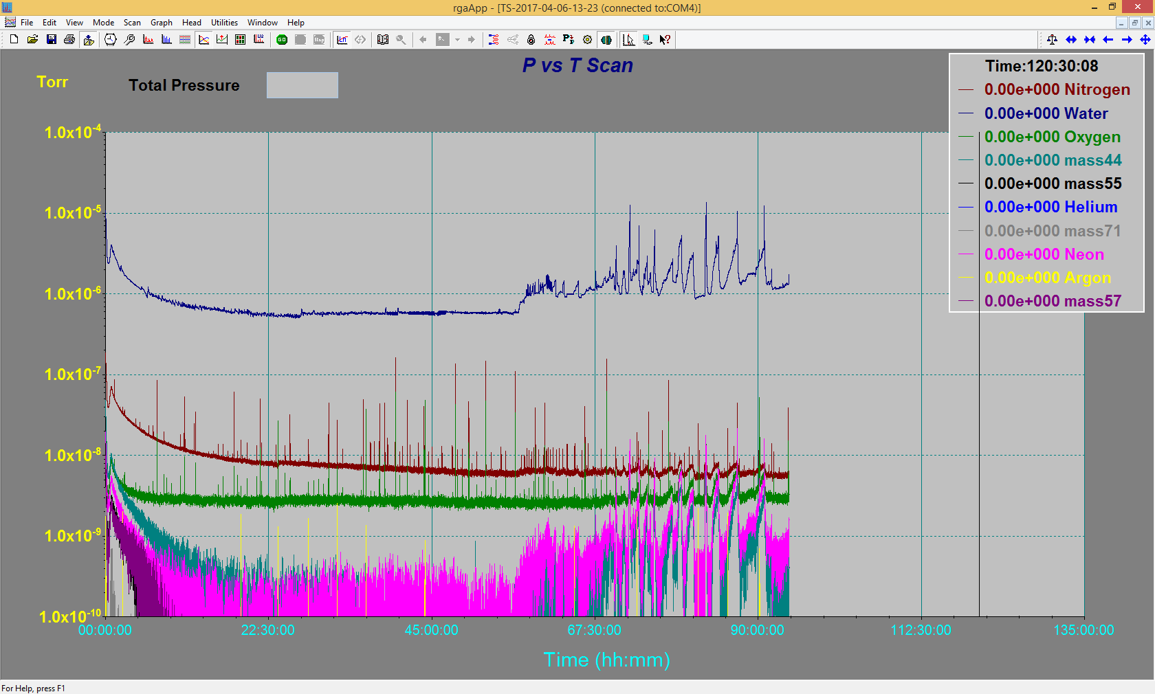

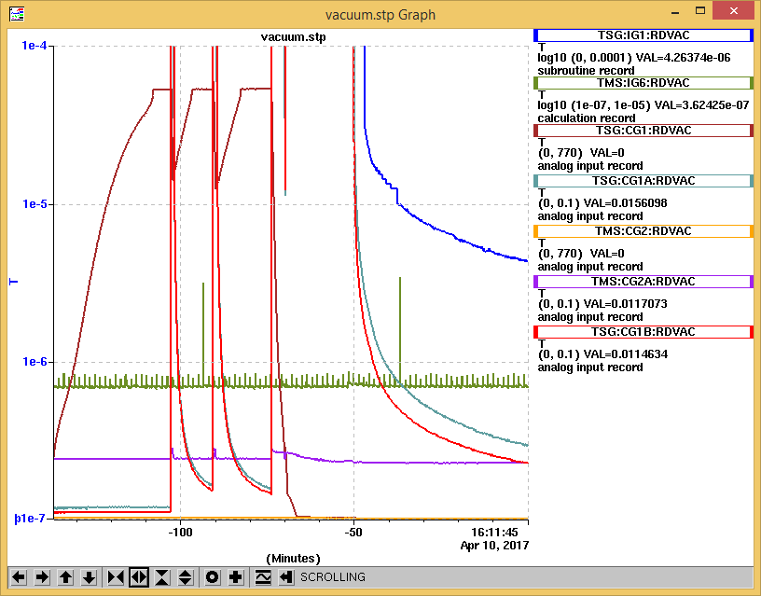

Figure : Leaky door

The vacuum behaved erratic over night with excursion up into the mid 10^-6 Torr range. To investigate the chamber was vented. With the doors open, the o-rings and sealing surfaces were cleaned. When pumping down again a vacuum leak could be heard at the front door by the lock. The chamber was vented again twice, finally the two o-rings were swapped. This removed the large leak. The door is prevented from contacting the box at the lock, which is likely the source of the leak.

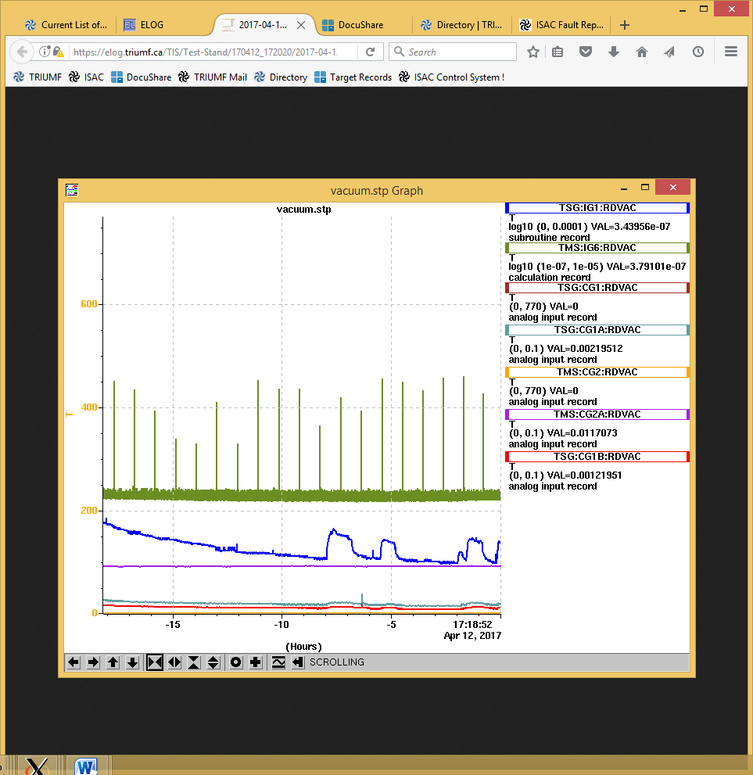

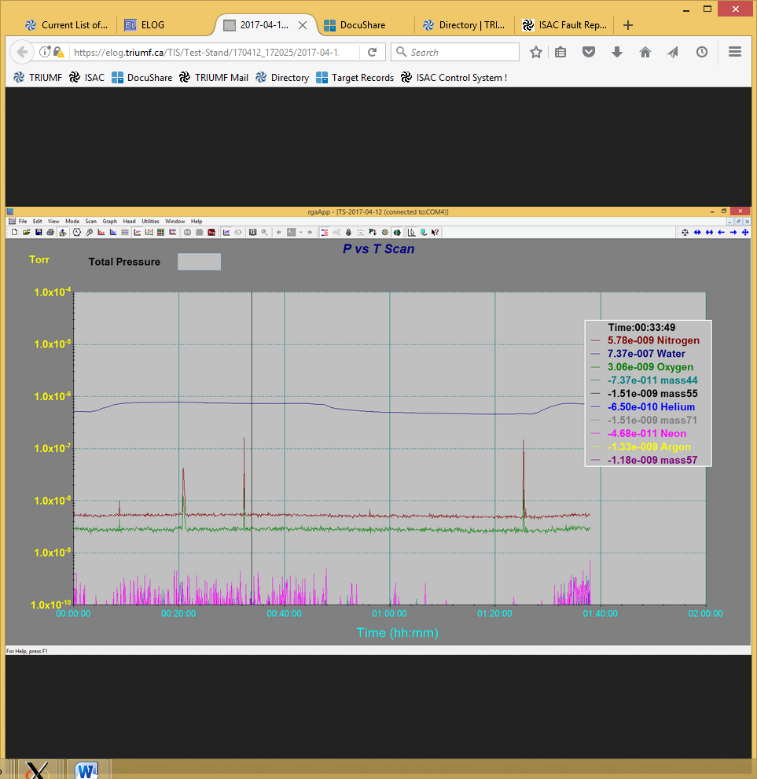

A water to vacuum leak has been found on FS#3. The leak is not detected on the leak detector, but can be seen as an increase in vacuum and on partial water pressure on the RGA

Wednesday, April 12, 2017, 17:11: The leak is on circuit EG (Coil +). Confirmed with water pressure

Wednesday, April 12, 2017, 17:21: RGA off. Turbos stopped.

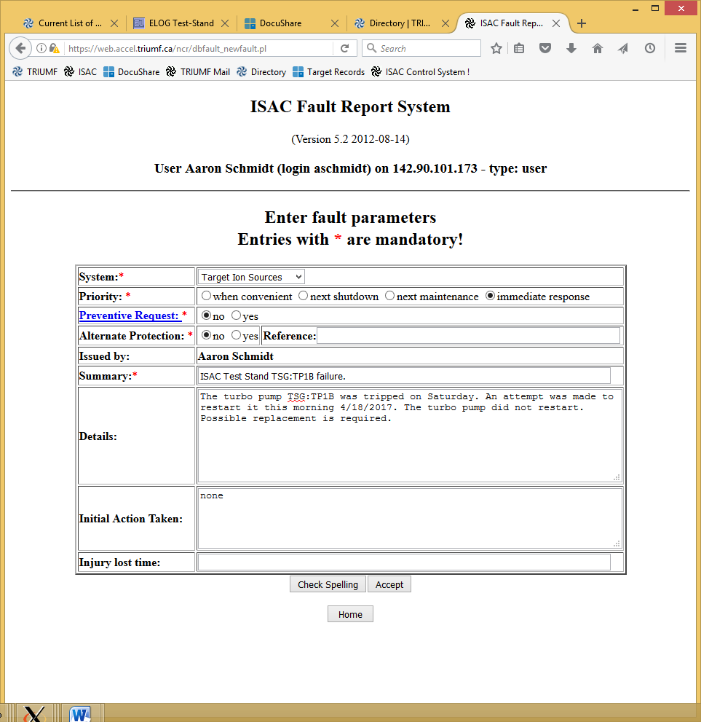

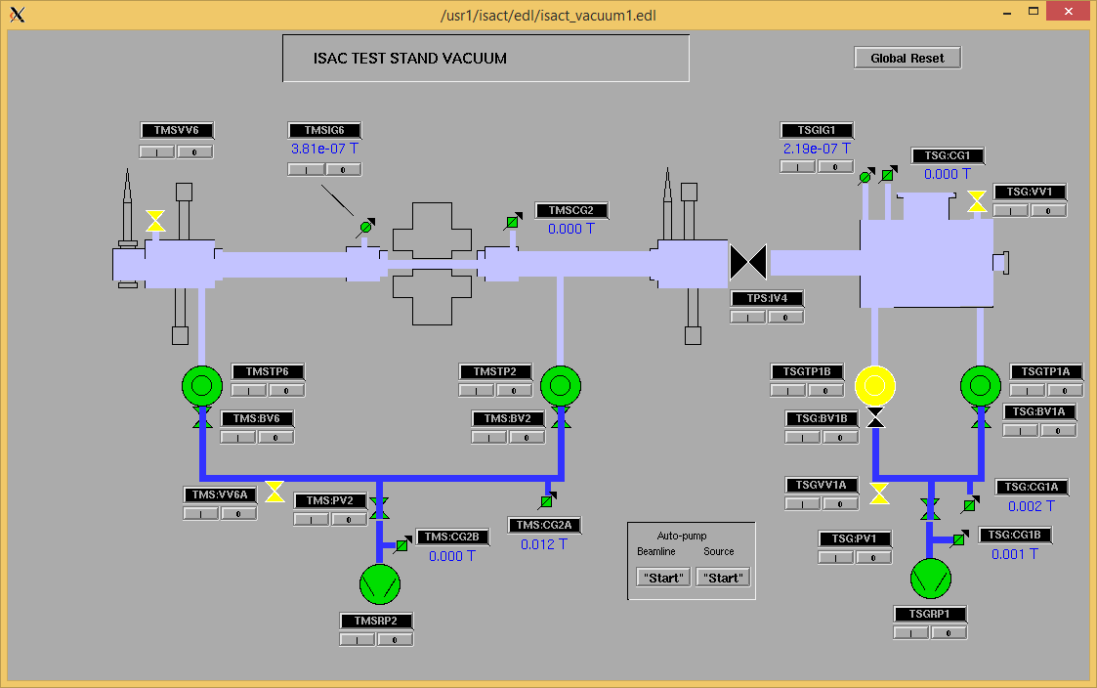

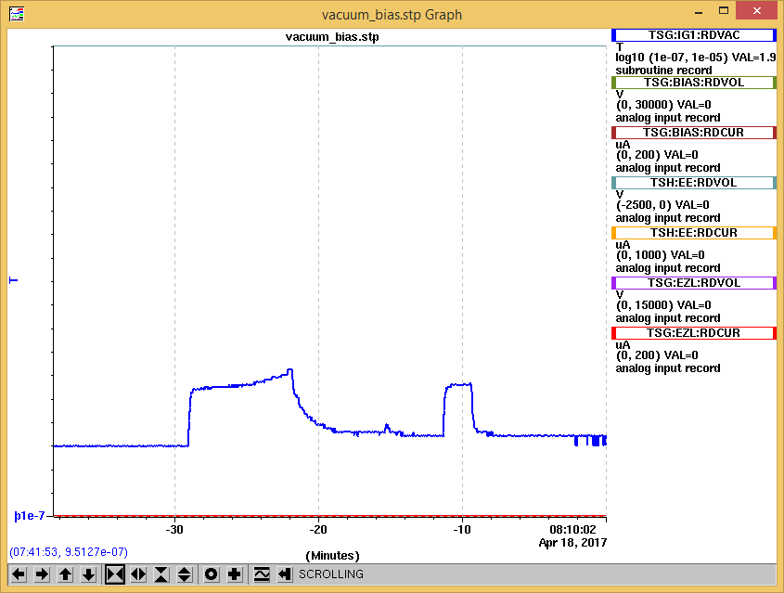

Tuesday, April 18, 2017, 07:30: TSG : TP1B Tripped on Saturday.

Tuesday, April 18, 2017, 07:40: TSG : BV1B opened. TSG : TP1B restarted.

Tuesday, April 18, 2017, 07:48: TSG : TP1B failed to restart.Turn off.

Tuesday, April 18, 2017, 07:59: TSG : BV1B opened. TSG : TP1B restart attempt. No audible response detected.

Tuesday, April 18, 2017, 08:01: The turbo pump is off and BV1B closed. Fault report entered #9815.

Tuesday, April 18, 2017, 09:40: Ion gauge, remaining turbo pump off.

Vacuum group has been notified and replacement of the turbo pump should occur within the next day or so. Leak detection port between TSG : TP1B & RP1. TSG:BV1B Closed due to turbo pump failure.

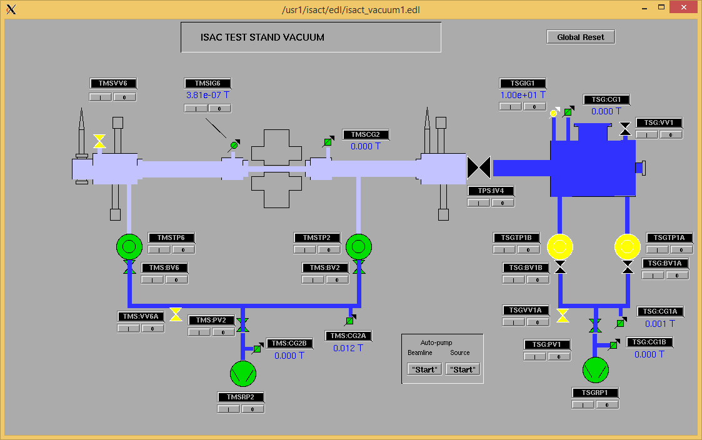

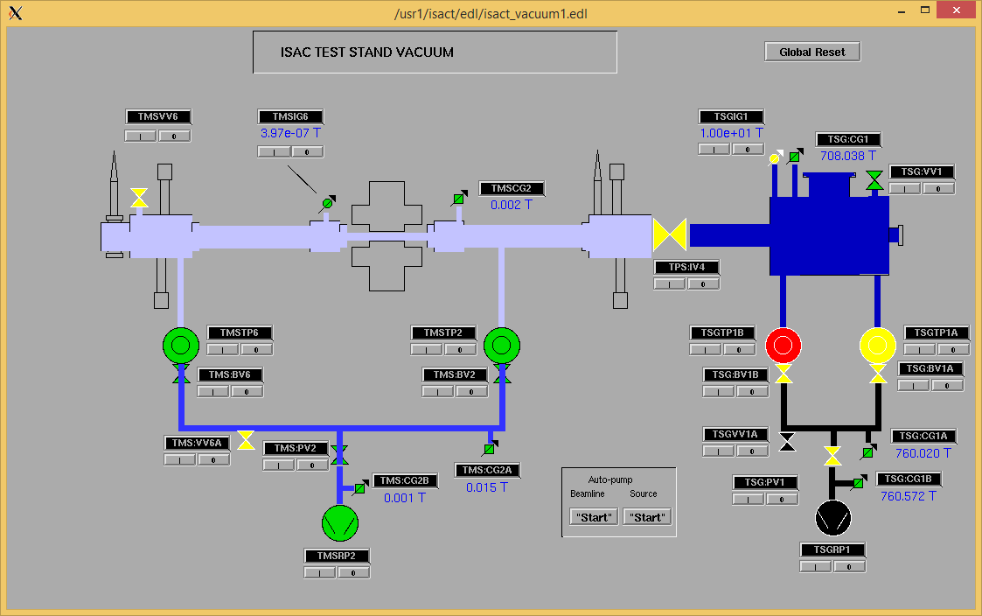

Tuesday, April 18, 2017, 13:00: Vacuum Group arrival to changed TSG : TP1B.

Once the turbo pump cooling line was loosened slightly, a slight water leak occurred. Line snapped. Water leak. Valves to all turbo pump cooling closed.

\*\*\*NOTE\*\*\* - From Thursday, November 24, 2016, 08:05: TMS:TP2

Friday, November 25, 2016, 14:45: Turbos at speed. Vacuum at 1.9E-5 T

\*\*\* Note \*\*\* : One of the copper cooling lines was leaking. The line was fixed. Monitor. <---- Due to this recurring issue, the decision was made to air cool the turbo pumps.

Tuesday, April 18, 2017, 14:10: Air cooling to replace water cooling. TSG : TP1A already has air cooling. Replace the cooling on the other 3 of 4 turbo pumps.

Wednesday, April 19, 2017, 07:57: Roughing.

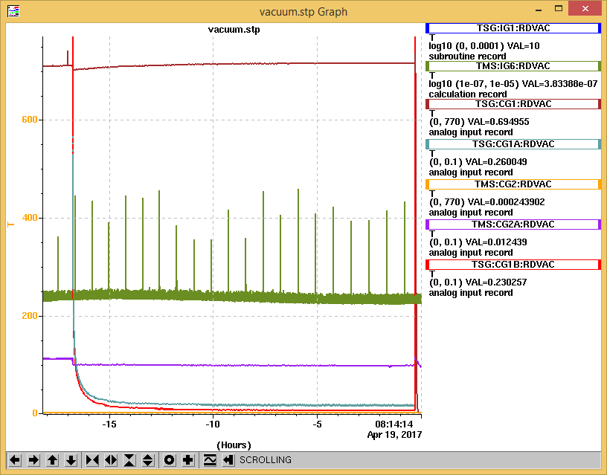

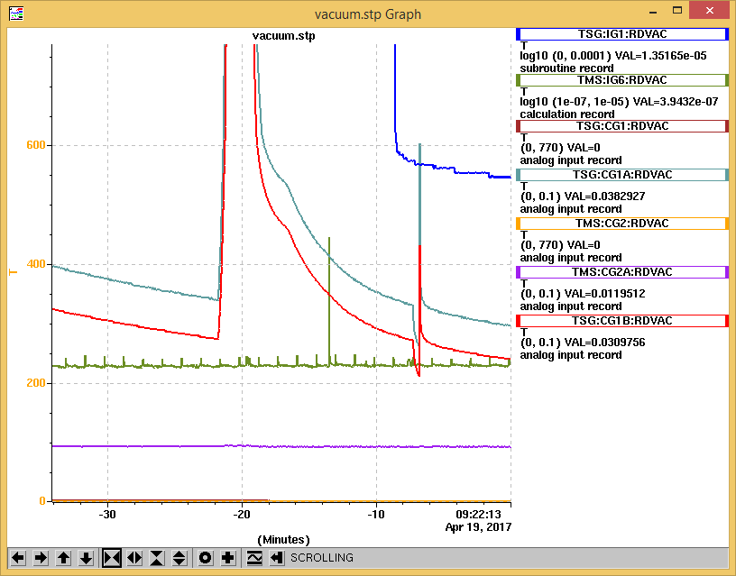

Wednesday, April 19, 2017, 11:04: Roughing.

Wednesday, April 19, 2017, 11:44: TSG :TP1A on.

Wednesday, April 19, 2017, 11:51: TSG :TP1B on.

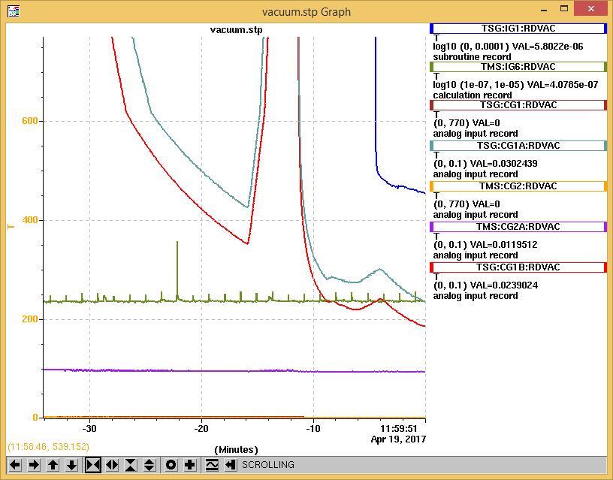

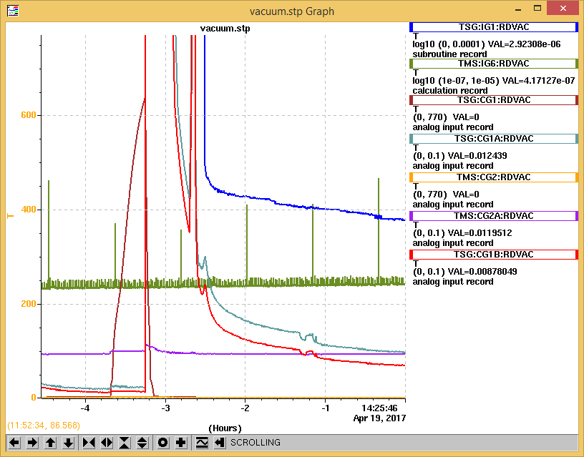

Thursday, April 20, 2017, 09:23: Water lines (E) (G) removed w/ block. Pump down to complete 1 more He test

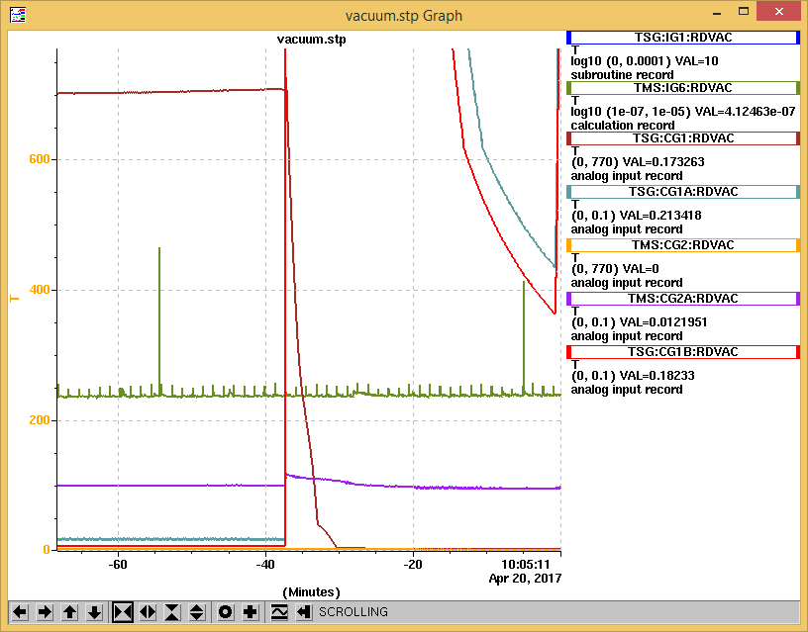

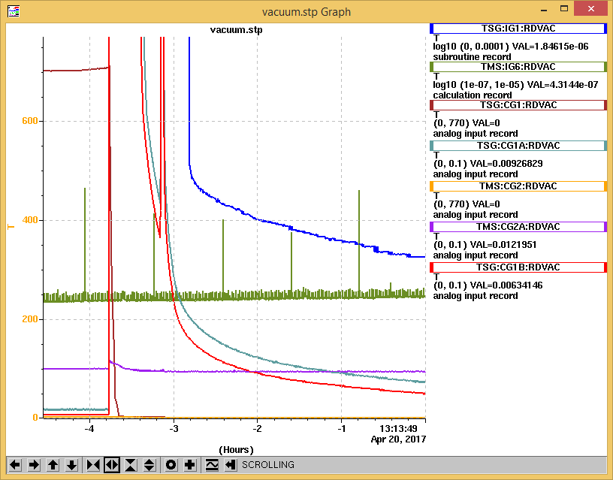

Wednesday, April 19, 2017, 14:31: Response on leak detector. Base leak rate: 2.3E-08 atm-cc/sec . Increase to 5.9E-08 atm-cc/sec on detector over 10 minutes. Lines charged with He to 30 PSI.

Leak rate continued to climb beyond 6.0E-08 atm-cc/sec over 20 minutes.No response on RGA.

Wednesday, April 19, 2017, 14:36: Manual valve closed. Leak detector off. RGA off.

Wednesday, April 19, 2017, 14:37: FS#3 purged.

Wednesday, April 19, 2017, 14:39: Ion gauge off. Turbos off.

Wednesday, April 19, 2017, 14:44: Leak detector disconnected.

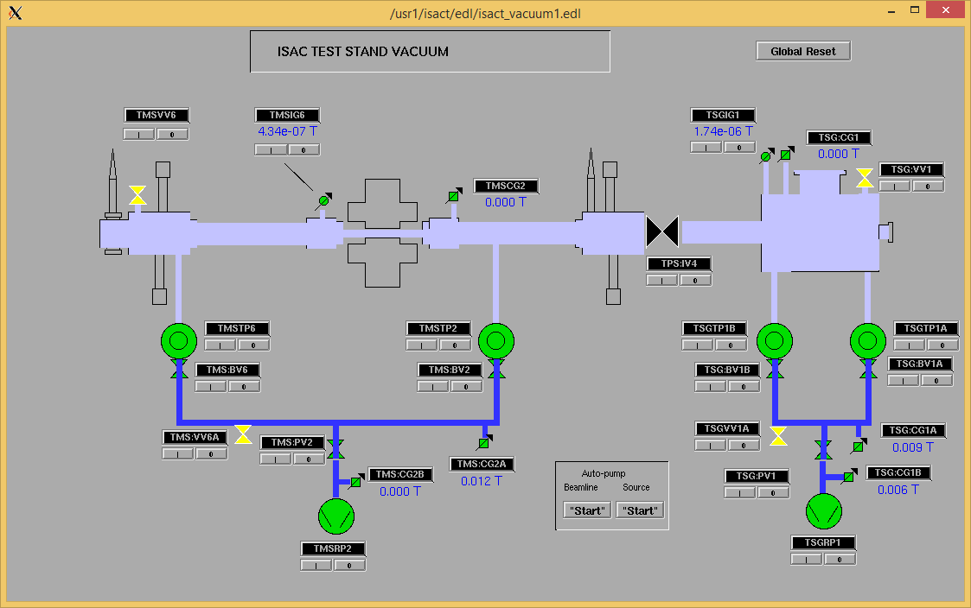

Thursday, April 20, 2017, 13:15: Leak detector attached & turned on. Base leak rate: 1.6E-07 atm-cc/sec

Thursday, April 20, 2017, 13:25: Water lines FS#5 opened to create loop. Pressurized @ 30 PSI.

Thursday, April 20, 2017, 13:58: All lines opened. Pressurized @ 30 PSI.

Thursday, April 20, 2017, 14:15: Leak rate climbed to 4.0E-07 atm-cc/sec. No response on RGA.

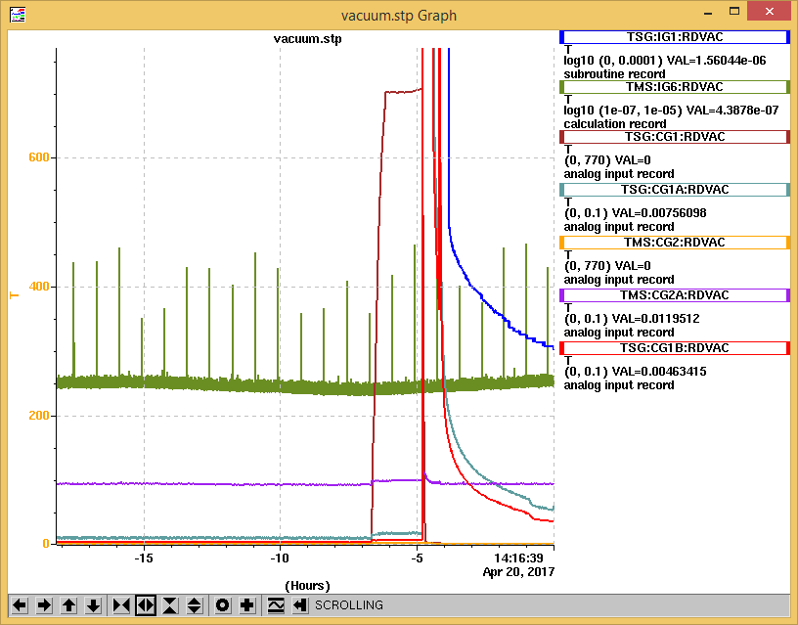

Thursday, April 20, 2017, 14:15: Manual valve closed. Leak detector off. Lines pressurized @ 30 PSI w/ He. Monitor w/ RGA as TS pumps down.

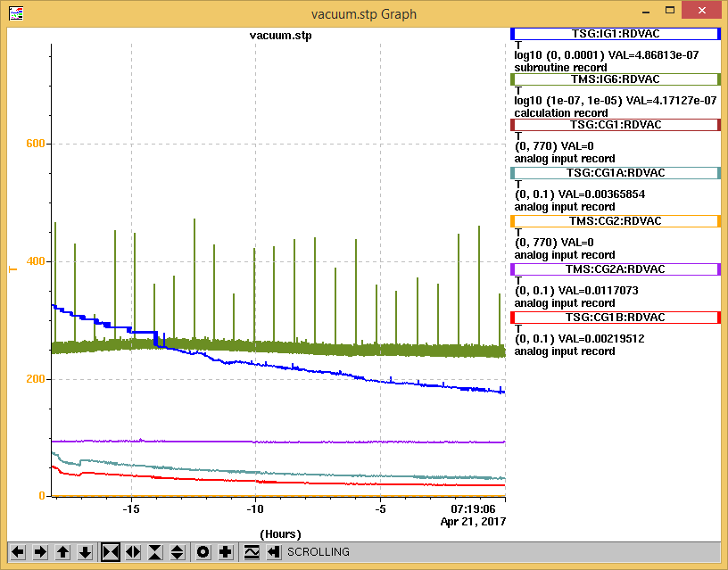

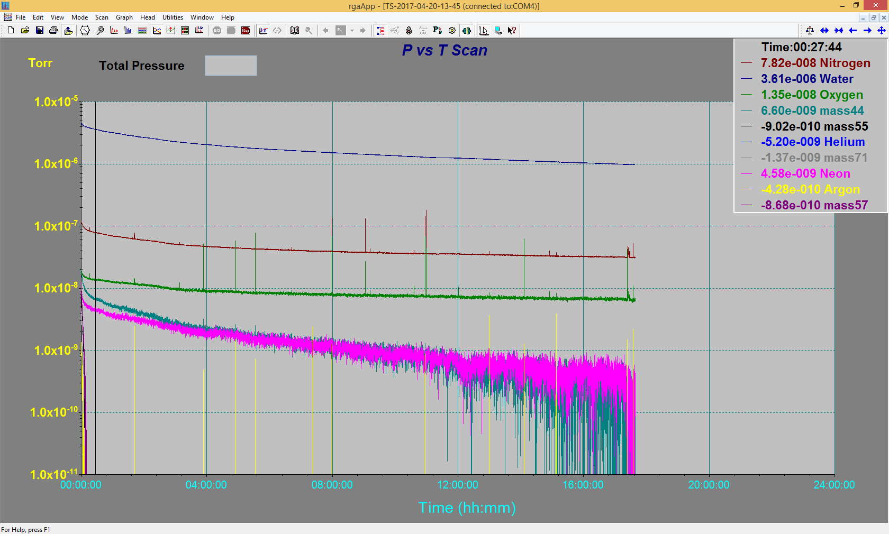

Vacuum level close, but not optimal after 24 hrs. 2e-07T range is optimal.

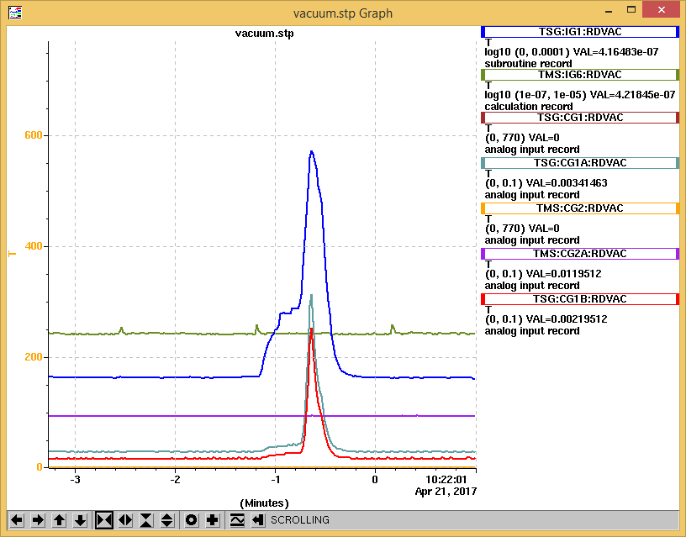

Adjustment of Turbo flange. (loose nuts found).

