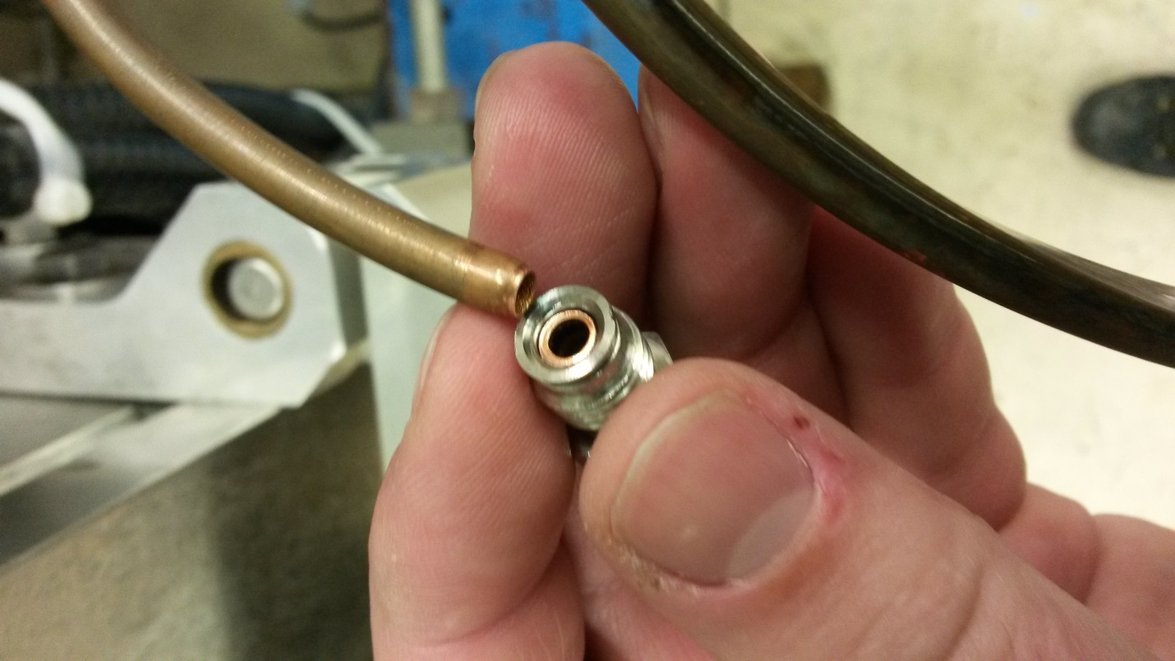

Sheared cooling line. The lines were easily broken.

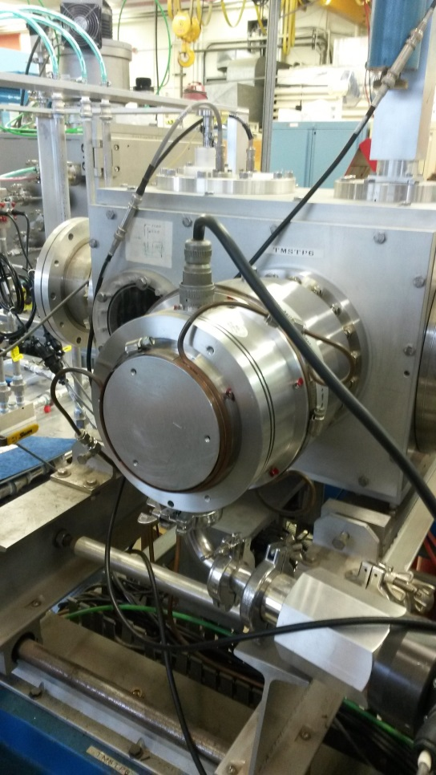 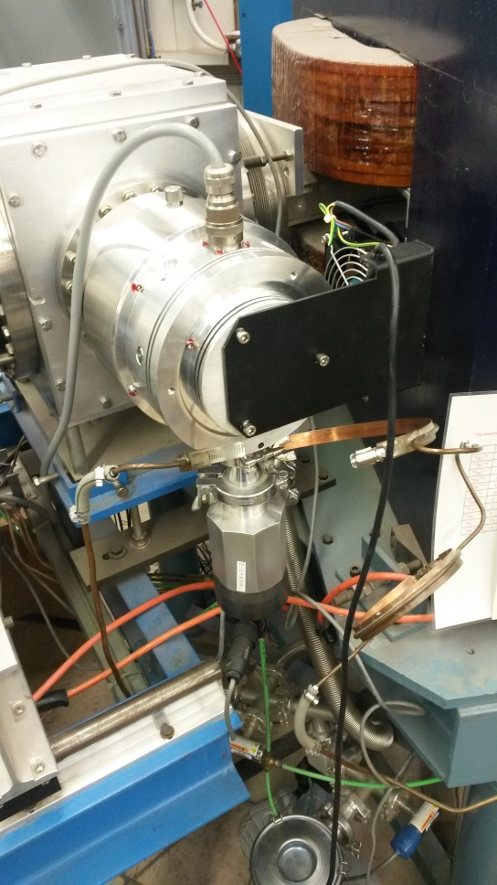

-Original Cooling setup (Water cooled) -New cooling setup (Air cooled)

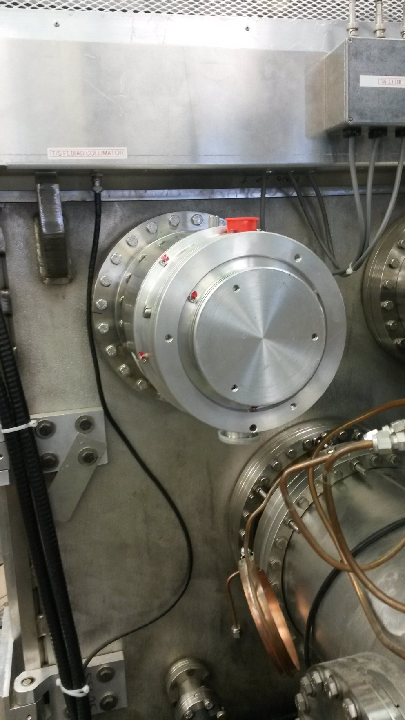

-New TSG : TP1B