Conditioning Report

|  |  |  |
| --- | --- | --- |
| Target material and number | | Ta (Test) |
| Target WO-SN | | 39530-3 |
| Operator name | | Aaron Schmidt |
|  | |  |
| Heating start date and time | | 2017-01-19 08:59 |
| BIAS | |  |
| Voltage [kV] | | 30 |
| Current [µA] | | 31 |
| Extraction Electrode (EE) | |  |
| Voltage [kV] | | 1.5 |
| Current [µA] | | 520 |
| TGHT | |  |
| Current [A] | | 582 |
| Voltage [V] | | 6.9 |
| TBHT | |  |
| Current [A] | | 290 - 312 |
| Voltage [V] | | 2.5 |
| FEBIAD ANODE | |  |
| Voltage [V] | | 200 |
| Current [mA] | | 27 |
| FEBIAD COIL | |  |
| Current [A] | | 50 - 100 |
| Voltage [V] | | 0.4 – 1.6 |
| Flow and Temperature HS + MSP | | 24.9 |
| Flow [lpm] | | 3.99 |
| Temperature increase [C] | | +9.2 (34.1) |
| FC6 currents [A] | | - |
| SIS | 7Li | - |
| FEBIAD | 20Ne | 9.063E-12 |
| SIS | 23Na | - |
| SIS | 39K | - |
| SIS | 85Rb | - |
| SIS | 133Cs | - |
| Heating end date and time | | 2017-01-23 13:25 |

Comments

TRI-COIL LP-FEBIAD Ta Target for testing optics tuning.

Plots

8h Vacuum Pump Down

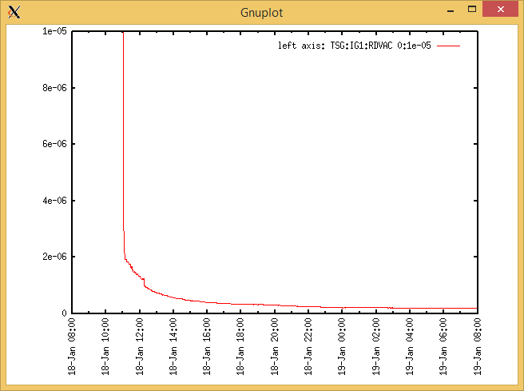

Target Heat Sequence Setup

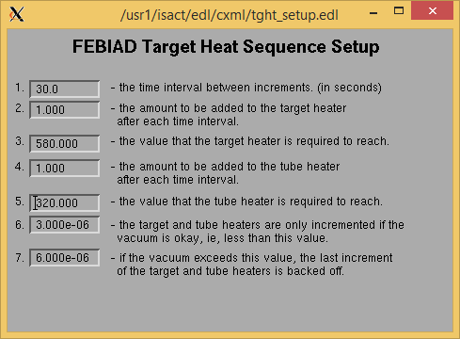

Source Tuning

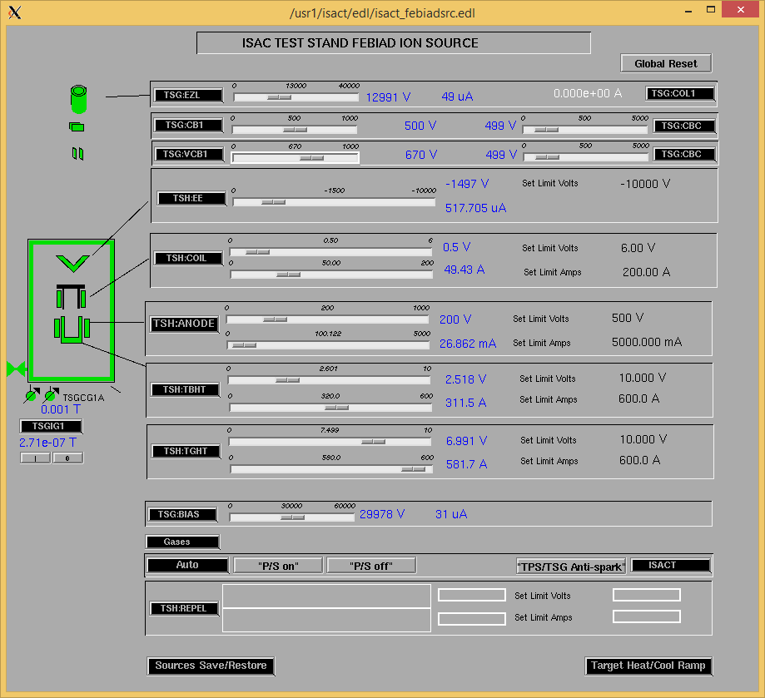

Wire Scanners RPM0A and RPM0B

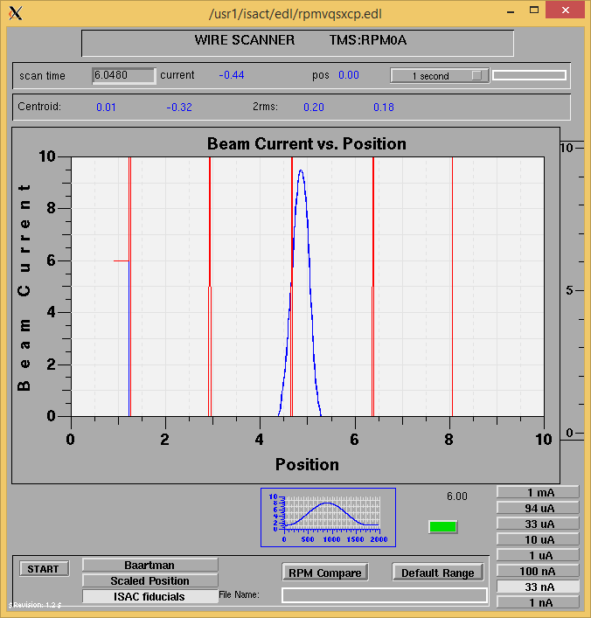

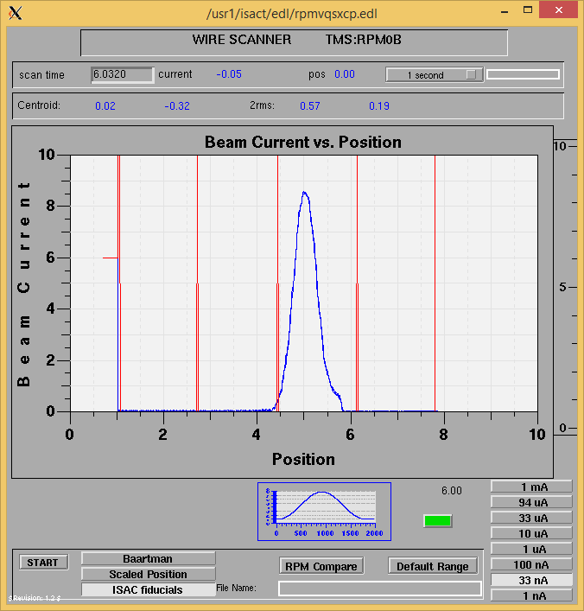

Optics Tuning

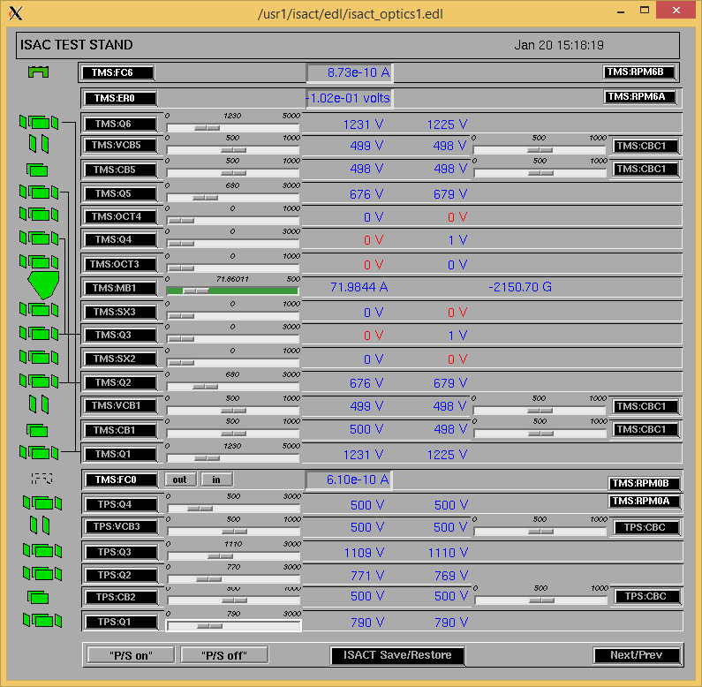

Wire Scanners RPM6A and RPM6B

Mass 20

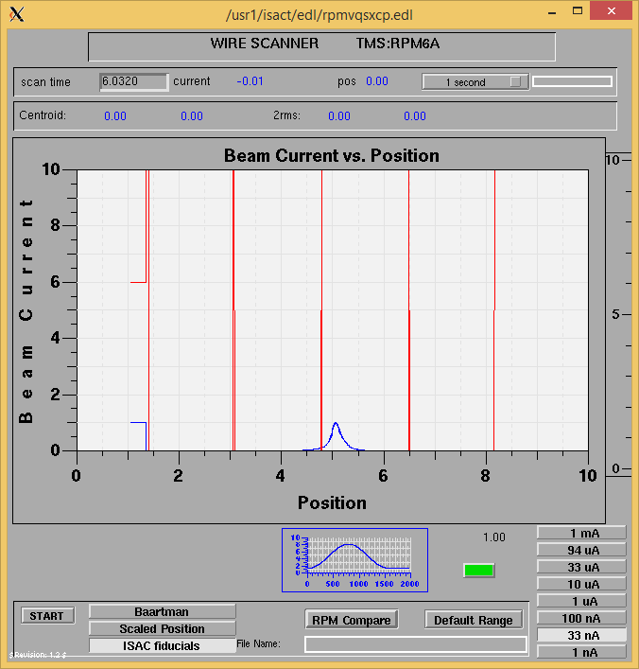

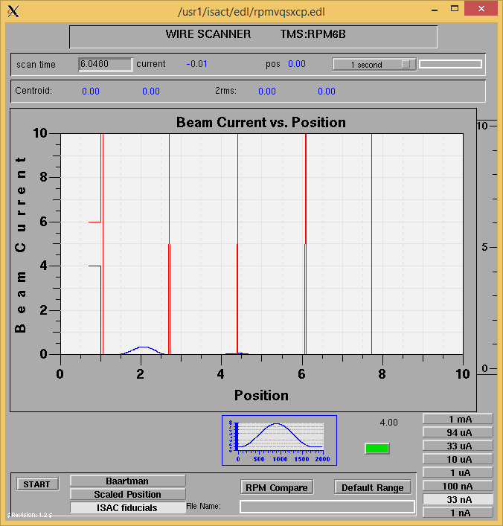

Mass 20

Mass Scan

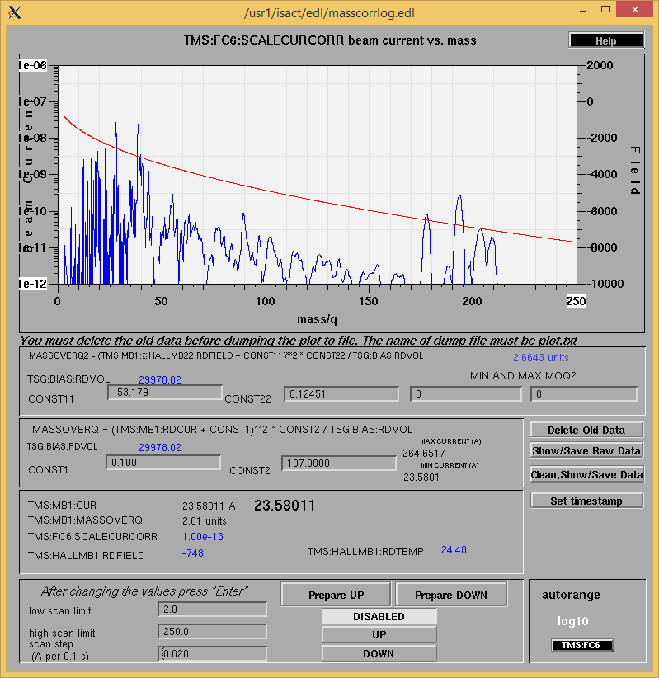

<http://isacwserv.triumf.ca/onlylocal/isactdata/save_restore/masscorr/2017-01-20-15-00>

Cooling Parameters

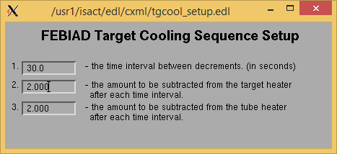

Overview Plots

Vacuum and FC0

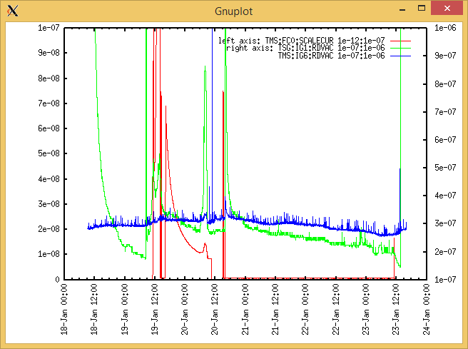

Heating, EE and BIAS

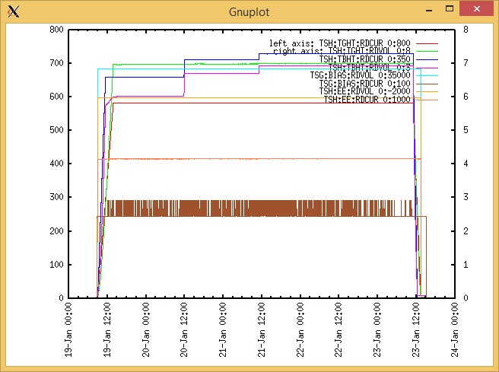

TGHT and TBHT Voltage

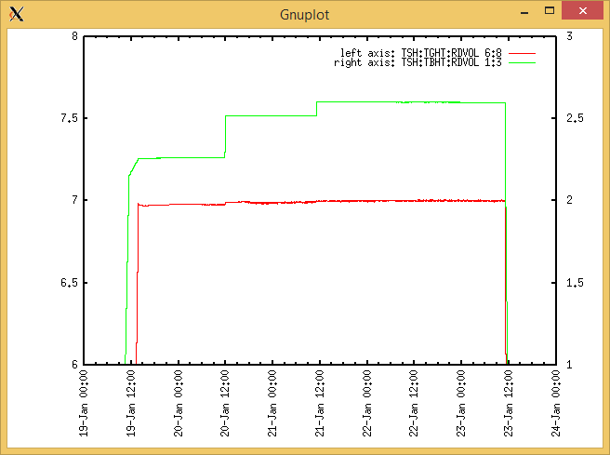

Flow and cooling water temperatures

Daqpro Graph un-available

|  |  |  |
| --- | --- | --- |
| **Device** | **Temp [C]** | **Flow [lpm]** |
| HS + MSP | 24.9 | 3.99 |
| TBHT | 24.8 | 3.15 |
| COIL + EE | 24.7 | 5.16 |
| TGHT | 24.7 | 5.05 |

|  |  |  |
| --- | --- | --- |
| **Device** | **Temp [C]** | **Flow [lpm]** |
| HS + MSP | 34.1 | 3.99 |
| TBHT | 25.0 | 3.19 |
| COIL + EE | 24.7 | 5.19 |
| TGHT | 26.5 | 5.05 |

RGA

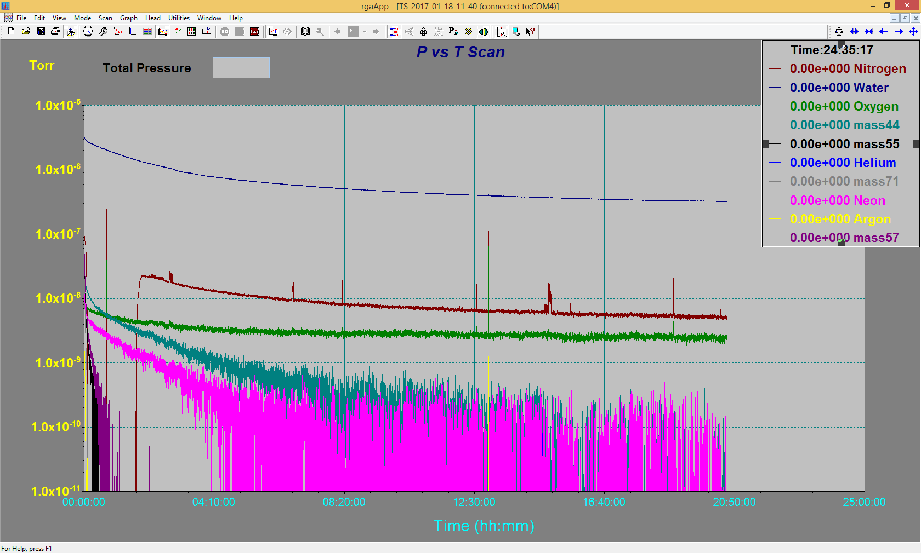

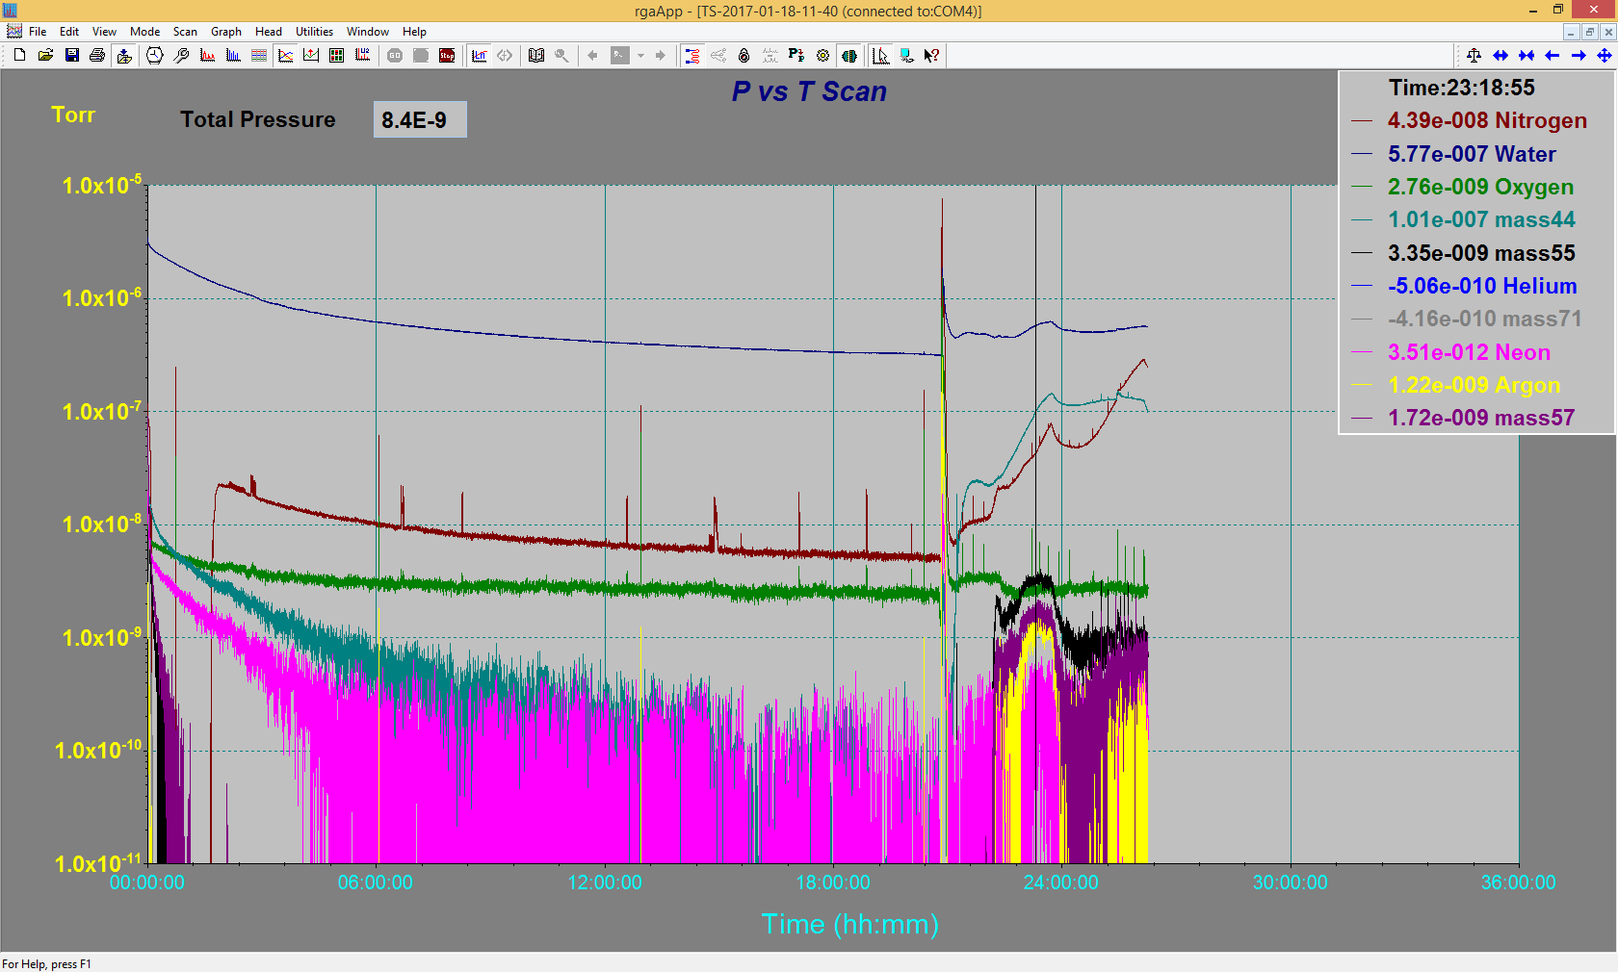

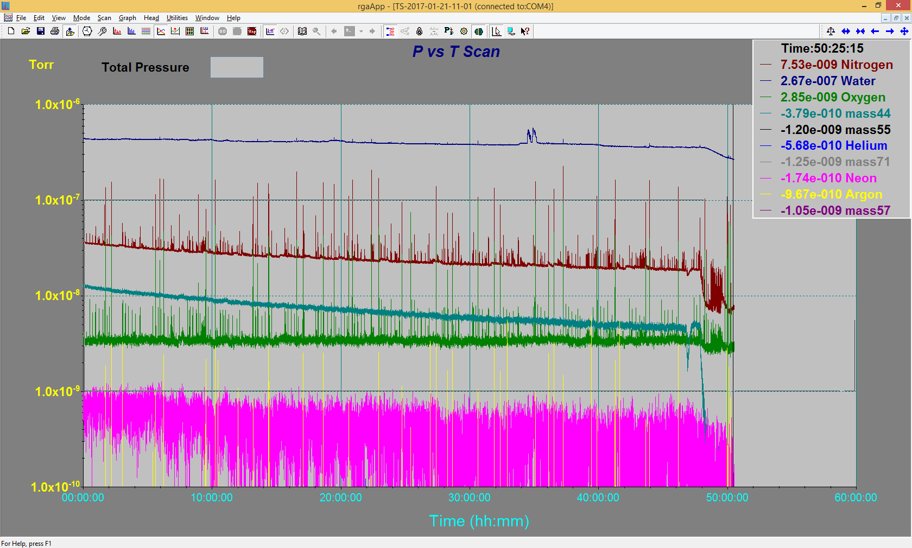

Emittance Scan

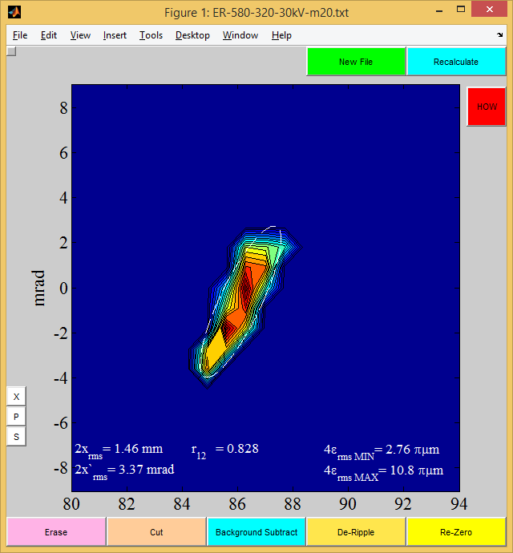

Mass 20

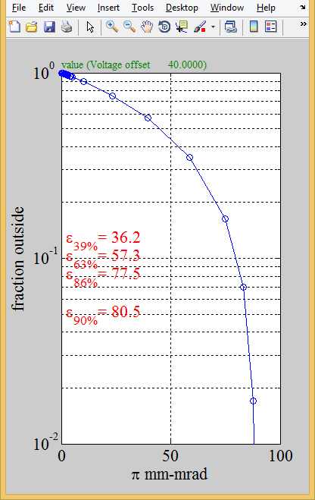

Mass 20

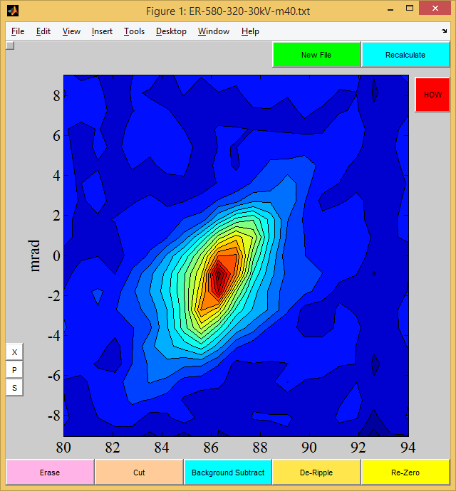

Mass 40

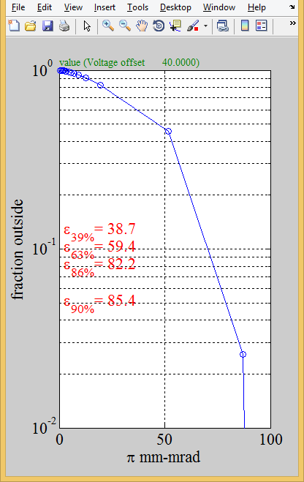

Mass 40