**Previous times taken to pump down test stand:**

(From “Heat shield cleaning tests” Time until turbo pumps available)

-41751-1

Monday, August 08, 2016, 10:10: Roughing. Door open for 9 minutes

Monday, August 08, 2016, 10:18: BV1B OPEN. Opened @ 88T.

Monday, August 08, 2016, 10:40: Both Turbo pumps started. **(30 minutes to 500mTorr)**

-41751-2

Wednesday, August 10, 2016, 10:10: Roughing. Door open for 20 minutes.

Wednesday, August 10, 2016, 10:13: Doors finally sealed for roughing.

Wednesday, August 10, 2016, 10:23: BV1B OPEN. Opened @ 59T.

Wednesday, August 10, 2016, 10:45: Both Turbo pumps started. **(32 minutes to 500mTorr)**

-41751-3

Monday, August 22, 2016, 10:18: Roughing. Door open for 25 minutes.

Monday, August 22, 2016, 10:19: Doors sealed for roughing.

Monday, August 22, 2016, 10:25: BV1B OPEN. Opened @ 151T.

Monday, August 22, 2016, 10:50: Both Turbo pumps started. **(31 minutes to 500mTorr)**

-41751-4

Monday, August 15, 2016, 10:10: Roughing. Door open for 22 minutes

Monday, August 15, 2016, 10:12: Doors sealed for roughing.

Monday, August 15, 2016, 10:21: BV1B OPEN. Opened @ 104T.

Monday, August 15, 2016, 10:44: Both Turbo pumps started. **(32 minutes to 500mTorr)**

-41751-5

Wednesday, August 17, 2016, 10:10: Roughing. Door open for 22 minutes.

Wednesday, August 17, 2016, 10:10: Doors sealed for roughing.

Wednesday, August 17, 2016, 10:18: BV1B OPEN. Opened @ 136T.

Wednesday, August 17, 2016, 10:41: Both Turbo pumps started. **(31 minutes to 500mTorr)**

-41751-6

Wednesday, August 24, 2016, 10:10: Roughing. Door open for 22 minutes.

Wednesday, August 24, 2016, 10:10: Doors sealed for roughing.

Wednesday, August 24, 2016, 10:18: BV1B OPEN. Opened @ 79T.

Wednesday, August 24, 2016, 10:41: Both Turbo pumps started. **(31 minutes to 500mTorr)**

**AVERAGE 31 MINUTES TO REACH 500mTorr**

**Monday, October 24, 2016, 15:45: Remove metal mesh covering roughing pump exhaust.**

**Clean out/visually inspect mesh (plugged with 3/4"-5/8" thick w/ layers of dust/material).**

Checked with RAM – No activity found.

Hose clamp on mesh ok – No rust or damage found.

-Pump down empty chamber.

Monday, October 24, 2016, 15:52: Roughing 710.0 T. Door/chamber @ atmosphere for nearly 2.5 hours.

Monday, October 24, 2016, 15:54: BV1B opened.

Monday, October 24, 2016, 16:00: Rouging 2.0 T.

Monday, October 24, 2016, 16:10: Turbo pumps available. **(18 minutes to 500mTorr)**

-Pump down empty chamber.

Tuesday, October 25, 2016, 08:08: Venting.

Tuesday, October 25, 2016, 08:40: Doors open.

Tuesday, October 25, 2016, 08:50: Roughing. Doors open for 10 minutes.

Tuesday, October 25, 2016, 08:41: Doors sealed for roughing.

Tuesday, October 25, 2016, 08:52: BV1B opened.

Tuesday, October 25, 2016, 09:10: Turbo pumps available & started. **(19 minutes to 500mTorr)**

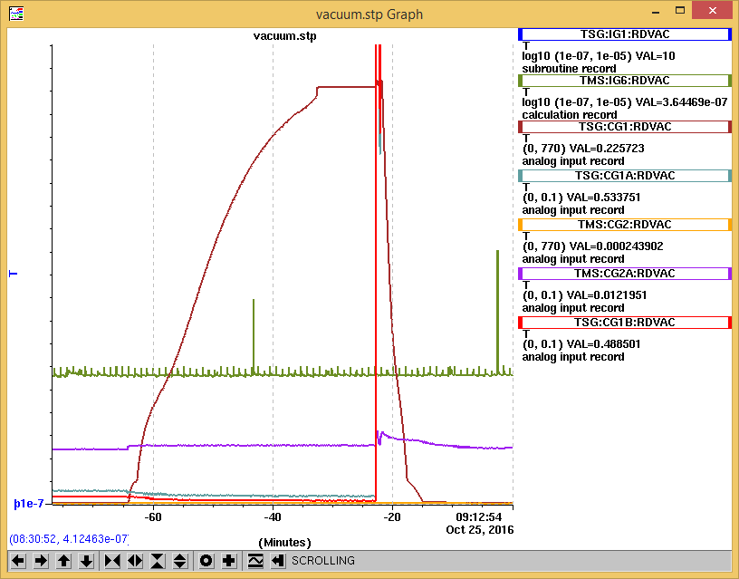

Reduced pump down time by nearly 12-13 minutes due to exhaust cleaning.

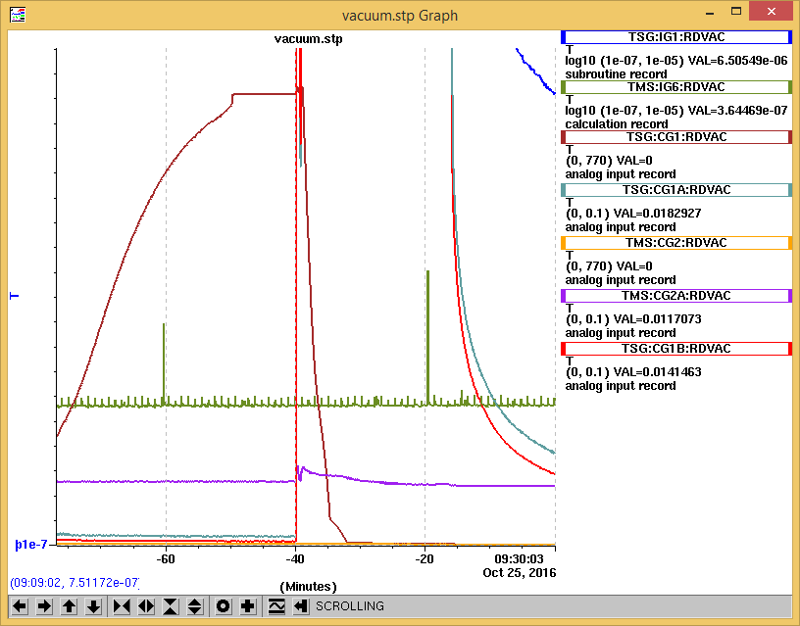

@ 20 minutes since turbo pumps started.

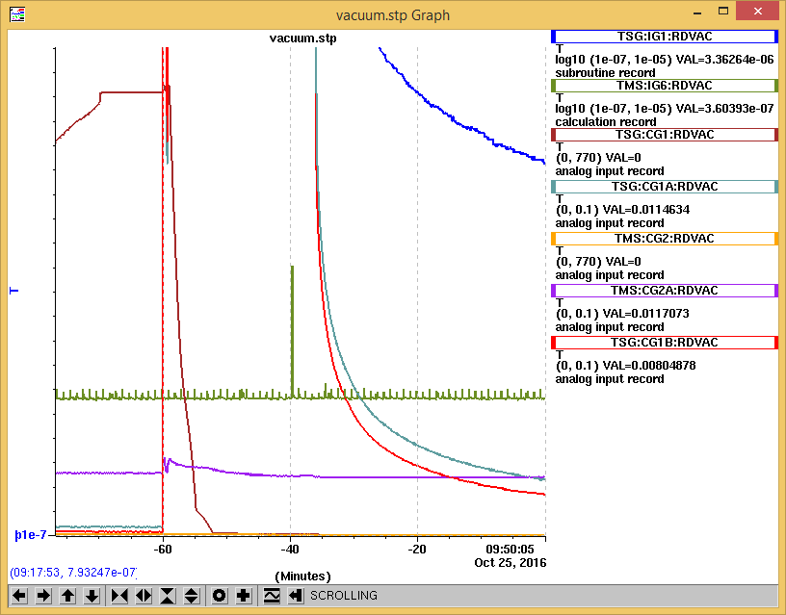

**@ 60 minutes since roughing started. Vacuum @ 3.36e-06 T**

**Compare:**

**41751-3: Vacuum @ 3.82e-06T after approximately 94 minutes.**

**41571-5: Vacuum @ 3.56e-06T after approximately 100 minutes.**

**41751-6: Vacuum @ 3.47e-06T after approximately 95 minutes.**

Side note:

Although not monitored as closely. A half hour or more wait was common.

-Approximately 6 months ago

Thursday, April 21, 2016, 14:25: Begin pumping down.

Thursday, April 21, 2016, 15:02: Turbo pumps started. (37 minutes)

Wednesday, April 13, 2016, 13:03: Begin roughing. (Plasma electrode in. Salts in)

Wednesday, April 13, 2016, 13:34: Turbo pumps started. (31 minutes)