Conditioning Report

|  |  |  |
| --- | --- | --- |
| Target material and number | | Ta#50 |
| Target WO-SN | | 41790-5 |
| Operator name | | Aaron Schmidt |
|  | |  |
| Heating start date and time | | 2016-10-19 09:01 |
| BIAS | |  |
| Voltage [kV] | | 30 |
| Current [µA] | | 37 |
| Extraction Electrode (EE) | |  |
| Voltage [kV] | | 1.5 |
| Current [µA] | | 510 |
| TGHT | |  |
| Current [A] | | 582 |
| Voltage [V] | | 7.0 |
| TBHT | |  |
| Current [A] | | 199 |
| Voltage [V] | | 2.2 |
| FEBIAD ANODE | |  |
| Voltage [V] | | - |
| Current [mA] | | - |
| FEBIAD COIL | |  |
| Current [A] | | - |
| Voltage [V] | | - |
| Flow and Temperature HS + MSP | | 27.9 |
| Flow [lpm] | | 3.92 |
| Temperature increase [C] | | 9.4 |
| FC6 currents [A] | | - |
| SIS | 7Li | 6.36E-10 |
| FEBIAD | 20Ne | - |
| SIS | 23Na | 1.52E-09 |
| SIS | 39K | 2.72E-09 |
| SIS | 85Rb | 6.06E-10 |
| SIS | 133Cs | 4.46E-09 |
| Heating end date and time | | 2016-10-21 13:27 |

Comments

-Strong reading from Aluminum noted throughout heating

|  |  |  |
| --- | --- | --- |
| SIS | 27Al | 3.03E-08 |

-Wednesday, October 19, 2016, 11:50: TMS:FC0 moved out & TMS:RPM0B began scanning continuously on their own.

“Pressed start” for wire scan, TMS:FC0 moved back in place. Operation appeared normal afterwards, although monitored.

Plots

8h Vacuum Pump Down

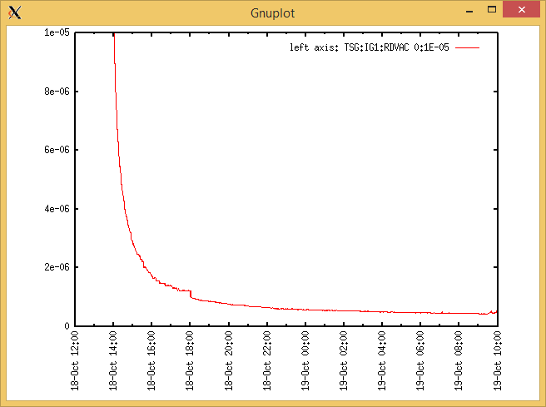

Target Heat Sequence Setup

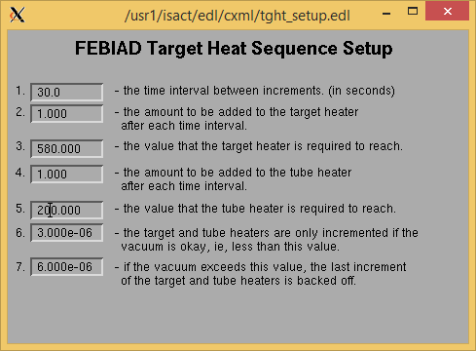

Source Tuning

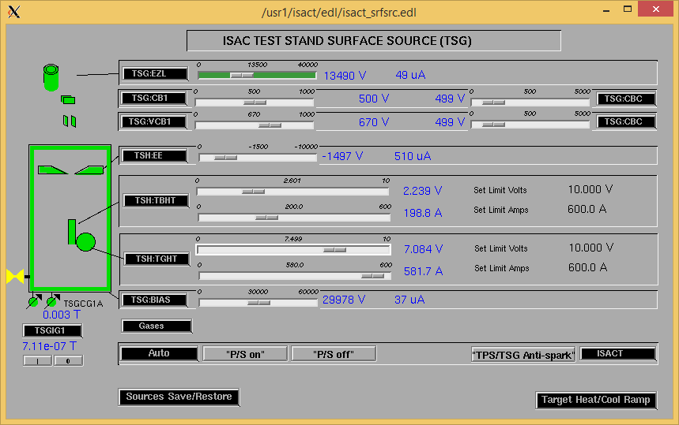

Wire Scanners RPM0A and RPM0B

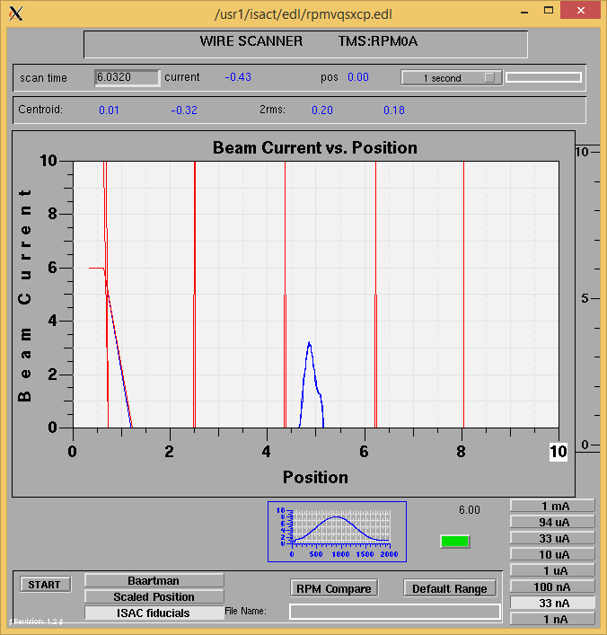

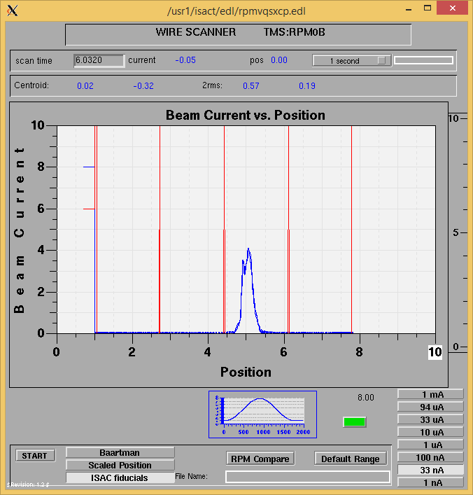

Optics Tuning

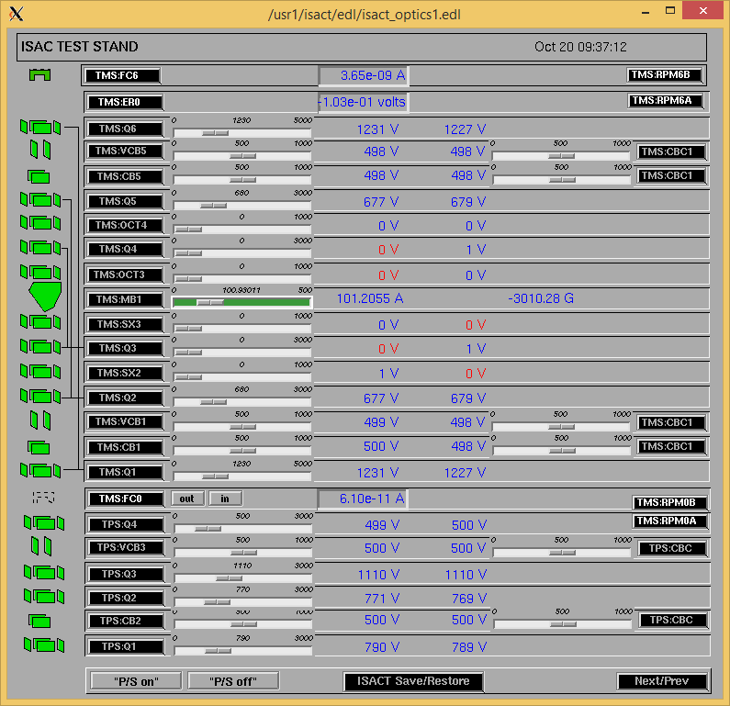

Mass 39

Wire Scanners RPM6A and RPM6B

Mass 39

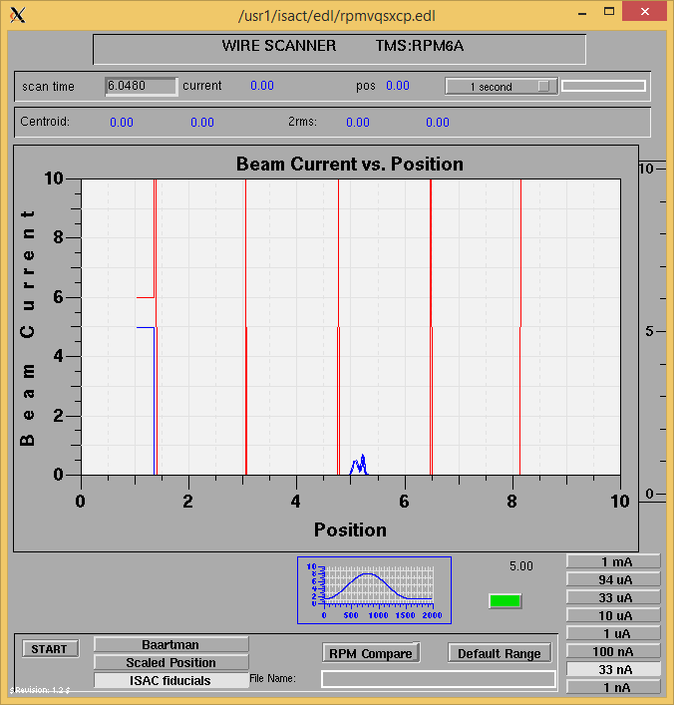

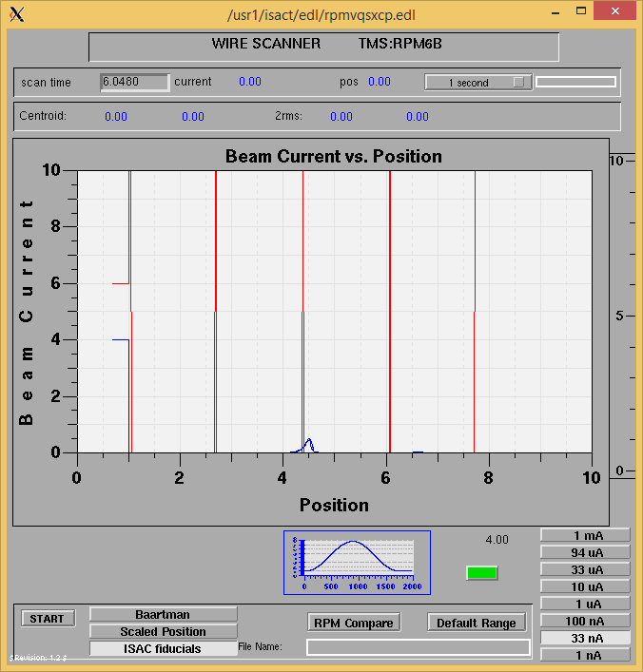

Mass 39

Mass Scan

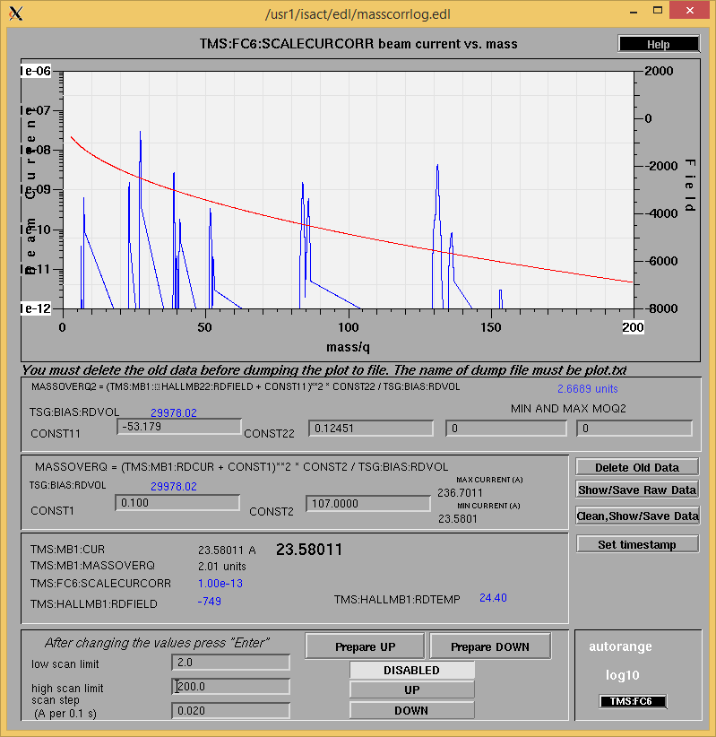

<http://isacwserv.triumf.ca/onlylocal/isactdata/save_restore/masscorr/2016-10-20-09-30%20Ta%2350>

Mass 39

Cooling Parameters

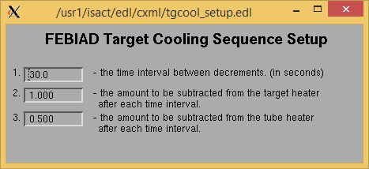

Overview Plots

Vacuum and FC0

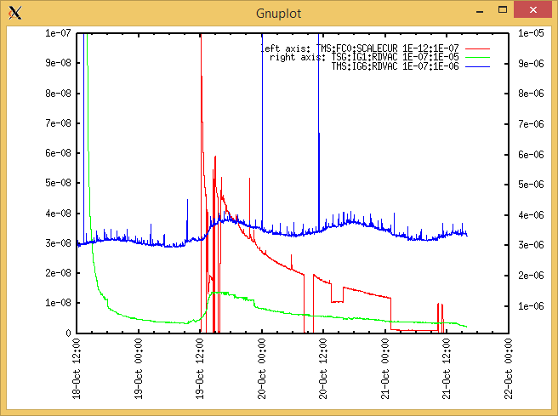

Heating, EE and BIAS

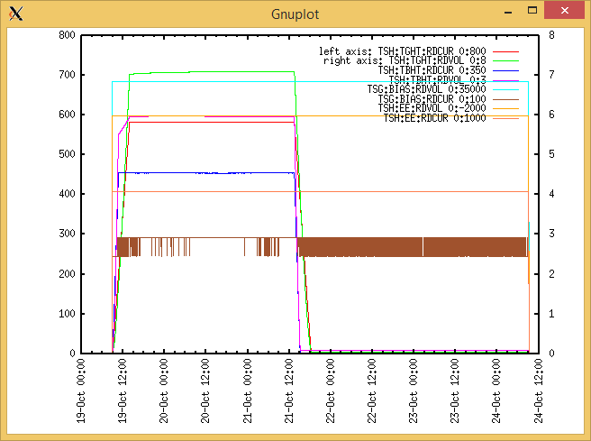

TGHT and TBHT Voltage

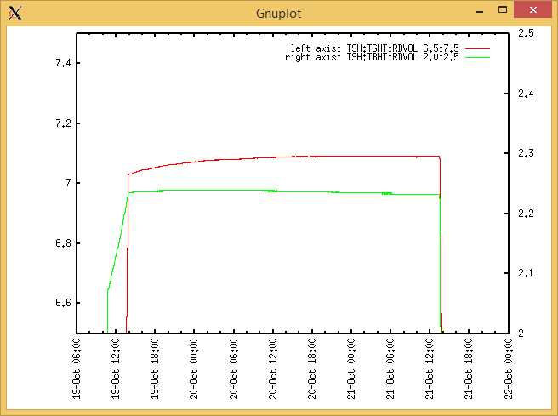

Flow and cooling water temperatures

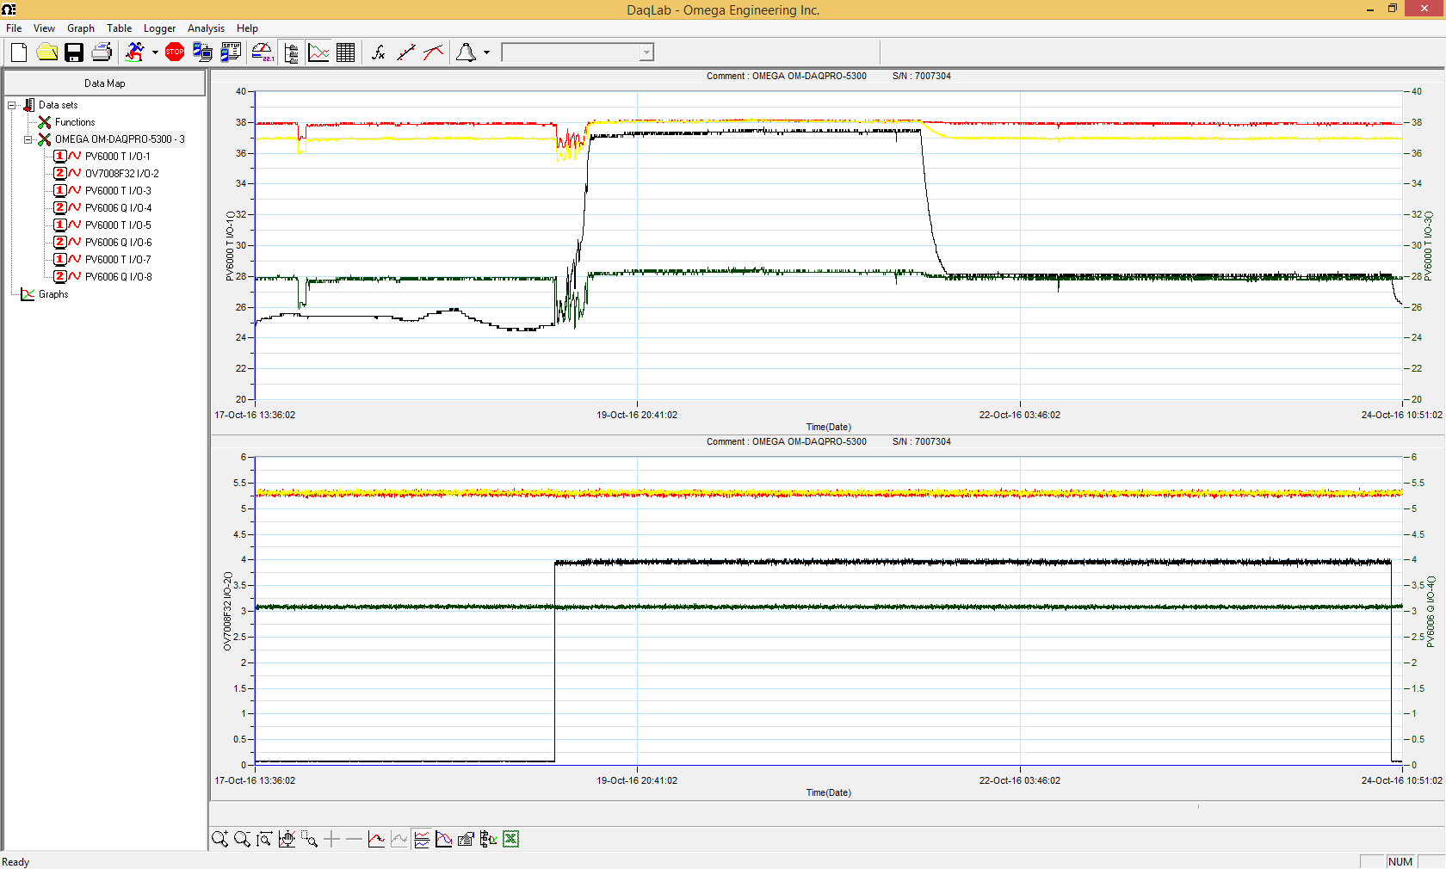

RGA

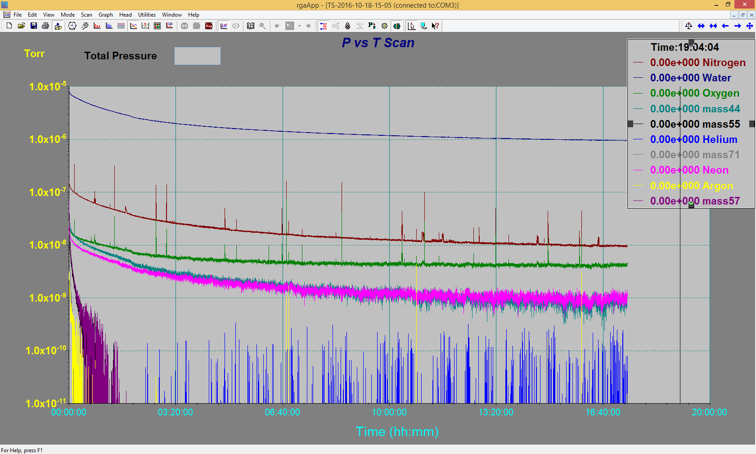

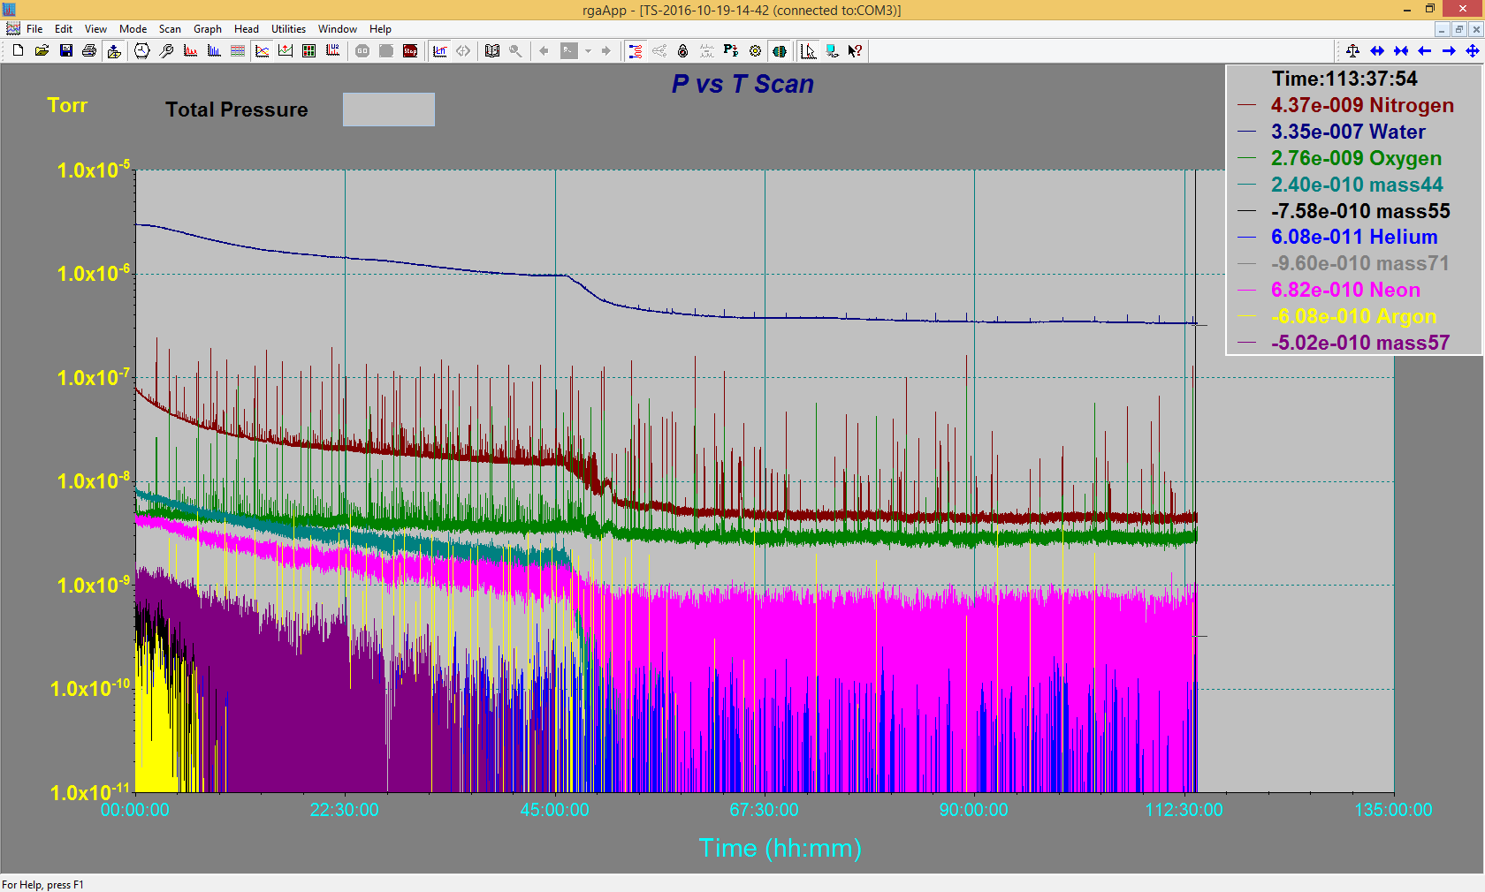

Emittance Scan

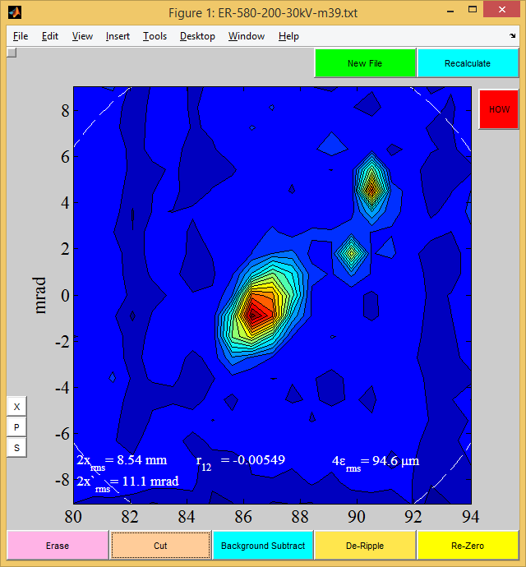

Mass 39

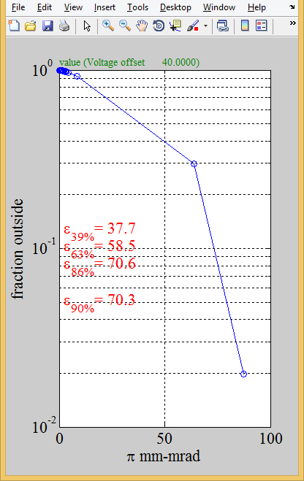

Mass 39

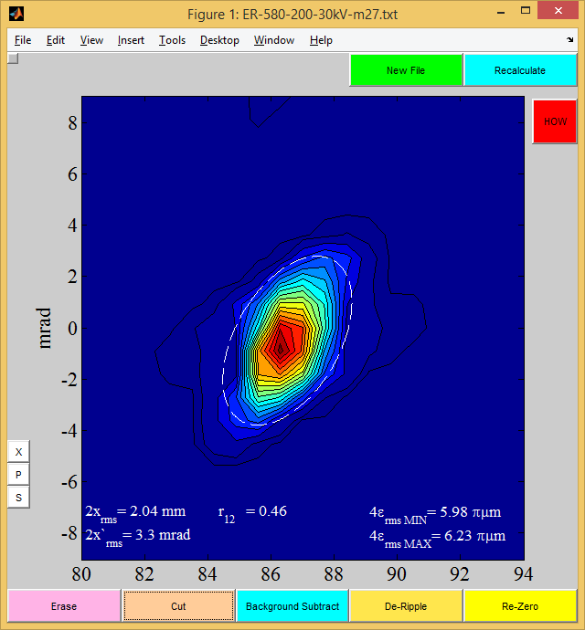

Mass 27

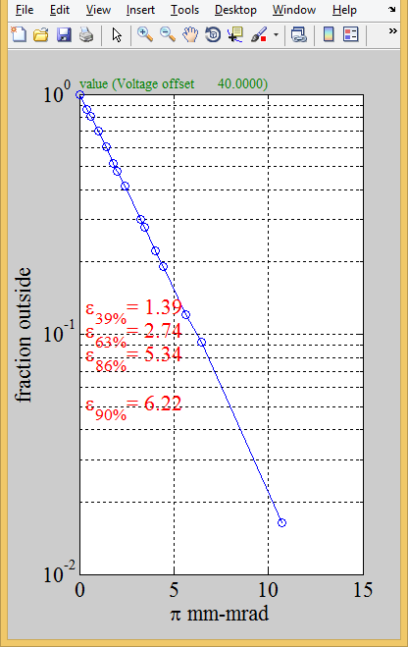

Mass 27