Conditioning Report

|  |  |  |
| --- | --- | --- |
| Target material and number | | SiC#34 |
| Target WO-SN | |  |
| Operator name | | Aaron Schmidt |
|  | |  |
| Heating start date and time | | 2016-09-06 08:34 |
| BIAS | |  |
| Voltage [kV] | | 30 |
| Current [µA] | | 43 |
| Extraction Electrode (EE) | |  |
| Voltage [kV] | | 1.5 |
| Current [µA] | | 503 |
| TGHT | |  |
| Current [A] | | 582 |
| Voltage [V] | | 7.482 |
| TBHT | |  |
| Current [A] | | 249 |
| Voltage [V] | | 2.017 |
| FEBIAD ANODE | |  |
| Voltage [V] | | - |
| Current [mA] | | - |
| FEBIAD COIL | |  |
| Current [A] | | - |
| Voltage [V] | | - |
| Flow and Temperature HS + MSP | | 28.4 |
| Flow [lpm] | | 3.78 |
| Temperature increase [C] | | +10 (38.4) |
| FC6 currents [A] | | - |
| SIS | 7Li | - |
| FEBIAD | 20Ne | - |
| SIS | 23Na | - |
| SIS | 39K | - |
| SIS | 85Rb | - |
| SIS | 133Cs | - |
| Heating end date and time | | 2016-09-06 20:49 |

Comments

Tuesday, September 06, 2016, 14:05: Turbo pump TP1A found off. Restarted.

Plots

8h Vacuum Pump Down

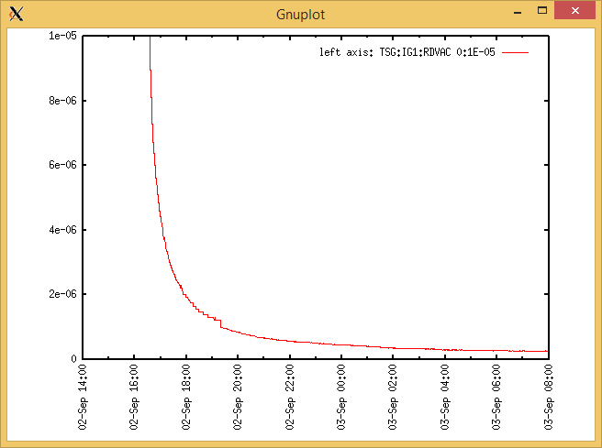

Target Heat Sequence Setup

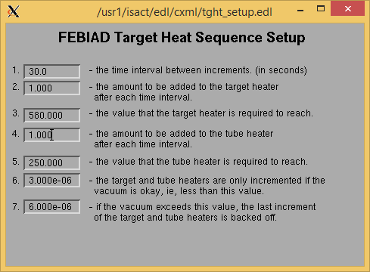

Source Tuning

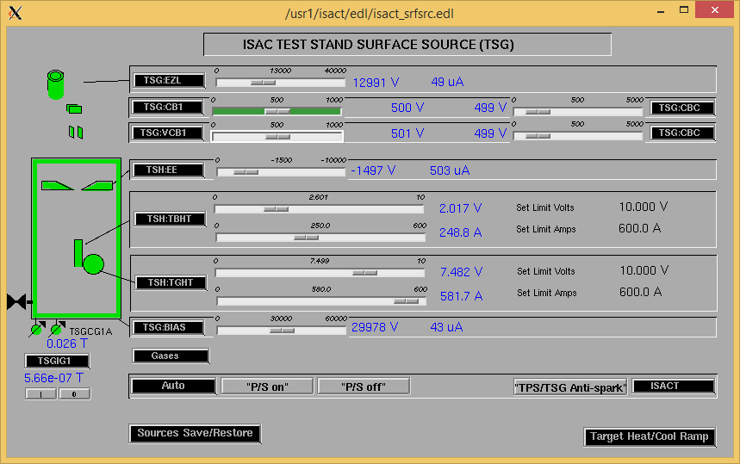

Wire Scanners RPM0A and RPM0B

Mass 40

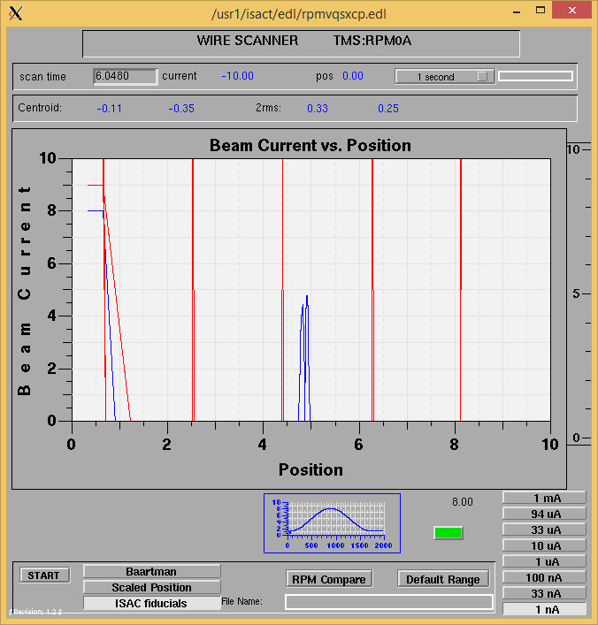

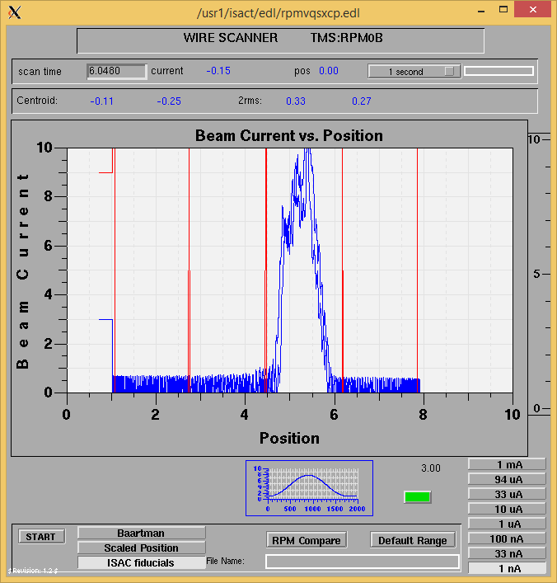

Mass 40

Optics Tuning

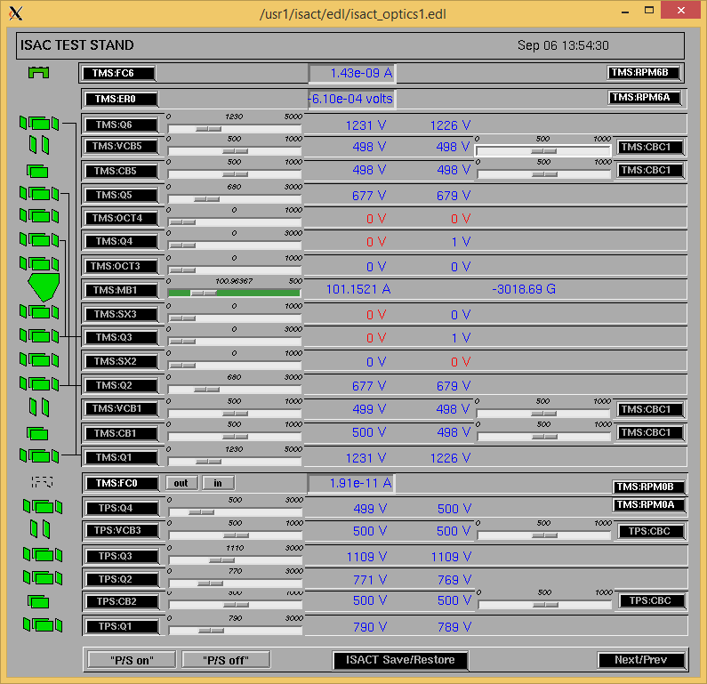

Wire Scanners RPM6A and RPM6B

Mass 40

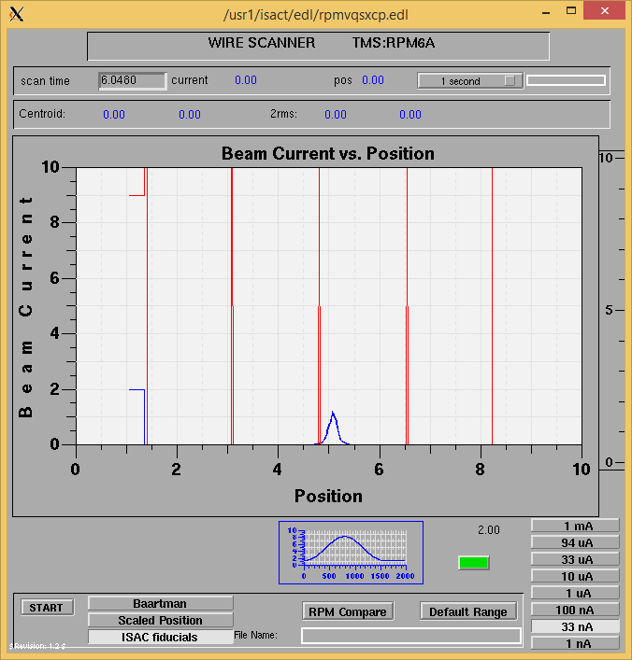

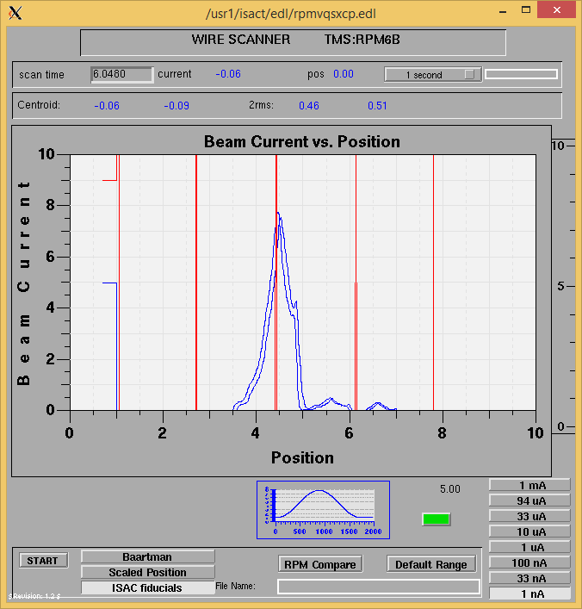

Mass 40

Mass Scan

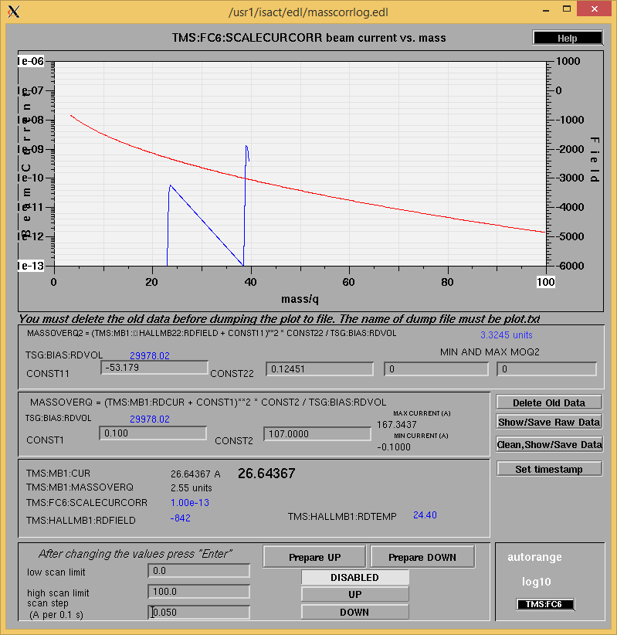

Cooling Parameters

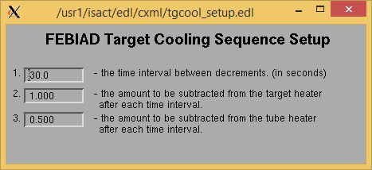

Overview Plots

Vacuum and FC0

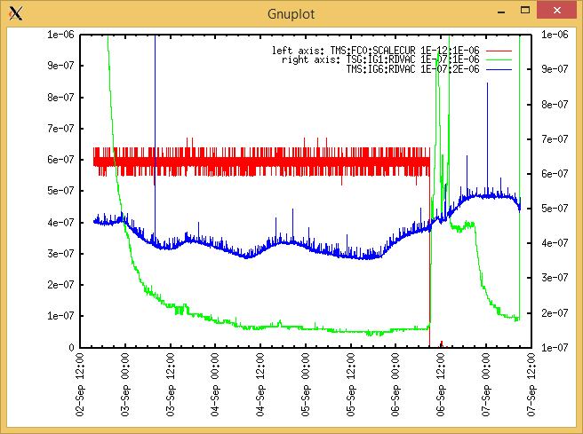

Heating, EE and BIAS

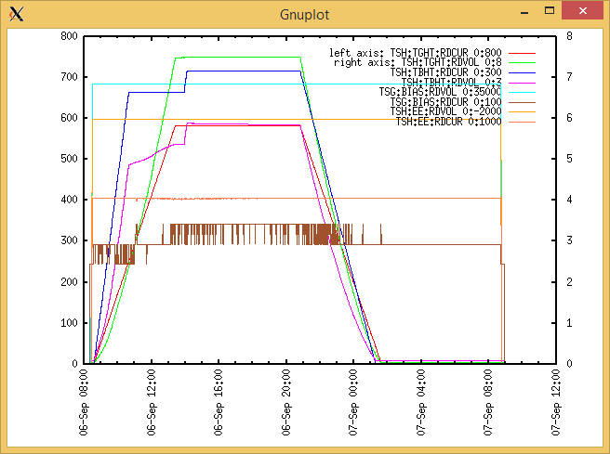

TGHT and TBHT Voltage

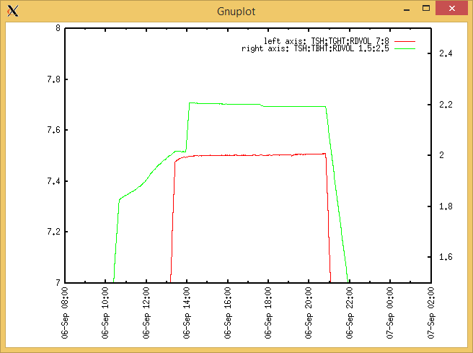

Flow and cooling water temperatures

|  |  |  |
| --- | --- | --- |
| **Device** | **Temp [C]** | **Flow [lpm]** |
| HS + MSP (1,2) | 28.4 | 3.78 |
| TBHT (3,4) | 28.3 | 2.96 |
| COIL + EE (5,6) | 28.0 | 4.89 |
| TGHT (7,8) | 29.6 | 5.50 |

|  |  |  |
| --- | --- | --- |
| **Device** | **Temp [C]** | **Flow [lpm]** |
| HS + MSP | 38.4 | 0.07 |
| TBHT | 28.5 | 2.98 |
| COIL + EE | 28.0 | 4.92 |
| TGHT | 30.0 | 5.54 |

Error on flow.

RGA

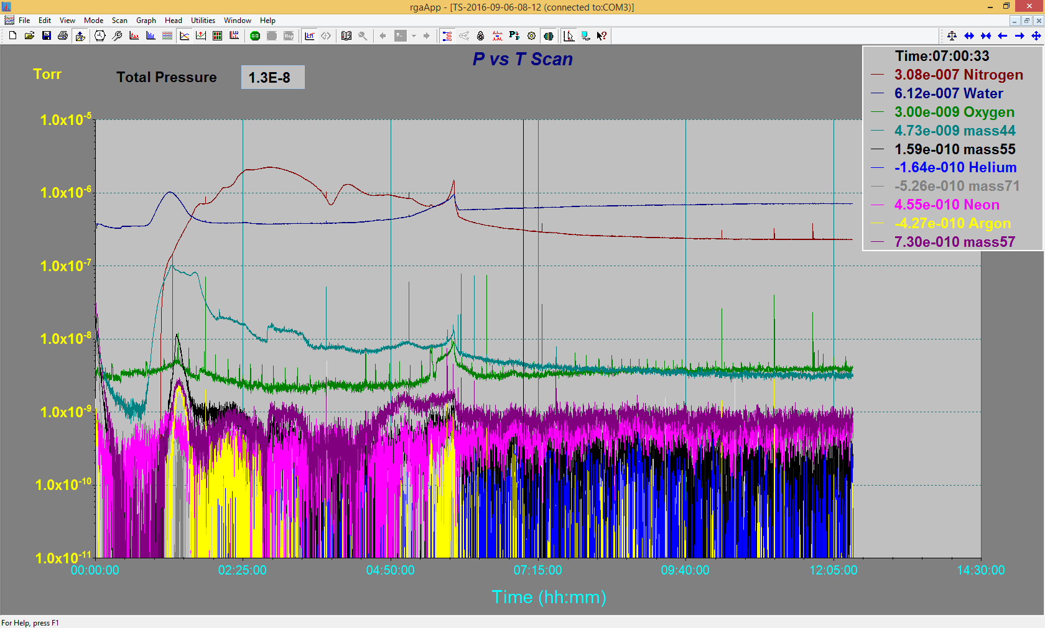

Emittance Scan

Not Available