Conditioning Report

|  |  |  |
| --- | --- | --- |
| Target material and number | | Ta#47 |
| Target WO-SN | | 41790-1 |
| Operator name | | Aaron Schmidt |
|  | |  |
| Heating start date and time | | 2016-03-31 08:48 |
| BIAS | |  |
| Voltage [kV] | | 30 |
| Current [µA] | | 37 |
| Extraction Electrode (EE) | |  |
| Voltage [kV] | | 1.5 |
| Current [µA] | | 515 |
| TGHT | |  |
| Current [A] | | 582 |
| Voltage [V] | | 6.989 |
| TBHT | |  |
| Current [A] | | 228 |
| Voltage [V] | | 2.623 |
| FEBIAD ANODE | |  |
| Voltage [V] | | - |
| Current [mA] | | - |
| FEBIAD COIL | |  |
| Current [A] | | - |
| Voltage [V] | | - |
| Flow and Temperature HS + MSP | | - |
| Flow [lpm] | | - |
| Temperature increase [C] | | - |
| FC6 currents [A] | | - |
| SIS | 7Li | 4.5E-10 |
| FEBIAD | 20Ne | - |
| SIS | 23Na | 9.4E-10 |
| SIS | 39K | 1.4E-09 |
| SIS | 85Rb | 1.6E-09 |
| SIS | 133Cs | 4.6E-09 |
| Heating end date and time | | 2016-04-01 22:00 |

Comments

Plots

8h Vacuum Pump Down

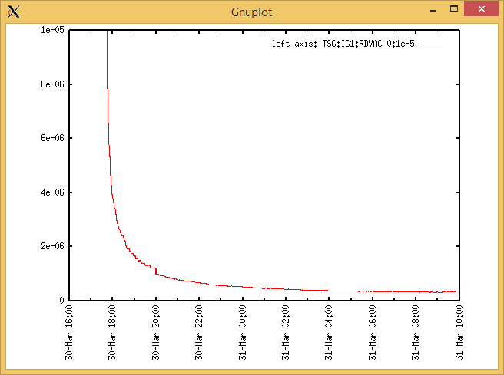

Target Heat Sequence Setup  
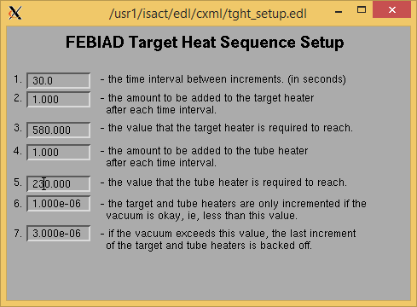

Source Tuning

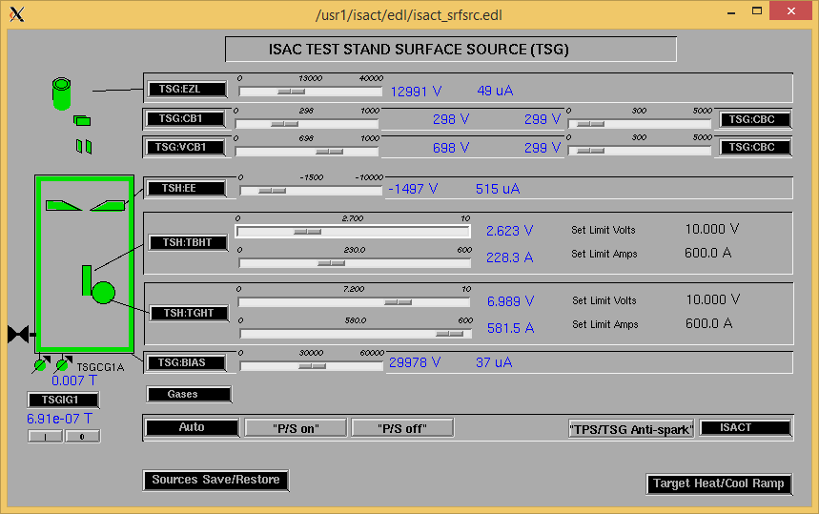

Wire Scanners RPM0A and RPM0B

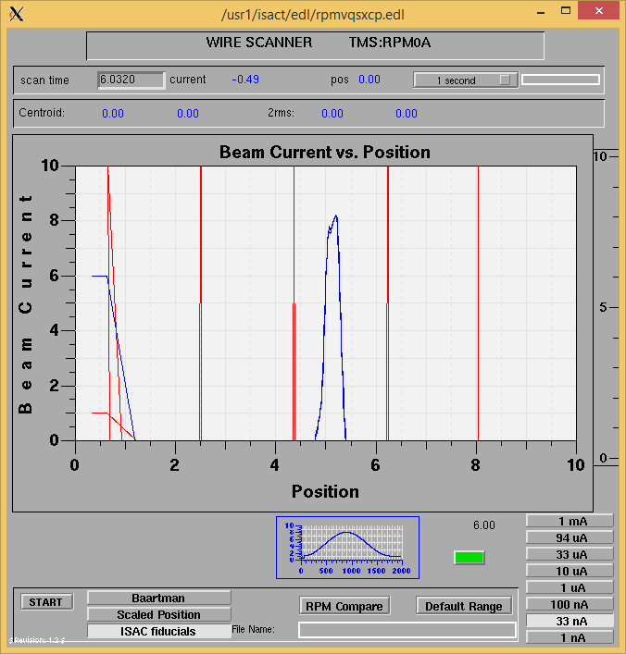

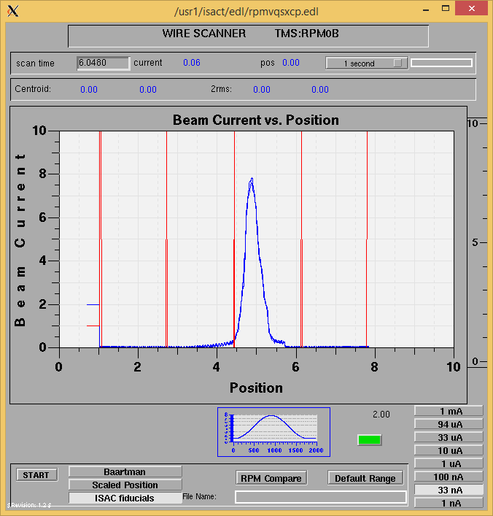

Optics Tuning

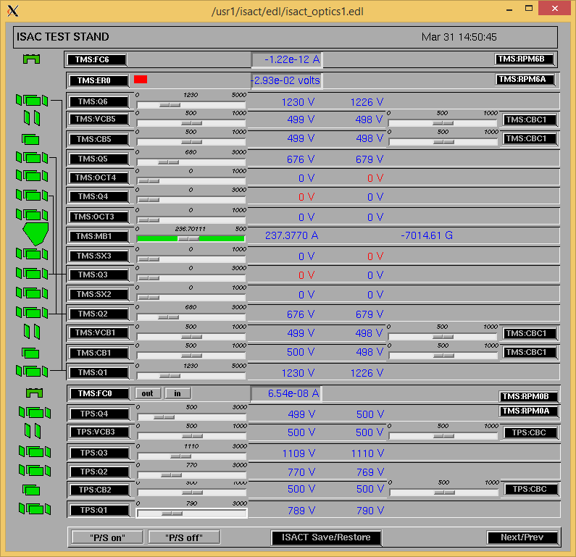

Wire Scanners RPM6A and RPM6B

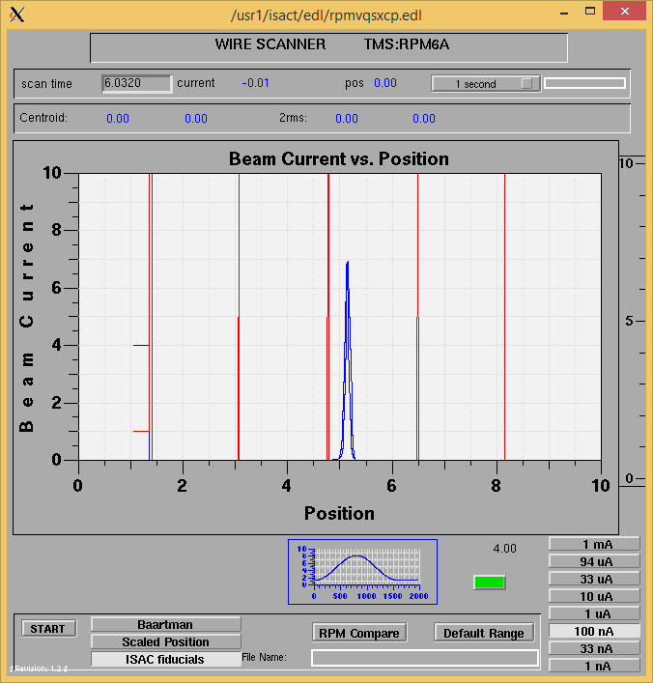

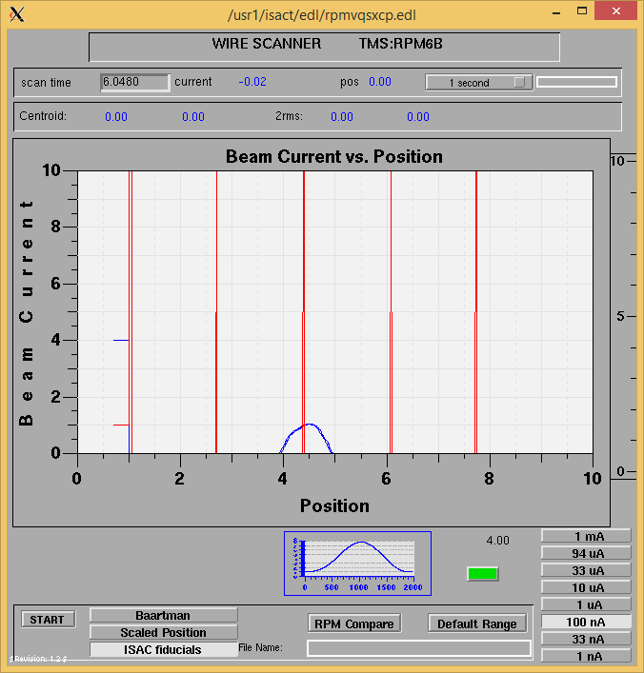

Mass Scan

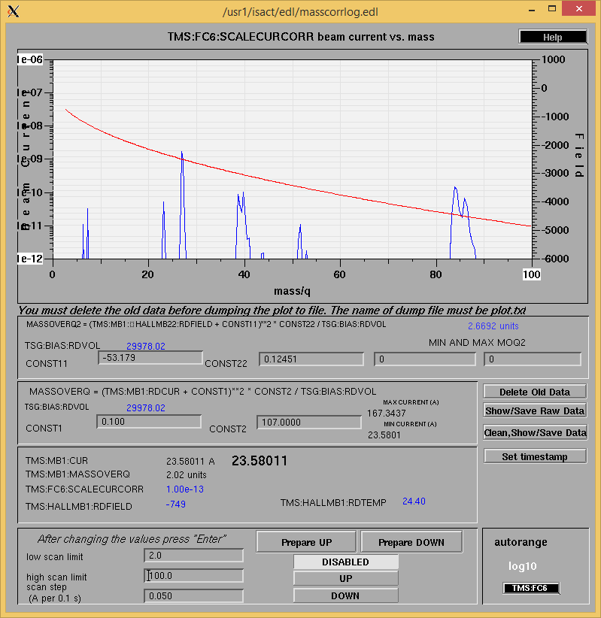

<http://isacwserv.triumf.ca/onlylocal/isactdata/save_restore/masscorr/2016-03-31-15-30%20Ta%2347>

Cooling Parameters

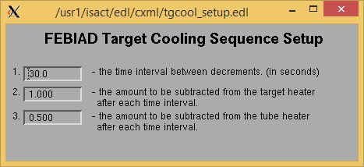

Overview Plots

Vacuum and FC0

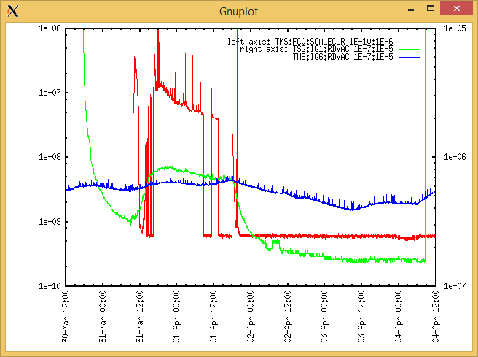

Heating, EE and BIAS

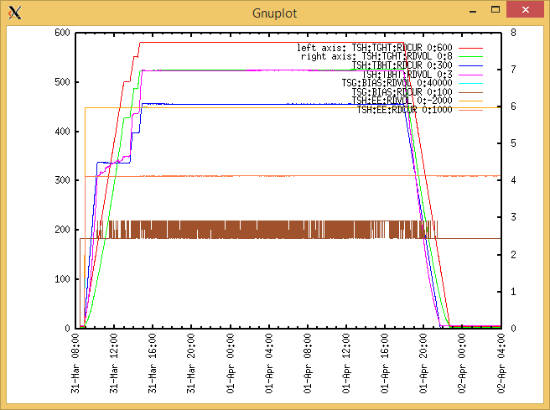

TGHT and TBHT Voltage

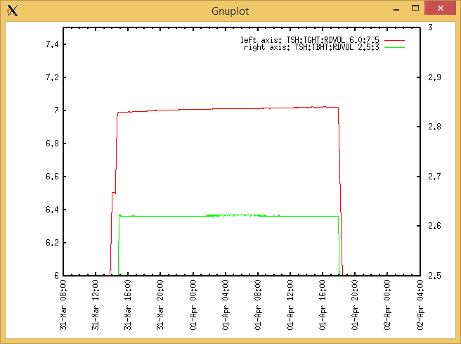

Flow and cooling water temperatures

RGA

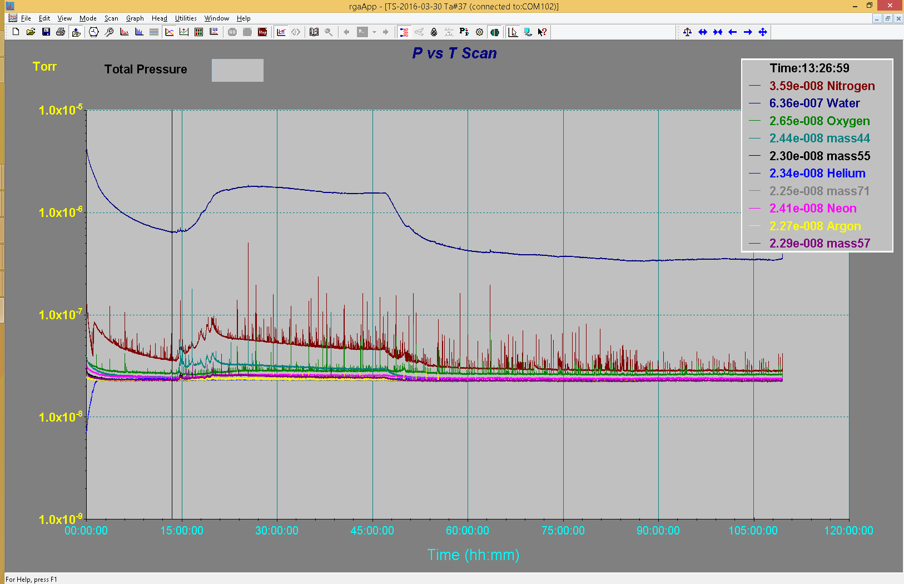

Emittance Scan

Mass 27

