Conditioning Report

|  |  |  |
| --- | --- | --- |
| Target material and number | | Ta#49 |
| Target WO-SN | |  |
| Operator name | | Aaron Schmidt |
|  | |  |
| Heating start date and time | | 2016-08-04 08:35 |
| BIAS | |  |
| Voltage [kV] | | 30 |
| Current [µA] | | 37 |
| Extraction Electrode (EE) | |  |
| Voltage [kV] | | 1.5 |
| Current [µA] | | 510 |
| TGHT | |  |
| Current [A] | | 582 |
| Voltage [V] | | 5.221 |
| TBHT | |  |
| Current [A] | | 199 |
| Voltage [V] | | 1.893 |
| FEBIAD ANODE | |  |
| Voltage [V] | | - |
| Current [mA] | | - |
| FEBIAD COIL | |  |
| Current [A] | | - |
| Voltage [V] | | - |
| Flow and Temperature HS + MSP | | - |
| Flow [lpm] | | - |
| Temperature increase [C] | | - |
| FC6 currents [A] | | - |
| SIS | 7Li | 1.21E-07 |
| FEBIAD | 20Ne | - |
| SIS | 23Na | 3.12E-09 |
| SIS | 39K | 2.36E-08 |
| SIS | 85Rb | 1.27E-08 |
| SIS | 133Cs | 1.49E-07 |
| Heating end date and time | | 2016-08-05 14:13 |

Comments

Plots

8h Vacuum Pump Down

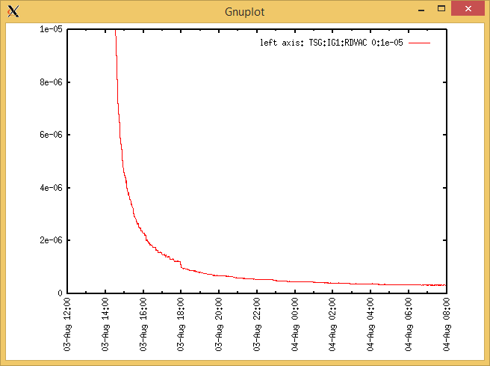

Target Heat Sequence Setup

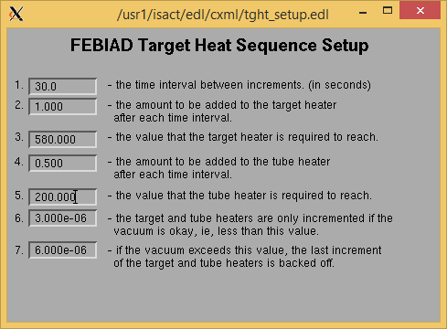

Source Tuning

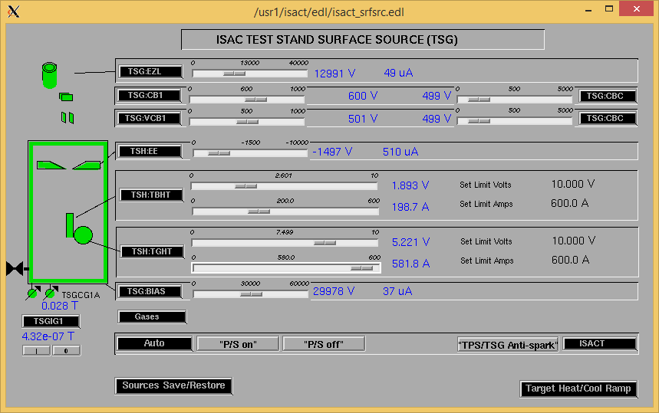

Wire Scanners RPM0A and RPM0B

Mass 7

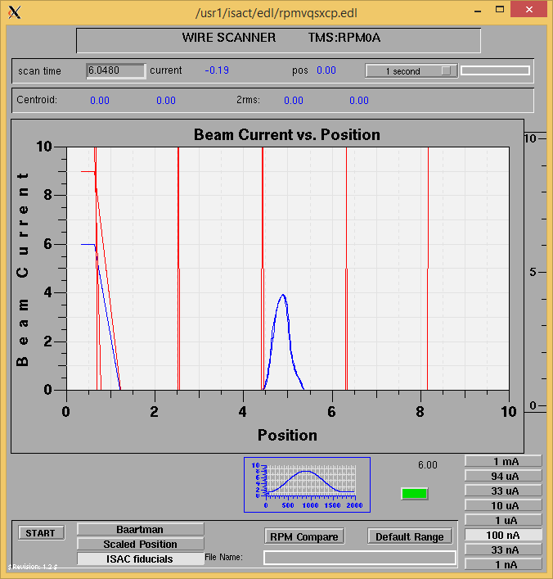

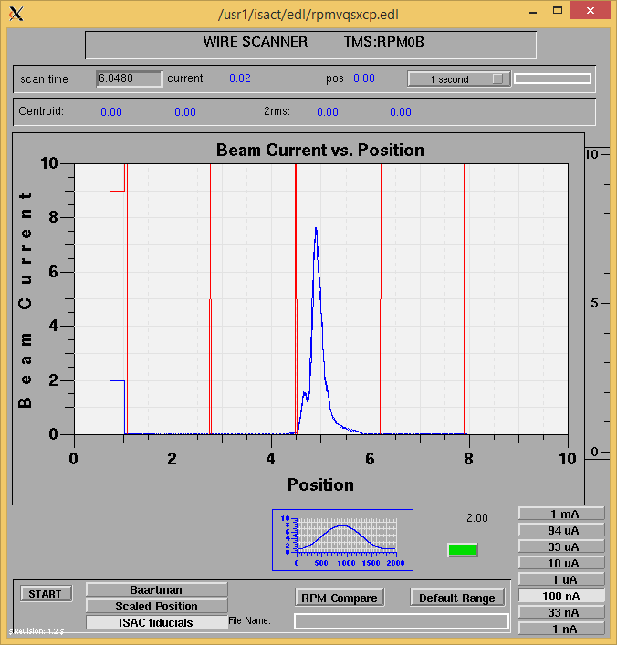

Mass 7

Optics Tuning

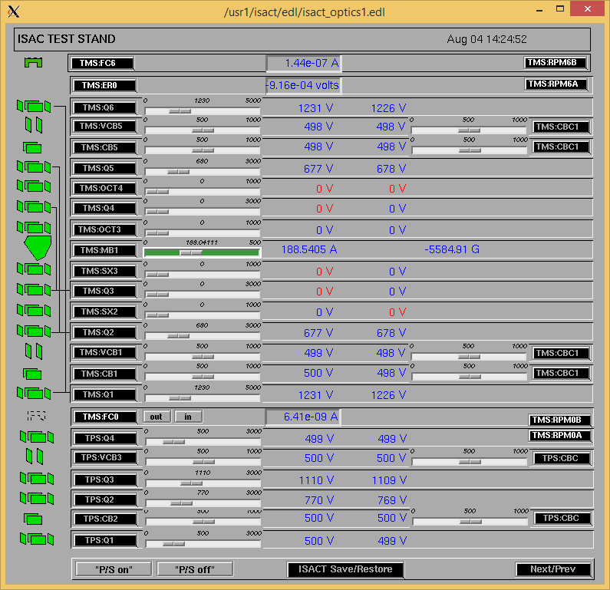

Wire Scanners RPM6A and RPM6B

Mass 7

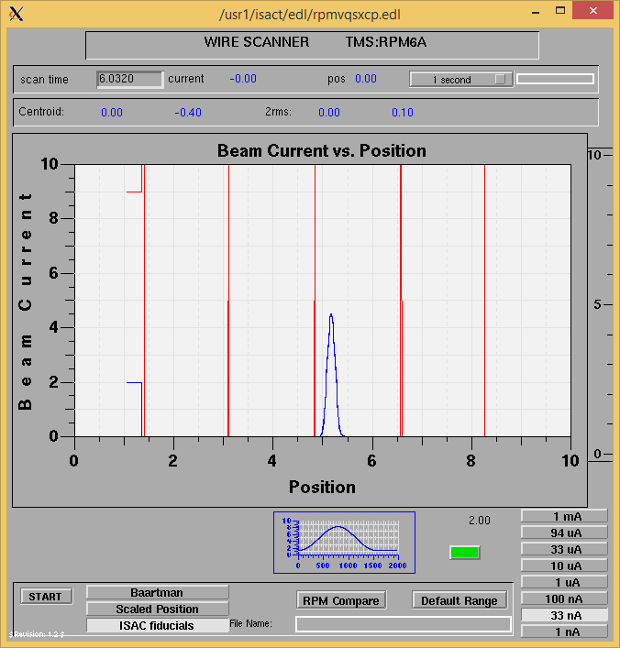

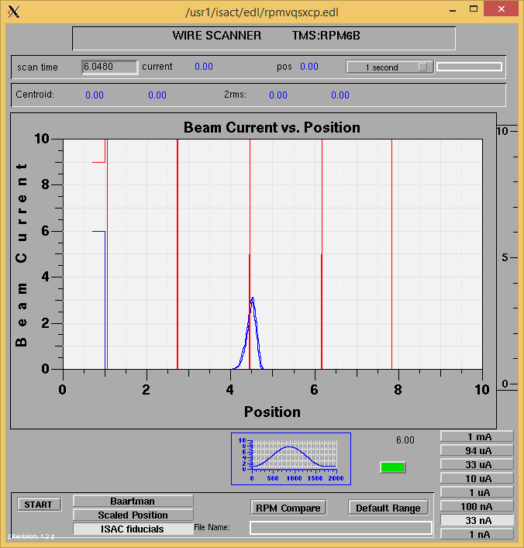

Mass 7

Mass Scan

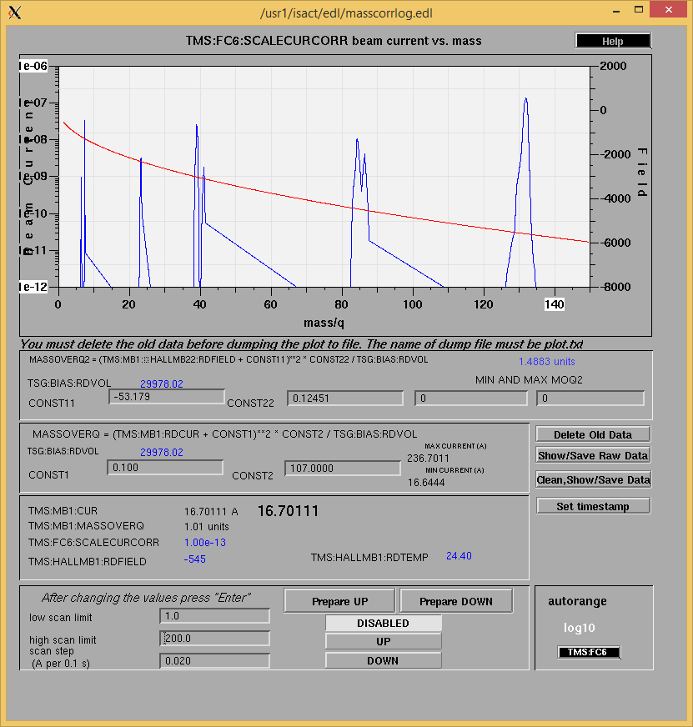

<http://isacwserv.triumf.ca/onlylocal/isactdata/save_restore/masscorr/2016-8-04-2016%20Ta%2349>

Cooling Parameters

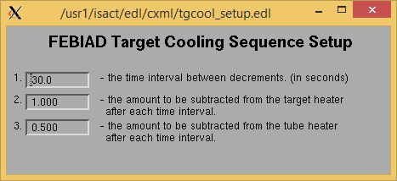

Overview Plots

Vacuum and FC0

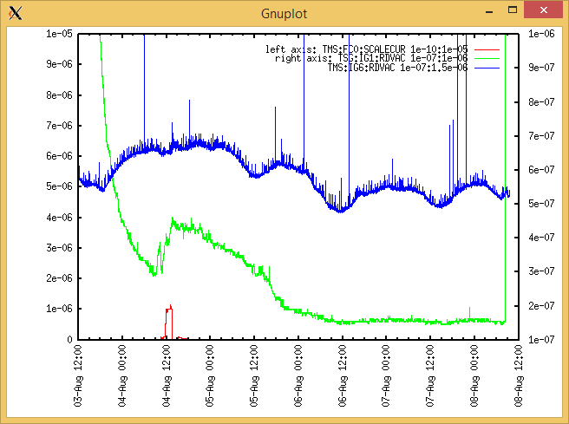

Heating, EE and BIAS

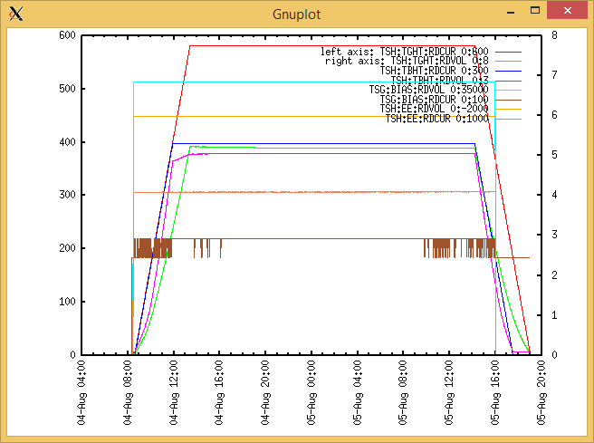

TGHT and TBHT Voltage

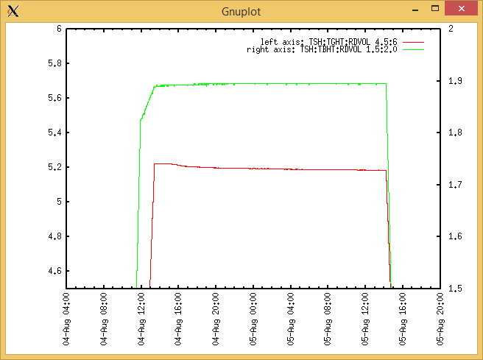

Flow and cooling water temperatures

|  |  |  |
| --- | --- | --- |
| **Device** | **Temp [C]** | **Flow [lpm]** |
| HS + MSP (1,2) | 33.3 | 3.85 |
| TBHT (3,4) | 28.8 | 3.00 |
| COIL + EE (5,6) | 27.6 | 4.89 |
| TGHT (7,8) | 29.6 | 5.50 |

RGA

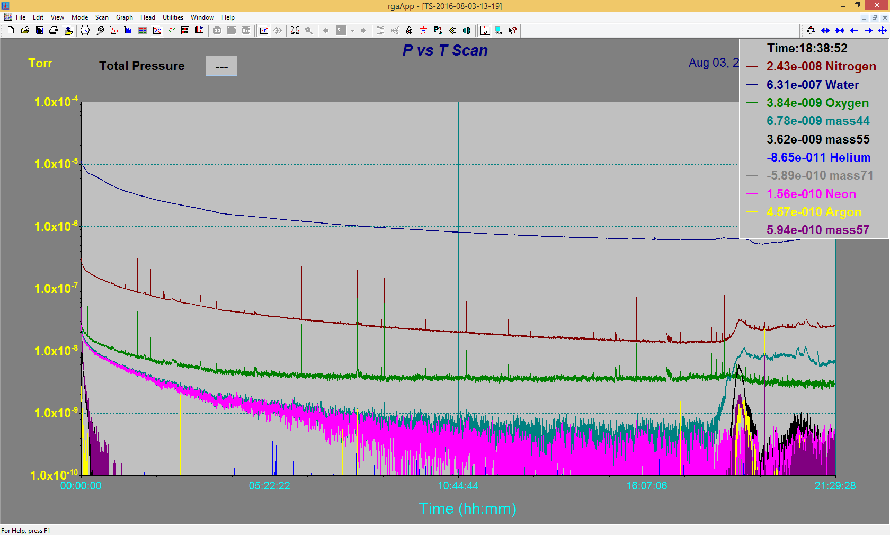

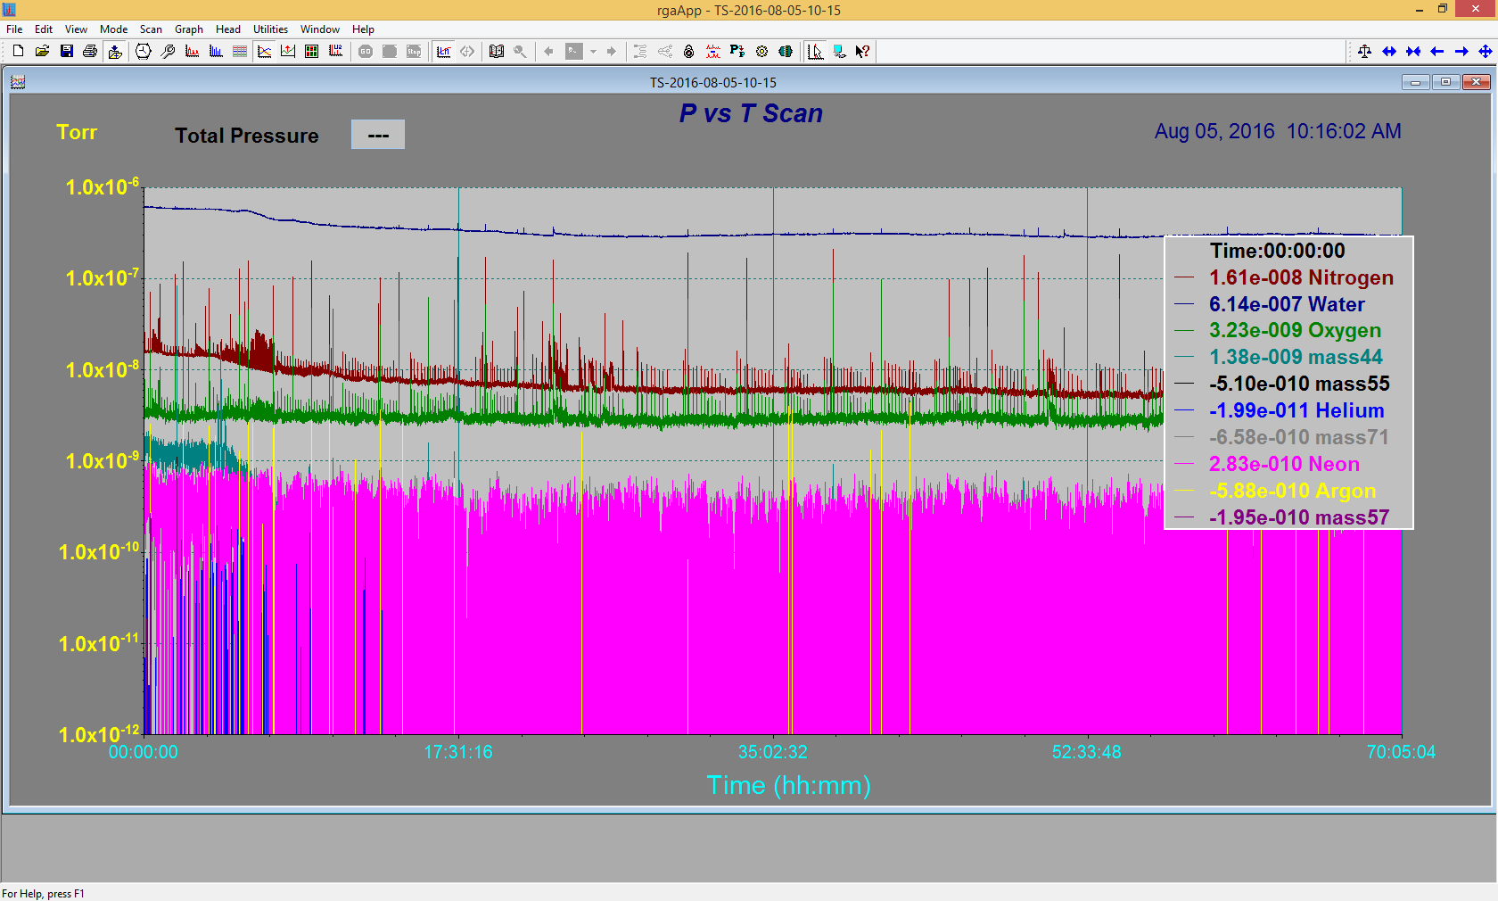

Emittance Scan

Not Available. Emittance Rig was down