Monday, June 27, 2016, 12:05: Roughing.

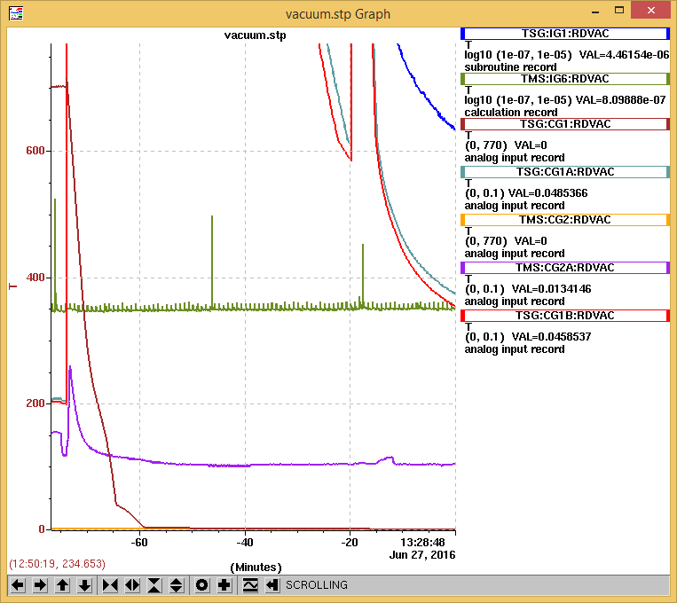

Monday, June 27, 2016, 13:08: Turbo pumps on.

Monday, June 27, 2016, 13:15: Ion Gauge on.

Monday, June 27, 2016, 13:27: RGA on.

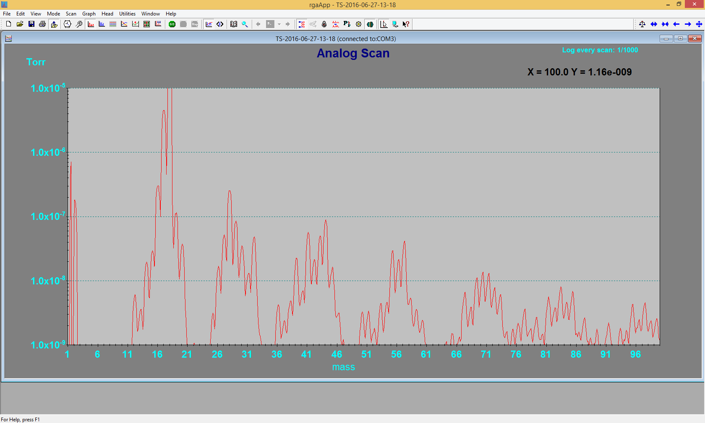

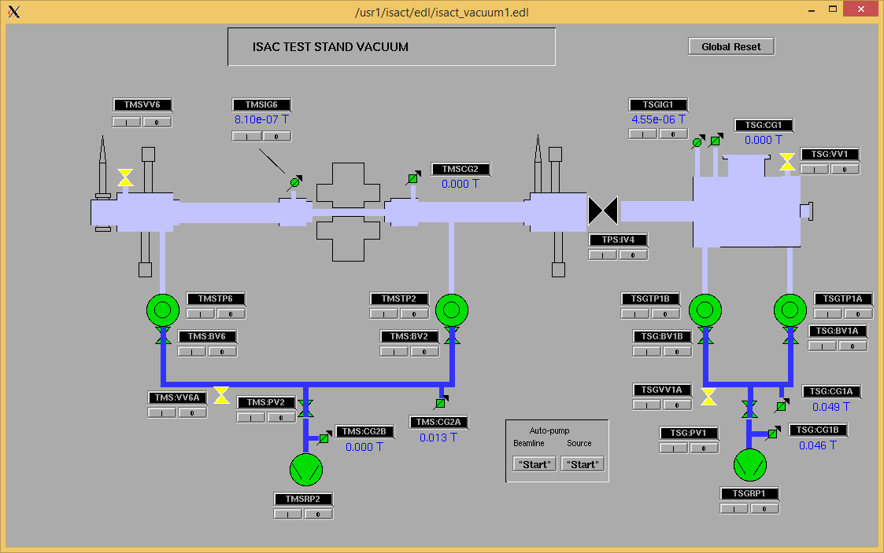

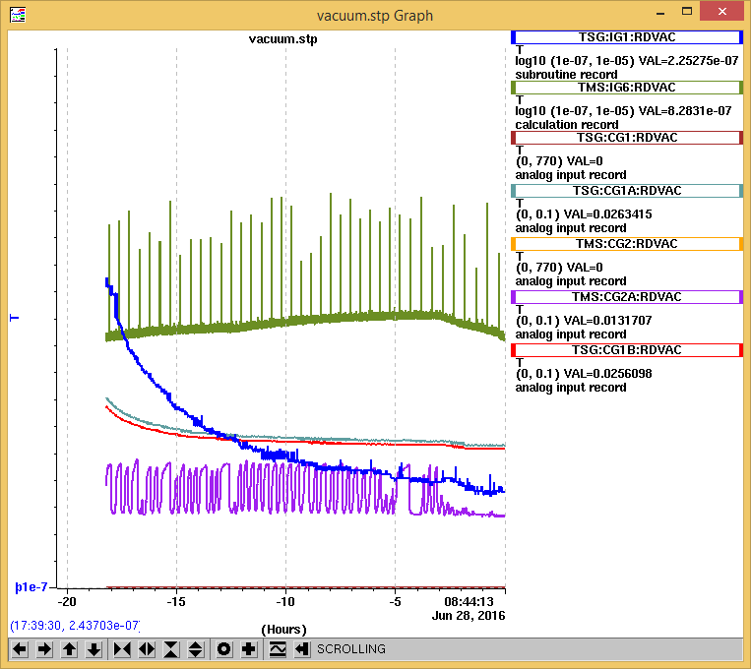

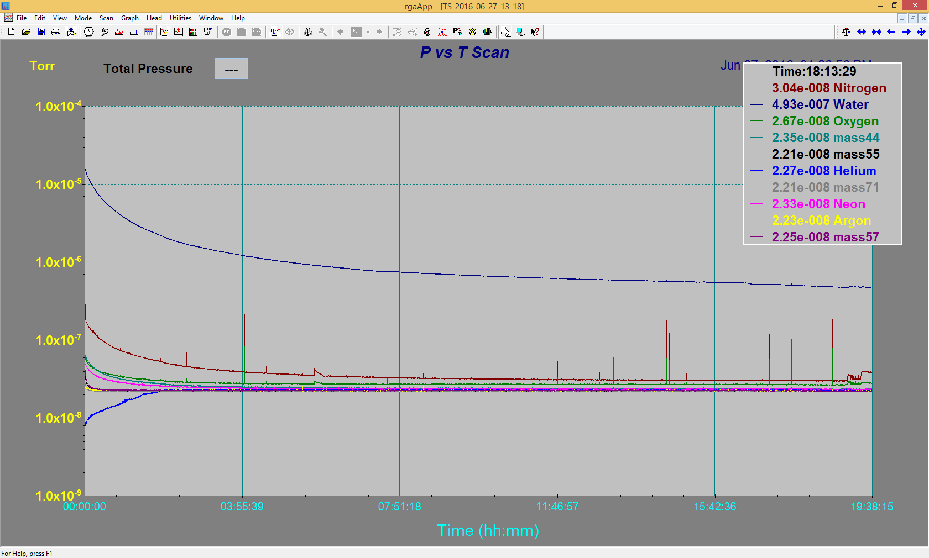

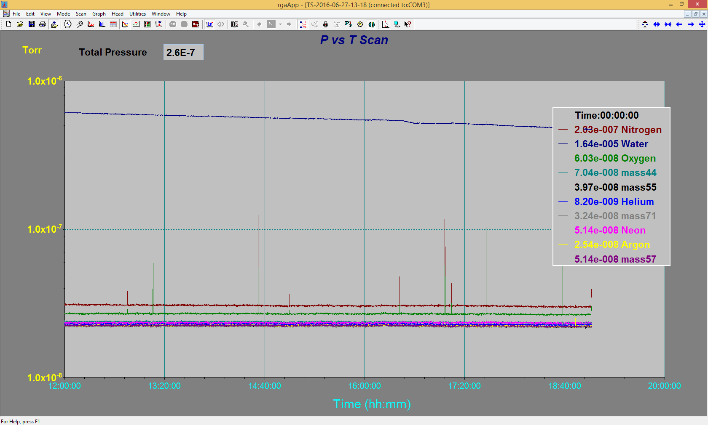

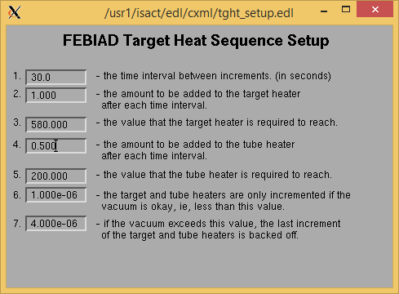

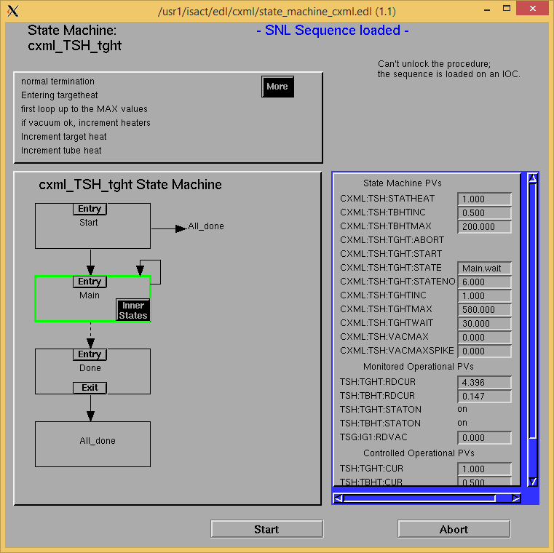

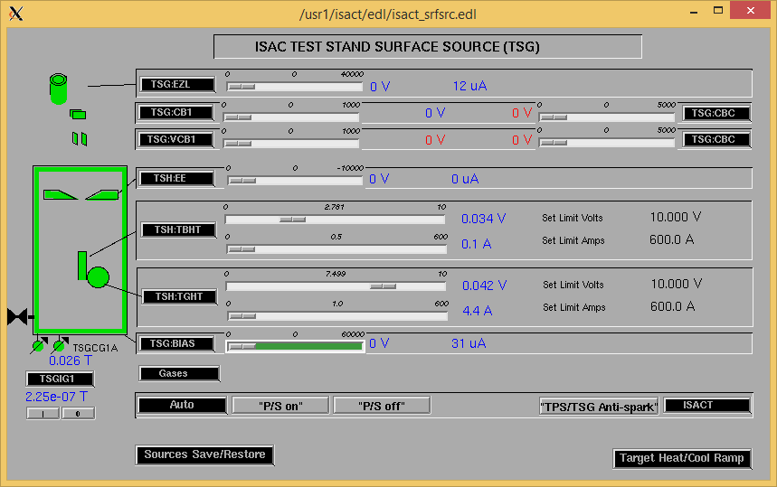

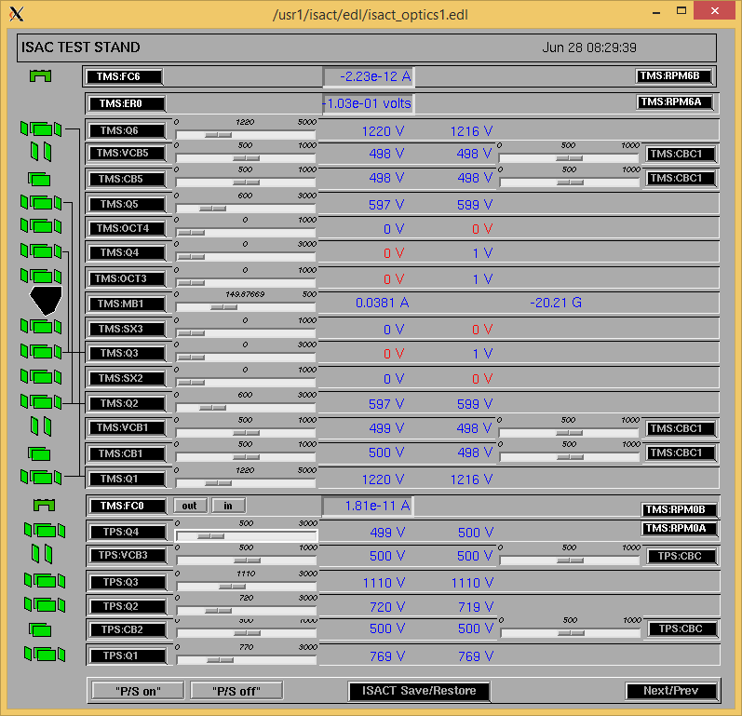

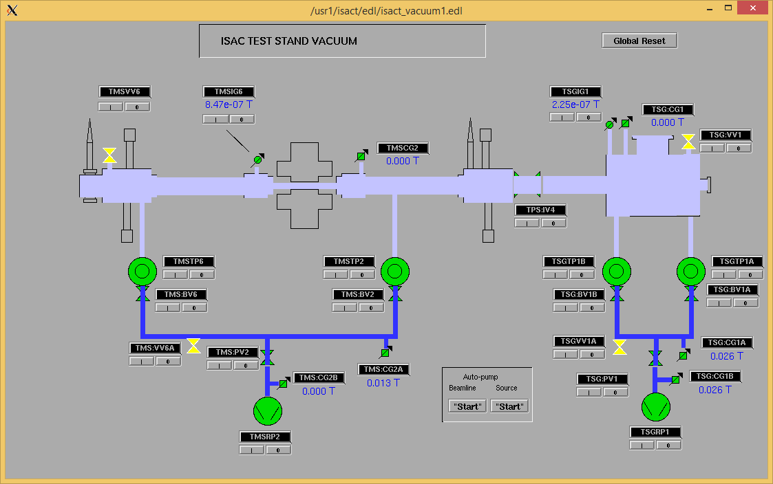

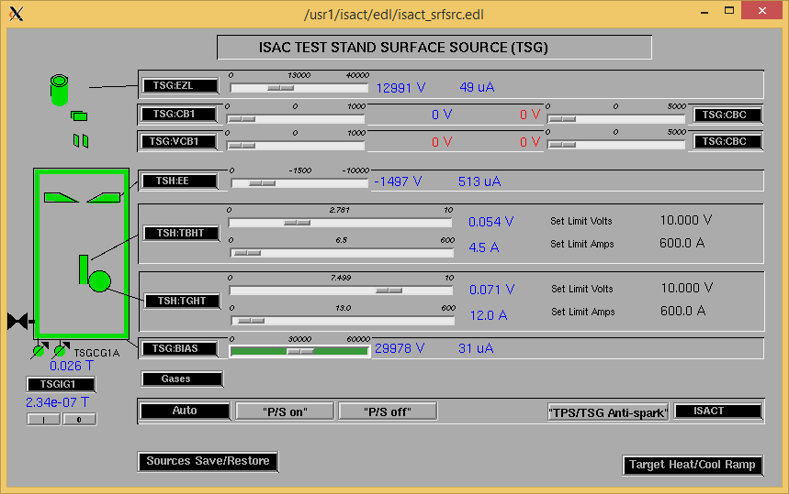

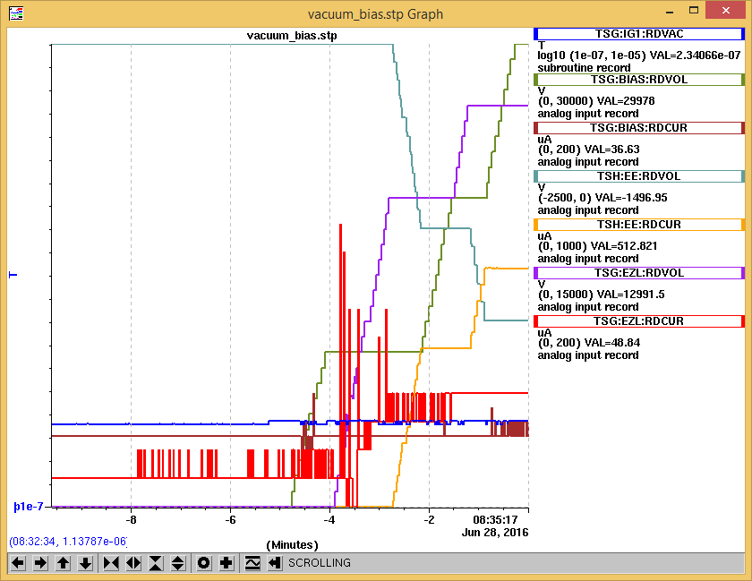

Tuesday, June 28, 2016, 08:20: Water, power/sources on. Vacuum stable at 2.2E-7 T. No response on RGA.

Tuesday, June 28, 2016, 08:33: Auto ramping TGHT/TBHT @ 2A/1A min to 580A/200A.

Tuesday, June 28, 2016, 08:35: Turned on optics. BIAS/EZL/EE to 30/13/1.5kV

Tuesday, June 28, 2016, 08:47:

|  |  |  |
| --- | --- | --- |
| **Device** | **Temp [C]** | **Flow [lpm]** |
| HS + MSP | 27.8 | 3.82 |
| TBHT | 28.8 | 3.06 |
| COIL + EE | 27.1 | 4.90 |
| TGHT | 27.3 | 5.50 |

Tuesday, June 28, 2016, 09:05: Spike

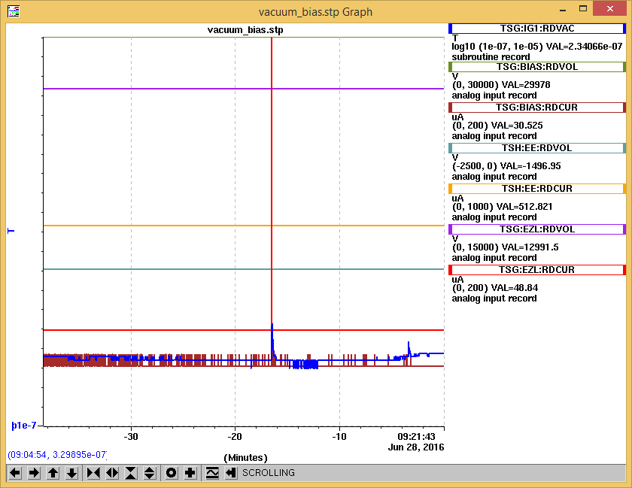

No noticeable spike in RGA.

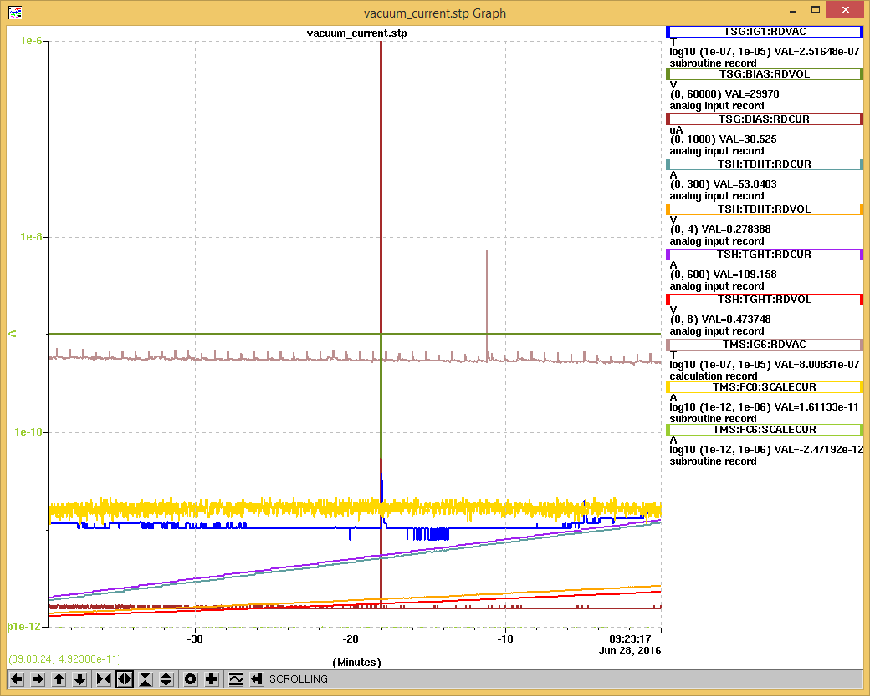

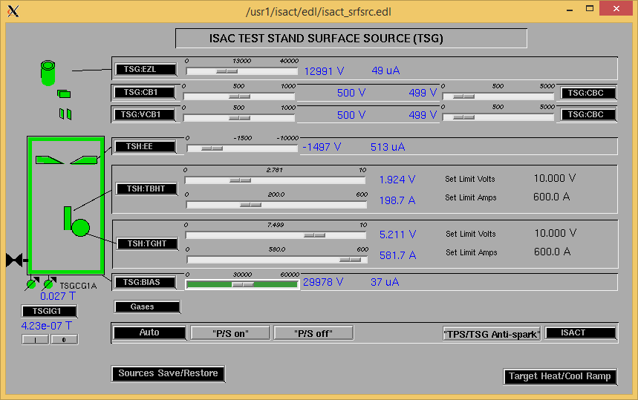

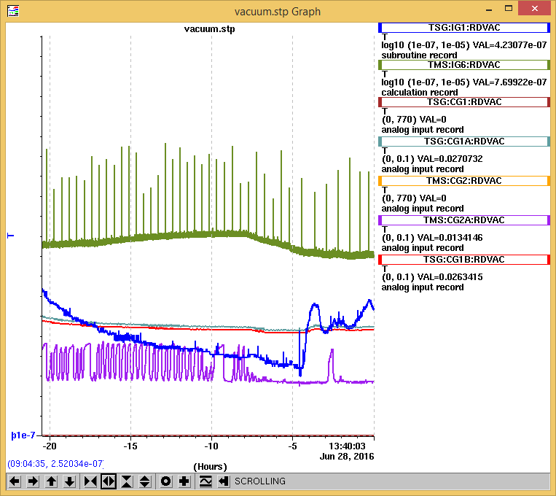

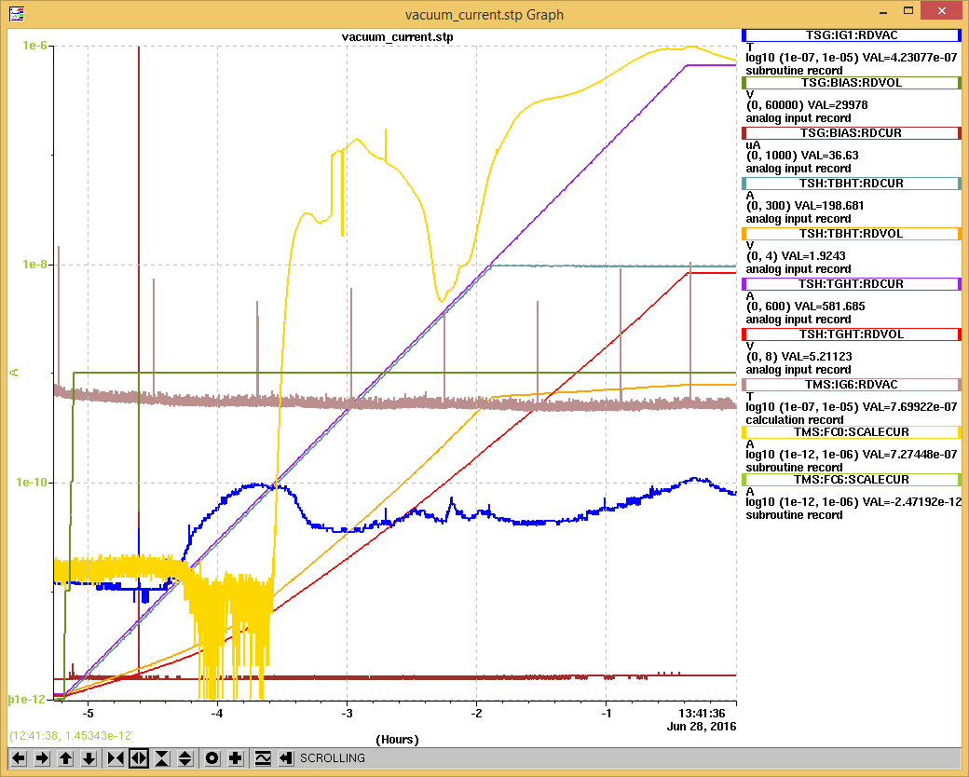

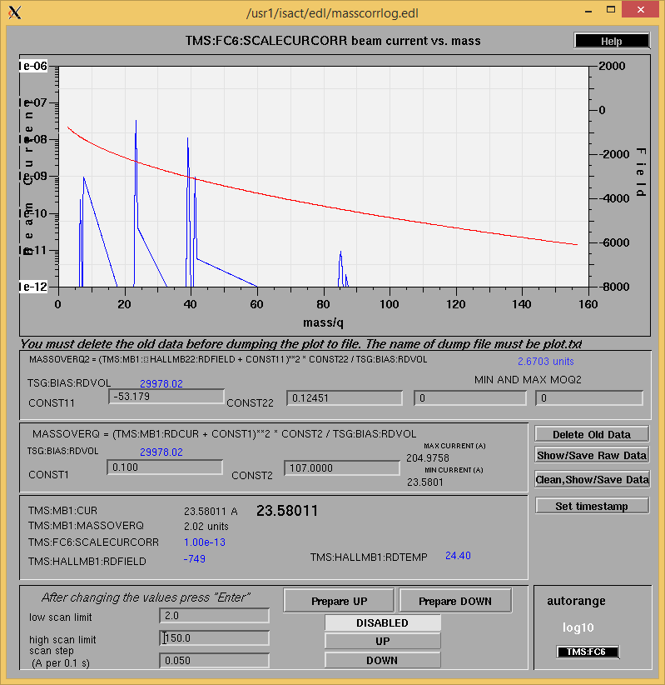

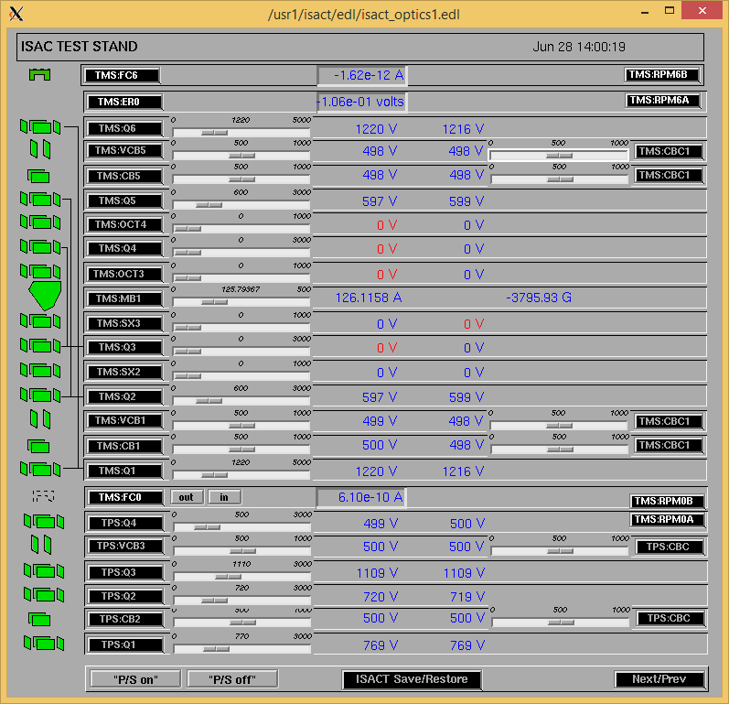

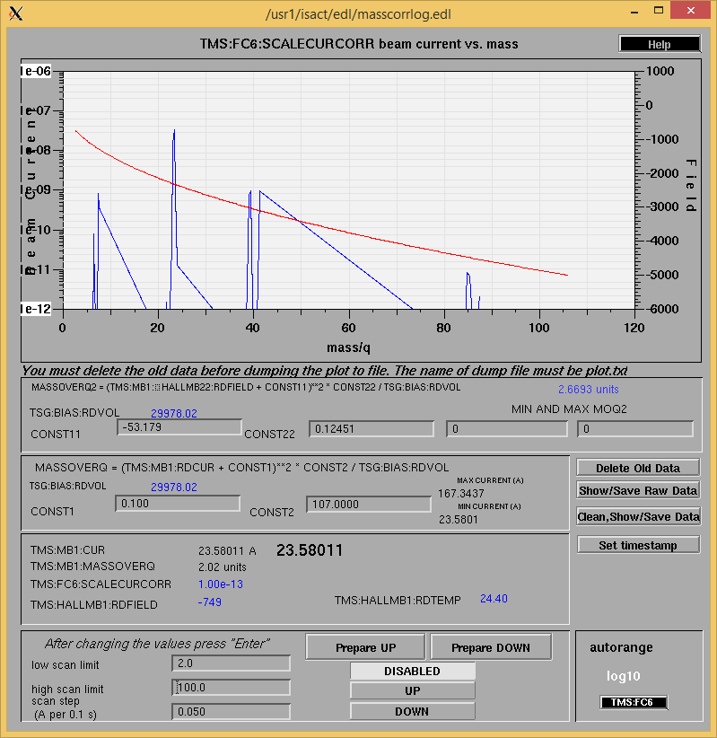

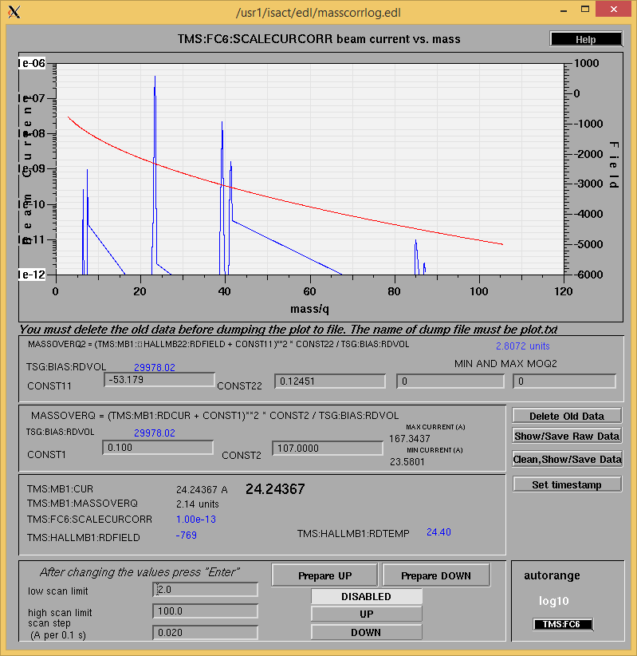

Tuesday, June 28, 2016, 11:17: Restarted RGA program (after crash) –AM

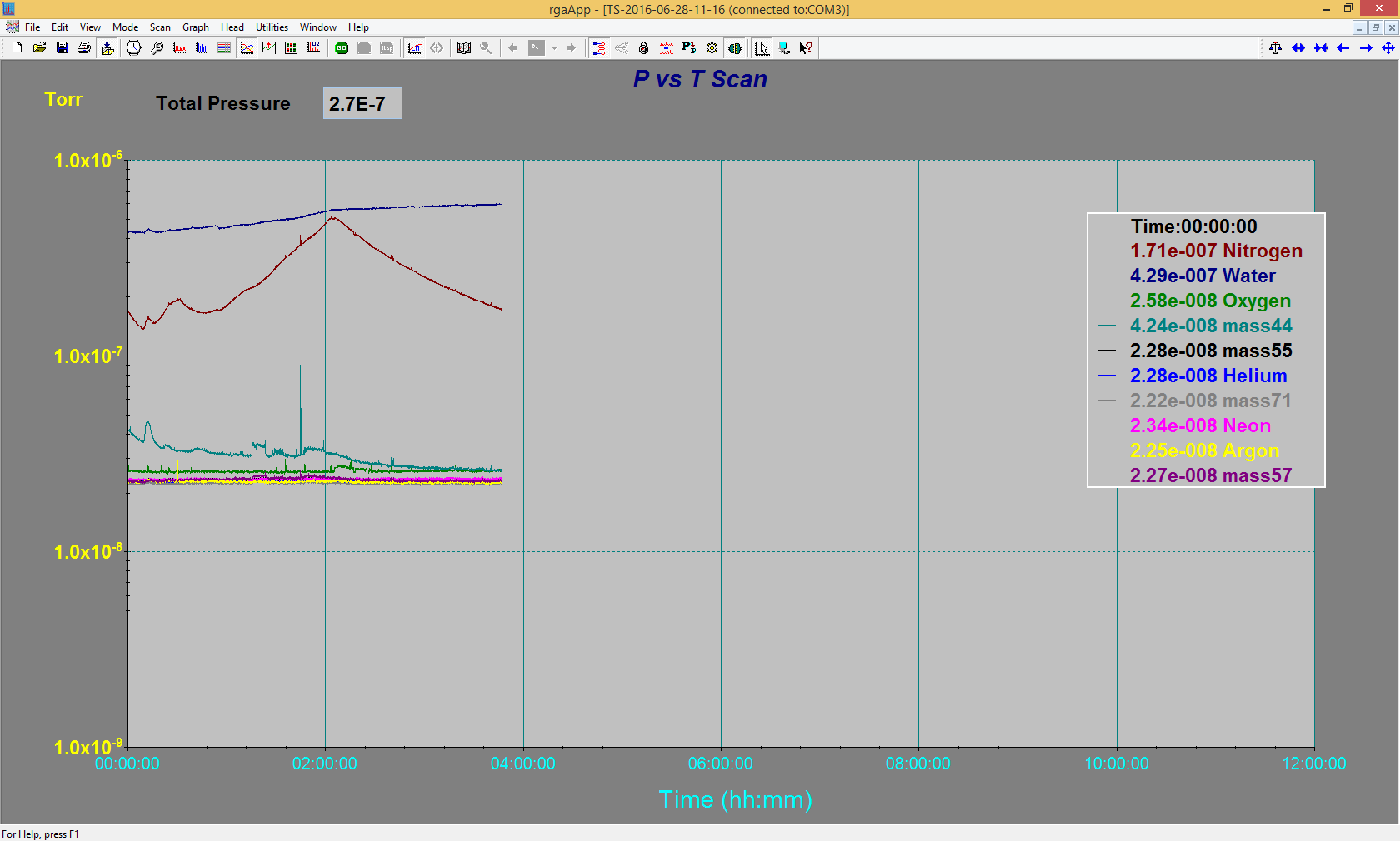

Tuesday, June 28, 2016, 15:46:

|  |  |  |
| --- | --- | --- |
| **Device** | **Temp [C]** | **Flow [lpm]** |
| HS + MSP | 34.8 | 3.82 |
| TBHT | 29.1 | 2.98 |
| COIL + EE | 28.8 | 4.84 |
| TGHT | 30.8 | 5.48 |

Wednesday, June 29, 2016, 08:21: Restarted RGA (crashed).

Wednesday, June 29, 2016, 08:22:

|  |  |  |
| --- | --- | --- |
| **Device** | **Temp [C]** | **Flow [lpm]** |
| HS + MSP | 34.8 | 3.82 |
| TBHT | 29.9 | 3.05 |
| COIL + EE | 28.7 | 4.84 |
| TGHT | 30.6 | 5.48 |

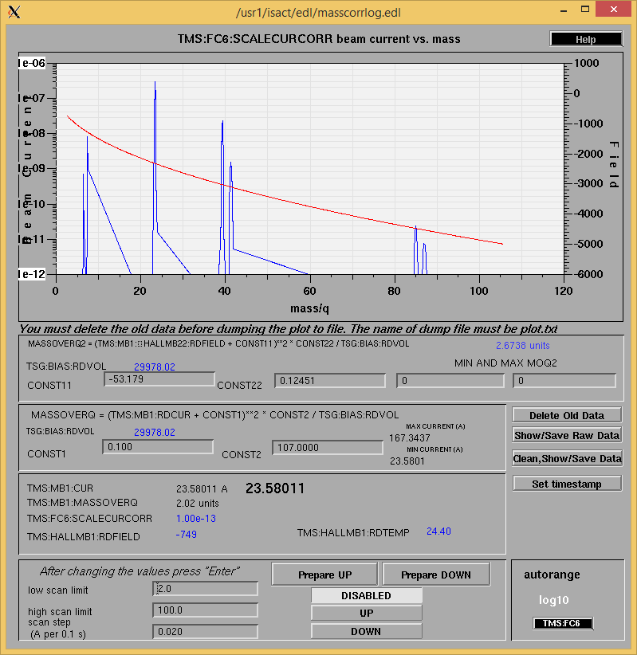

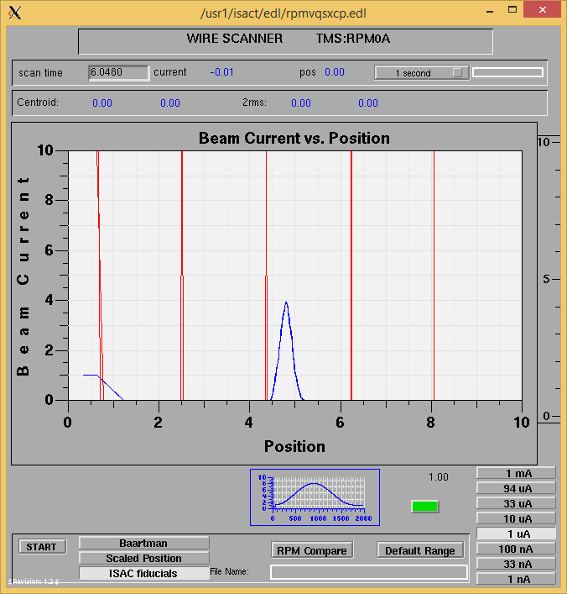

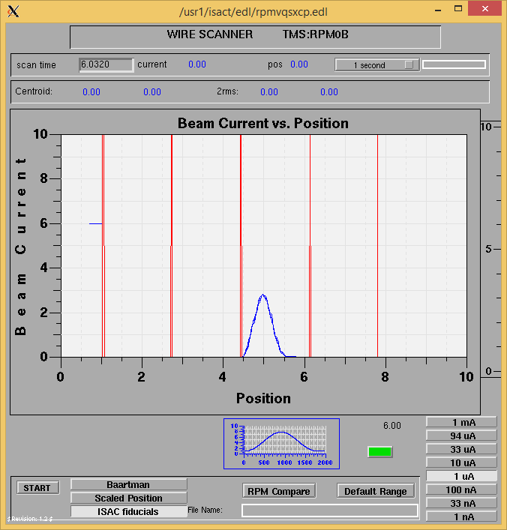

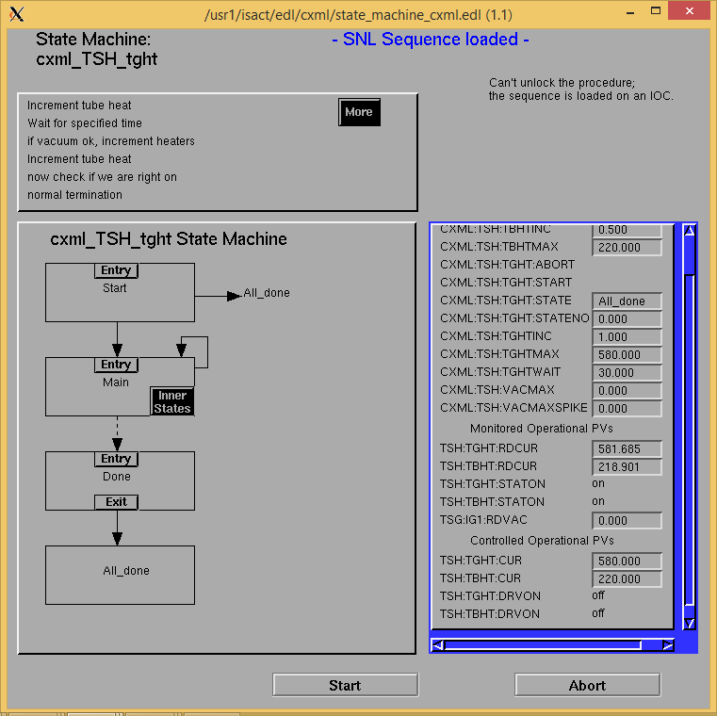

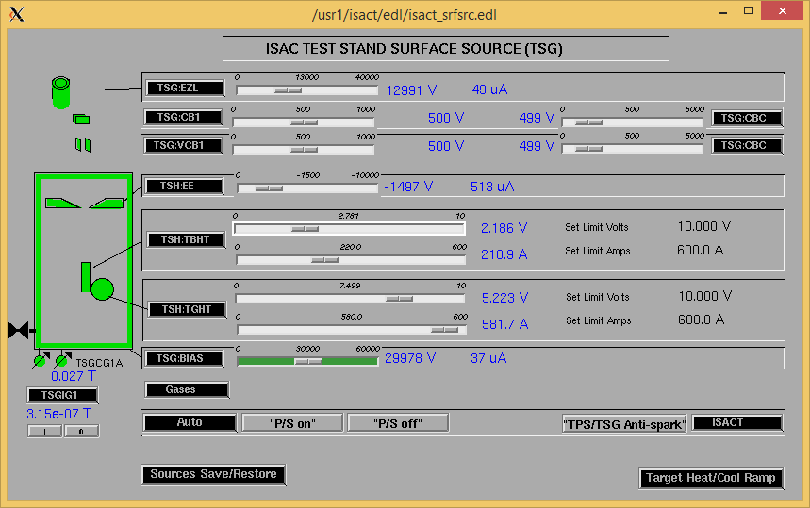

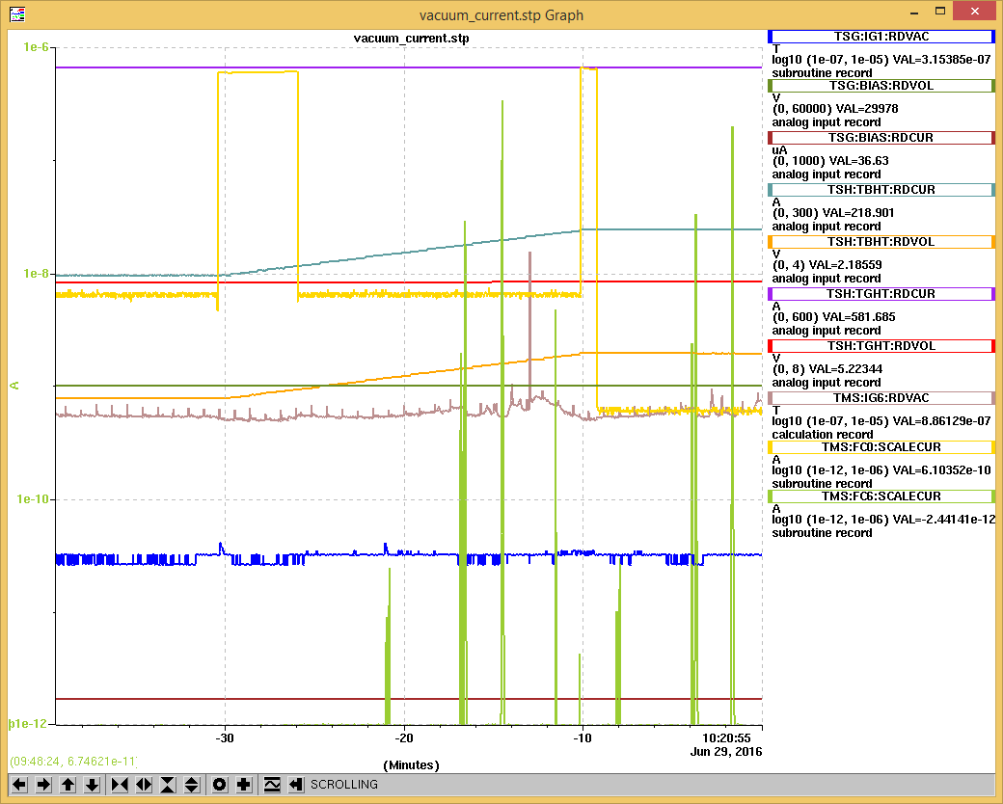

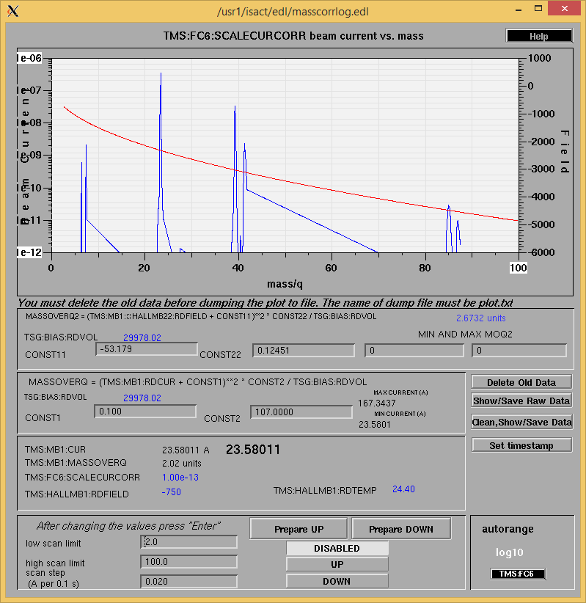

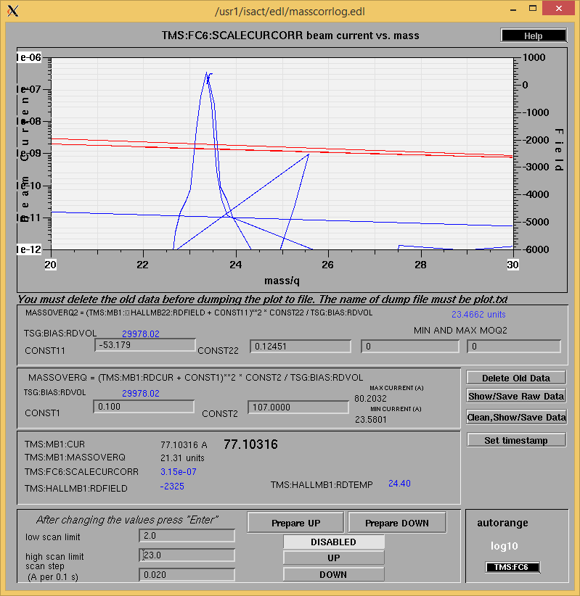

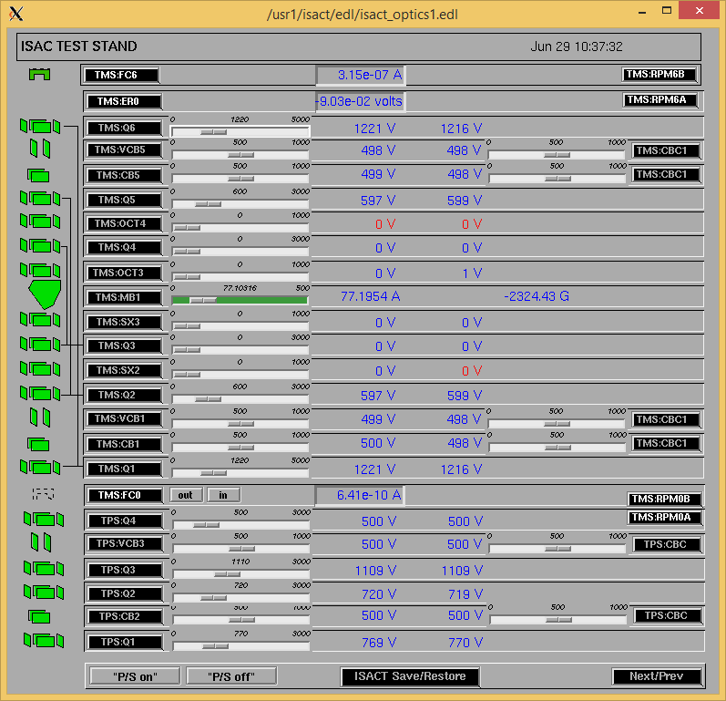

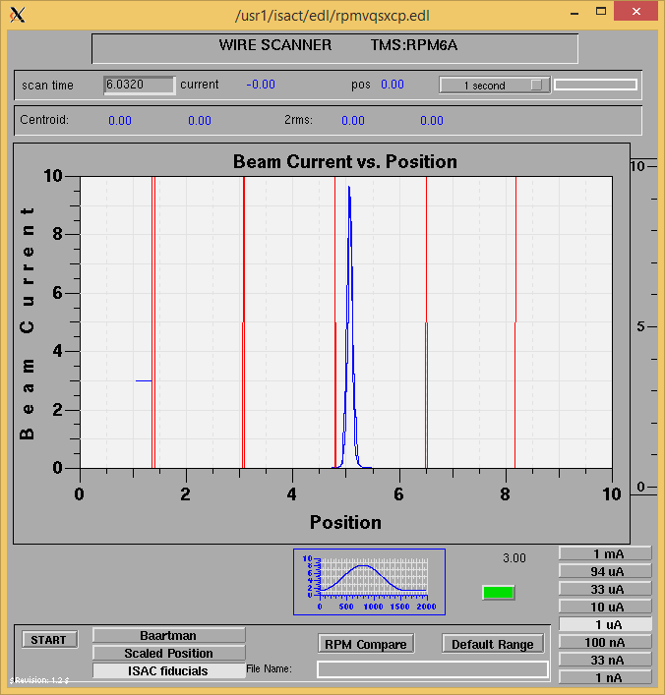

Mass 23

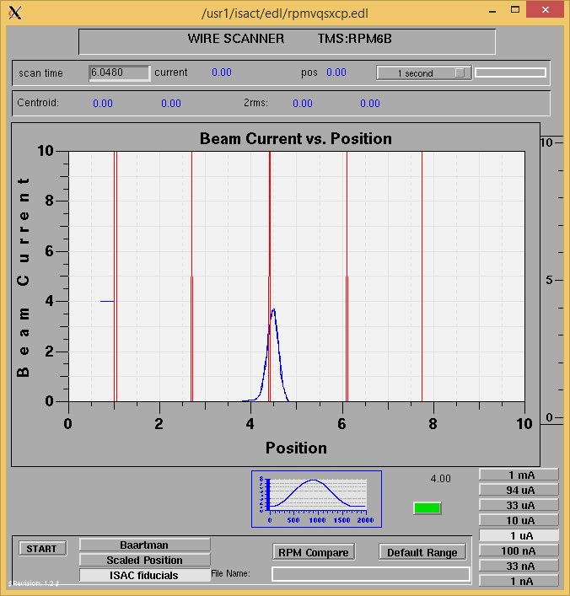

Mass 23

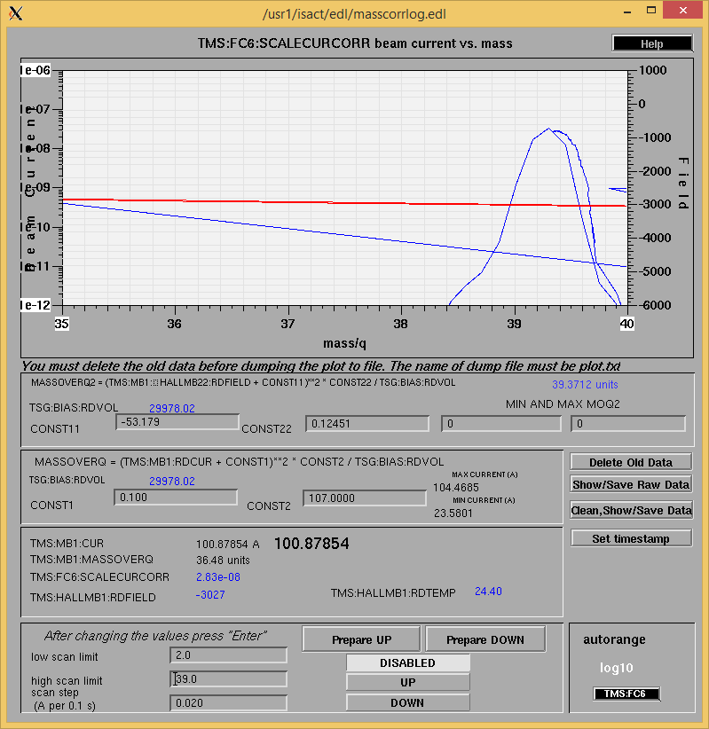

Mass 39

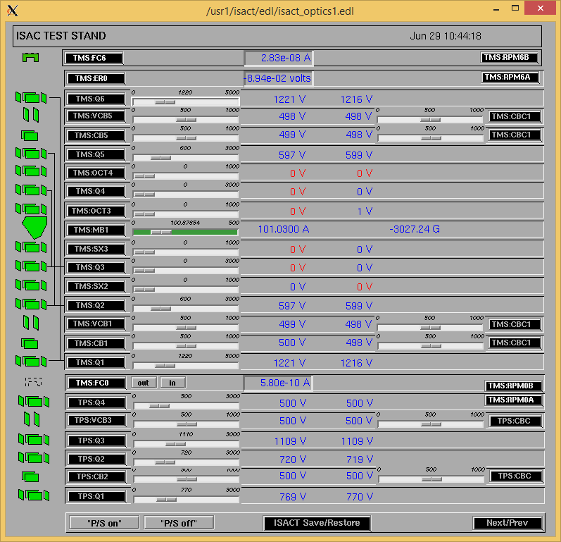

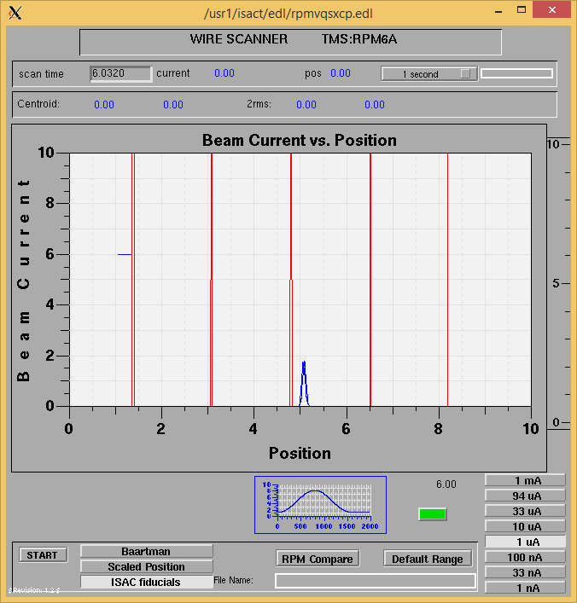

Mass 39

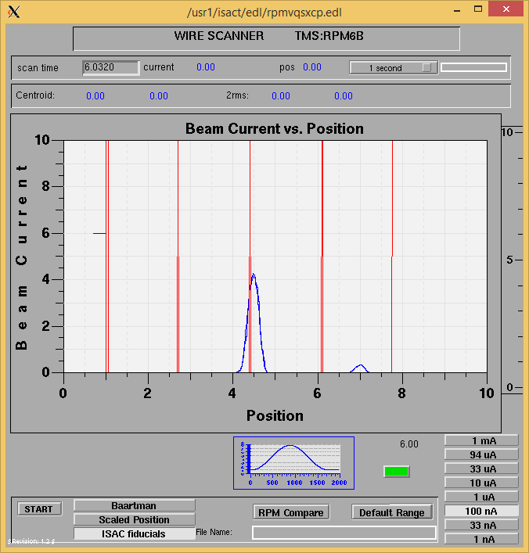

Mass 39

