Conditioning Report

|  |  |  |
| --- | --- | --- |
| Target material and number | | SiC#33 |
| Target WO-SN | |  |
| Operator name | | Aaron Schmidt |
|  | |  |
| Heating start date and time | | 2016-06-28 08:33 |
| BIAS | |  |
| Voltage [kV] | | 30 |
| Current [µA] | | 37 |
| Extraction Electrode (EE) | |  |
| Voltage [kV] | | 1.5 |
| Current [µA] | | 513 |
| TGHT | |  |
| Current [A] | | 582 |
| Voltage [V] | | 5.223 |
| TBHT | |  |
| Current [A] | | 219 |
| Voltage [V] | | 2.186 |
| FEBIAD ANODE | |  |
| Voltage [V] | | - |
| Current [mA] | | - |
| FEBIAD COIL | |  |
| Current [A] | | - |
| Voltage [V] | | - |
| Flow and Temperature HS + MSP | | - |
| Flow [lpm] | | 3.8 |
| Temperature increase [C] | | - |
| FC6 currents [A] | | - |
| SIS | 7Li | 4.06E-09 |
| FEBIAD | 20Ne | - |
| SIS | 23Na | 3.01E-07 |
| SIS | 39K | - |
| SIS | 85Rb | - |
| SIS | 133Cs | - |
| Heating end date and time | | 2016-06-29 11:16 |

Comments

No emittance scan available.

Plots

8h Vacuum Pump Down

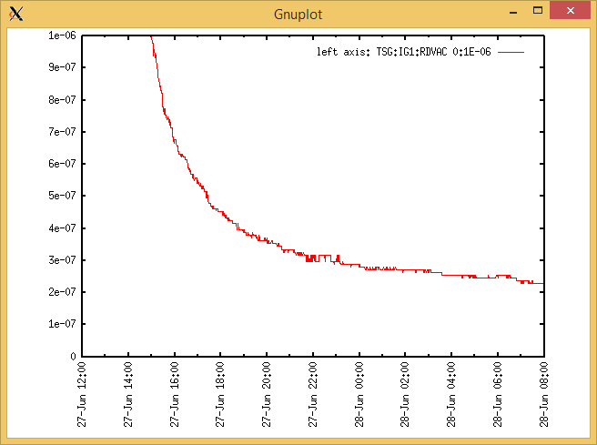

Target Heat Sequence Setup

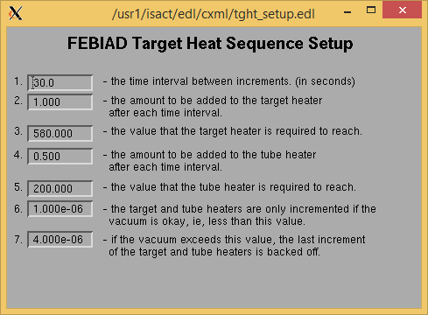

Source Tuning

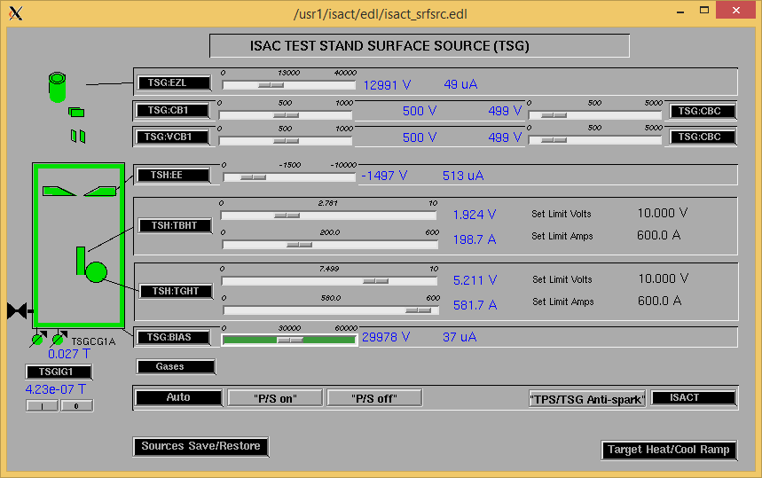

Wire Scanners RPM0A and RPM0B

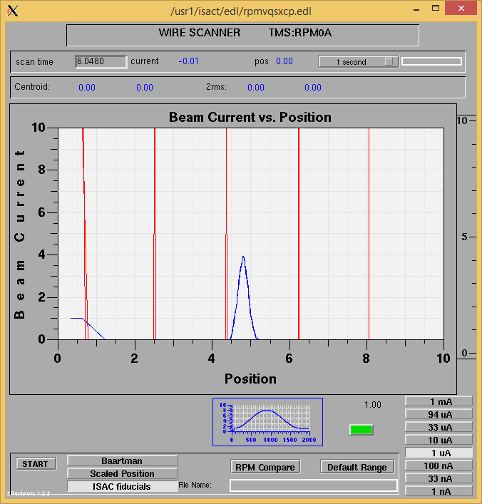

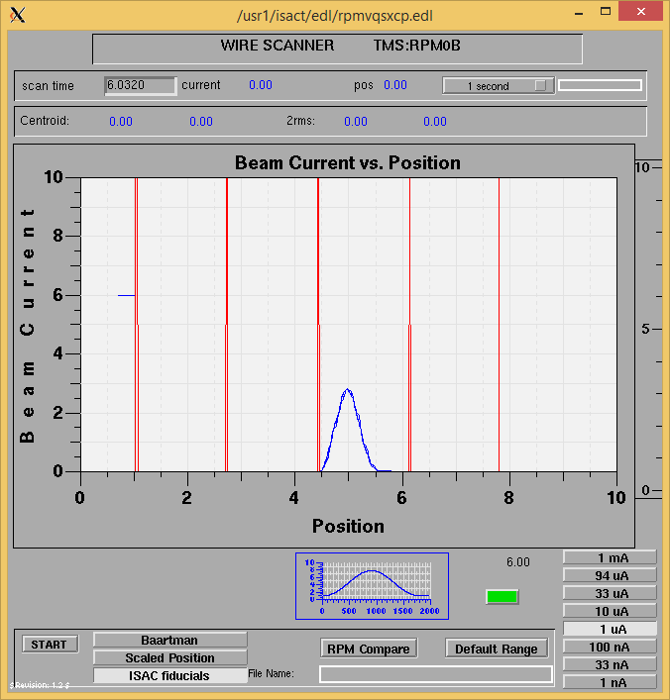

Optics Tuning

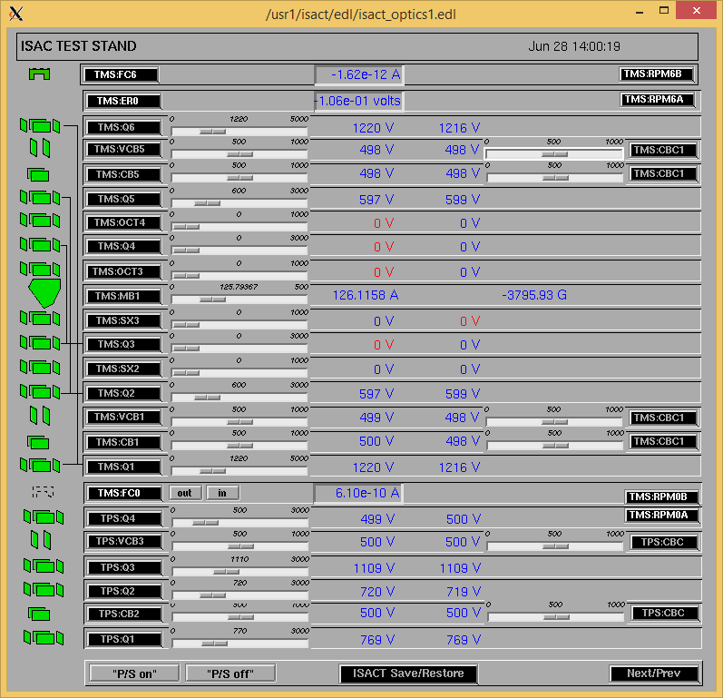

Wire Scanners RPM6A and RPM6B

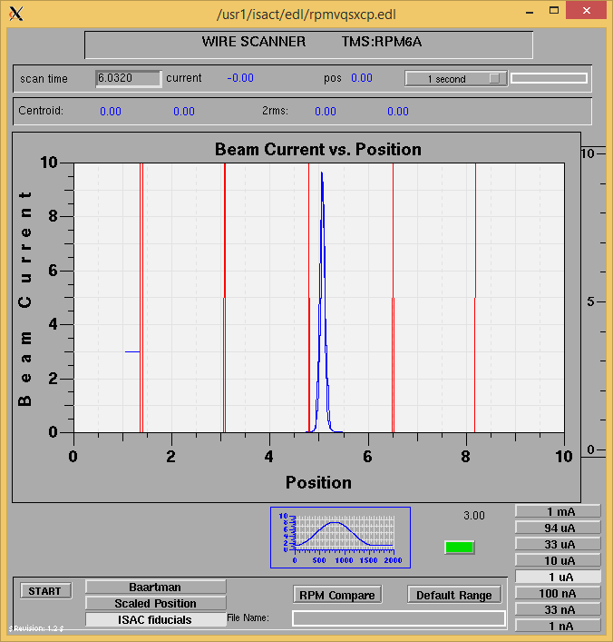

Mass 23

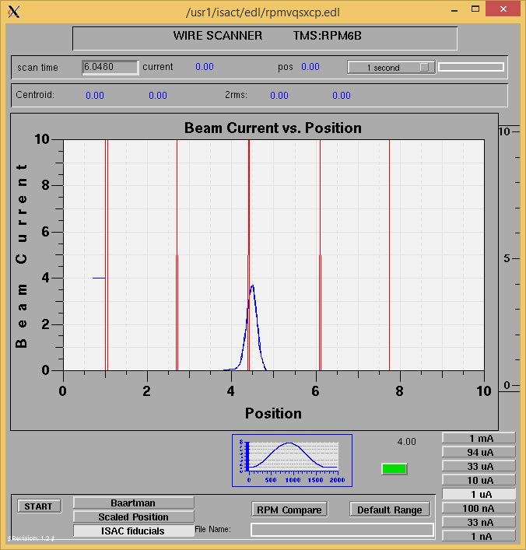

Mass 23

Mass Scan

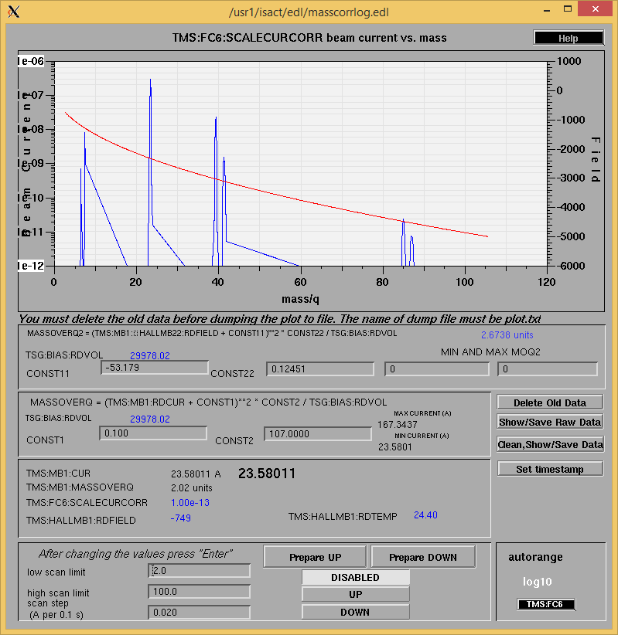

<http://isacwserv.triumf.ca/onlylocal/isactdata/save_restore/masscorr/2016-6-29-08-40%20SiC%2333>

Cooling Parameters

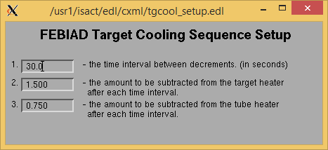

Overview Plots

Vacuum and FC0

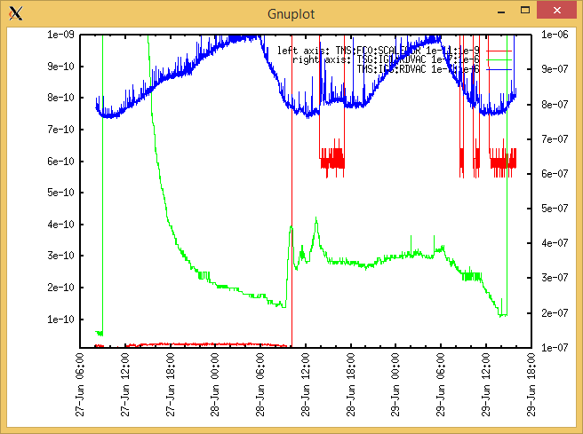

Heating, EE and BIAS

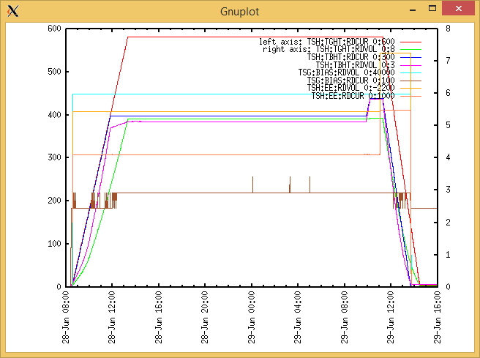

TGHT and TBHT Voltage

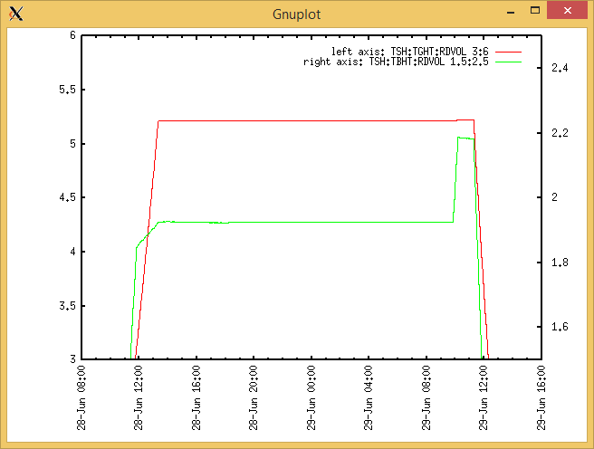

Flow and cooling water temperatures

Tuesday, June 28, 2016, 08:00:

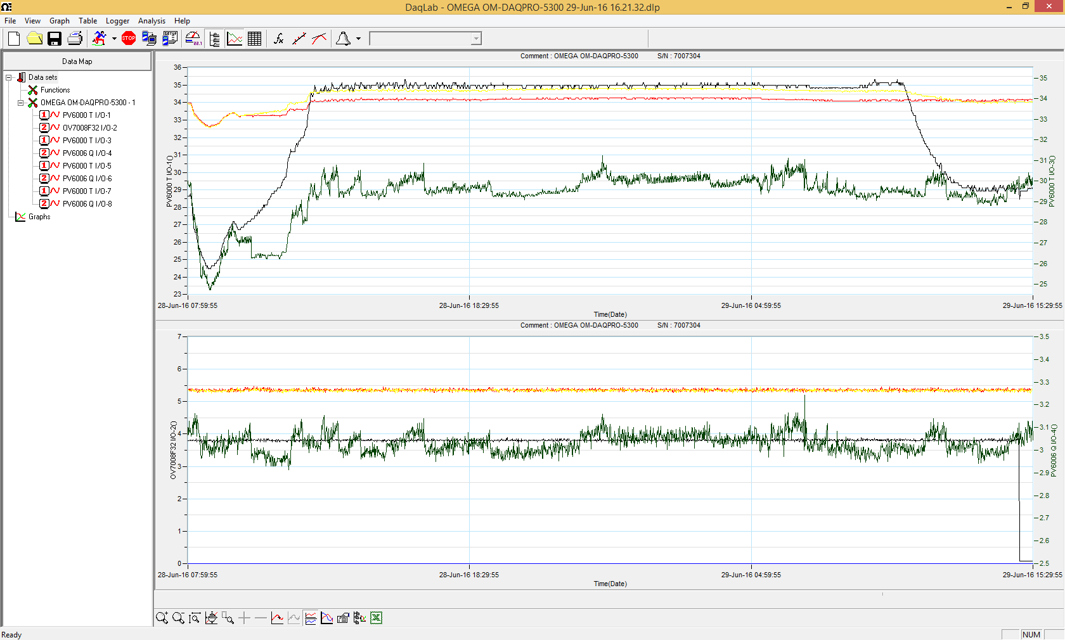

Wednesday, June 29, 2016, 15:30:

RGA

Some data may be missing due to RGA connection crashes.

