## TEMPERATURE

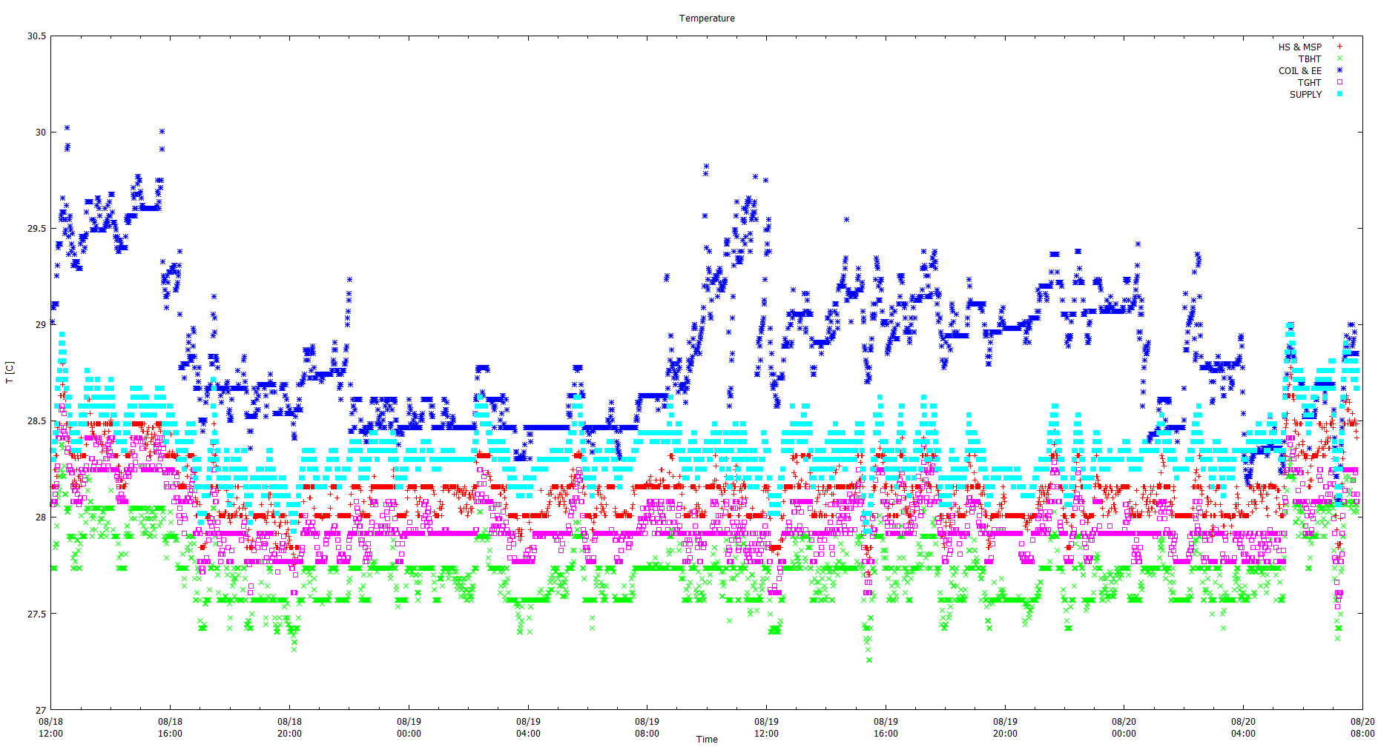

Figure 1: Temperature data (before calibration)

## FIT

$$T_{DEVICE}=mT_{SUPPLY}+b$$

$$T_{DEVICE}=T_{SUPPLY}+c$$

## HS & MSP

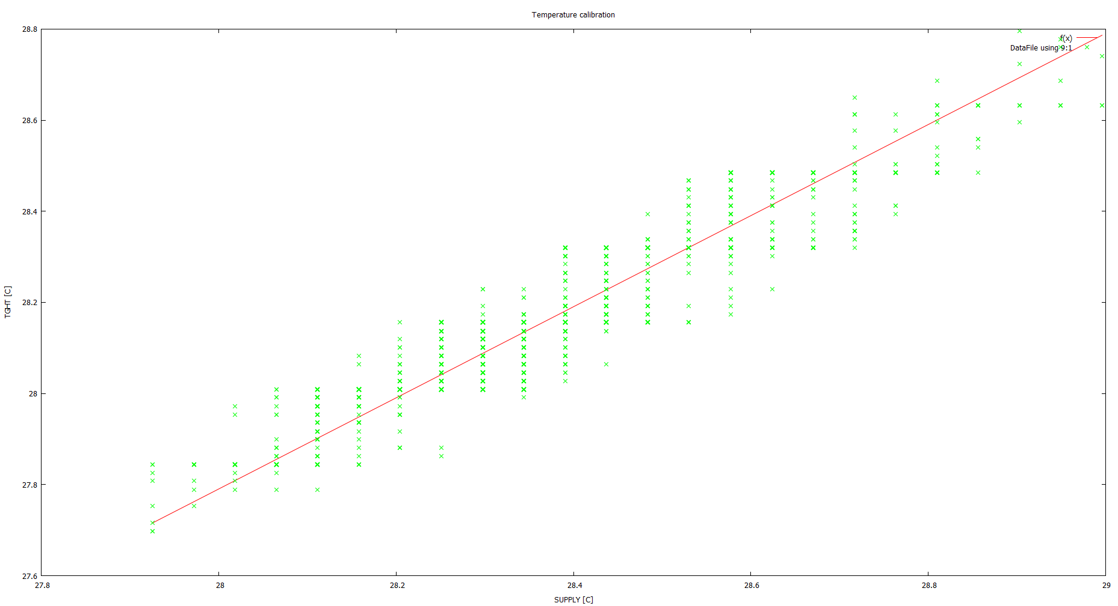

Figure 2: HS & MSP vs SUPPLY temperatures

|  |  |  |  |
| --- | --- | --- | --- |
| **Parameter** | **Value** | **Standard Error** | **Standard Error [%]** |
| b | 2.41207 | 0.1983 | 8.222 |
| m | 0.907517 | 0.006996 | 0.7709 |
| c | -0.209534 | 0.001178 | 0.562 |

## TBHT

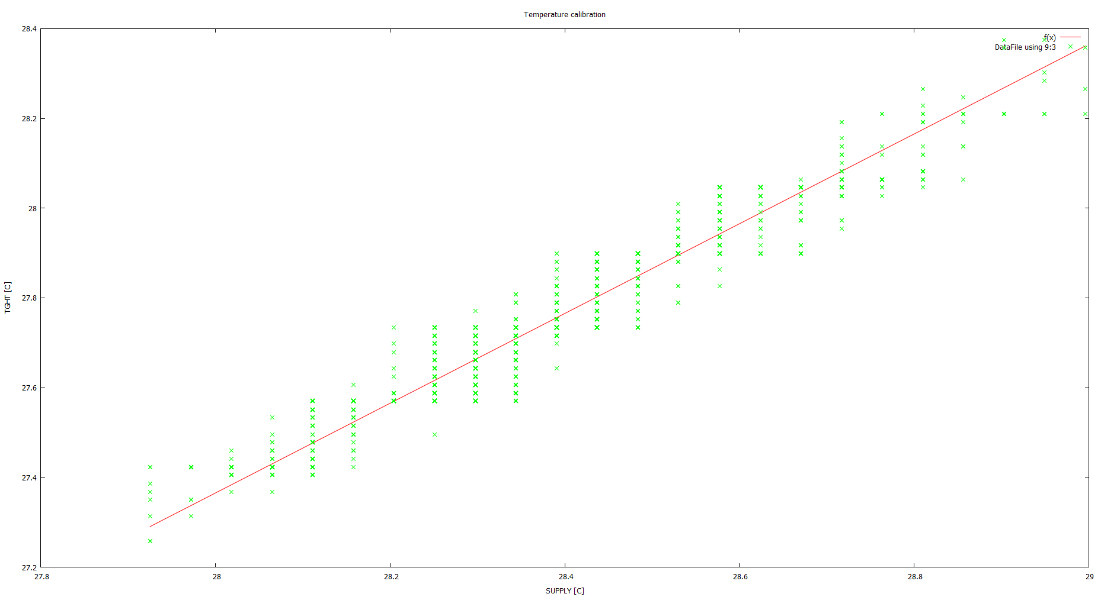

Figure 3: TBHT vs SUPPLY temperatures

|  |  |  |  |
| --- | --- | --- | --- |
| **Parameter** | **Value** | **Standard Error** | **Standard Error [%]** |
| b | 0.605288 | 0.1716 | 28.35 |
| m | 0.956256 | 0.006053 | 0.633 |
| c | -0.634718 | 0.0009966 | 0.0009966 |

## COIL & EE

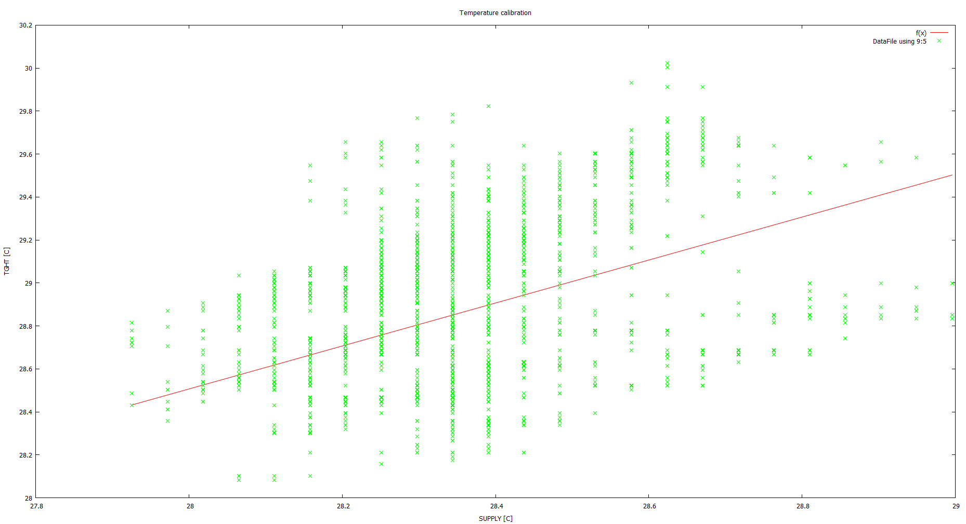

Figure 4: COIL & EE vs SUPPLY temperatures

|  |  |  |  |
| --- | --- | --- | --- |
| **Parameter** | **Value** | **Standard Error** | **Standard Error [%]** |
| b | 6.56973 | 1.123 | 17.09 |
| m | 0.786113 | 0.03961 | 5.039 |
| c | 0.506714 | 0.006494 | 1.282 |

## TGHT

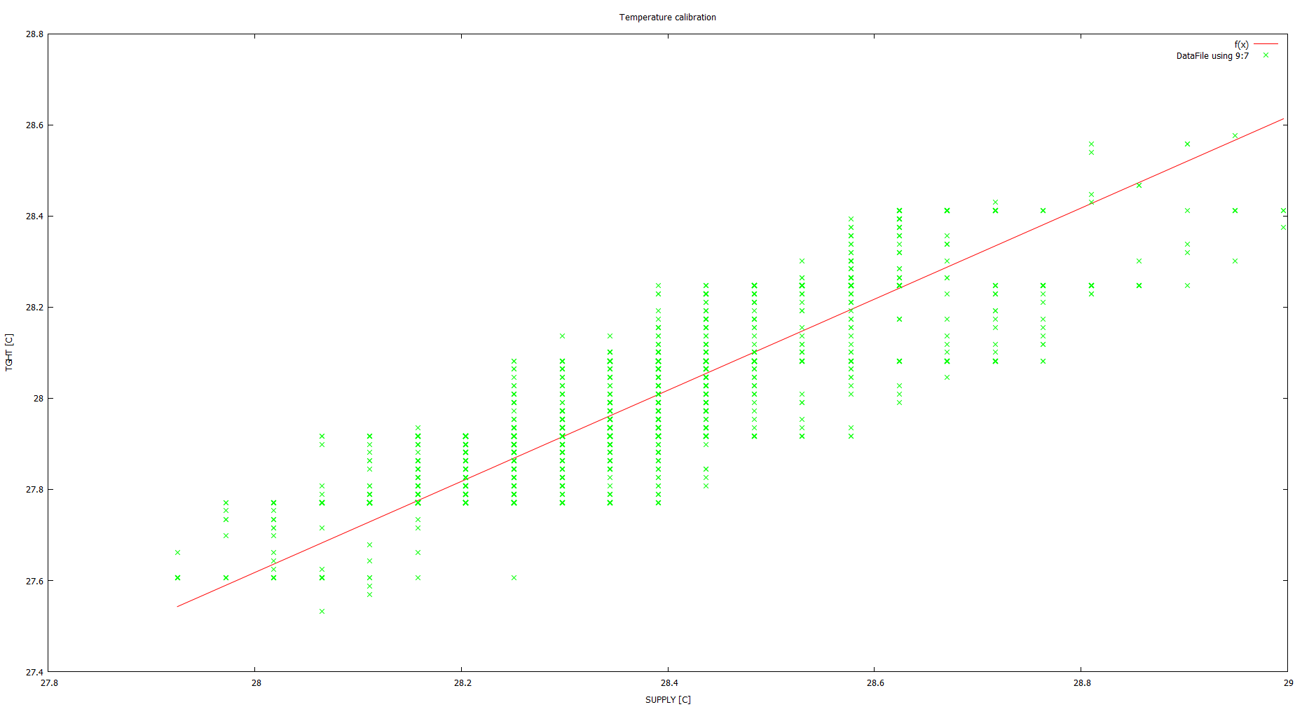

Figure 5: TGHT vs SUPPLY temperatures

|  |  |  |  |
| --- | --- | --- | --- |
| **Parameter** | **Value** | **Standard Error** | **Standard Error [%]** |
| b | 4.08852 | 0.289 | 7.069 |
| m | 0.842281 | 0.0102 | 1.211 |
| c | -0.382314 | 0.001736 | 0.4542 |

## FLOW

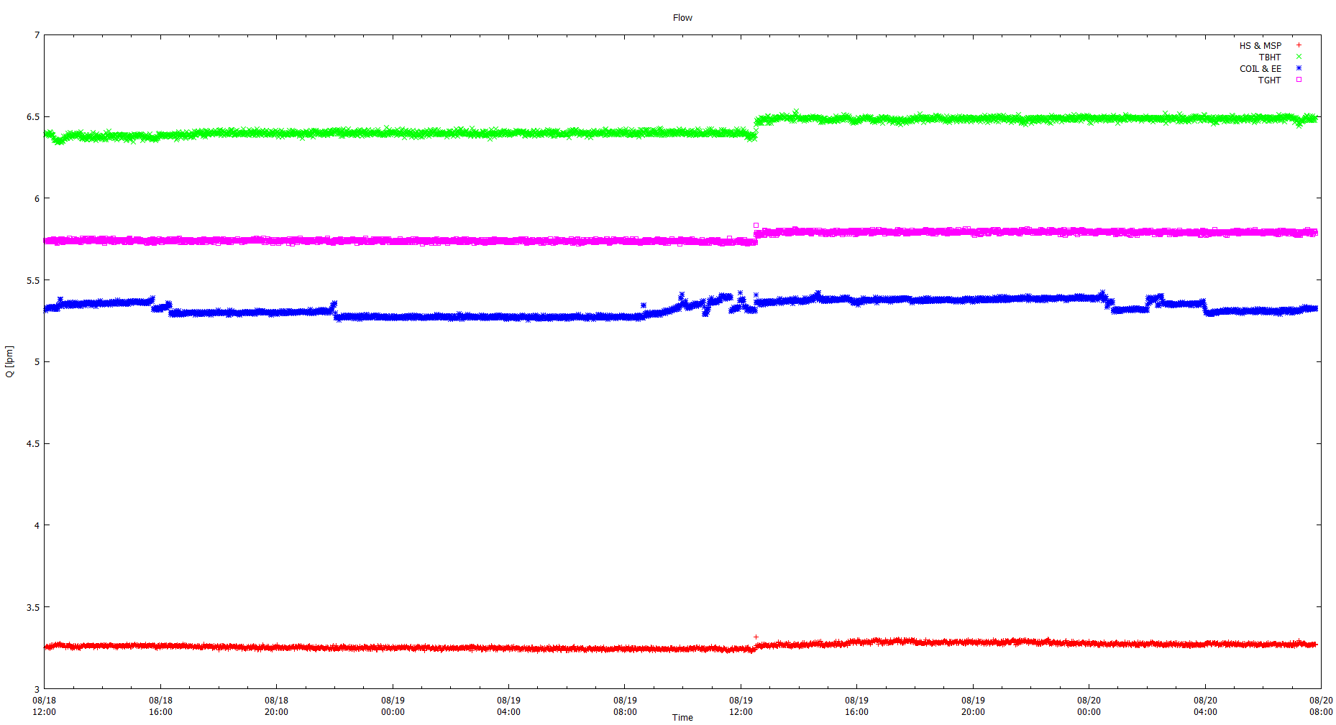

Figure 6: Flow data

CALIBRATED DATA

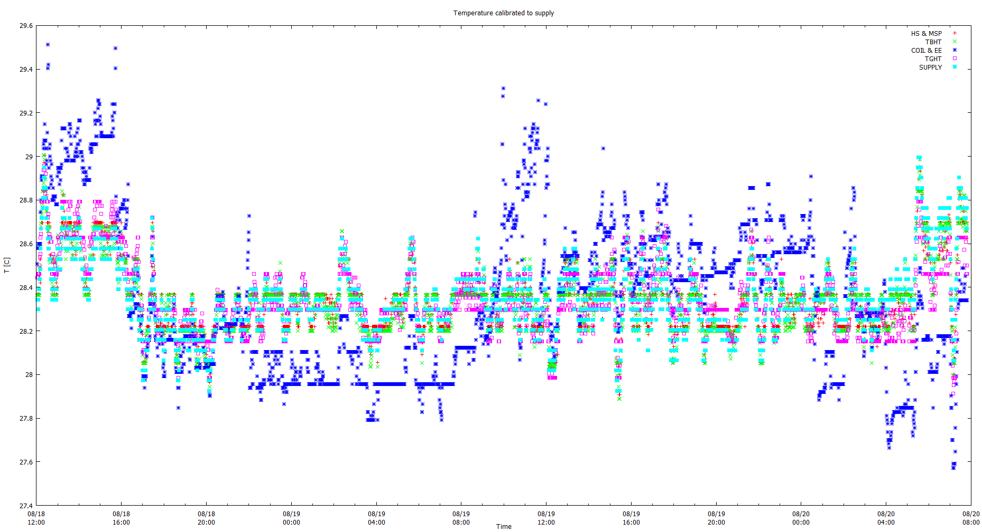

Figure 7: Temperature data (after calibration)

|  |  |
| --- | --- |
| **Device** | **Offset [C]** |
| HS & MSP | +0.21 |
| TBHT | +0.63 |
| COIL & EE | -0.51 |
| TGHT | +0.38 |

## GNUPLOT CODE

reset

f(x) = m*x +b

DataFile = '2014-08-18-ZrC#6.CSV'

set datafile separator ","

set datafile commentschars '\"'

set title 'Temperature calibration'

set ylabel 'TGHT [C]'

set xlabel 'SUPPLY [C]'

fit f(x) DataFile using 9:7 via b,m

plot f(x), DataFile using 9:7