TiC#4 ITE HP-SIS TM3 – A. Laxdal

March 31, 2014

Pumpdown:

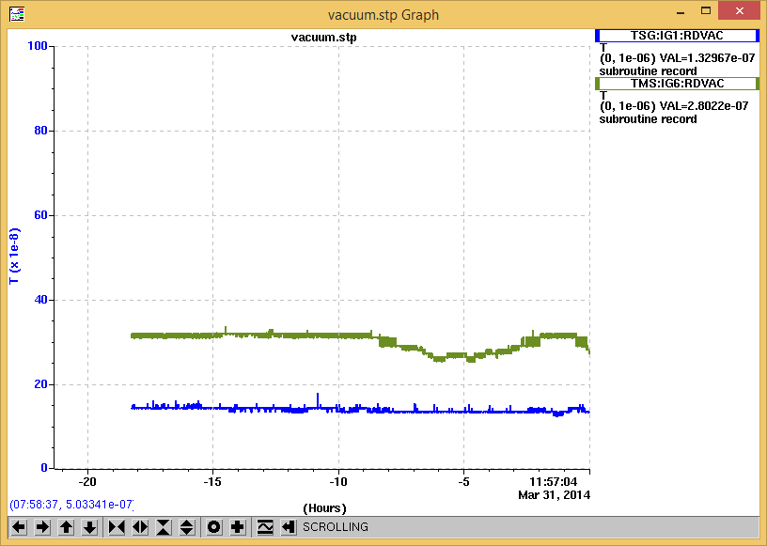

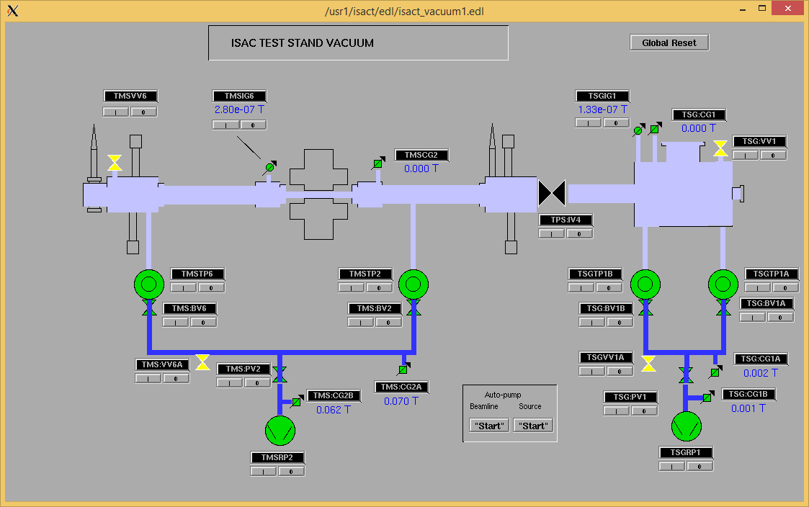

Started the HV Conditioning.

April 1, 2014

Over the night:

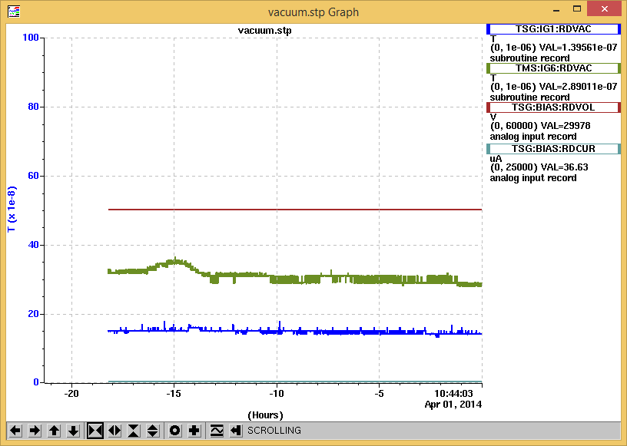

Started the Heaters;

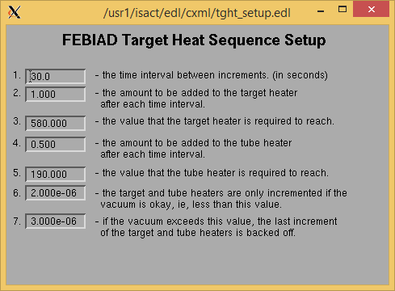

In EPICS we have a 500 A TBHT power supply, but in reality we have a 600 A supply. So, the actual current is 1.2 times more than what you ask for: 190 A should be target value in EPICS, it gives an actual value of 230 A.

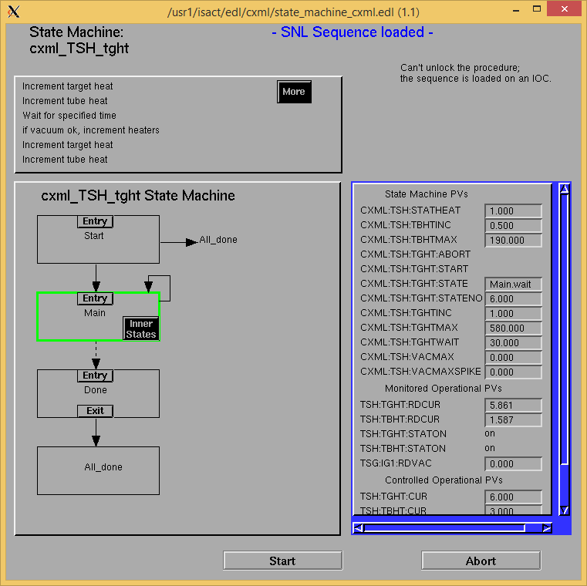

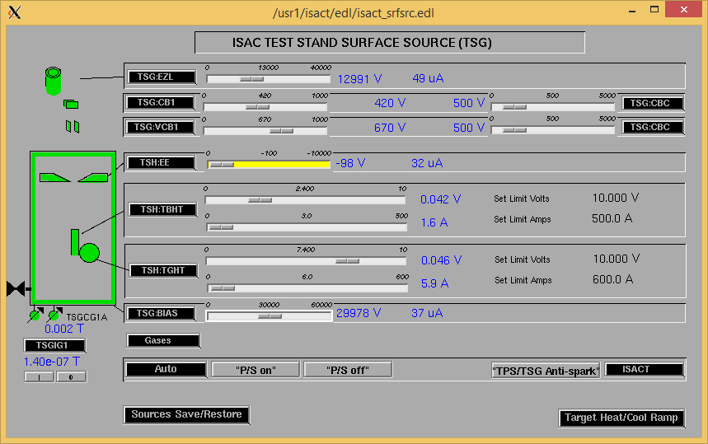

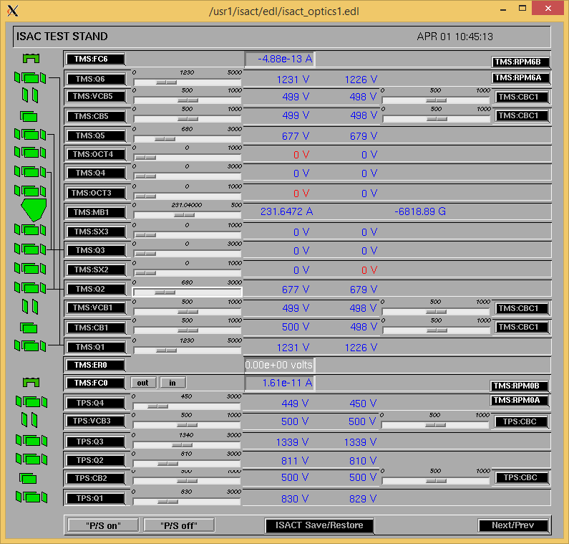

Heaters conditioning done:

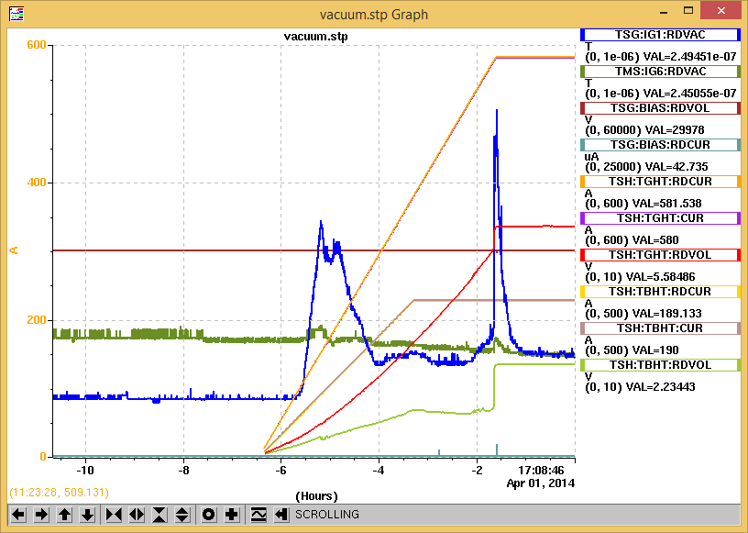

  
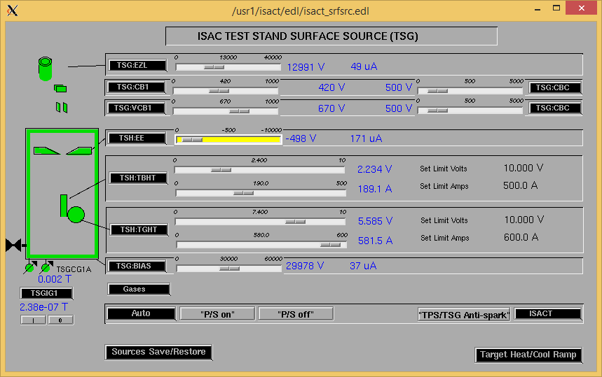

The Power Supplies front panel:

TGHT: 5.56V and 580A

TBHT: 2.23V and 227A

April 2, 2014

Overnight striptool:

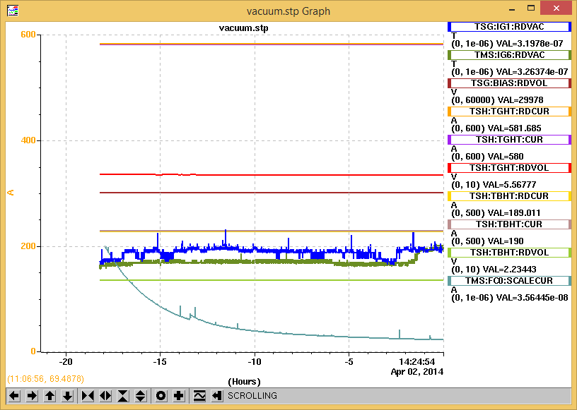

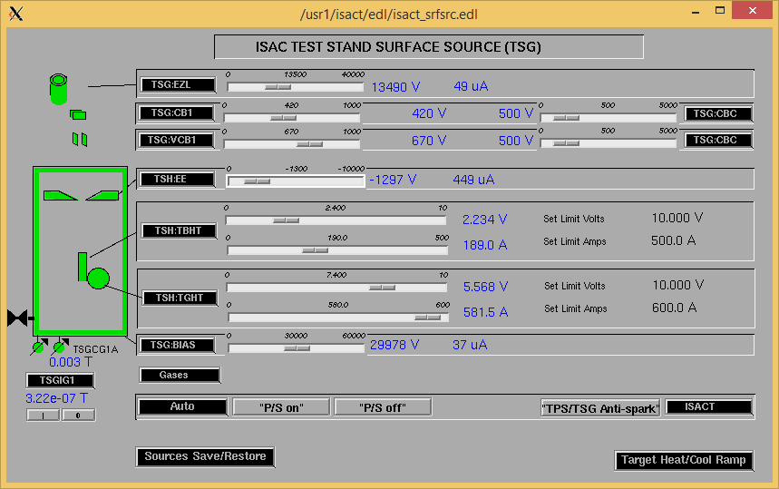

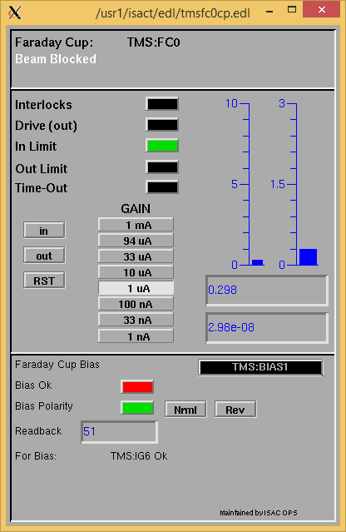

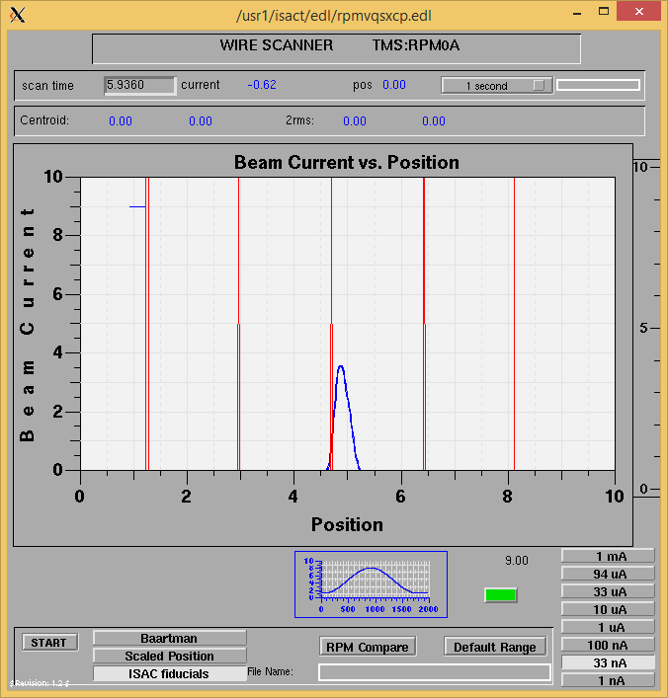

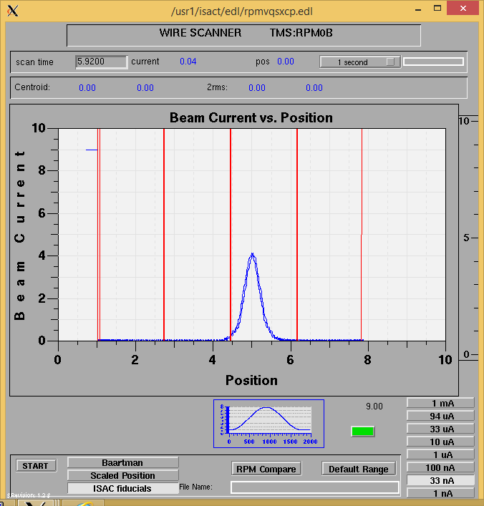

So far mass scan: [plotdump-local-clean.txt_Apr2_14_16-33-19.txt](http://isacwserv.triumf.ca/onlylocal/isactdata/save_restore/masscorr/plotdump-local-clean.txt_Apr2_14_16-33-19.txt)

NOTE: data is shifted by 10-15%.

After the scan finished I found the Test Stand EPICS screens whited-out. Decided with Friedhelm to leave it as it was for the night and to contact Controls next day to reboot it without tripping the heaters and the HV.

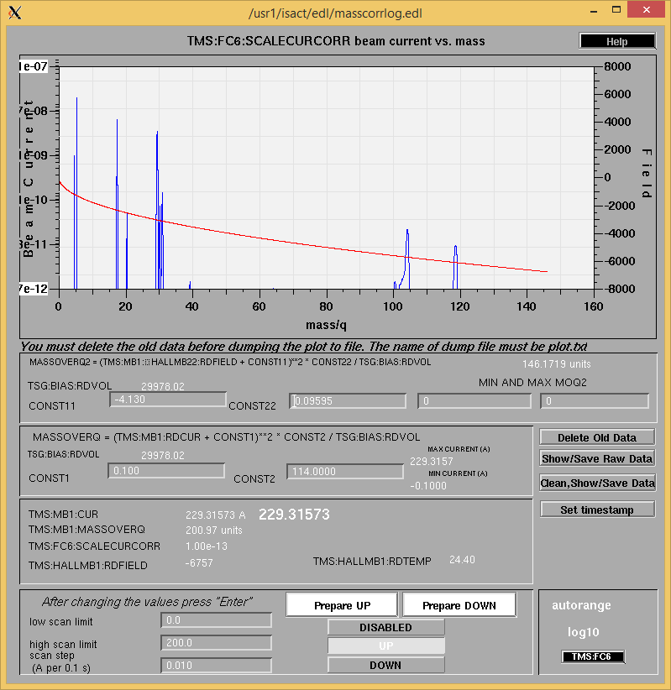

April 3, 2014:

Found everything recovered. Except: “SOURCES ARCH IS RUNNING” was red. So, I restarted it. Jane Richards and Friedhelm didn’t do any IOC reboot. Also found that the data from yesterday’s scan was saved (see the previous scan).

Did another mass scan: [plotdump-local-clean.txt_Apr3_14_10-18-13.txt](http://isacwserv.triumf.ca/onlylocal/isactdata/save_restore/masscorr/plotdump-local-clean.txt_Apr3_14_10-18-13.txt)

NOTE: data is shifted by 10-15%.

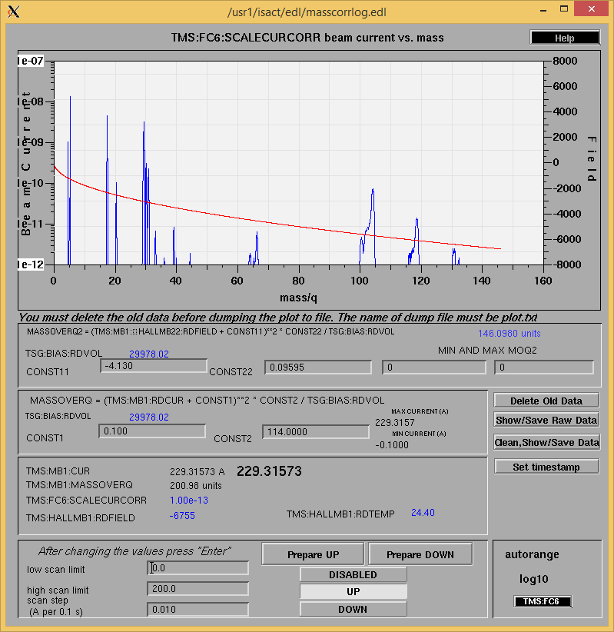

See the Controls communication interruptions on the striptool: 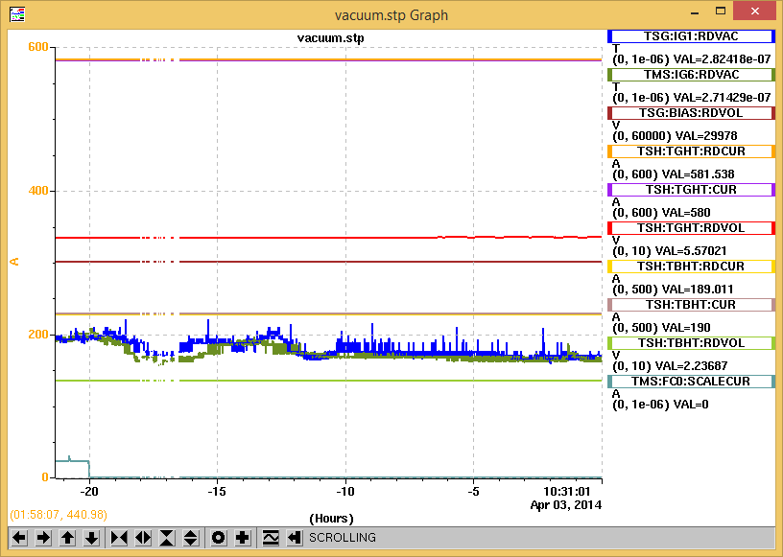

Before cooling down:

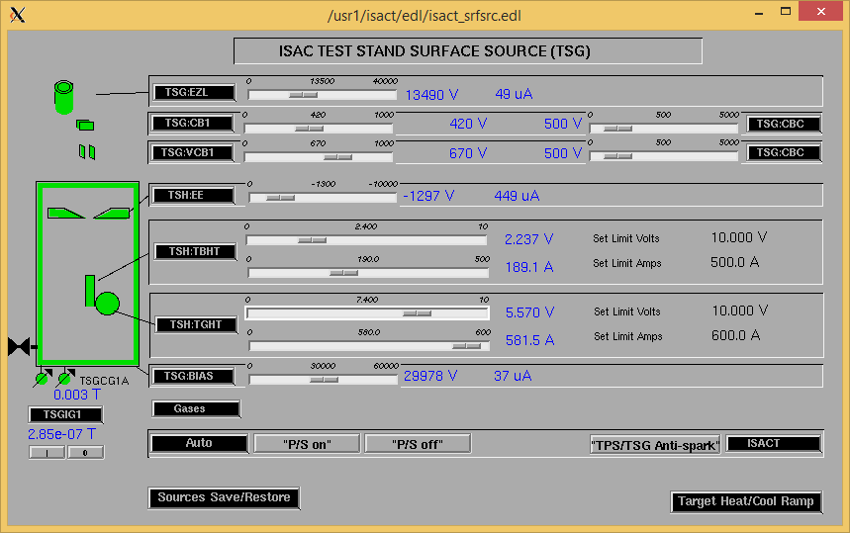

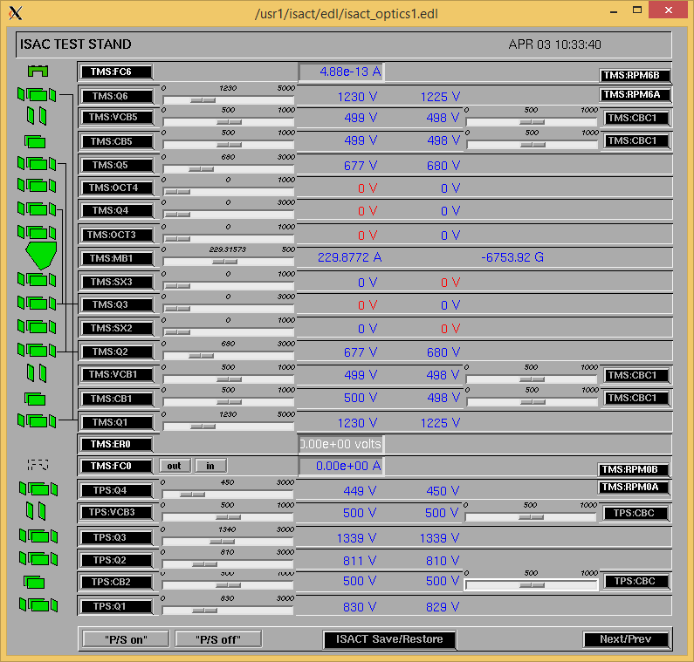

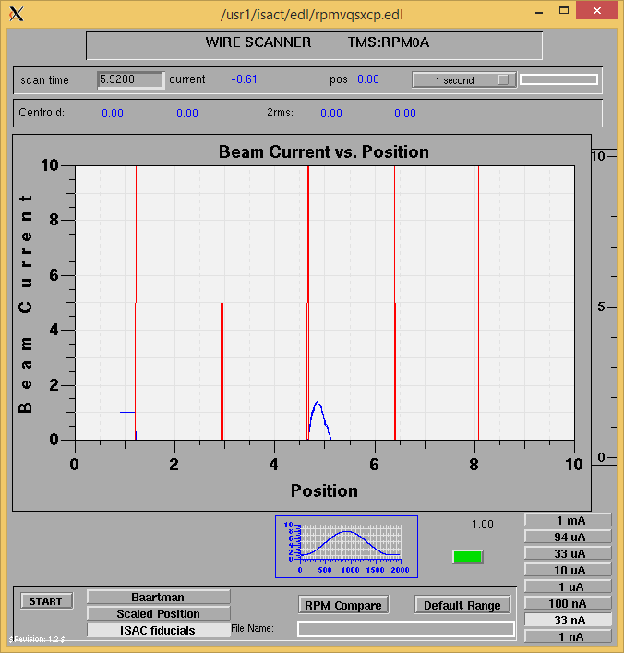

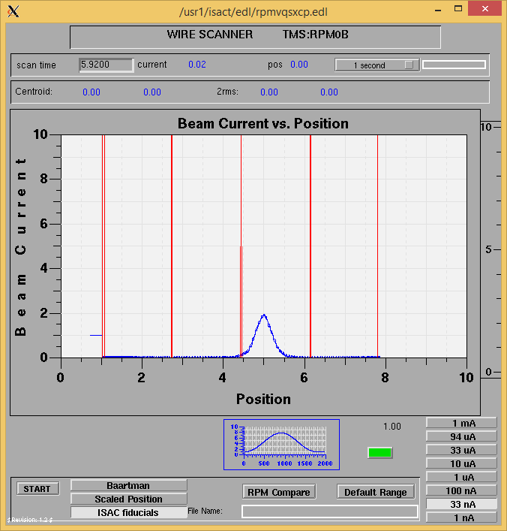

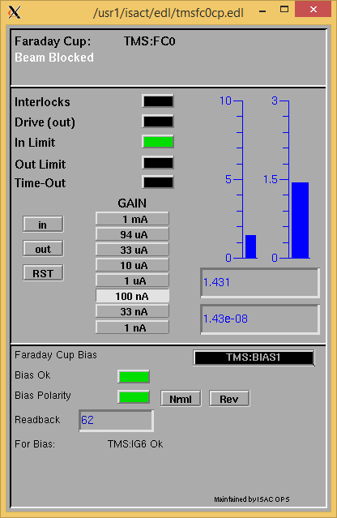

Cooling down:

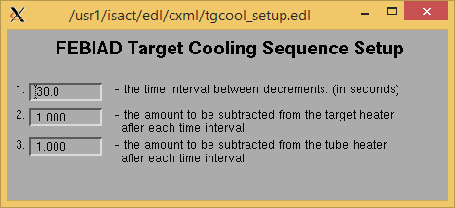

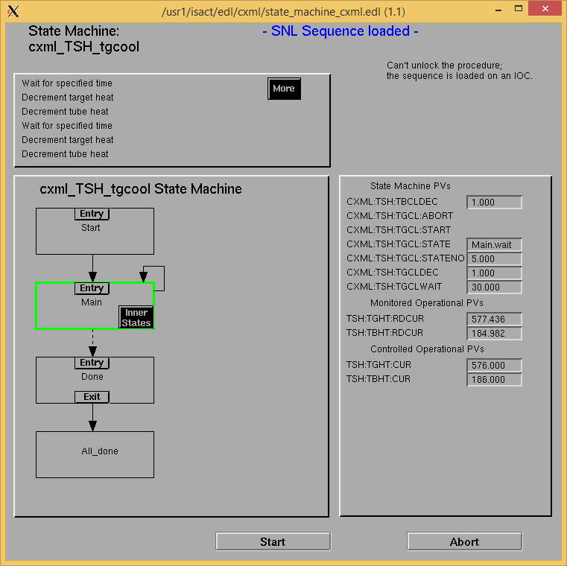

Cooled down finished:

