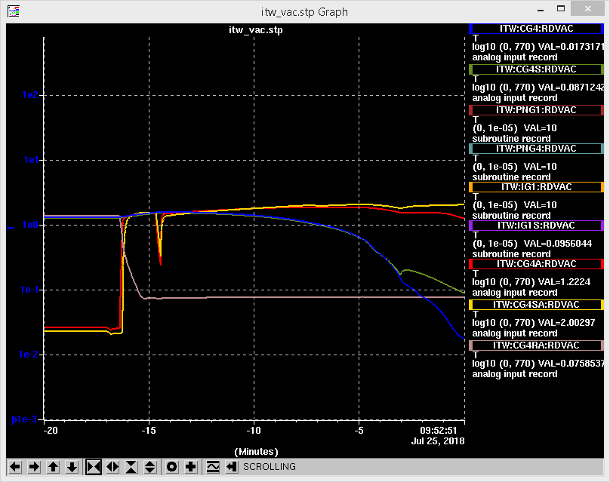

Figure : Vacuum response to actuating p beam monitor in Entrance Module

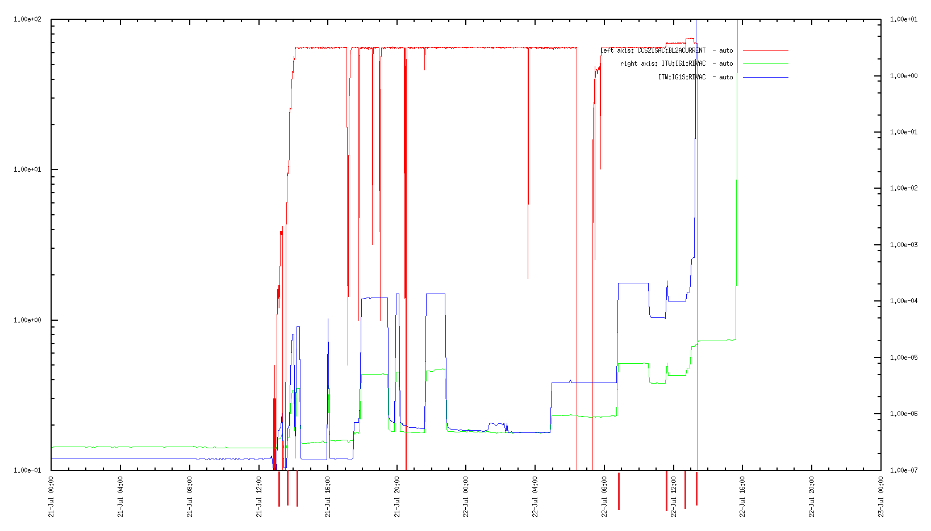

Figure : Vacuum response and proton scans (from e-log)