**E-Linac Beam Dump Water Block Remote Handling Test Procedure**

June 2, 2015

**Prepared by:** I. Earle, K. Ng

**Purpose:** To test the remote handling procedure for connecting and disconnecting the RH water block connections (TEL4260) for the beam dump. The beam dump vacuum and water connections must be disconnected anytime the beam dump needs to be removed for service and it is prudent to test the procedure before beam is started and the equipment becomes radioactive.

This procedure applies for service after de-rated (10kW) running conditions only. Higher beam powers will require a different shielding arrangement and will cause higher residual fields, so a different Remote Handling setup may be required. If fields are prohibitively high in the future, it may be necessary to work from a Remote Handling setup on top of the E-Hall hatch blocks, approximately 20 feet above the beam line.

**Assumed State:**  
- All four water blocks are installed as per TEL4761  
- The service stand plug is removed  
- The cooling package is shut-off, drained and locked out  
- The water lines have been purged with air

**Personnel:** 2 personnel are required for this procedure.

**Required Tools & Supplies:**  
  
- Hook tool on 10’ pole (or 1X if new wedge tool developed to hold BD upstream)  
- 3/8”-16 stud tool on 10’ pole  
- RH Pole Tool (TRH1244) with Water Tool Wrench (TRH1243)  
- ½” Socket Drive Torque Wrench  
- Rubber nut thread tool on 10’ pole  
- Camera on 10-12’ pole with screen and recorder  
  
- New gasket(s) in retainers (TEL4264)  
- Seal installation and removal tools (in design)  
- Kimwipes and methanol for cleaning gaskets

1. **Water Block RH Test**
   1. Crack the nut on the water block which is to be detached using the water block wrench and pole tool (TRH1243, TRH1244) with a ½” socket drive torque wrench. Approximately 60 ft*lbs of torque will be required.  
        
      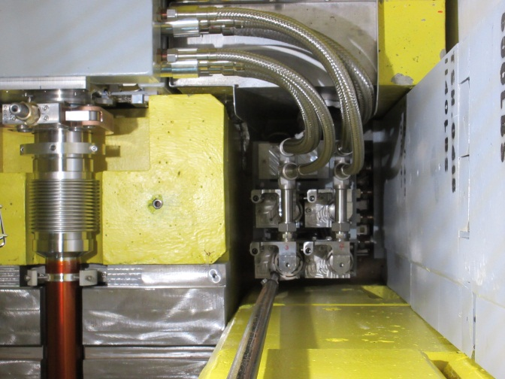 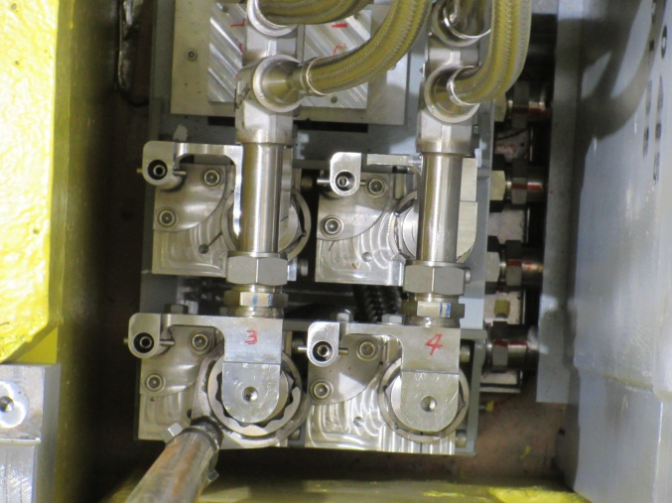
   2. Completely unthread the nut using the rubber nut thread tool  
        
      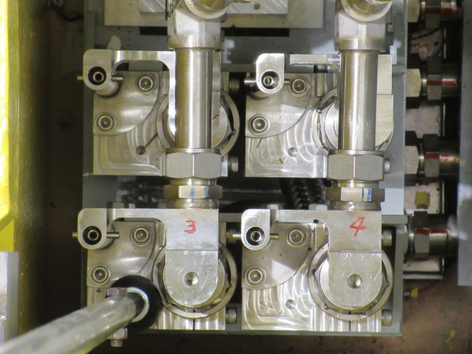
   3. Thread the stud tool into the water block upper half lift hole and carefully lift the upper half. Hold the pole steady while doing so to prevent swing in the east direction caused by stiffness of the flexible hose. It is possible that the gasket may become dislodged during this process. Move the WB upper half to the side so the gasket is easily accessible.  
        
      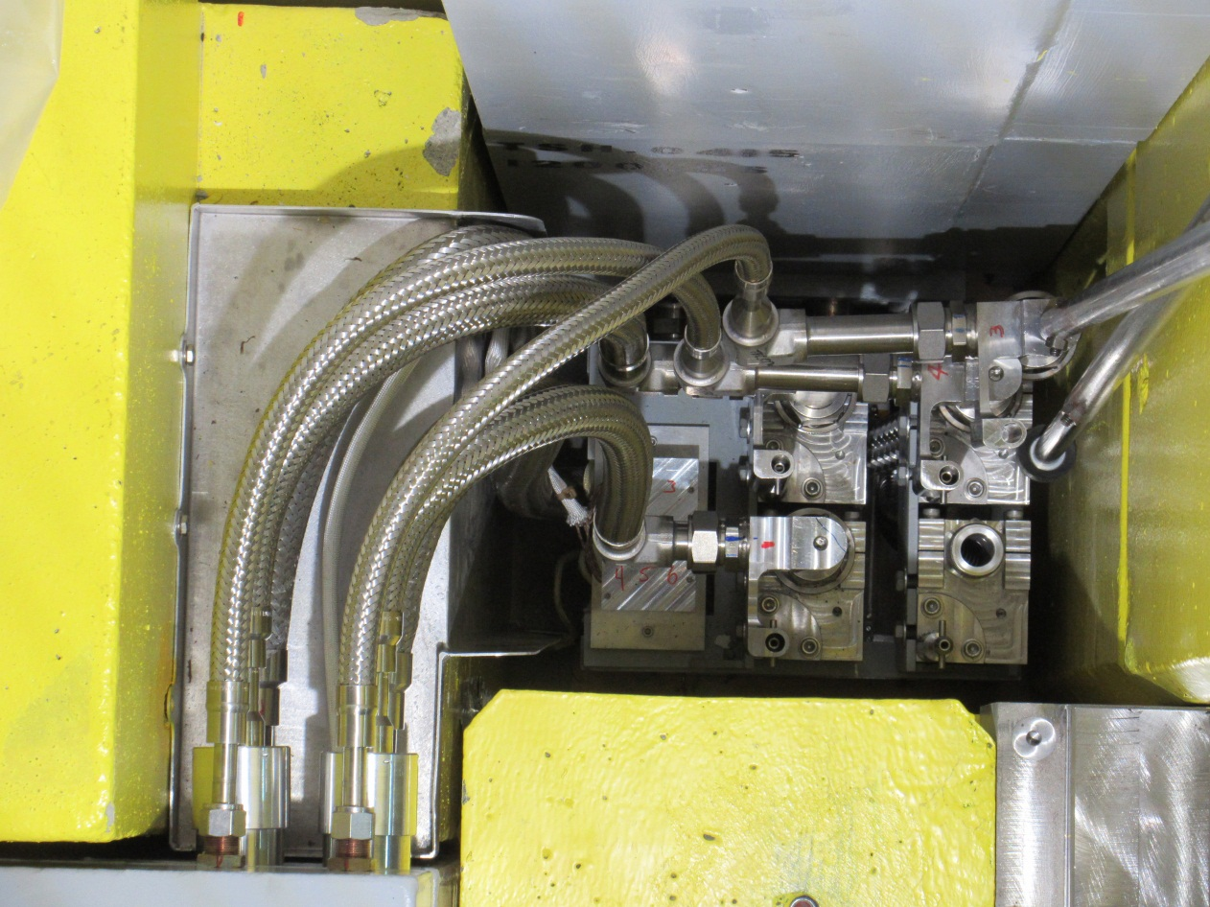
   4. Remove the gasket using a plastic hook or other appropriate tool that will not damage the water block glands (not yet developed).   
        
      Note: When this hardware has become radioactive it will be necessary to handle the seal in a way to avoid excessive exposure or spread of contamination.
   5. Inspect the gland on the water block lower half using field glasses. Wipe the gland surface with RH cleaning tool soaked in methanol if necessary.
   6. Clean the new seal (TEL4264) with a Kimwipe and methanol and inspect thoroughly. Do not use if any non-concentric machining marks are observed.
   7. Install the new seal and retainer onto the water block lower half (tool not yet developed)
   8. Move the WB upper half with the stud tool and locate the lower half shaft in the mating hole on the upper half. Adjust the WB upper half to the correct orientation so that it slides down into place in the pipe bore. Water blocks #3 and #4 may require assistance with a hook tool to get the WB upper half in the correct orientation (see photo below). Water blocks #1 and #2 do not require this.  
        
      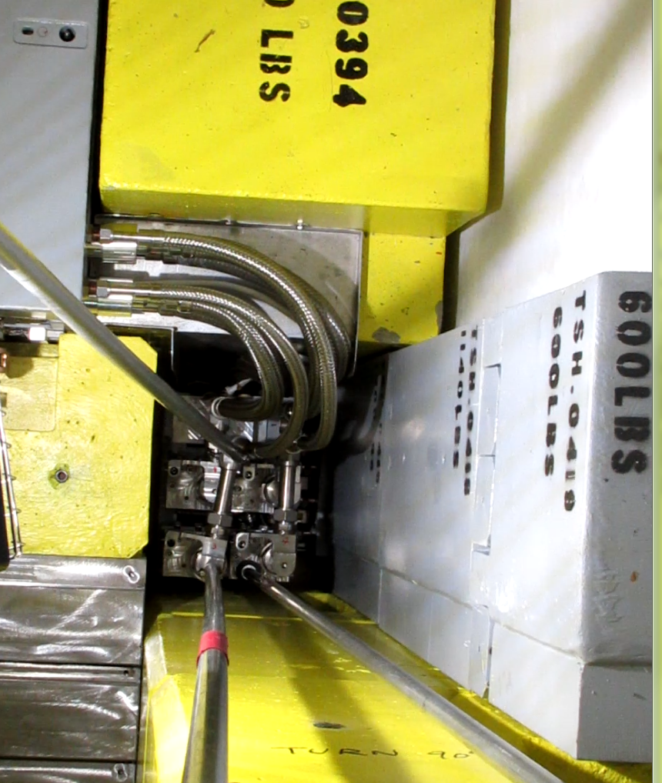
   9. Thread the nut down using the rubber nut thread tool, then torque to 60ft*lbs with the water block wrench and pole tool (TRH1243, TRH1244) with a ½” socket drive torque wrench.
   10. Remove all tools and have a leak check performed on the system before restarting.