**E-Linac Beam Dump Vacuum Flange Remote Handling Test Procedure**

June 2, 2015

**Prepared by:** I. Earle, B. Paley, K. Ng

**Purpose:** To test the remote handling procedure for changing the vacuum seal on the front flange of the E-Linac beam dump (TEL4938). The beam dump vacuum and water connections must be disconnected anytime the beam dump needs to be removed for service and it is prudent to test the procedure before beam is started and the equipment becomes radioactive.

This procedure applies for service after de-rated (10kW) running conditions only. Higher beam powers will require a different shielding arrangement and will cause higher residual fields, so a different Remote Handling setup may be required. If fields are prohibitively high in the future, it may be necessary to work from a Remote Handling setup on top of the E-Hall hatch blocks, approximately 20 feet above the beam line.

**Assumed State:**  
- The beam dump and beam dump local shielding is installed as per TEL4957  
- The EHDT beam pipe and EHDT shielding are installed as per TSH0293  
- The EHDT beam pipe and beam dump flanges are connected using a RH 4” Marman Flange Clamp (IRH0001) and a TEL5568 seal

**Personnel:** 3 personnel are required for this procedure.

**Required Tools & Supplies:**  
- Vice grip seal holding tool (TEL5571) on 10’ pole  
- 2X Hook tool on 10’ pole (or 1X if new wedge tool developed to hold BD upstream)  
- 2X 3/8”-16 stud tool on 10’ pole  
- Flange cleaning tool on 10’ pole  
- Clamp drive socket (3/4”-16 UNF) on 6’ pole  
- New 4” helicoflex seal (TEL5568)  
- Methanol  
- Video camera on 10-12’ pole, monitor, and video recording device  
- Work light on tripod stand

**Procedure:**

1. **Vacuum Seal RH Test**
   1. Configure the beam dump shielding and remote handling bridges as per the figures below. Two 6 foot RH bridges, as well as some 4” thick dunnage will be required; the remainder of the required blocks are part of the beam dump or EHDT shielding.

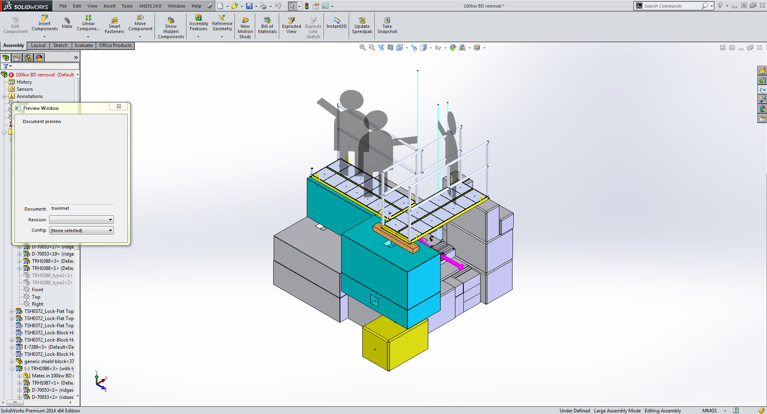 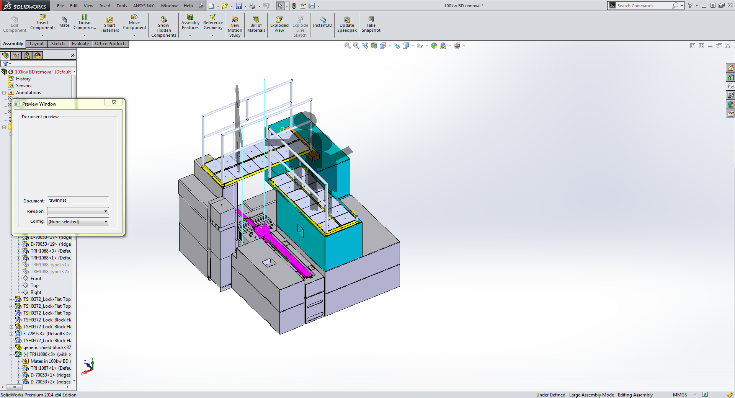

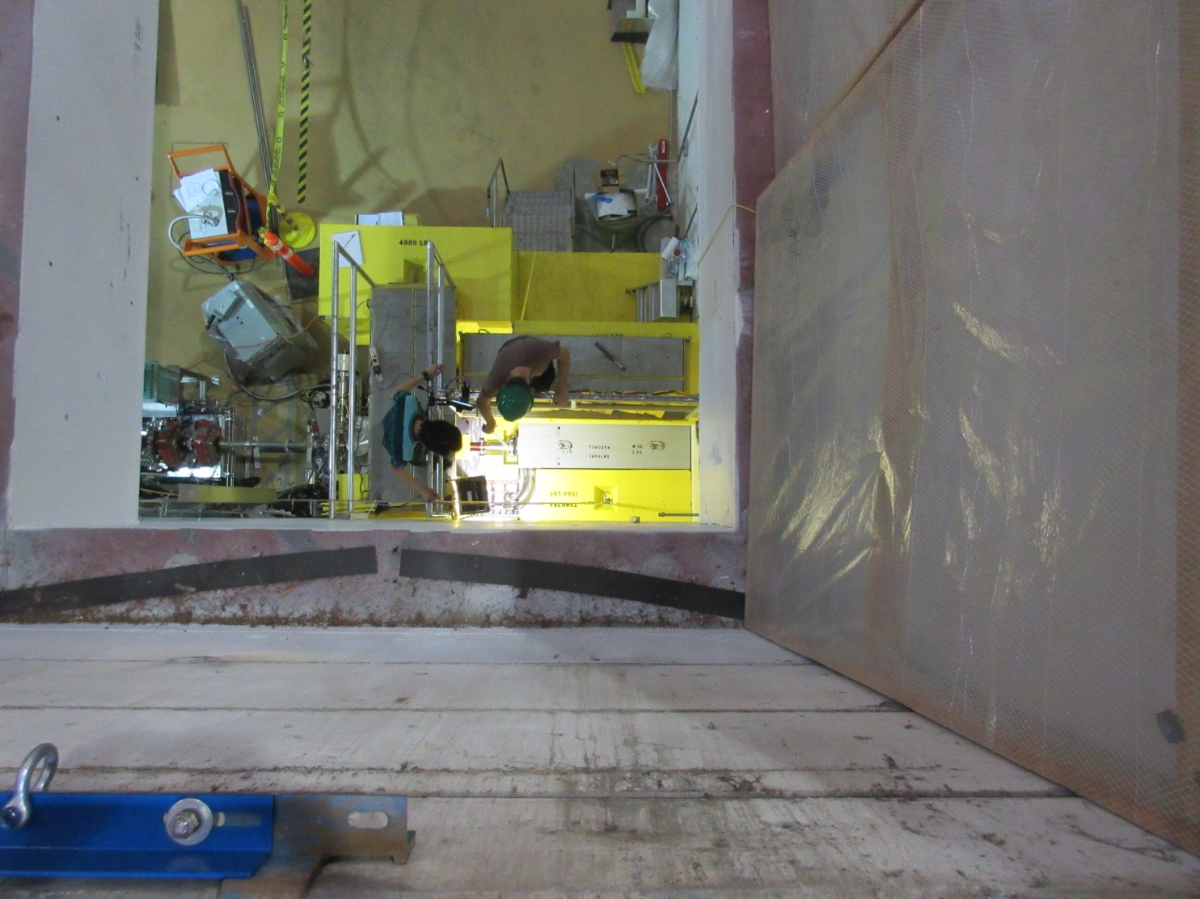 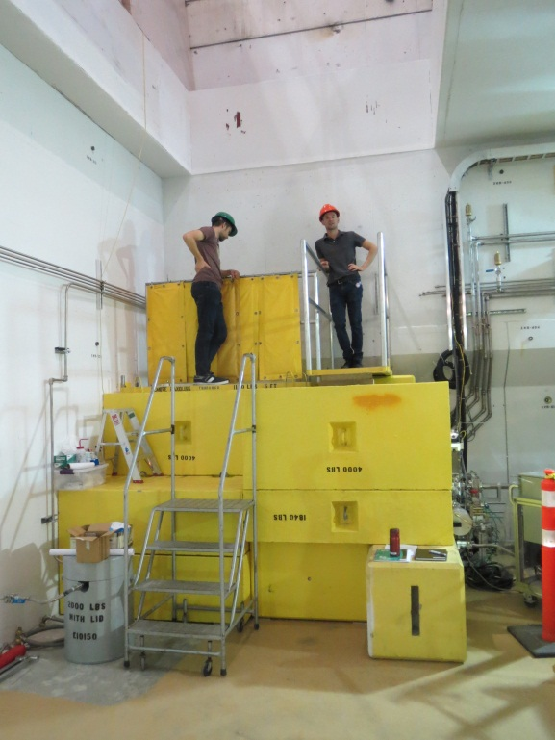

* 1. Undo the RH clamp with drive socket pole tool. If one of the clamp jaws is stuck while opening, shake gently until free. Lift the clamp out using a 3/8”-16 stud pole tool.  
       
     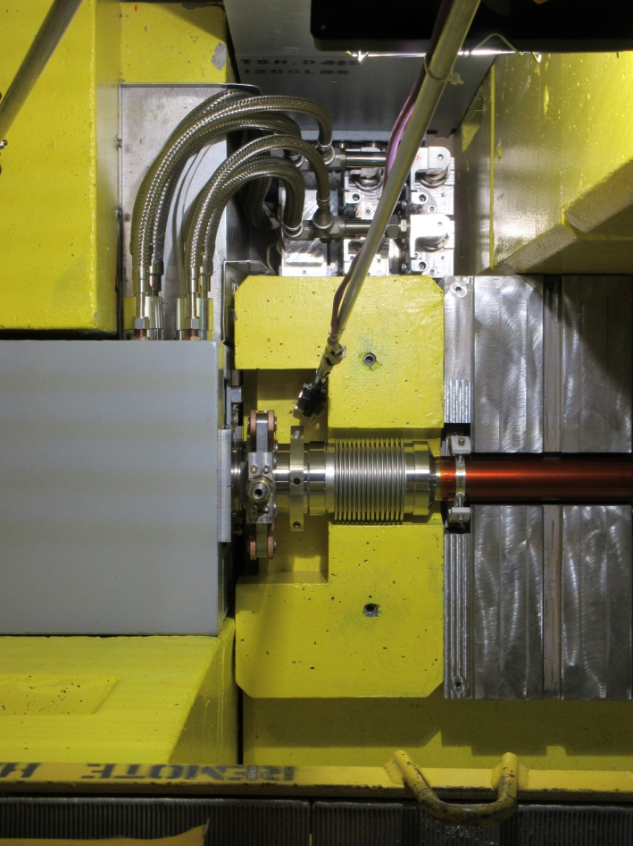 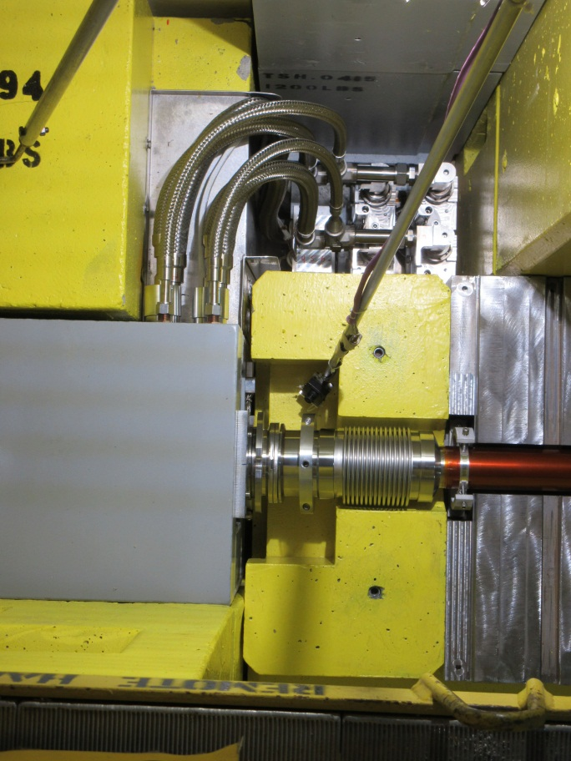
  2. If the old seal remains attached to one of the flanges carefully pull it off by the raised cuff tab using the hook pole tool (it is ok for it to fall onto the shielding below). After the seal is dislodged from the flange it may be necessary to push the BD flange downstream with the hook tool to get the seal to come loose and drop down. Pick up the old seal with a hook pole tool and remove.  
       
     Note: After beam activation use precautionary measures as required by RPG to handle the radioactive seal  
       
     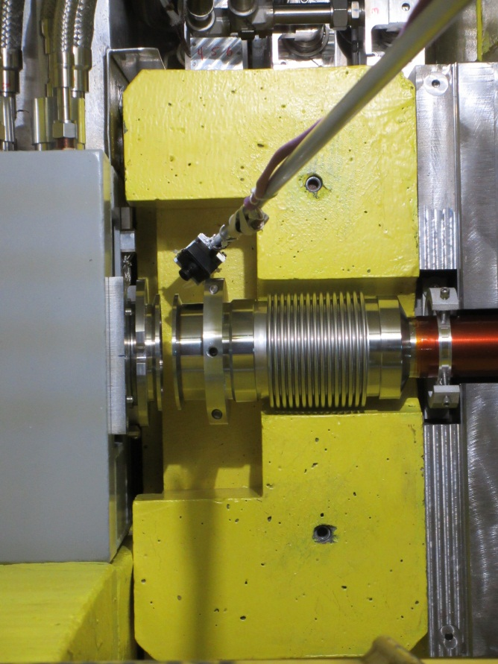
  3. Inspect both flange faces using a pole tool camera (record video for future reference).
  4. Thread a stud tool into the EHDT flange and hold it steady. Wipe both flanges with the flange cleaning tool and methanol. (The flange cleaning used for the test was a cotton lint free inspection glove secured to a plexiglass flat bar (1/4”x1”x12”) taped to a long pole)  
       
     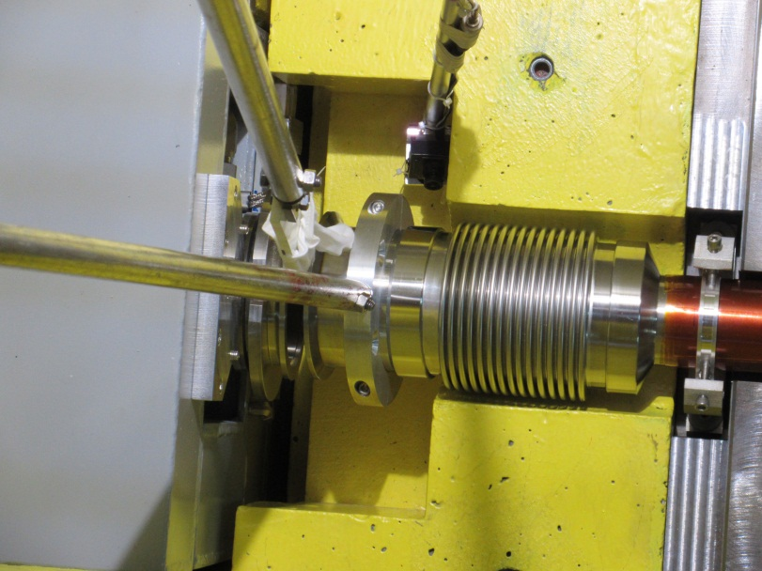
  5. Repeat video inspection with recording.
  6. Carefully wipe both faces of the new seal using methanol and a Kimwipe. Inspect the seal thoroughly. Do not use the seal if there is any visible damage to the seal delta.
  7. Attach the vice grip seal holding tool to the new seal, tune the vice grip adjustment screw so that the seal is held securely but the vice grip can still be disengaged easily (by releasing the vice-grip with hook pole tool); lower the seal down with the vice grip handle facing upstream, and locate it onto the beam dump flange  
     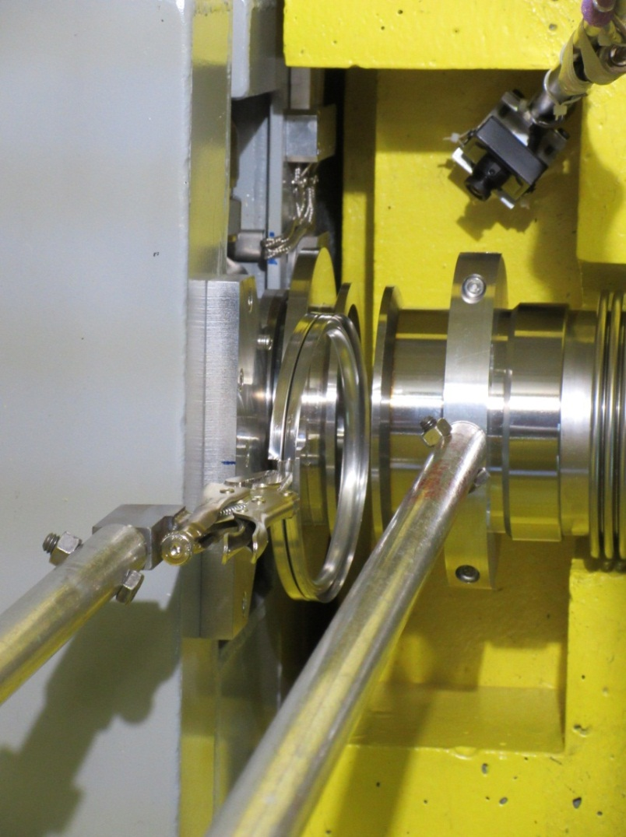
  8. Move the beam dump upstream using the hook pole tool by inserting it between the back side of the clamp flange and the east face of the lead shielding, then twisting it to force the BD upstream (if the upper lead shield is removed it may be easier to insert the hook tool between the downstream end of the beam dump and the lower lead shield). Adjust the EHDT flange until the seal is properly seated on both flanges. Confirm visually from above and with the camera pole tool from below.  
       
     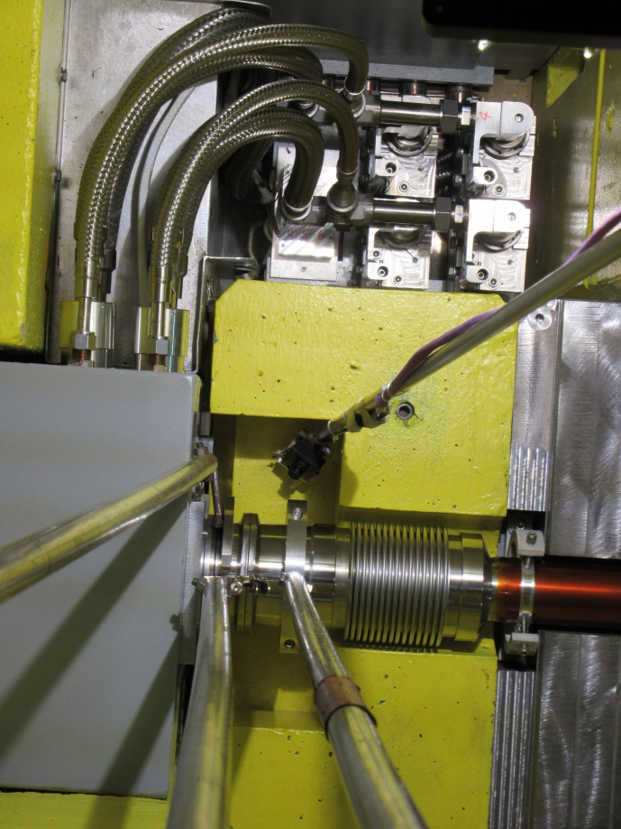
  9. Maintain pressure on the BD clamp flange while disconnecting the seal holding tool and stud tool.  
       
     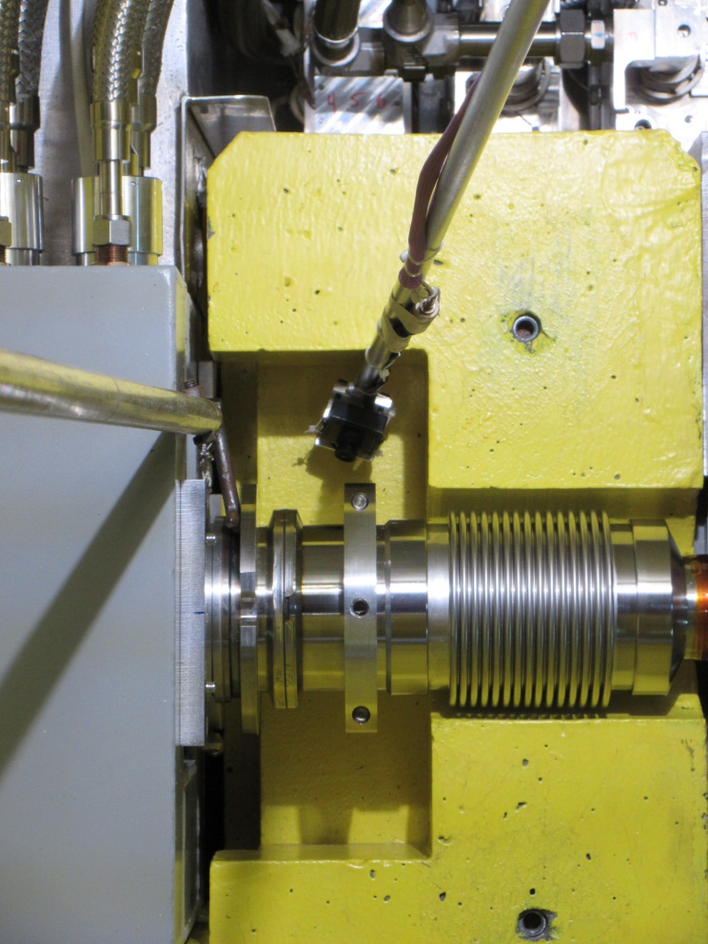
  10. Maintain pressure on the BD clamp flange while lowering the clamp down onto the locating features on the BD clamp flange.
  11. Begin closing the clamp using the drive socket tool turned by hand (no wrench attached to pole). Inspect continuously while closing (visually from above and with cameras from below) to ensure the jaws close properly over the flanges. If the clamp becomes hand-tight while the hard stop gap is greater than 0.375”, one of the clamp jaws may not be seated properly on the flanges. Try to free the stuck jaw by lightly shaking or rocking the clamp.
  12. When the clamp is hand-tight, and the hard stop gap is less than 0.375”, attach a torque wrench set at 40ft*lbs (to prevent damaging the clamp), and continue tightening the clamp until the slide block reaches the hard stop while observing for any abnormalities with the camera tool
  13. Perform a final video inspection of all visible sides, remove all tools, and perform helium leak check (Vacuum Group)  
        
      Note: use long pole helium probe tool when the rad fields from the beam dump become excessive



