**When:** 15/03/17 Between 11:00 & 14:45

**Where:** ISAC 1 – Cold Lab

**Who:** Ron Murray & Aaron Schmidt

**Issue:** A pin hole leak was found in the D.H.W waterline. Soldering of new copper pipe is required. Any fire alarms in the Cold Lab will need to be disabled. Safety glasses, gloves, steel toes shoes required.

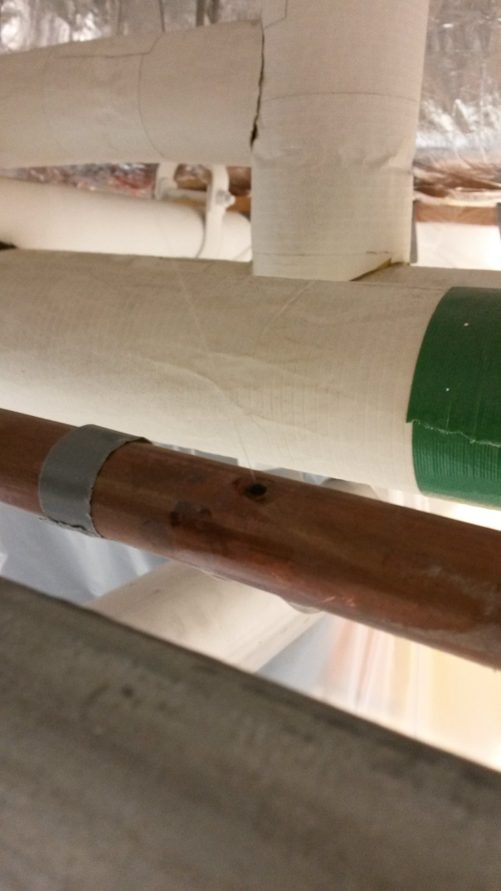 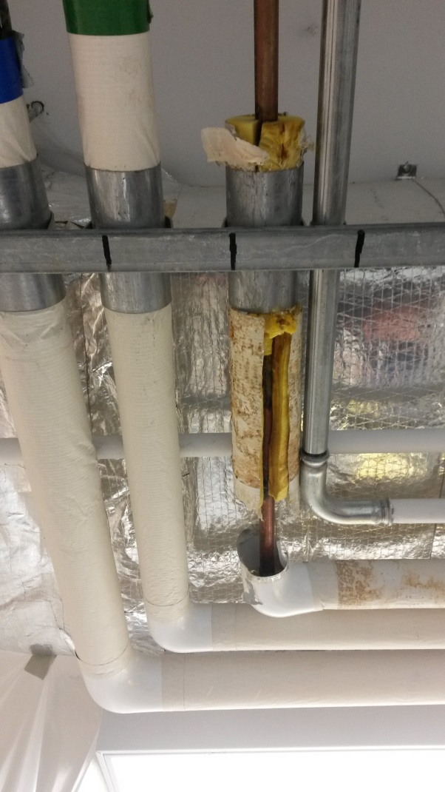

**Background:** Fri 03/03/2017 15:00 - The emergency shower was tested. The water was too dirty & hot for proper use and a leak was detected. Water @ 55 degrees C. Fri 03/03/2017 17:00 - A water leak was noticed on the D.H.W line. Hot water to the Cold lab was shut down.

**Summary:** The corroded copper pipe section was replaced. An insulating tape was added where the pipe rests on another metal joint; however the pipe is not fully insulated yet. The Main Control Room was called for the smoke alarm to be re-activated.

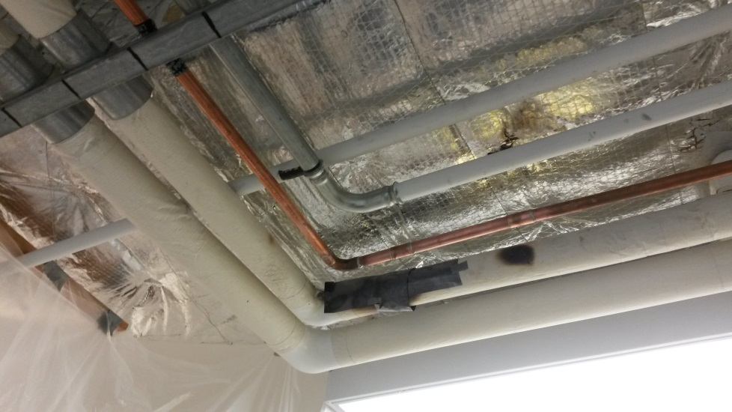

**Noteworthy comments:**

-Plastic sheets where placed around the work area to protect the lab from dust/water/solder. This is still in place at the moment, but easy to by-pass.

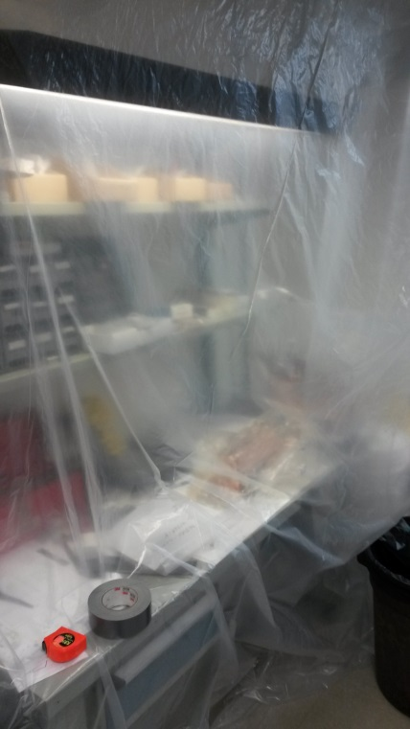 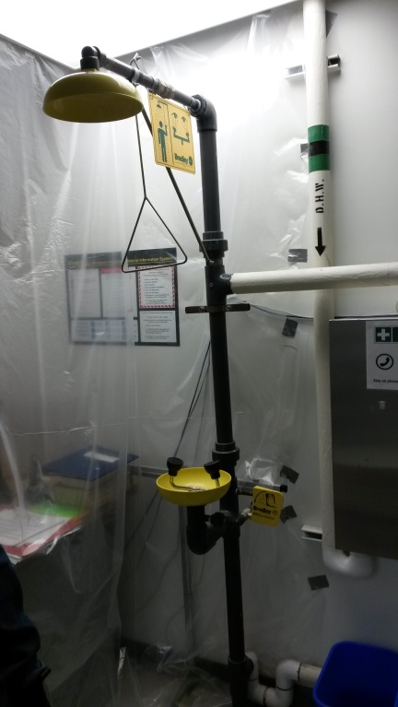 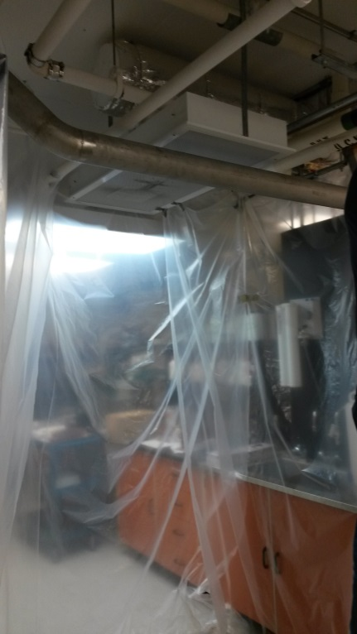

-The new pipe may require insulation.

-The water quality is still poor coming from the pipe. The water needs to be run continuously for a few minutes before it develops clarity. Hot water is used to effectively activate the Oxide remover when cleaning copper parts in the lab. Just note to make sure the any parts cleaned in the lab are adequately rinsed with D.I water when cleaning.

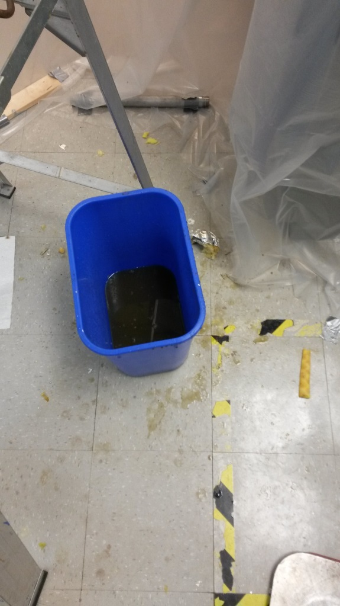 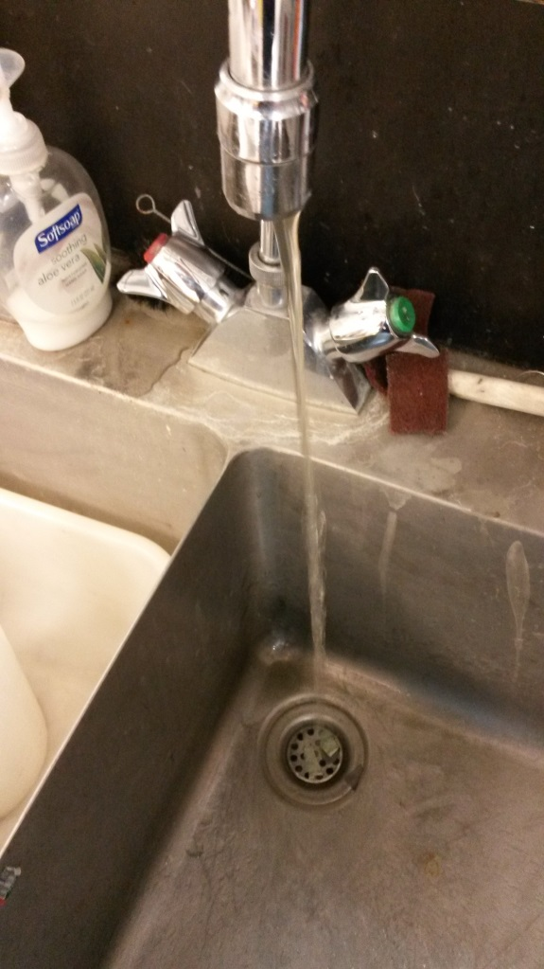

-The water coming through the emergency eyewash station & shower is still a near scalding 50-55 degrees C. This still requires attention.

-Some of the insulation on a nearby pipe and above the D.H.W pipe was burned during this work but is otherwise fine.

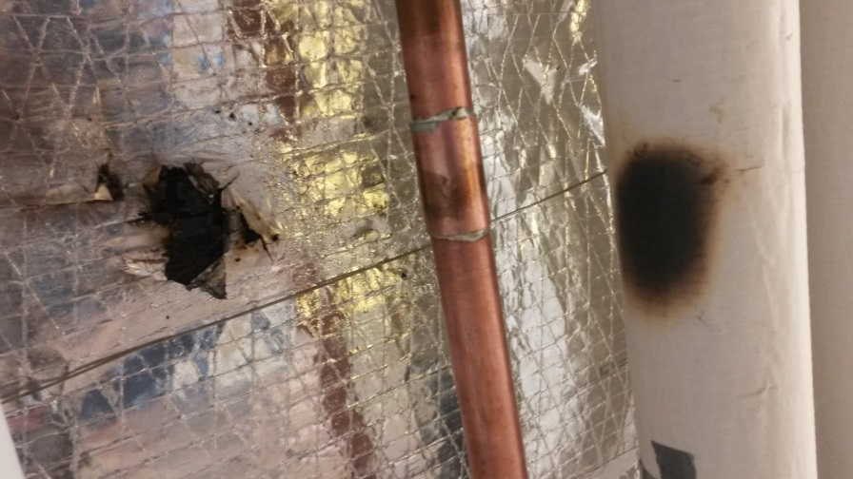

-The pipe removed was quite corroded. Likely other pipe in the area is in similar condition. Something to be mindful of.

