Notes on water leak in ISAC I  
Tuesday 21, 2012

A water leak was discovered at about 12:10 by Anders Mjos. Water was dripping down from the ceiling / ventilation in the South Hot Cell service area, level B2. See Figure 1.

ISAC operations were notified. The hot lab and cold lab on the B1 level was checked immediately, but no sign of water was found. Water supply for ongoing acetone and methanol distillation in the cold lab fume hoods were closed, nevertheless.

[ISAC Operations logbook for Tue Feb 21, 2012](https://web.accel.triumf.ca/isac_elog/Elog_date_view.pl?submit=Go!&goyear=2012&gomonth=02&goday=21)

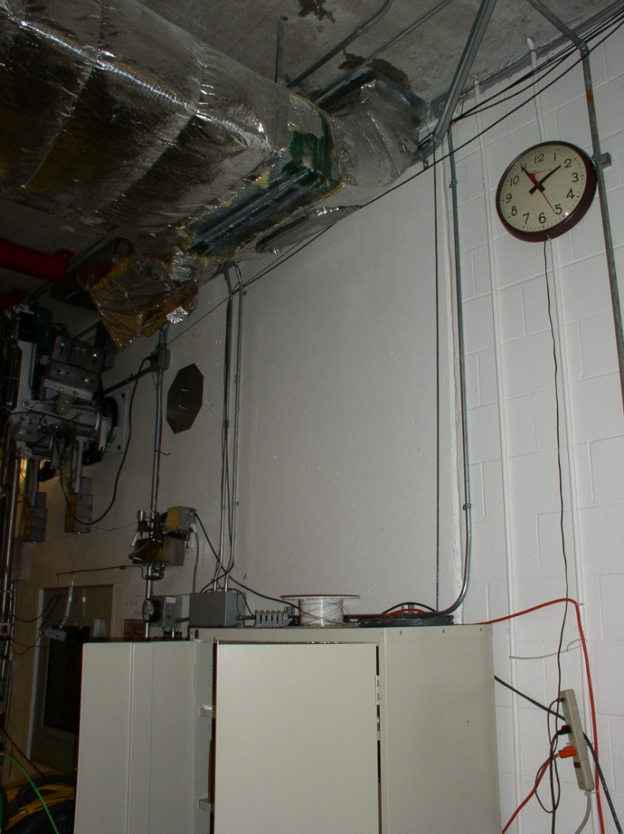

Figure : Location of dripping water in the South Hot Cell service area. B2 Level

With the help from ISAC operations more rooms on the B1 level were checked.

The fume hood acid storage was eventually opened and the back panels providing access to water and gas services removed. At this point a small water puddle had developed on the floor in front of the fume hoods. A leak was found on the drain for the middle fume hood. See Figure 2. A crack had developed on the connection to the drain where water could escape.

By this time the water dripping in the B2 level had decreased due to the shut-off water supply.

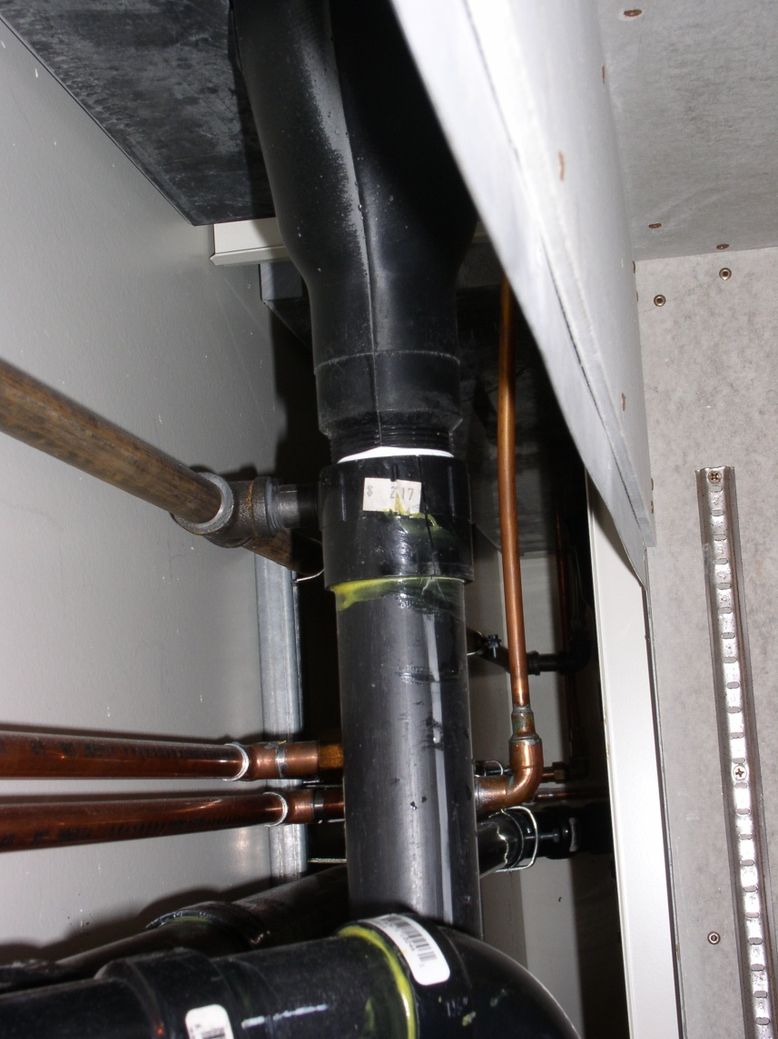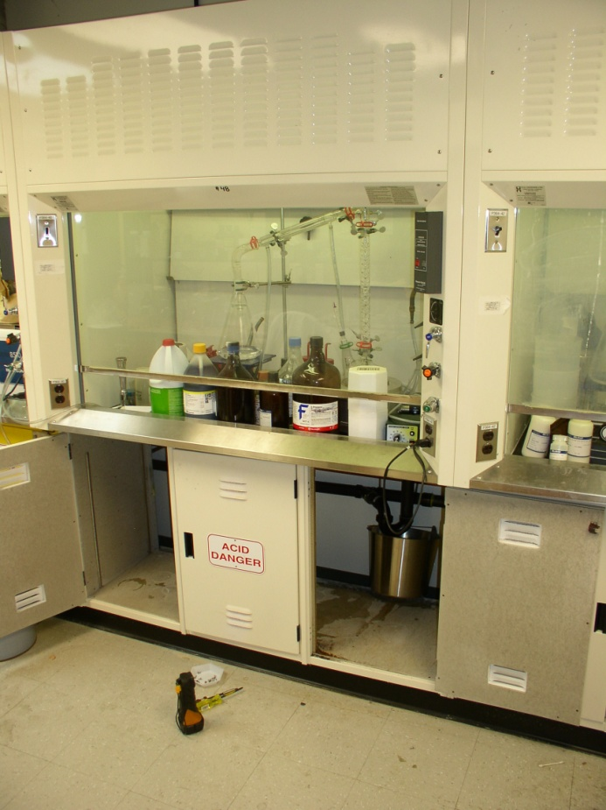

Figure : Location of the leak and the cracked drain pipe

The broken drain pipe has been replaced and acid storage cabinets left open to allow them to dry out. When the piping for the drain was replaced, it was noticed that it was very tight. It is quite possible that it failed and cracked because of this. The work was done in response to ISAC E-fault [5837](https://web.accel.triumf.ca/ncr/dbfault.pl?btn_submit=5837&faultgroup=ISAC).

A piece in the upper right corner of the back panel in the center fume hood has broken off. It was possible to put it back in place using two existing screws. See Figure 3.

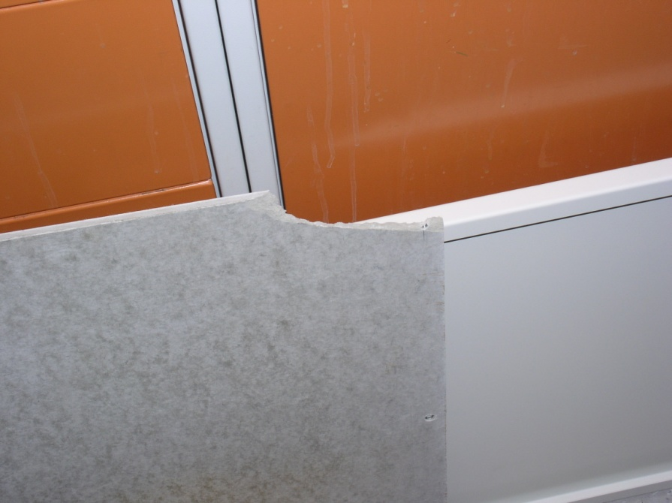

Figure : Fume hood cabinet back panel with broken corner.

The reason we have not seen leaks earlier may be because we are inserting a hose into the drain when distilling. Until the 21st we may have been lucky with the placement of the hose and the direction of the water flow has been away from the crack.

It appears to be minimal or no damage in the South Hot Cell service area. The water amounts only to some puddles on the floor. See Figure 4. The remote manipulator arm located close to the leak was pulled away to avoid contact with water.

No contamination was found in the water.

Most of the water has been mopped up on the B2 level in the South Hot Cell service area. As the insulation on the ventilation got wet, water may still drip onto the floor for a little longer.

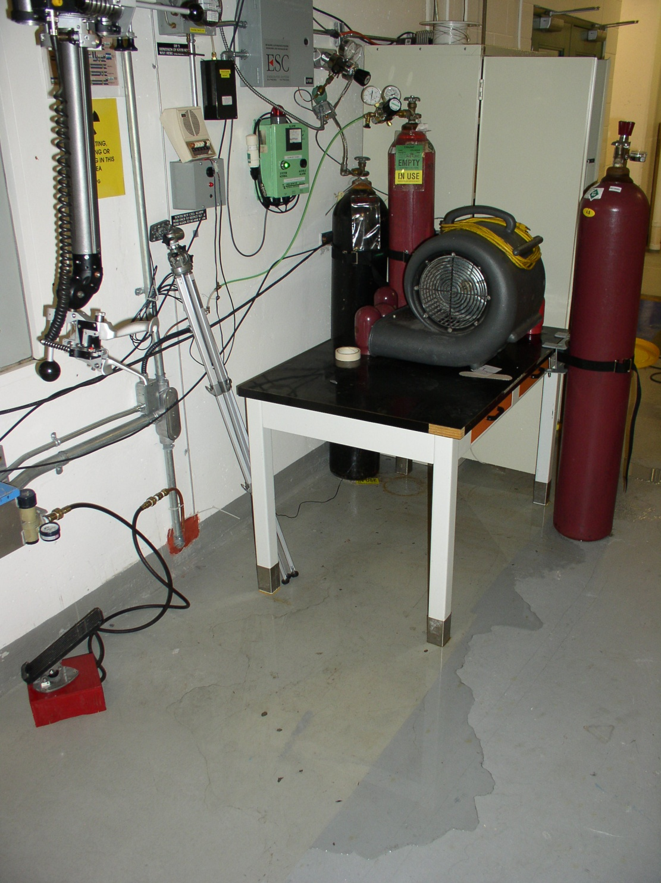

Figure : Water accumulated on the floor in the B2 level