## Turbo pump off test 1 (Date 180111)

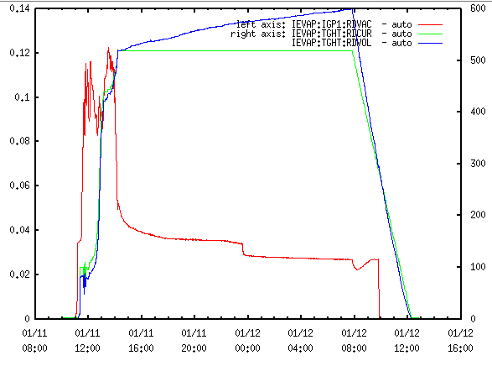

* 05: 10A/s -> 100 A with P = 3.5x10e-2 Torr
* 100s: Wait for pressure response
  + Current reduced to 60 A at 9x10e-2 Torr
* 16 min 40 s Waited in 60 A
* 19 min 17 s Increase current to 90 A at 9.5x10e-2 Torr
* 21 min 50 s Increase current to 110 A as stabilizes at 8.3x10e-2 Torr
* 24 min 10 s Reduced current to 100 A when
* 28 min 10 s trying to stabilize pressure at 0.1 Torr ~ 95 A
* At ~420 A (13:53) Rate increased 10A/**5**min until 470 A
* At (14:07) rate was increased to 10A/**2**min

Suggestions:

1. Fast (rate 1 A/s, wait period 20 s) to 95 A (80 A), wait for stabilization and fast onset of decrease
2. Until 125 A (1 A/min)
3. 10 A/**4**min until 155 A but in small steps
4. 10 A/**2**min in small steps until 175 A
5. 10 A/min in small steps until 225 A
6. 15 A/min in small steps until 300 A
7. 20 A/min in small steps until 360 A
8. 15 A/min until 390 5 min
9. 15 A/**4**min in small steps until 440 A
10. Wait for Pto drop C